Contents
Background and planning 9
Introduction 10
Target audience 11
Primary issues addressed 11
System dev. methodology 12
Project management 14
Gantt chart 14
PERT chart 15
Project plan 16
User requirements 19
Hardware and Software Requirements 21
Draft storyboards 22
frmLogin 22
frmMainMenu 22
frmStaffData 23
frmCustomerData 23
frmVehicleData 24
frmVehicleTypeData 24
frmServiceAppointments 25
frmServiceData 25
frmPartData 25
frmRoleData 26
frmReports 27
User feedback 27
Design 30
Final sketches 31
frmLogin 31
Drawing 31
Explanation 31
Pseudocode and diagrams 32
Validation and error-trapping 33
Input specifications 33
frmMainMenu 34
Drawing 34
Explanation 34
Pseudocode and diagrams 35
Validation and error-trapping 36
User requirements met: 2, 3, 4, 5, 9, 15, 23, 24 36
frmMainMenuStartingForm 37
Drawing 37
Explanation 37
Pseudocode and diagrams 38
Validation and error-trapping 38
frmStaffData 39
Drawing 39
Explanation 39
Pseudocode and diagrams 40
Validation and error-trapping 42
Input specifications 43
frmCustomerData 44
Drawing 44
Explanation 44
Pseudocode and diagrams 45
Validation and error-trapping 45
Input specifications 46
frmVehicleData 47
Drawing 47
Explanation 47
Pseudocode and diagrams 48
Validation and error-trapping 49
Input specifications 50
frmVehicleTypeData 52
Drawing 52
Explanation 52
Pseudocode and diagrams 53
Validation and error-trapping 53
Input specifications 54
frmServiceAppointments 55
Drawing 55
Explanation 55
Pseudocode and diagrams 56
Validation and error-trapping 61
Input specifications 61
frmServiceData 63
Drawing 63
Explanation 63
Pseudocode and diagrams 64
Validation and error-trapping 65
Input specifications 65
frmPartData 66
Drawing 66
Explanation 66
Pseudocode and diagrams 67
Validation and error-trapping 68
Input specifications 68
frmRoleData 69
Drawing 69
Explanation 69
Pseudocode and diagrams 70
Validation and error-trapping 70
Input specifications 71
frmReports 72
Drawing 72
Explanation 72
Pseudocode and diagrams 73
Validation and error-trapping 73
frmLogs 74
Drawing 74
Explanation 74
Pseudocode and diagrams 75
Validation and error-trapping 76
frmHelp____ 77
Drawing 77
Explanation 77
Pseudocode and diagrams 77
Validation and error-trapping 77
Program flow 78
Normalisation 79
ER diagram 80
Final database design 82
Customers 82
Parts 82
ServiceAppointments 83
ServiceAppointmentsServices 83
ServiceAppointmentsServicesParts 84
Services 84
Staff 85
Vehicles 85
VehicleTypes 86
Data requirements 87
ComboBoxItem (ComboBoxItem.cs) 87
CurrentUser (CurrentUser.cs) 87
Customer (Customer.cs) 88
DBConnect (DBConnect.cs) 88
Logging (Logging.cs) 88
MechanicSchedule (MechanicSchedule.cs) 89
Part (Part.cs) 89
Role (Role.cs) 90
Service (Service.cs) 90
ServiceAppointments (ServiceAppointments.cs) 91
Staff (Staff.cs) 92
Timeblock (Timeblock.cs) 92
Validation (Validation.cs) 92
Vehicle (Vehicle.cs) 93
VehicleTypes (VehicleTypes.cs) 94
Logs (logs.txt) 94
Class diagram 95
Report specifications 96
rptAppointmentMonthlyProfitsByMechanic 96
Purpose 96
Data Sources 96
Content/Fields 96
Design 96
rptCustomerInterest 97
Purpose 97
Data Sources 97
Content/Fields 97
Design 97
rptInvoices 98
Purpose 98
Data Sources 98
Content 98
Design 99
rptMissedAppointments 100
Purpose 100
Data Sources 100
Content 100
Design 100
rptVehicleStock 101
Purpose 101
Data Sources 101
Content 101
Design 101
rptVehicleTypeProfits 101
Purpose 101
Data Sources 101
Content 101
Design 101
Testing 102
Testing 103
Purpose of testing 103
Types of testing undergone 103
Types of test data used 103
Items to be tested 104
frmLogin 104
frmMainMenu 110
frmStartingMainMenuForm 116
frmCustomerData 117
frmStaffData 138
frmRoleData 164
frmVehicleData 177
frmVehicleTypeData 220
frmPartData 232
frmServiceData 246
frmServiceAppointments 277
frmLogs 315
Logging 319
frmReports 321
Corrective action 325
frmLogin 325
1.1.13-1.1.14 325
1.1.24 327
frmStartingMainMenuForm 329
3.1.2 329
frmCustomerData 332
4.1.2 332
frmServiceAppointments 335
11.2.14 335
11.2.21 338
Acceptance Testing 340
Questionnaire 340
Responses 343
Analysis 344
Testing conclusion 344
User guide 346
Hardware and Software Requirements 346
Installation 347
Compilation 347
Execution 348
Operating the system 349
Logging-in 349
Navigation 350
Creating a new user 351
CRUD operations (general) 352
Creating 352
Reading 355
Updating 356
Deleting 357
Searching 358
CRUD operations (appointments) 358
Creating 359
Reading 363
Updating 364
Updating Schedule 366
Deleting 367
Searching 368
Reports 371
Changing reports 371
Printing reports 372
Logs 373
Filtering 373
FAQ 377
Purpose of evaluation 380
Meeting user requirements 381
Future development 397
Strengths and weaknesses of the system 400
Design process 405
Implementation process 407
Evaluation of chosen methodology 409
Comparison between final design and final system 410
Testing process 422
Personal and technical skills 423
Adherence to project plan 424
User feedback 430
frmLogin 430
frmMainMenu 430
frm______Data 431
frmServiceAppointments 432
frmLogs 432
frmReports 433
Conclusion 433
SQL to create tables 436
Customers 436
Parts 436
Roles 437
ServiceAppointments 437
ServiceAppointmentsServices 438
ServiceAppointmentsServicesParts 438
Services 439
Staff 439
Vehicles 440
VehicleTypes 440
SQL to populate tables 441
Customers 441
Parts 445
Roles 446
ServiceAppointments 447
ServiceAppointmentsServices 451
ServiceAppointmentsServicesParts 454
Services 456
Staff 457
Vehicles 458
VehicleTypes 461
SQL for additional constraints 463
Staff 463
Vehicles 463
Customers 463
Parts 463
Roles 463
ServiceAppointments 464
ServiceAppointmentsServices 464
ServiceAppointmentsParts 465
Services 465
Staff 465
Vehicles 466
VehicleTypes 466

Background and planning

Introduction

Since the advent of the ubiquitous integration of technology - particularly database systems - into all facets of commerce, the processing and storing of business data has become a task more streamlined than ever: the validation of data; abstraction of the underlying storage medium; and seamless accessibility all offer a cohesive and highly effective solution to a challenge that has long confronted enterprises. However, this comes at a cost to those who remain tethered to antiquated methodologies, often leaving them unable to keep accurate and consistent records commensurate with their growth, impeding operational efficiency and constraining sustainable growth.

Unfortunately, this is the predicament that has beset Patrick Doherty, proprietor of the local, family-operated car dealership Doherty Cars. Over two decades of consistent customer-focused, high-quality service, they have established a firm local reputation that has contributed to their gradual yet notable influx in customer traffic. However, the dealership’s continued dependence on manual processes - namely written memoranda, disparate spreadsheets and fragmented, interpersonal emails - has rendered it incapable of managing its schedules, customer interactions and inventory with the precision and consistency now required.

While such methods may have sufficed during the company’s formative years, in the present day it creates critical - and more importantly, preventable - problems, including delays (often as a result of underestimating the time taken for activities such as appointments, inspections and deliveries to be carried out), lost paperwork which leads to uncertainty and ultimately customer dissatisfaction, and human errors such as miscommunication. These all stem from the current-day difficulty in ensuring that all employees have consistent, up-to-date information when it comes to appointments, records, schedules, queries, etc. Furthermore, the administrative workload provided by the dealership’s expansion into territories such as new car sales, servicing, financing and trading-in has imposed unmanageable strain on the current system, urging for a universal, centralised replacement better-equipped to handle this strain. This urgency is underscored by Mr Doherty’s desire to open a second branch, further pressing for a system that would be able to compartmentalise each branch’s actions while ensuring that they are accessible by him.

In response, Mr Doherty envisions the incremental implementation of an integrated digital administrative system, with modular components addressing discrete domains before converging on the final centralised framework. Such a framework would mitigate any errors and inefficiencies by ensuring the synchronisation of data across all sectors of the enterprise, ensuring organisational coherence.

Target audience

Unlike any of my previous projects, the final system is intended to be an internal tool - one used solely by the company for its operation - and so the target audience for the system will only be staff members. However, due to the inherent hierarchy present in the enterprise (with staff split into sectors such as technical, financial and managerial, each of which have their own lead staff members), the actions carried out by each role and consequently their interaction with the system will differ. For example, mechanics will be able to access and modify data relating to appointments, vehicles and parts, whereas finance staff will be able to access reports to gain information on profits and performance.

Taking into account the habits of staff members, attempts will be made to ensure the system is intuitive to improve ease of transition. Minimal experience with technology will be assumed, and this will be reflected in the simple design and verbal explanations implemented. Due to the internal nature of the system, the ability to register an account will not be provided to prevent unauthorised access.

Primary issues addressed

Due to limitations of time and solo development, the solution developed will only be able to address issues with the system deemed most critical. Hence, the solution will predominantly address service appointments, staffing, reporting and the implicit issue of logging. However, this is not to say that other issues will not be partially addressed, as many - such as stock management - are interdependent on those chosen.

For service appointments, a subsystem will be implemented which displays each of the 3 mechanics’ appointments on a particular day alongside the services, parts and extras required for each appointment, ensuring that mechanics can easily modify and see the latest changes to them. This should ensure consistency in schedules due to the centralised nature of the system and, consequently, mitigate any problems arising from appointments being made when mechanics or parts are unavailable, ultimately making the whole process a lot smoother. By extension, this will accommodate reporting, as a separate form will be provided which will allow staff to view the performance of mechanics, total profits from appointments etc. based on this data, as well as that of any adjacent tables implemented.

For staffing and logging, a system will be implemented which keeps track of the user currently logged in, externally writing their actions to a text file and preventing them from accessing forms that are not relevant to their role, thus providing full traceability and accountability which will prevent the mistakes which plague Mr Doherty.

System dev. methodology

Without defined structure in the development of the system, it is unlikely that a cohesive, functional solution would be delivered within time and budget constraints. Thus, a suitable system development methodology is to be chosen prior to any design, implementation or testing.

Agile (in this case denoting more specifically the XP, DSDM and Scrum approaches) is one of the most widely used modern methodologies. An incremental and iterative approach, development is split into multiple releases, with each release going through the SDLC (software development life cycle) before being released to the customer as a functional subset of the system that they can then use and provide feedback which informs future iterations. Similarly, Rapid Application Application (RAD) emphasises rapid prototyping and frequent user feedback. RAD may involve throwaway prototyping, where prototypes are discarded after validation, or evolutionary prototyping, where prototypes are incrementally refined into the final system. Both methodologies promote adaptability and continuous improvement, which are valuable in projects with evolving requirements or highly engaged stakeholders.

Therein lies their unsuitability for the project, despite their advantages. For this project, the requirements consist of a fixed and clearly defined list of issues, reducing the need for evolving requirements. Furthermore, ongoing stakeholder involvement is limited due to my distance from the company, preventing regular feedback. The overhead associated with Agile practices, such as sprint planning, backlog management, and retrospectives, would also introduce unnecessary complexity for a project of relatively small scope executed by a solo developer. In a similar vein, RAD relies heavily on repeated user feedback and rapid prototyping, which are not required here due to the stability and clarity of the project requirements.

Instead, the Waterfall approach has been selected. Within the Waterfall approach, the development life cycle is split into stages such as design, implementation, and testing, and each stage is followed sequentially. Given that the requirements provided by Doherty Cars are unambiguous, clear and unchanging, a linear approach is appropriate, as the client is only required at the start to define these requirements and at the end to test the system - accommodating our difficulty in communication. Additionally, the structured and sequential nature of Waterfall provides a clear framework for managing the project effectively. The constraints of the project - its small, stable scope, limited stakeholder availability, and single-developer environment - make Waterfall an efficient, low-risk choice.

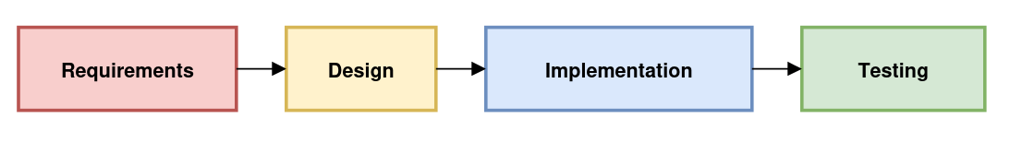
Although only a subset of the system will be developed in this cycle, the Waterfall process can be applied to future development if more functionality is deemed required.

The stages followed during the system development lifecycle will be requirements, followed by design, implementation, and testing, with the deployment of the program left to Doherty Cars. Testing will include white box, black box and ultimately acceptance to ensure a suitable solution has been developed, but will be further discussed in the testing section

Project management

Gantt chart
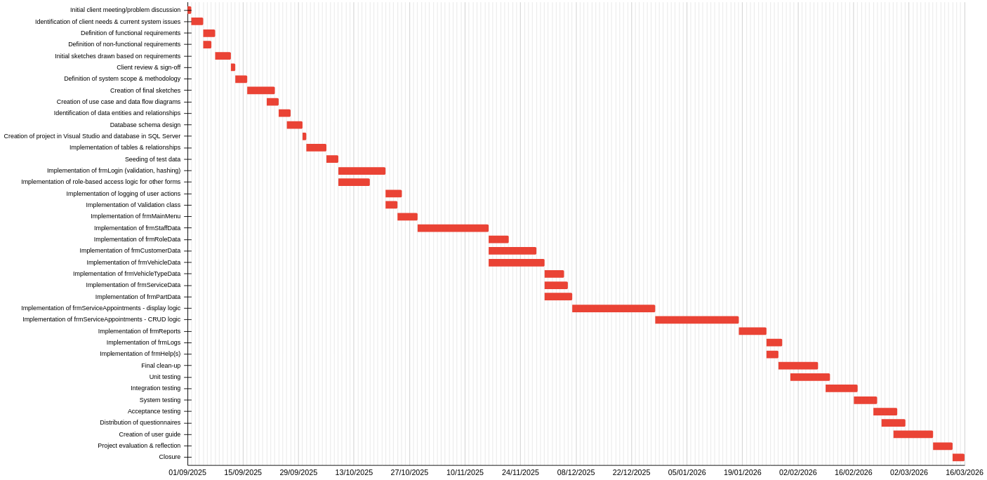
To provide the project with a tentative timescale, a Gantt chart has been constructed as seen below. An attempt will be made to adhere to the allocated time to each task, but the delivery time may fluctuate as a result of underestimating the complexity of tasks, additional tasks being introduced or - hopefully - a task being completed sooner than expected. Ultimately, it will serve to guide the project lifecycle and monitor progress. Note that forms are planned to be developed in batches where noticeable overlap in functionality is expected to improve efficiency.

PERT chart
As the majority of the tasks in the project are sequential in nature, a PERT chart for the entire project is unnecessary. However, many of the tasks within the implementation phase of the project can be carried out concurrently, and a Gantt chart alone may not properly illustrate the interdependencies between the modules of the system or the impact delaying a component may have on others.

For this reason, a PERT chart has been constructed for the implementation phase, depicting the early start and early finish at the top of each node, representing the earliest points at which a task can begin and conclude, and the late start and late finish at the bottom, indicating the latest a task may commence and complete without delaying subsequent tasks.

The critical path - the longest sequence of tasks that must be completed on time for the entire project to be delivered on time - has been marked in red. As illustrated, the majority of effort will have to be spent addressing the handling of service appointments. Other modules exhibit measurable float, meaning limited delays in their completion would not immediately impact the overall time of completion.
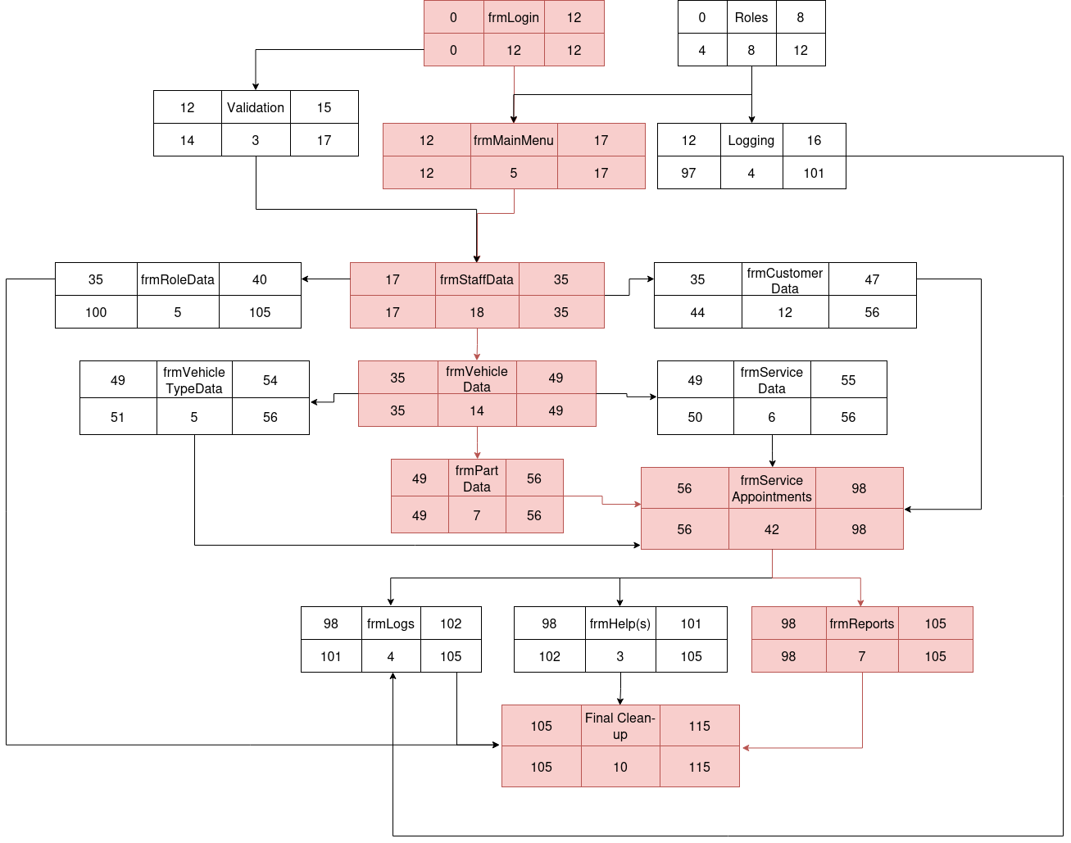

Project plan
Based on the tasks defined in creating the initial Gantt chart, a rough project plan has been created as follows, defining the resources (both human and physical) required at each stage. Note that the developer - I - and the workstation on which the system is developed are involved in all stages but excluded for brevity. Also, the start date denotes that the task starts at the start of that day, while the end date denotes that it ends at the end of that date, e.g. task 1 starts the morning of the 1st of September and finishes that evening.

Task No. | Task | Start Date | Duration (days) | End Date | Resources
Analysis
1 | Initial client meeting/problem discussion | 1-Sep | 1 | 1-Sep | Client
2 | Identification of client needs & current system issues | 2-Sep | 3 | 4-Sep | Client
3 | Definition of functional requirements | 5-Sep | 3 | 7-Sep | —
4 | Definition of non-functional requirements | 5-Sep | 2 | 6-Sep | —
5 | Initial sketches based on requirements | 8-Sep | 4 | 11-Sep | —
6 | Client review & sign-off | 12-Sep | 1 | 12-Sep | Client
Design
7 | Definition of system scope & methodology | 13-Sep | 3 | 15-Sep | —
8 | Creation of final sketches | 16-Sep | 7 | 22-Sep | —
9 | Use case and data flow diagrams | 21-Sep | 3 | 23-Sep | —
10 | Identification of data entities & relationships | 24-Sep | 3 | 26-Sep | —
11 | Database schema design | 26-Sep | 4 | 29-Sep | SQL Server
Implementation
12 | Project setup in Visual Studio and database setup | 30-Sep | 1 | 30-Sep | Visual Studio, SQL Server
13 | Implementation of tables & relationships | 1-Oct | 5 | 5-Oct | Visual Studio, SQL Server
14 | Seeding of test data | 6-Oct | 3 | 8-Oct | SQL Server
15 | Implementation of frmLogin (validation, hashing) | 9-Oct | 12 | 20-Oct | Visual Studio, SQL Server
16 | Role-based access logic | 9-Oct | 8 | 16-Oct | Visual Studio
17 | Logging of user actions | 21-Oct | 4 | 24-Oct | Visual Studio, SQL Server
18 | Validation class implementation | 21-Oct | 3 | 23-Oct | Visual Studio
19 | Implementation of frmMainMenu | 24-Oct | 5 | 28-Oct | Visual Studio
20 | Implementation of frmStaffData | 29-Oct | 18 | 15-Nov | Visual Studio, SQL Server
21 | Implementation of frmRoleData | 16-Nov | 5 | 20-Nov | Visual Studio, SQL Server
22 | Implementation of frmCustomerData | 16-Nov | 12 | 27-Nov | Visual Studio, SQL Server
23 | Implementation of frmVehicleData | 16-Nov | 14 | 29-Nov | Visual Studio, SQL Server
24 | Implementation of frmVehicleTypeData | 30-Nov | 5 | 4-Dec | Visual Studio, SQL Server
25 | Implementation of frmServiceData | 30-Nov | 6 | 5-Dec | Visual Studio, SQL Server
26 | Implementation of frmPartData | 30-Nov | 7 | 6-Dec | Visual Studio, SQL Server
27 | ServiceAppointments (display logic) | 7-Dec | 21 | 27-Dec | Visual Studio, SQL Server
28 | ServiceAppointments (CRUD logic) | 28-Dec | 21 | 17-Jan | Visual Studio, SQL Server
29 | Implementation of frmReports | 18-Jan | 7 | 24-Jan | Visual Studio, SQL Server
30 | Implementation of frmLogs | 25-Jan | 4 | 28-Jan | Visual Studio, SQL Server
31 | Implementation of frmHelp(s) | 25-Jan | 3 | 27-Jan | Visual Studio
32 | Final clean-up | 28-Jan | 10 | 6-Feb | Visual Studio
Testing
33 | Unit testing | 31-Jan | 10 | 9-Feb | Visual Studio, SQL Server
34 | Integration testing | 9-Feb | 8 | 16-Feb | Visual Studio, SQL Server
35 | System testing | 16-Feb | 6 | 21-Feb | Visual Studio, SQL Server
36 | Acceptance testing | 21-Feb | 6 | 26-Feb | Client, Test Users
Evaluation
37 | Distribution of questionnaires | 23-Feb | 6 | 28-Feb | Test Users
38 | Creation of user guide | 26-Feb | 10 | 7-Mar | —
39 | Project evaluation & reflection | 8-Mar | 5 | 12-Mar | —
40 | Closure | 13-Mar | 3 | 15-Mar | —

User requirements

The solution must…
-------------------------------------------------------------- Functional requirements
- …implement a login system that authenticates staff members using their username and password, preventing unauthorised system access
- …keep a record of the logged-in user in memory, enabling dynamic modification of the system and its functionality using their information
- …allow users to log out and log back in with different credentials
- …assign access to certain forms based on the user’s role, ensuring they only modify data that is relevant to them
- …allow users to easily access relevant forms through the use of a centralised main menu form
- …maintain records relevant to the business externally in a database, including tables for:
  - Customers
  - Staff
  - Vehicles
  - Vehicle types
  - Parts
  - Roles
  - Services
  - Service appointments
- …allocate certain permissions - namely read, restricted write and unrestricted write - based on the user’s role’s authorisation level, determining the actions they can take on the system
- …enable users to access pertinent records in the database by providing a form for each table and displaying it in a tabular, interactive format
- …validate any data input to the system before making changes to the database to ensure data is consistent, accurate and correct
- …enable users to create new records in the database by inputting the data into the respective fields provided within the table’s form
- …allow users to easily select records that they wish to modify or delete, either through the use of controls or mouse interaction
- …enable users to update a selected record in the database by making changes to the data automatically populated into the form
- …allow users to soft delete a selected record, ensuring that it is ignored by the system during data display and processing, but still exists on the database
- …clear a form’s fields after a CRUD action to accommodate new data entry
- …prevent data entry upon a system error, ensuring data cannot become corrupted or lost due to a non-existent or broken database
- …properly handle entity relationships, ensuring referential integrity through foreign keys. In particular, when soft-deleting, the following rules will apply:
  - Deleting a customer will delete any of their vehicles and service appointments related to those vehicles
  - Deleting a vehicle will delete any of its service appointments
  - Deleting a staff member will not be permitted while they have existing service appointments
  - Deleting a vehicle type will not be permitted while its being used by existing vehicles
  - Deleting a part will not be permitted while its being used in an existing service appointment
  - Deleting a role will not be permitted while it applies to existing staff
  - Deleting a service will not be permitted while its being used in an existing service appointment
- …ensure that new users added to the system by administrators can log in using the administrators’ determined username and password
- …allow mechanics to easily view, modify, create and delete appointments using a drag and drop system, displaying each day’s available and taken timeslots
- …enable mechanics to select the services and parts used for each appointment
- …ensure that all appointments created are valid i.e. don’t conflict with other appointments, fit within one work day, and don’t occur on a weekend
- …generate reports and invoices using data stored on the database to analyse the business’ performance and assist with customer service
- …automatically determine an appointment’s length and cost based on the services carried out, parts used and the type of vehicle serviced
- …capture any error messages resulting from invalid data or system errors and display them to the user so they can respond accordingly
- …provide relevant feedback through confirmation and success messages to provide certainty
- …log user actions externally with timestamps, activity type and user, ensuring that no critical actions can be taken on the system without accountability
- …offer help forms to ensure that new users of the system are able to navigate and make use of it effectively, mitigating any risk of error and thus data loss
- …hash passwords before storing them to ensure the security of the system
—----------------------------------------------------- Non-functional requirements

- …implement an intuitive and visually appealing interface to maximise staff efficiency
- …ensure users can easily navigate between their required forms, and that navigation is fluid
- …implement icons where applicable to graphically denote the purpose of each section and aid in navigation
- …have designs consistent throughout the program. In particular, all menus will:
  - follow a similar colour scheme
  - implement the same fonts and and similar font sizes throughout
- …respond to user input within acceptable time frames (i.e less than 2 seconds)

Hardware and Software Requirements
As with all systems, the environment on which the solution will be executed must be taken into consideration before beginning development. While most imagine a “program” to be a Windows-native GUI-based application, many solutions exist solely for Linux or BSD and live within the terminal. Therefore, it is worthwhile explicitly defining what we want the system to run on.

Software requirements:
- Operating system:
  - Windows 10 or later (64-bit)
  - OR Windows Server
  - OR if the user is sufficiently technologically capable, execution on Linux through a compatibility layer such as WINE may be possible. However, as the program will be executed from Visual Studio, it is unlikely this is viable
- Runtime/framework
  - .NET 8 (Windows Desktop Runtime)
- Dependencies
  - Microsoft SQL Server
  - Visual Studio 2019
  - Relevant NuGet packages
Hardware requirements:
- Minimum:
  - Dual-core 1.6 GHz CPU
  - 4GB RAM
  - 500MB-2GB free disk space
  - 1366x768 resolution display
  - Stable LAN connection
- Recommended:
  - Intel i5/Ryzen 5 or equivalent
  - 8GB+ RAM
  - 2-5GB free SSD disk space
  - 1920x1080 resolution display

Draft storyboards

frmLogin
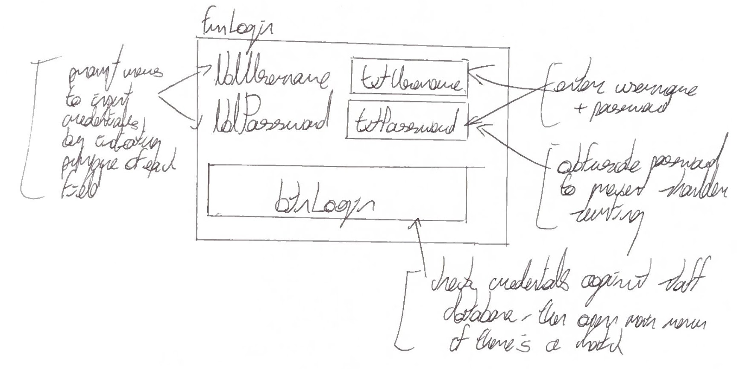

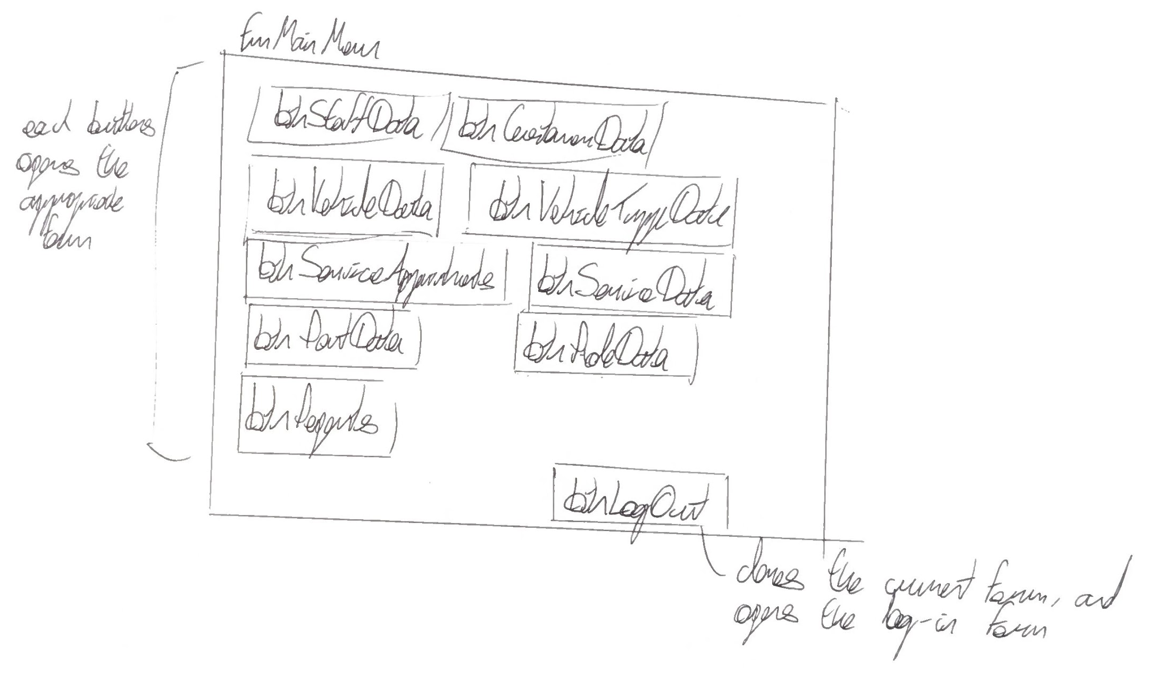
frmMainMenu

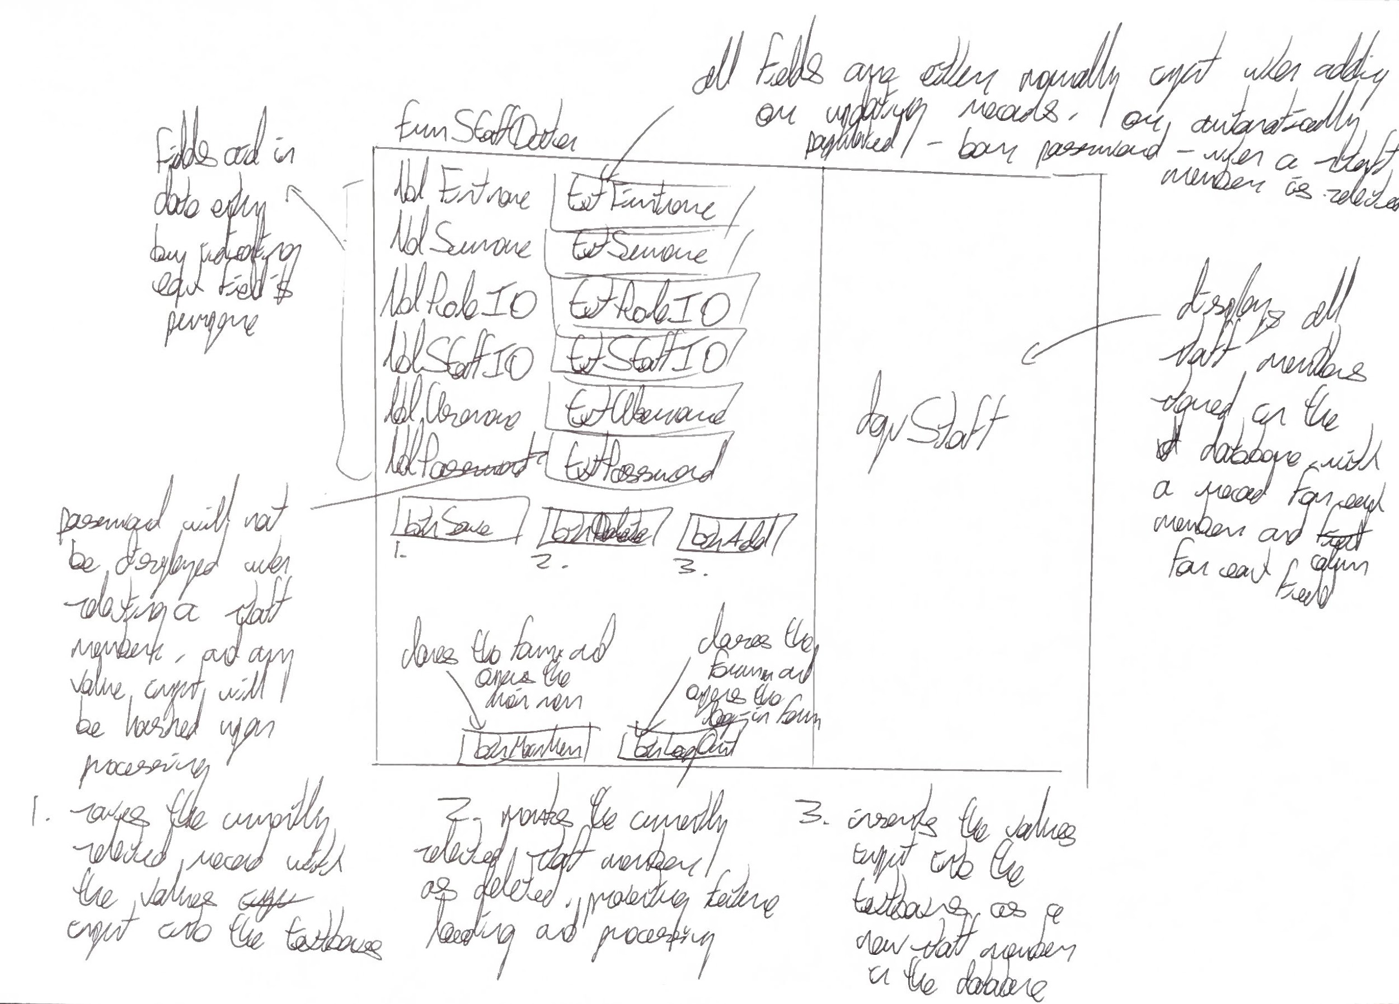
frmStaffData

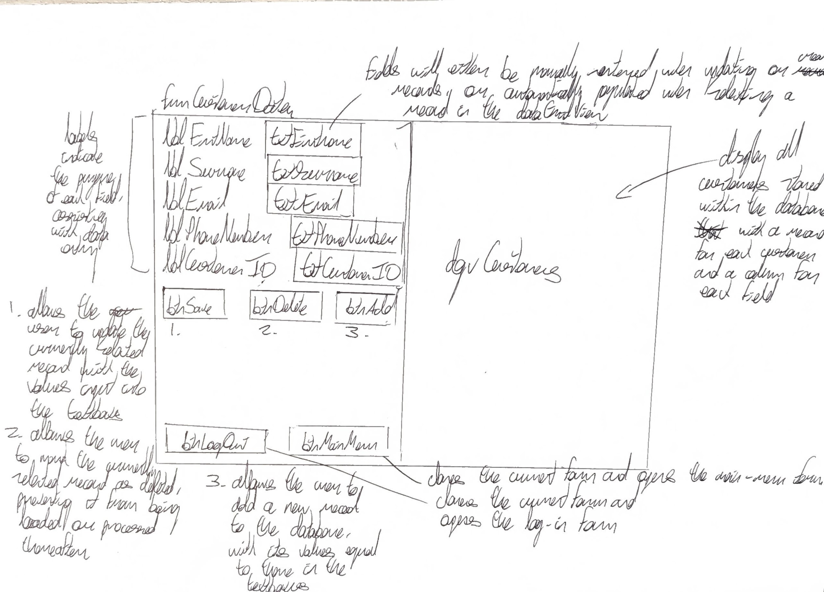
frmCustomerData

frmVehicleData
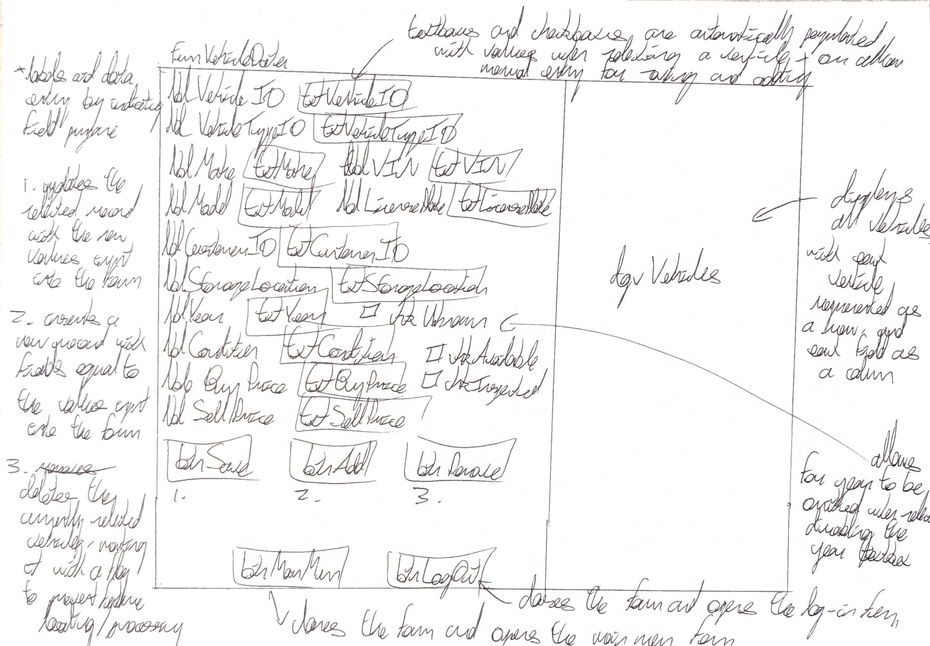

frmVehicleTypeData
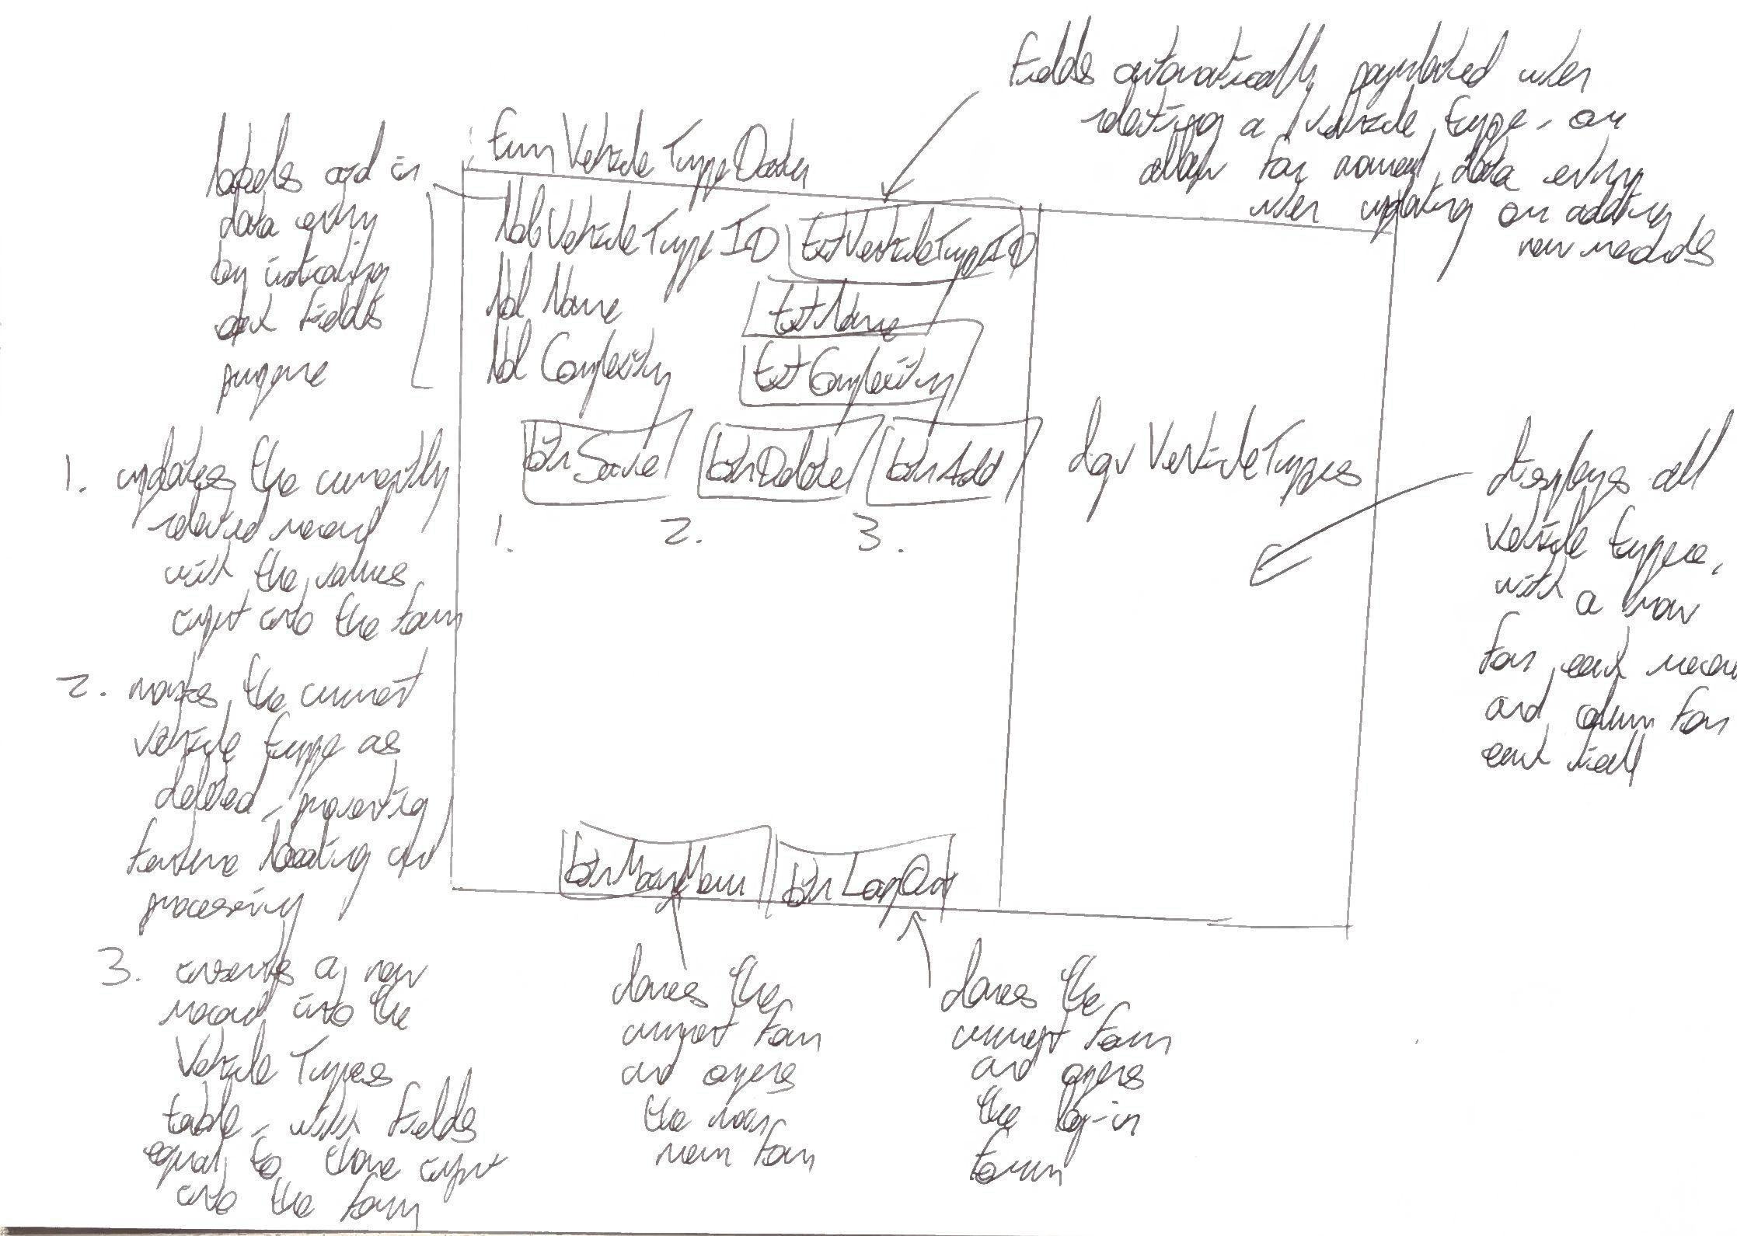

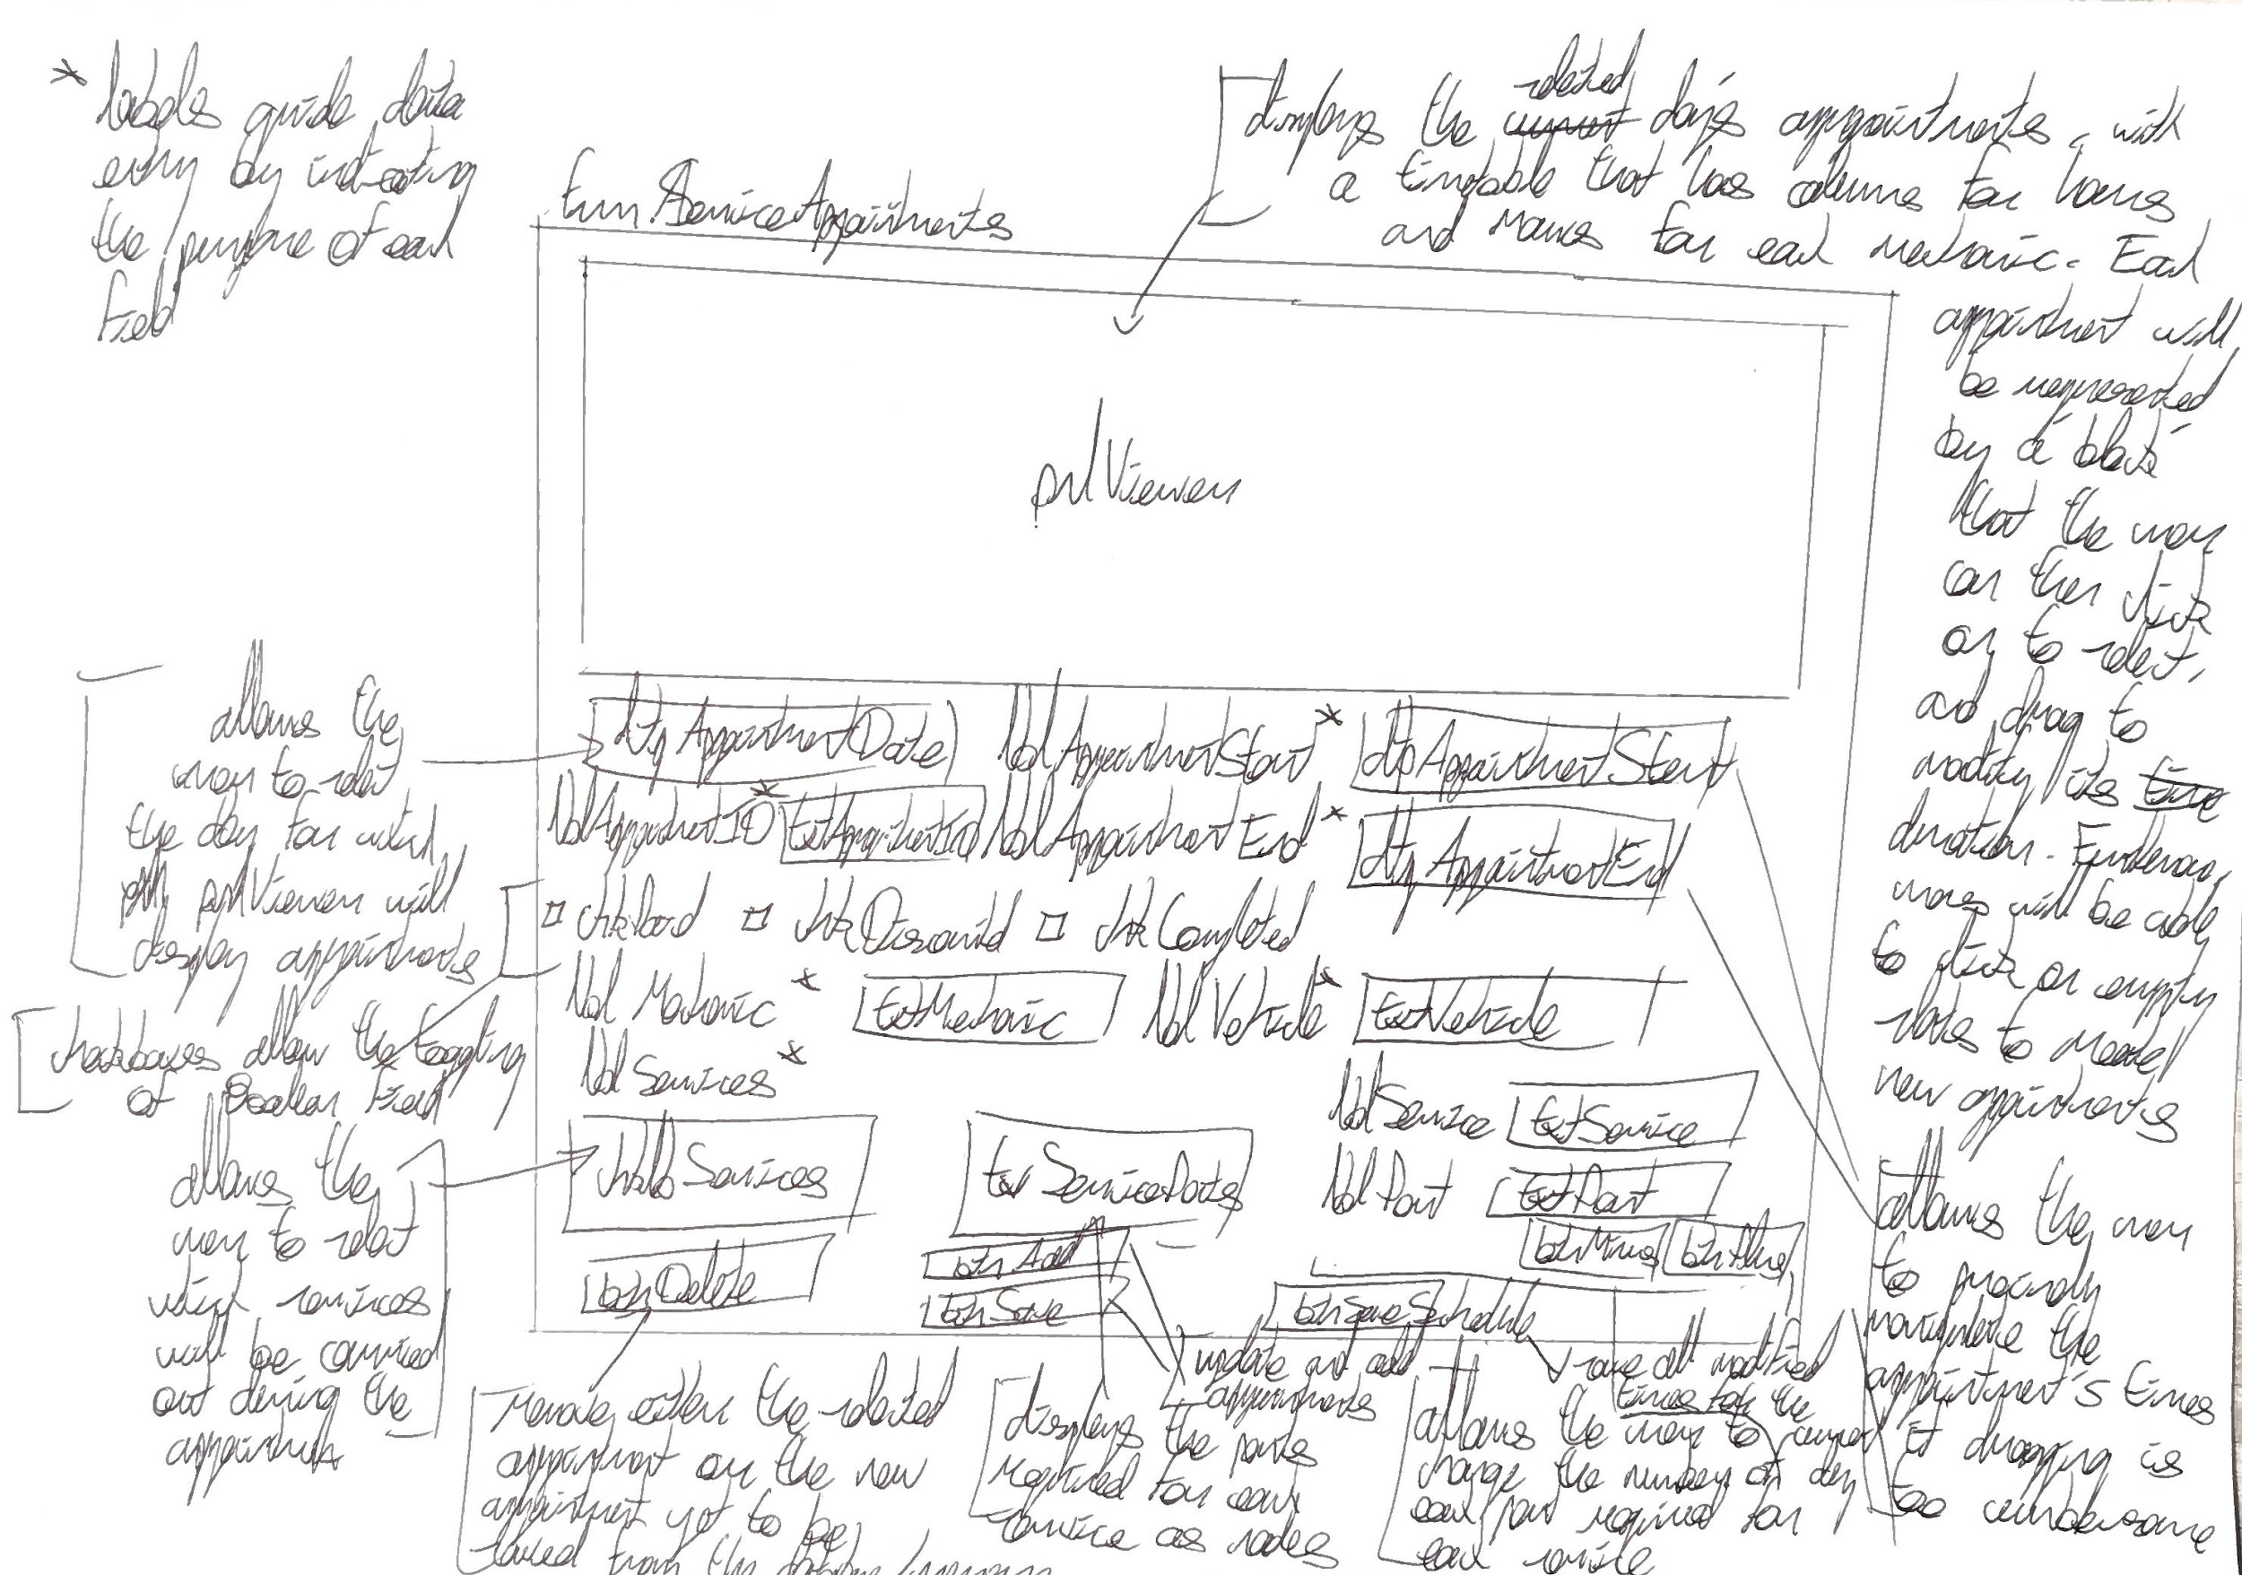
frmServiceAppointments

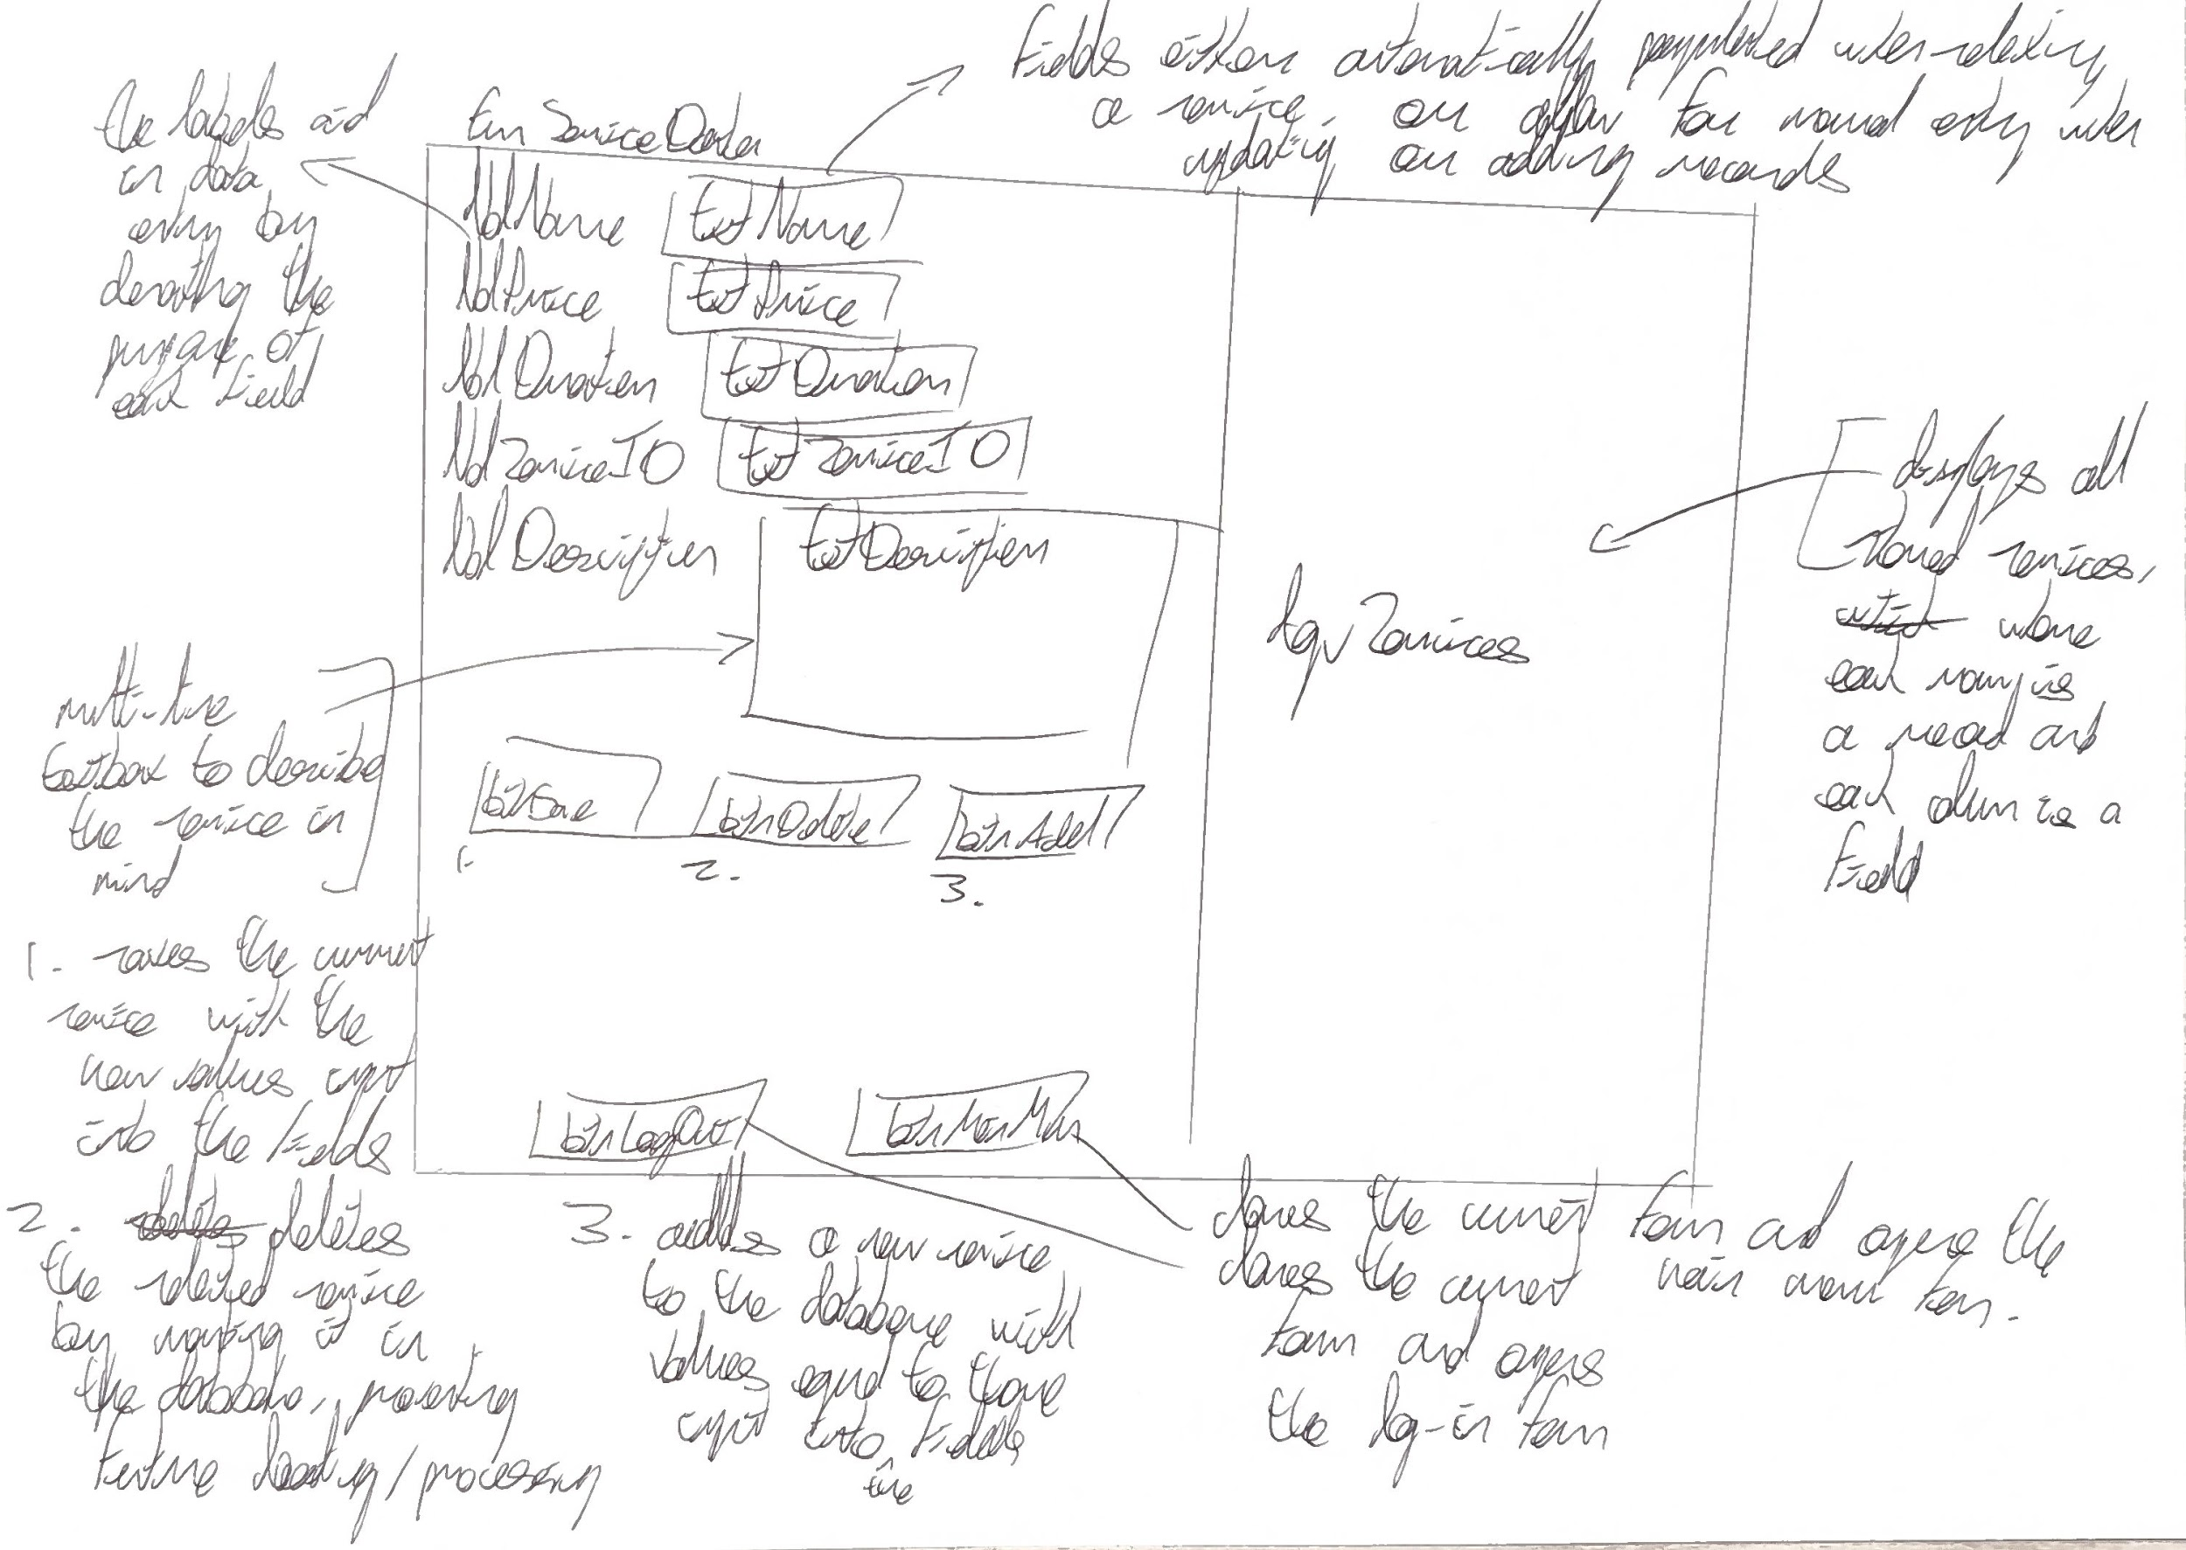
frmServiceData

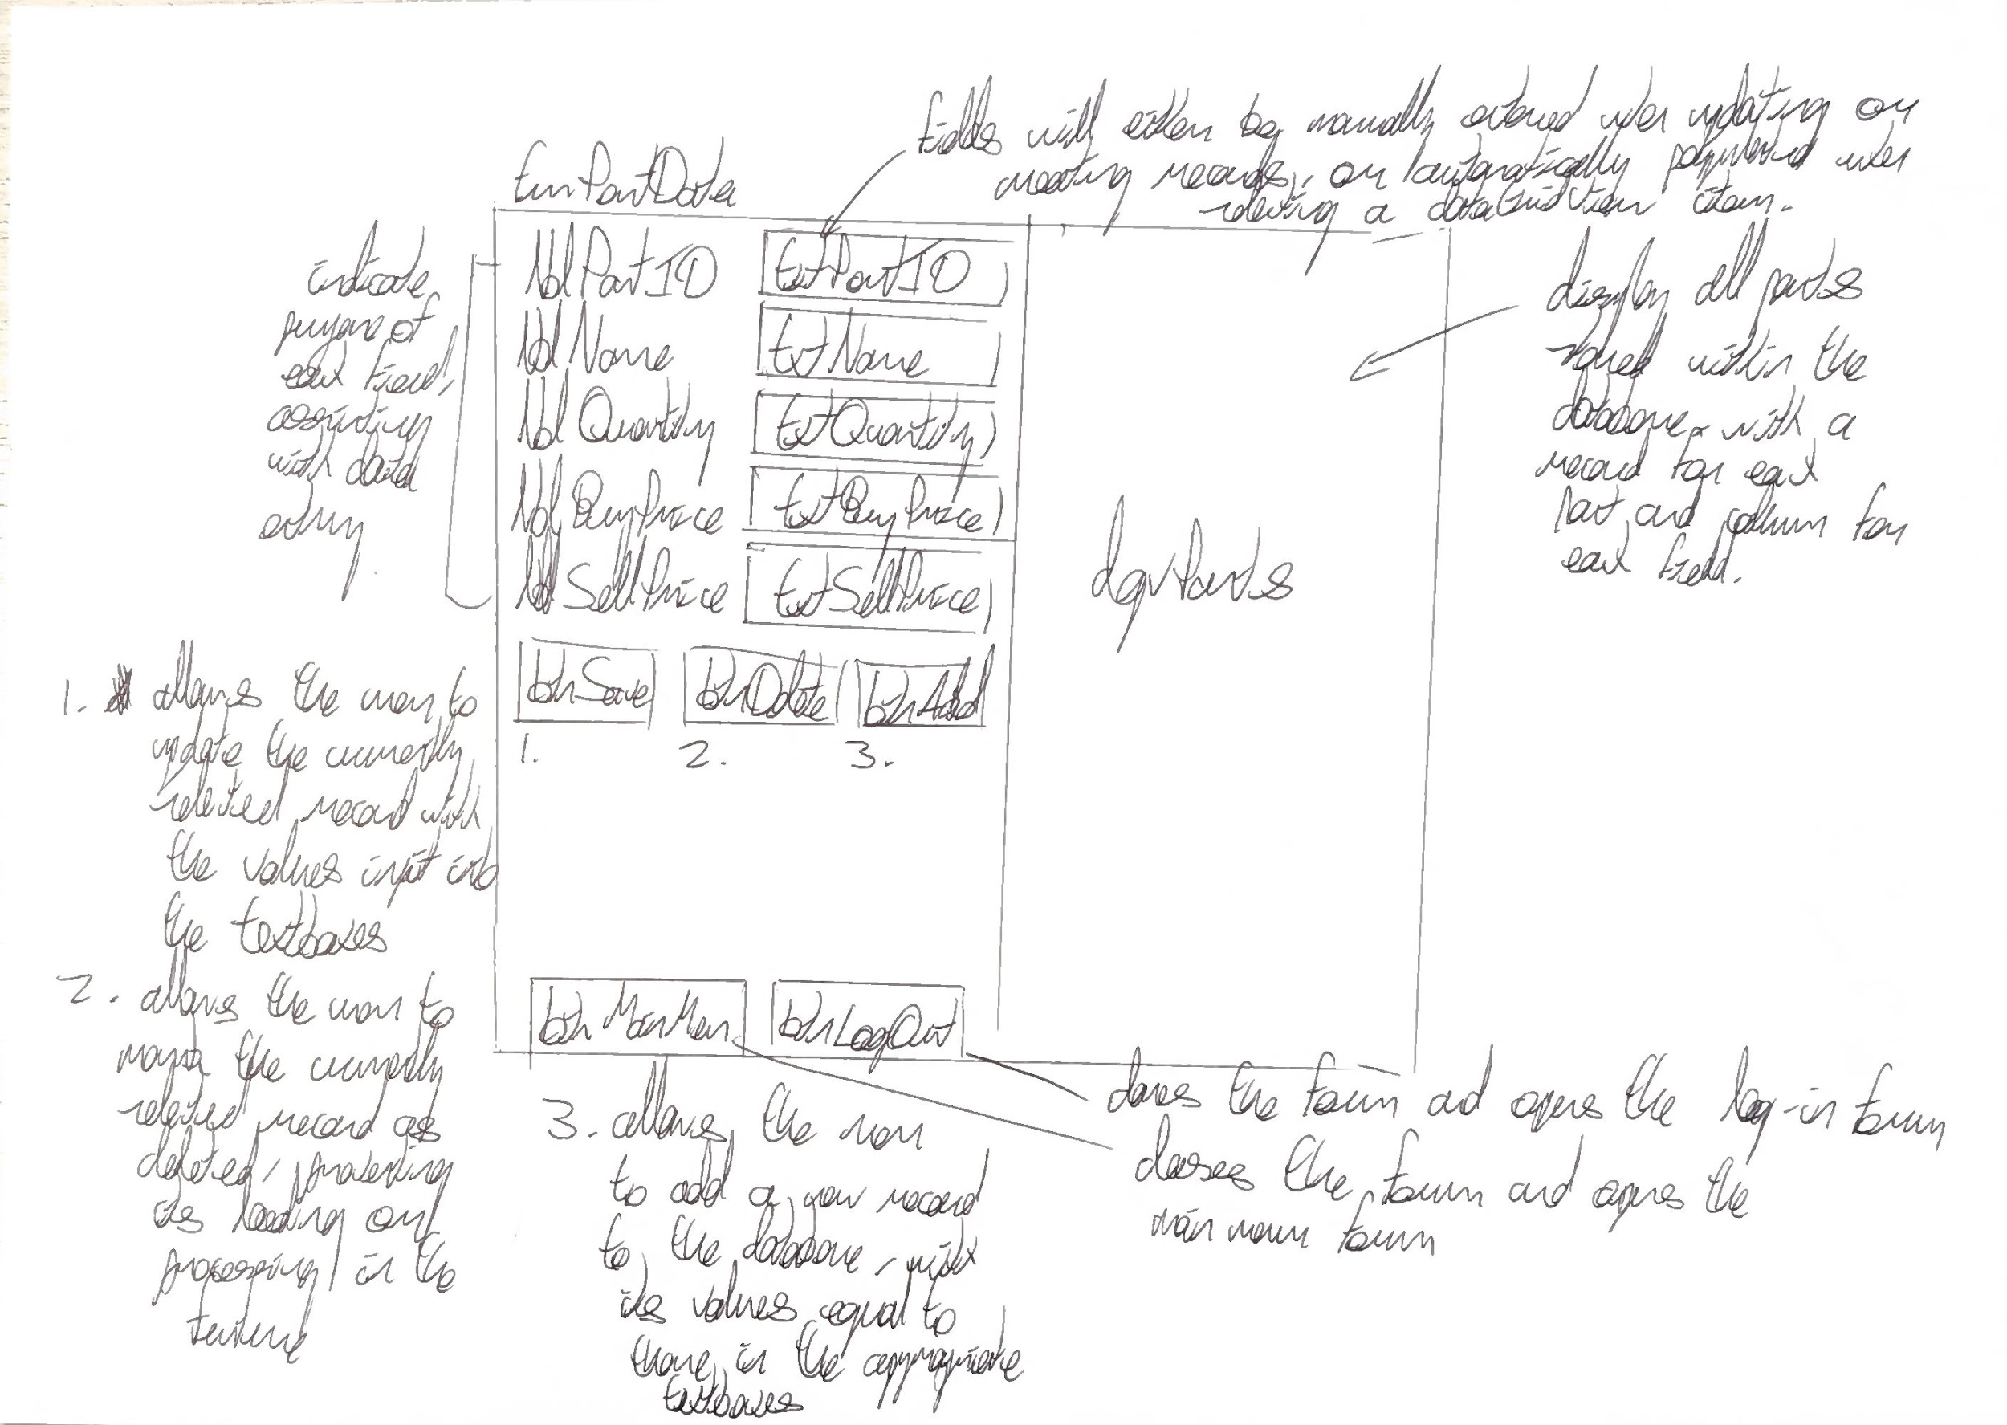
frmPartData

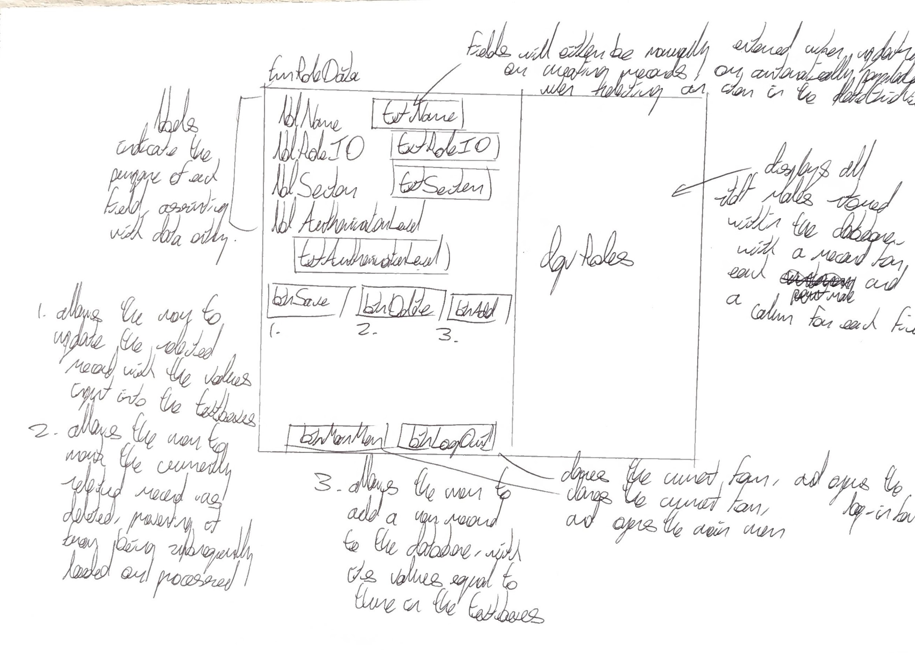
frmRoleData

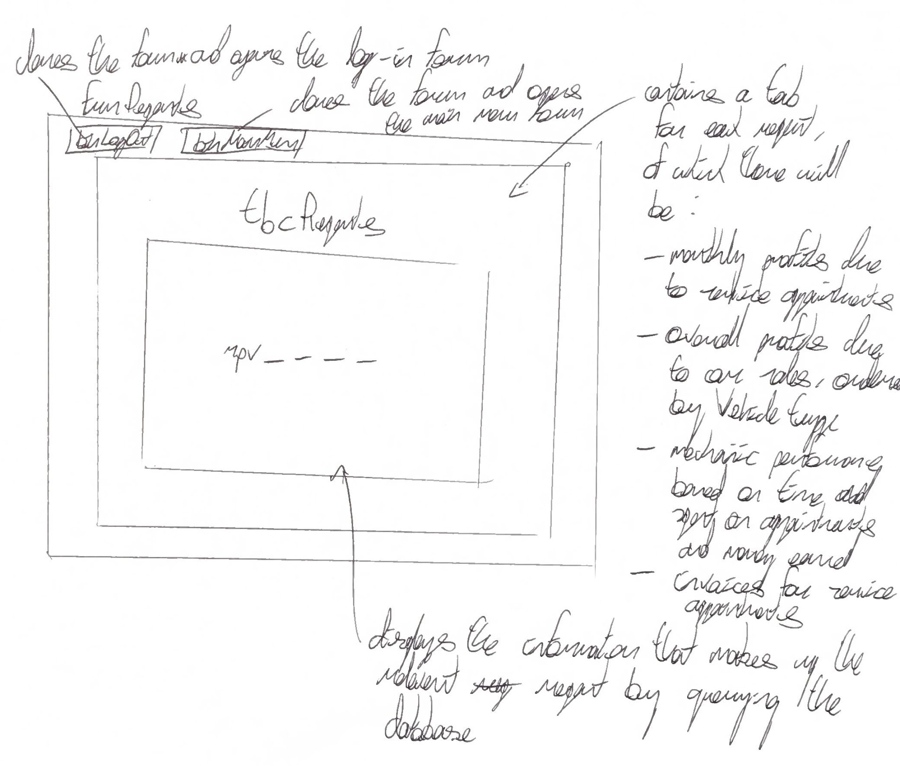
frmReports

User feedback
After presenting each of these sketches to the client, they requested me to implement the following changes:
- frmLogin
  - Add a “show password” feature to ensure that users are able to verify they’ve input the correct credentials, improving the accessibility of the program and assisting those who struggle to type accurately
  - Add the company logo at the top of the form to add aesthetic value
  - Visually separate the log-in functionality from the rest of the form by adding a panel behind the textboxes and buttons
- frmMainMenu
  - Place all buttons in a sidebar on the left
  - Implement hover logic on the sidebar so that buttons display only their icon when idle, but expand to show text as well when hovered over
  - Add a help button to explain how to start using the program
  - Instead of having each button open its respective form separately, display each form within a panel in the main menu for continuity
  - Add a home form which displays within this panel upon logging in which displays the user’s name, the date, and the user’s role, as well as the company’s logo
  - Add home and log out buttons
- All frm_____Data
  - Change the layout of the forms so that the dataGridViews are horizontal instead of vertical
  - Add search functionality in each form, allowing the user to select the field to search, type of search and search text
  - Add a reset button which clears each field in a form without having to carry out a CRUD action first
  - Ensure that the add, update and delete buttons are appropriately and pleasantly coloured
  - Visually separate groups of related fields by adding lines as dividers within the form
  - Visually separate the search and CRUD functionality by adding panels to house it
  - Ensure that primary key fields are read-only to maintain data integrity
  - Ensure that all controls in related groups are visually aligned with each other i.e. have the same or very similar lengths and the same end-point vertically
  - Add a help form which explains any restrictions to the data that can be input or the purpose of fields
  - Remove the main menu and log out buttons
- frmStaffData
  - Store passwords as hashes instead of plain text to improve security
  - Do not display the password hash when selecting a user, instead leaving it blank, allowing the user to input a new plain text password to be hashed upon updating or adding a record
  - Change the role field to a ComboBox control which is automatically populated with valid records
- frmVehicleData
  - Change the vehicle type, customer, storage location and condition fields to be ComboBox controls automatically populated with valid records/values
  - Change the buy and sell price fields to be NumericUpDown controls to prevent the entry of invalid data
- frmVehicleTypeData
  - Change the complexity field to be a NumericUpDown control to prevent the entry of invalid data
- frmServiceAppointments
  - Add a toggleable “insert mode” that determines whether the user can edit existing appointments or create new ones, ensuring that users do not accidentally add unnecessary appointments during editing or edit valid ones during creation
  - Ensure that regular mechanics are unable to edit the schedules of their colleagues, reserving this right to the lead mechanic
  - Dynamically update and display the time required and cost of the appointment as changes are made to its vehicle, parts and services
  - Add a help button which explains exactly how the user can add, delete, insert and update appointments
  - Change the mechanic, vehicle, service and service part fields to ComboBox controls which are automatically populated with valid records
  - Add search functionality which allows the user to filter by vehicle and mechanic
  - Visually separate groups of related fields by adding lines as dividers within the form
  - Visually separate the search and CRUD functionality by adding panels to house it
  - Ensure that primary key fields are read-only to maintain data integrity
  - Ensure that all controls in related groups are visually aligned with each other i.e. have the same or very similar lengths and the same end-point vertically
  - Remove the main menu and logout buttons
- frmServiceData
  - Add a character count to description to ensure that users know exactly how much more they can use
  - Change the price and duration fields to NumericUpDown controls to prevent the entry of invalid data
- frmPartData
  - Change the buy price, sell price and quantity field to NumericUpDown controls to prevent the entry of invalid data
- frmRoleData
  - Change the sector and authorisation level fields to ComboBox controls with predetermined values
- frmReports
  - Add the following reports:
    - Vehicle stock
    - Customer interest by vehicle type
    - Missed appointments
  - Add a help button to explain what each report tells the user and how to use the form
- frmLogs
  - Add a logs form which parses and displays the logs that have been stored externally
  - Add functionality to filter these logs by date, type of action and staff member
  - Add a help button to explain how the log system works, including the log types

Design

Final sketches

frmLogin

Drawing
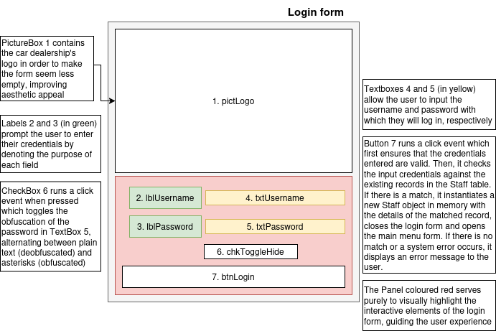

Explanation
As the first form seen upon opening the application, this form allows staff members to validate their identity by inputting their username and password. Through this process, it is ensured that the details relating to that particular staff member are loaded into memory. By doing so, the actions the staff member takes on the system can now be attributed to them - introducing a form of traceability - and the system can dynamically update its state, particularly in the main menu when populating the starting main menu form and determining which forms the user is able to access. Consequently, the user details in memory are always set to null when loading this form to ensure any details from a staff member who has previously logged out are not carried over. Notably, no register button is present to prevent unauthorised access to the system, and users must be added manually by an administrator. If any issues arise as a result of a login attempt, an appropriate error MessageBox is displayed, and if the user wishes to see their password before logging in, they may use the respective checkbox.

Pseudocode and diagrams
Form event listener | Pseudocode
chkToggleHide_CheckedChanged | IF checked IS true  SET txtPassword.HideChar TO null  ELSE  SET txtPassword.HideChar TO "*"

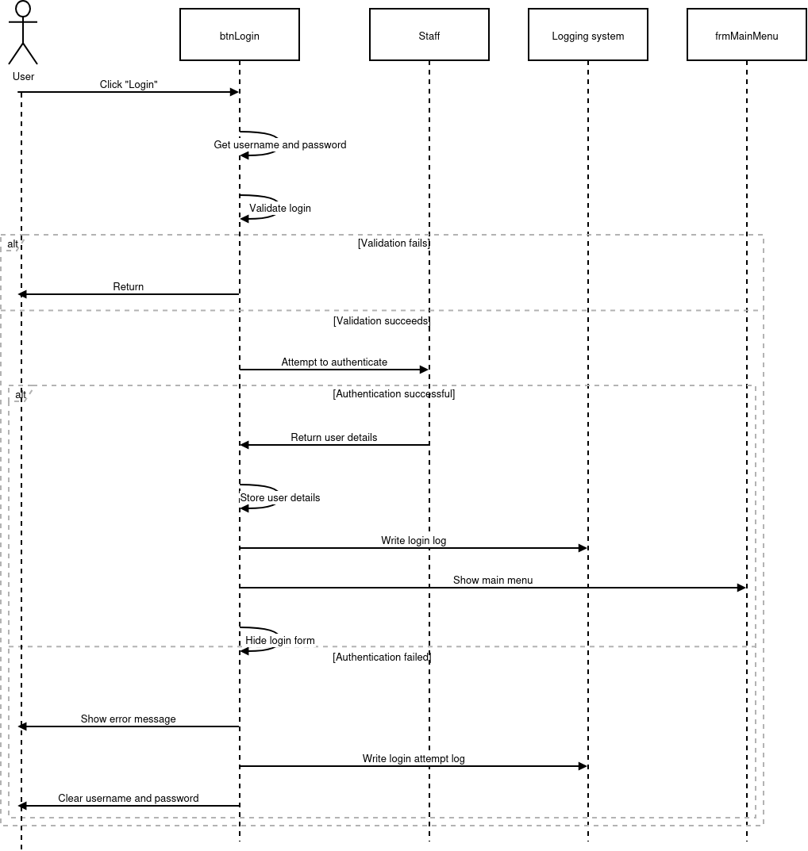

Validation and error-trapping
- If statements will be used to ensure the following:
  - Usernames input are between 3-50 characters
  - Passwords input are between 8-128 characters
  - Usernames only alphanumeric characters or underscores
  - Password or username fields are not empty
- Try-catch statements will surround the loading of staff objects from the database when authenticating a user, ensuring that a system error does not cause a crash
Field/Control | Data Type | Validation Rules | Purpose
txtUsername | Text | Required, 3-50 characters, alphanumeric, _ or . allowed, trimmed, converted to lowercase | User enters login username
txtPassword | Text | Required, 8-128 characters, trimmed, case-sensitive | User enters login password

Input specifications
User requirements met: 1, 2, 3, 9, 23, 24

frmMainMenu

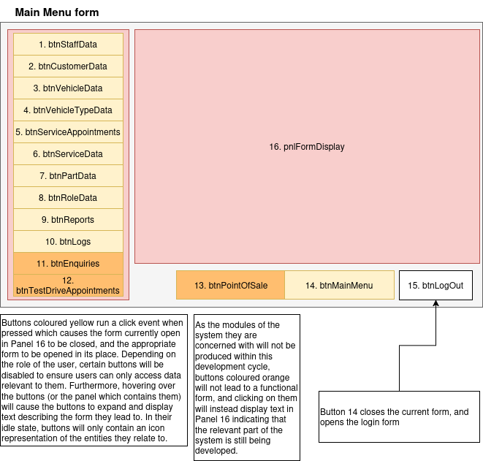
Drawing

Explanation
As the form seen upon logging in, frmMainMenu serves as the central navigation point to the rest of the forms on the system. Using the details stored in memory after a user logs in, their role’s sector is determined and the appropriate buttons are enabled, with all others being disabled by default. Important to note is the method by which forms available in the sidebar are displayed: rather than opening a separate form and closing the main menu, these forms are instantiated and docked within the appropriate display panel, preventing any confusion or delay caused by navigating between various disjointed forms. Furthermore, the sidebar on the left is collapsed by default, with only icons visible to the user, but will expand smoothly to reveal text on the buttons, aiding in navigation. Due to the centralised nature of the program, the log-out button will only be present on this form as it will always be visible, thus preventing the cluttering of the forms displayed in the panel which already have limited space available. Lastly, some buttons are planned to eventually lead to functionality that has not been addressed in this development cycle (this being enquiries, test drive appointments and point of sale) but at the moment will simply display text indicating they are under development.

Pseudocode and diagrams
Form event listener | Pseudocode
frmMainMenu_Load | IF NO USER IS LOGGED IN  OUTPUT "Session expired. Please log in again."  REDIRECT TO frmLogin  END IF  OPEN frmMainMenuStartingForm  RETRIEVE USER'S Role  IF NO Role FOUND  OUTPUT "Role configuration error"  STOP LOADING  END IF  FOREACH Button IN frmMainMenu  IF USER'S Role IS PERMITTED  ENABLE Button  END IF  END FOREACH
tmrTransition_Tick | WHILE EXPANDING  IF THE MOUSE ENTERED THE PANEL  INCREMENT THE BUTTON AND PANEL WIDTHS  IF THE BUTTONS AND PANEL MEET A PARTICULAR LENGTH  DISPLAY BUTTON TEXT  END IF  ELSE IF THE MOUSE LEFT THE PANEL  DECREMENT THE BUTTON AND PANEL WIDTHS  HIDE BUTTON TEXT  END IF  END WHILE
btn———_Click | LOG ACCESS ACTION  REMOVE EXISTING FORM IN PANEL  INSTANTIATE NEW FORM  ADD IT TO THE PANEL  DOCK TO THE PANEL  SHOW THE NEW FORM

Validation and error-trapping
- If statements will be implemented to ensure that the current user is valid i.e. their object in memory is not null. If it is, they will be redirected back to the login form
- If statements will be implemented to ensure that the user’s role has been successfully loaded and that their sector exists within the list of sector-form associations
- If statements will be implemented to ensure that the referenced form exists before attempting to load it within the viewing panel

User requirements met: 2, 3, 4, 5, 9, 15, 23, 24

frmMainMenuStartingForm

Drawing
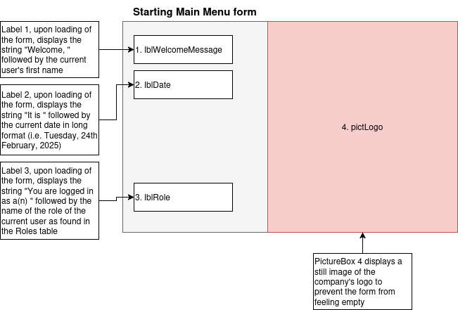

Explanation
The first form docked within the main menu panel upon opening the program, this form serves no functional purpose, aiming instead to prevent the main menu from looking incomplete or barren. However, there is still a dynamic element present, as each label’s text is determined at runtime. The first label seen - the welcome message - will simply access the Staff object stored in memory, retrieve their first name and display it, adding visual confirmation that the user has logged in with the correct credentials. Furthermore, the second label will contain the current date, ultimately serving as a reminder to ensure that the user accesses and edits records pertaining to the correct date. Lastly, the role label states the user’s role’s name as stored on the system, aiming to explain why access to particular forms is disabled.

Pseudocode and diagrams
Form event listener | Pseudocode
frmStartingMainMenuForm_Load | IF A USER IS LOGGED IN  DISPLAY "Welcome, " FOLLOWED BY THEIR FIRST NAME  ELSE  OUTPUT "Your name could not be retrieved. Please ensure you have logged in correctly."  END IF  DISPLAY “It is “ FOLLOWED BY THE CURRENT DATE  IF THE USER HAS A VALID ROLE  DISPLAY “You are logged in as a(n) “ + FOLLOWED BY THEIR FIRST NAME  ELSE  OUTPUT “Your role could not be retrieved”  END IF

Validation and error-trapping
- If statements will ensure that the current user has a valid staff object in memory before displaying their name
- If statements will ensure that the current user has a valid role associated with them before displaying its name

User requirements met: 2, 15

frmStaffData

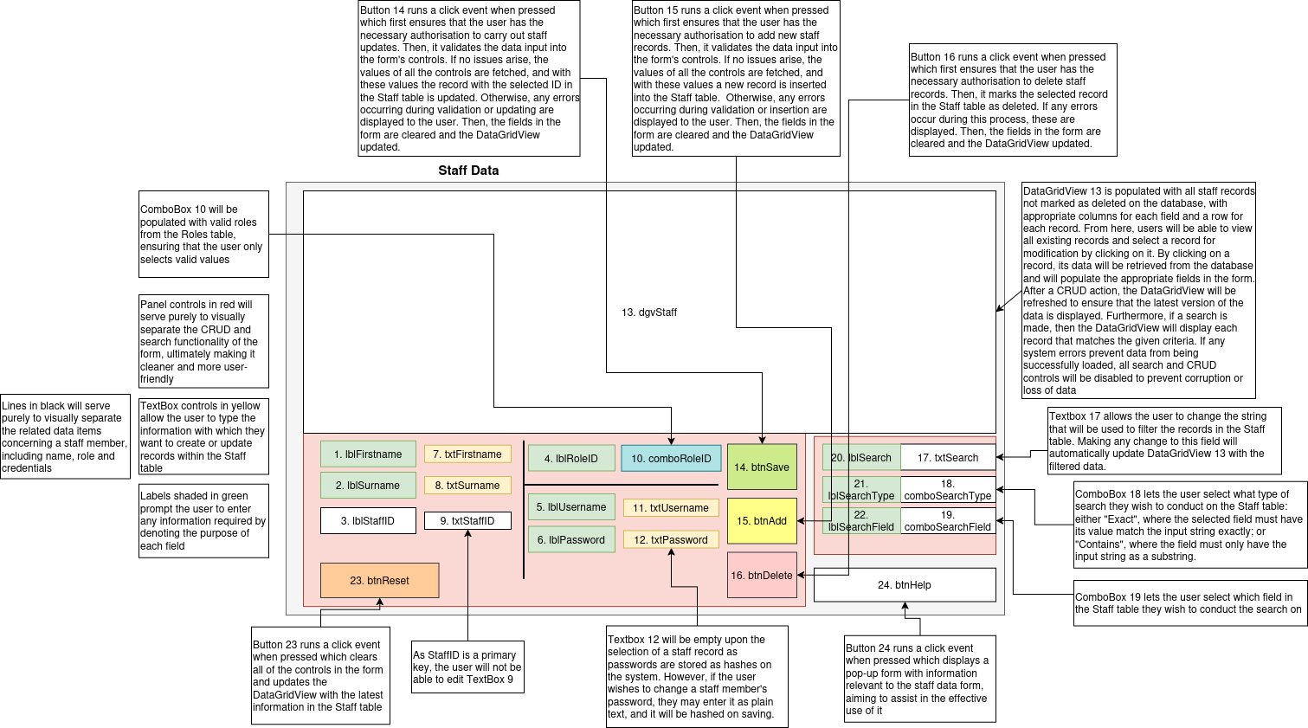
Drawing

Explanation
Currently planned to be accessible only by administrators, the staff data form allows for the viewing and manipulation of records stored on the Staff table. Upon loading, all records in the table will be instantiated on the system as Staff objects and displayed in the dataGridView. If any errors arise during this process, an error will be displayed and the form locked down to prevent further damage to the system. Furthermore, checks will be made to ensure that usernames input are duplicates which could compromise the login system. Important to note is the nature of the password field - users can see the hash stored in the Staff table on the dataGridView, but this will not be loaded into the appropriate textbox when selecting a record. Instead, the textbox will purely be for the input of new passwords, which are hashed before being used to update the table. Furthermore, the password field will not be available within the search functionality. Upon modifying or adding a record, preliminary checks are made to ensure that the fields input are valid for storage in the table, before a Staff object is instantiated with the fields to ensure that it can exist on the system. If both checks pass, the appropriate action will be carried out with the fields. Column names will be manually set upon displaying data from the table to ensure that the purpose of each field remains clear. Furthermore, all values in the role ComboBox will be fetched from the Roles table at runtime. It is important to note that deleting a staff member will not be possible if they have at least one associated service appointment

Pseudocode and diagrams
Form event listener | Pseudocode/diagram
dgvStaff_SelectionChanged | RETRIEVE THE STAFF BY THE SELECTED RECORD’S ID  IF THE STAFF MEMBER EXISTS  POPULATE THE APPROPRIATE FIELDS IN THE FORM WITH THEIR DATA  END IF
btnAdd_Click | CHECK PERMISSION  IF permissionError IS NOT null THEN  DISPLAY permissionError  EXIT process  ENDIF  VALIDATE fields  IF password IS empty OR whitespace THEN  ADD "Password cannot be empty." TO validationErrors  ENDIF  IF validationErrors IS NOT empty THEN  DISPLAY all validationErrors  EXIT process  ENDIF  TRY  CREATE newStaff WITH FIELDS  IF IsUsernameUnique(username, 0) IS FALSE THEN  DISPLAY "Username already exists. Choose a different username."  EXIT process  ENDIF  ATTEMPT TO ADD newStaff, OUTPUTTING ERROR MESSAGE TO addingMessage  IF addingMessage IS null THEN  DISPLAY "Staff member has been added successfully."  LOG ACTIOn  ELSE  DISPLAY "Staff member not added: " + addingMessage  ENDIF  CATCH exception  DISPLAY exception message  EXIT process  ENDTRY  CALL LoadFormDefaults()
btnSave_Click | 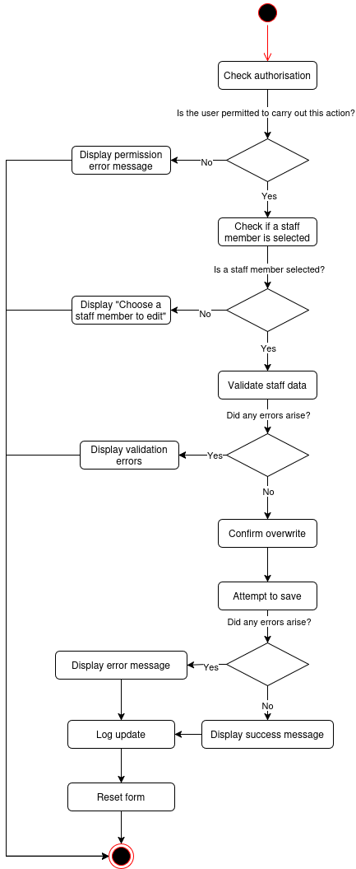
btnDelete_Click | CHECK PERMISSION  IF permissionError IS NOT null THEN  DISPLAY permissionError  EXIT process  ENDIF  CHECK A STAFF MEMBER HAS BEEN SELECTED AND IT IS NOT THE ONE LOGGED IN  IF CHECK PASSES  TRY  CHECK IF THE SELECTED STAFF MEMBER HAS ANY APPOINTMENTS  IF THEY DO  OUTPUT ERROR MESSAGE  END PROCESS  ELSE  MARK STAFF MEMBER AS DELETED  END IF  CATCH  OUTPUT ERROR MESSAGE  END CATCH  ELSE  OUTPUT ERROR MESSAGE  END IF  LOG DELETE  RESET FIELDS
txtSearch_TextChanged | RETRIEVE THE TYPE OF SEARCH SELECTED  RETRIEVE THE FIELD SELECTED FOR SEARCHING  FIND ALL RECORDS ON THE DATABASE WHICH MATCH THE SEARCH TYPE AND STRING IN THAT PARTICULAR FIELD

Validation and error-trapping
- If statements will be used to ensure:
  - StaffID is greater than 0
  - RoleID is greater than 0
  - Firstname and surname fields are not empty
  - Firstname and surname are no longer than 50 characters
  - Username is not empty
  - Username length is between 3–50 characters
  - Username contains only letters, numbers, underscores, or periods
  - Username does not contain spaces
  - Password is not empty
  - Password length is between 8–255 characters
- Try-catch statements will surround all database operations to handle errors and provide user feedback
- Try-catch statements executed during loading of the form will ensure that the form is locked down in the event of a database error
- If statements will be used to ensure that a valid staff member has been selected for manipulation
- If statements will be used to ensure that, if roles fail to load, the form is locked down

Input specifications
Field/Control | Data Type | Validation Rules | Purpose
txtStaffID | Integer | Must be >= 0; auto-populated for existing staff | Represents the StaffID of the staff member being edited; used for updates
txtFirstname | Text | Required; cannot be blank; max 50 characters | First name of the staff member
txtSurname | Text | Required; cannot be blank; max 50 characters | Surname of the staff member
txtUsername | Text | Required; cannot be blank; 3–50 characters; letters, numbers, _ or . only; must be unique | Username for staff login
txtPassword | Text | Optional for updates; if provided, 8-128 characters | Password for staff login; hashed before storing
comboRoleID | ComboBox (Integer) | Required; value > 0 | Role assigned to the staff member (used for authorisation)

User requirements met: 6b, 7, 8, 9, 10, 11, 12, 13, 14, 15, 16c, 17, 23, 24, 26, 27

frmCustomerData

Drawing
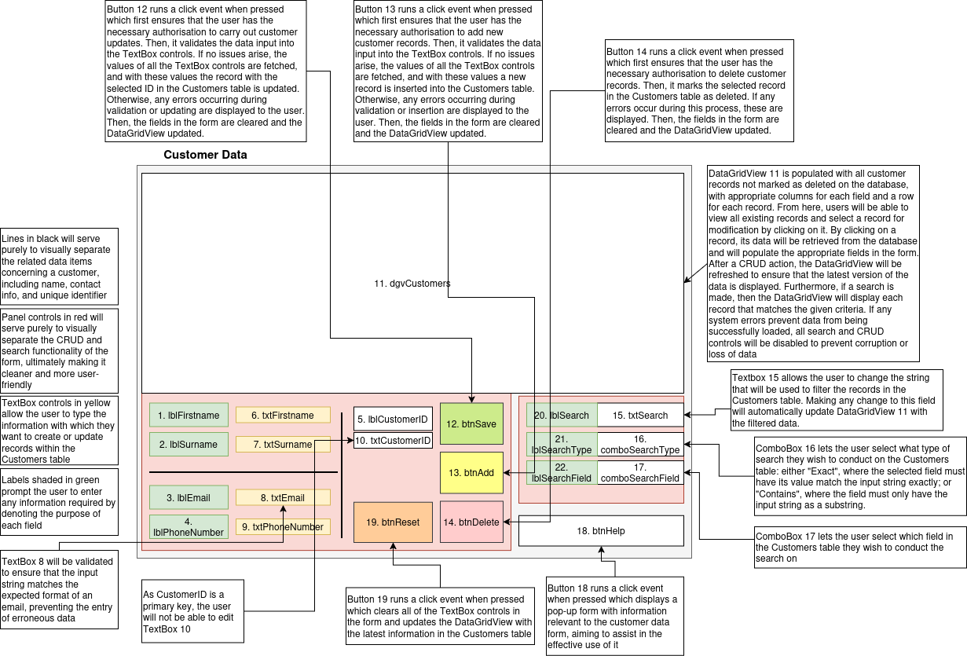

Explanation
Planned to be accessible by both administrative and customer service staff, the customer data form will allow for the manipulation and viewing of records on the Customers table. Similarly to frmStaffData, all records stored in the table are instantiated as Customer objects to be displayed in the dataGridView, and in the event of an error the form will be locked down to prevent further input. Saving and adding customers will only require “restricted write” access due to the rather harmless nature of these actions, but deleting will require “unrestricted write” to prevent the loss of pertinent data. Once again, column names will be manually set rather than using the names of the public properties of the Customer class. Unique to this form will be the validation of emails - to ensure that valid contact information is stored in the table, it will be ensured that the value within the email field matches the expected format before carrying out updates or adds. However, no such validation will exist for the phone number field due to the relatively unpredictable nature of phone numbers, and so only length checks will be implemented for it. Much of the logic for this form carries over from frmStaffData, and as such will not be repeated for brevity. However, it is important to note that deleting a customer will also cause any associated vehicles and appointments to be deleted.

Pseudocode and diagrams
Note: most of the CRUD logic carries over from frmStaffData, so only new or significantly different functionality will be represented in future CRUD forms

Form event listener | Pseudocode
btnDelete_Click | CHECK PERMISSION  IF permissionError IS NOT null THEN  DISPLAY permissionError  EXIT process  ENDIF  CHECK A CUSTOMER HAS BEEN SELECTED  IF NOT  OUTPUT “Select a customer to delete.”  END PROCESS  END IF  DISPLAY A CONFIRMATION PROMPT  IF CONFIRMED  TRY  DELETE ALL RECORDS IN ServiceAppointments CONTAINING A  VEHICLE OWNED BY THE CUSTOMER  DELETE ALL RECORDS IN Vehicles THAT ARE OWNED BY THE  CUSTOMER  DELETE THE CUSTOMER  CATCH  OUTPUT ERROR MESSAGE  END TRY  END IF  LOG THE DELETE  RESET FORM

Validation and error-trapping
- If statements will be used to ensure
  - CustomerID is greater than 0
  - First name and surname fields are not empty
  - First name and surname are no longer than 50 characters
  - Email, if provided, is properly formatted
  - Email is no longer than 50 characters
  - Phone number is no longer than 15 characters
- Try-catch statements will surround all database operations to handle errors and provide user feedback
- Try-catch statements executed during loading of the form will ensure that the form is locked down in the event of a database error
- If statements will be used to ensure that a valid customer has been selected for manipulation

Input specifications

Field/Control | Data Type | Validation Rules | Purpose
txtCustomerID | Integer | Must be >= 0; auto-populated for existing customers | Represents the CustomerID; used for identifying the customer in updates
txtFirstname | Text | Required; cannot be blank; max 50 characters | Customer’s first name
txtSurname | Text | Required; cannot be blank; max 50 characters | Customer’s surname
txtEmail | Text | Optional; must be valid email format if provided; max 50 characters | Customer’s email address
txtPhoneNumber | Text | Optional; max 15 characters | Customer’s phone number

User requirements met: 6a, 7, 8, 9, 10, 11, 12, 13, 14, 15, 16a, 23, 24, 26

frmVehicleData

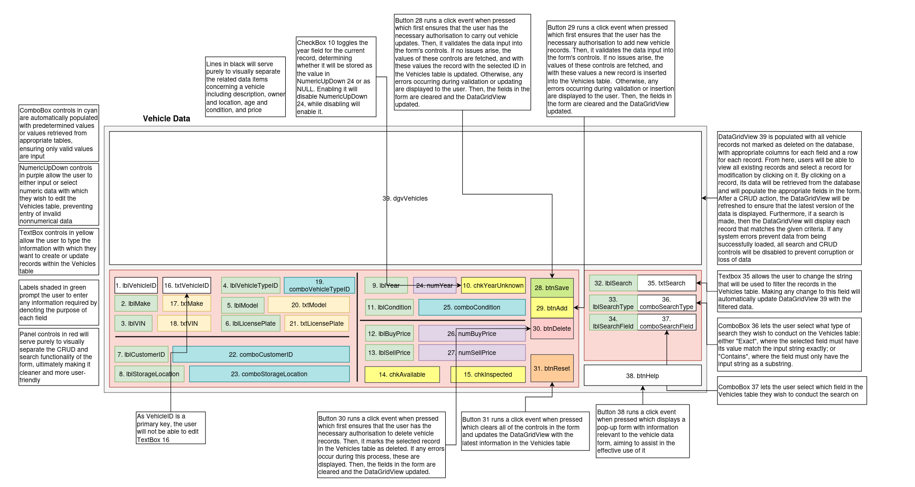
Drawing

Explanation
Planned to be accessible by administrative and technical staff, this form will serve as an interface to the Vehicles table. Once again, much of the functionality carries over from the previous CRUD forms, and as such only differences will be highlighted. Notably, two ComboBox controls exist for records existing in other tables (these being VehicleTypes and Customers), and consequently all records in those tables will be stored as a list containing the record ID followed by an human-readable identifier such as a name. Furthermore, the condition and storage location ComboBox controls will contain hard-coded valid values. Though not scalable, this is due to the fact that these fields are not used in any calculations within the subsystem being developed, and only contain a fixed number of values. A cleaner, reusable solution may be implemented in the future, but this will suffice for now. Important to note is the CheckBox for unknown year, which prevents the year from being fetched from its field, instead being stored as null. Furthermore, as the VIN of a car is unique, checks will be made to ensure that there are no duplicate values and thus that each car has an identifier that links it to the physical world. There are no checks to ensure that the vehicle is being sold at a profit to prevent compromising the system in the event that a vehicle must be sold at below retail value, such as when clearing old stock. Lastly, deleting a vehicle will delete all related service appointments.

Pseudocode and diagrams
Form event listener | Pseudocode
frmVehicleData_Load | FETCH ALL CUSTOMERS FROM THE Customers TABLE  IF AN ERROR PREVENTS CUSTOMERS FROM BEING LOADED  OUTPUT “No customers could be loaded.”  LOCK DOWN THE FORM  END PROCESS  END IF  FOR EACH CUSTOMER  ADD A NEW OPTION TO THE COMBOBOX CONTAINING THE CUSTOMER’S  ID FOLLOWED BY THEIR FULL NAME  END FOR  FETCH ALL VEHICLE TYPES FROM THE VehicleTypes TABLE  IF AN ERROR PREVENTS VEHICLE TYPES FROM BEING LOADED  OUTPUT “No vehicle types could be loaded.”  LOCK DOWN THE FORM  END PROCESS  END IF  FOR EACH VEHICLE TYPE  ADD A NEW OPTION TO THE COMBOBOX CONTAINING THE VEHICLE  TYPE’S ID FOLLOWED BY ITS NAME  END FOR  ATTEMPT TO LOAD VEHICLES  IF AN ERROR OCCURS  OUTPUT "There was an error when attempting to load  vehicle data. Please amend erroneous data in the database  before proceeding."  LOCK DOWN FORM  END IF

btnDelete_Click | CHECK PERMISSION  IF permissionError IS NOT null THEN  DISPLAY permissionError  EXIT process  ENDIF  CHECK A VEHICLE HAS BEEN SELECTED  IF NOT  OUTPUT “Select a vehicle to delete.”  END PROCESS  END IF  DISPLAY A CONFIRMATION PROMPT  IF CONFIRMED  TRY  DELETE ALL RECORDS IN ServiceAppointments CONTAINING THE  VEHICLE  DELETE THE VEHICLE  CATCH  OUTPUT ERROR MESSAGE  END TRY  END IF  LOG THE DELETE  RESET FORM

Validation and error-trapping
- If statements will be used to ensure the following:
  - Vehicle ID is greater than 0
  - Vehicle Type ID is greater than 0
  - Customer ID, if provided, is greater than 0
  - Make and Model fields are not empty and do not exceed 50 characters
  - Year, if provided, is between 1800 and 2050
  - VIN field is not empty, does not exceed 50 characters, and is unique
  - Condition field is not empty and does not exceed 50 characters
  - Buy price and Sell price, if provided, are not negative
  - License plate, if provided, does not exceed 20 characters.
  - Storage location, if provided, does not exceed 50 characters.
- Try-catch statements will surround all database operations to handle errors and provide user feedback
- Try-catch statements executed during loading of the form will ensure that the form is locked down in the event of a database error
- If statements will be used to ensure that a valid vehicle has been selected for manipulation
- If statements will be used to ensure that the form is locked down if no customers or vehicle types could be loaded

Input specifications
Field / Control | Data Type | Validation Rules | Purpose
txtVehicleID | Integer | Must be >= 0; 0 for new records, >0 for existing vehicles | Identifies the vehicle in the database
comboVehicleTypeID | ComboBox (integer) | Must select a valid VehicleTypeID (>0) | Specifies the vehicle type
comboCustomerID | ComboBox (integer) | Nullable; if selected, must be >= 0 | Associates a customer with the vehicle
txtMake | Text | Required; cannot be blank; max 50 characters | Vehicle make
txtModel | Text | Required; cannot be blank; max 50 characters | Vehicle model
numYear / chkYearUnknown | Integer / Checkbox | Year must be 1800–2050 or null if unknown | Vehicle manufacture year
txtVIN | Text | Required; cannot be blank; max 50 characters; must be unique | Vehicle VIN
txtLicensePlate | Text | Optional; max 20 characters | Vehicle license plate
comboCondition | ComboBox (text) | Required; cannot be blank; max 50 characters | Vehicle condition
chkAvailable | Checkbox | Boolean | Vehicle availability
chkInspected | Checkbox | Boolean | Vehicle inspection status
numBuyPrice | NumericUpDown (decimal) | Optional; >= 0 if provided | Purchase price
numSellPrice | NumericUpDown (decimal) | Optional; >= 0 if provided | Selling price
comboStorageLocation | ComboBox (text) | Optional; max 50 characters | Vehicle storage location

User requirements met: 6b, 7, 8, 9, 10, 11, 12, 13, 14, 15, 16b, 23, 24, 26

frmVehicleTypeData

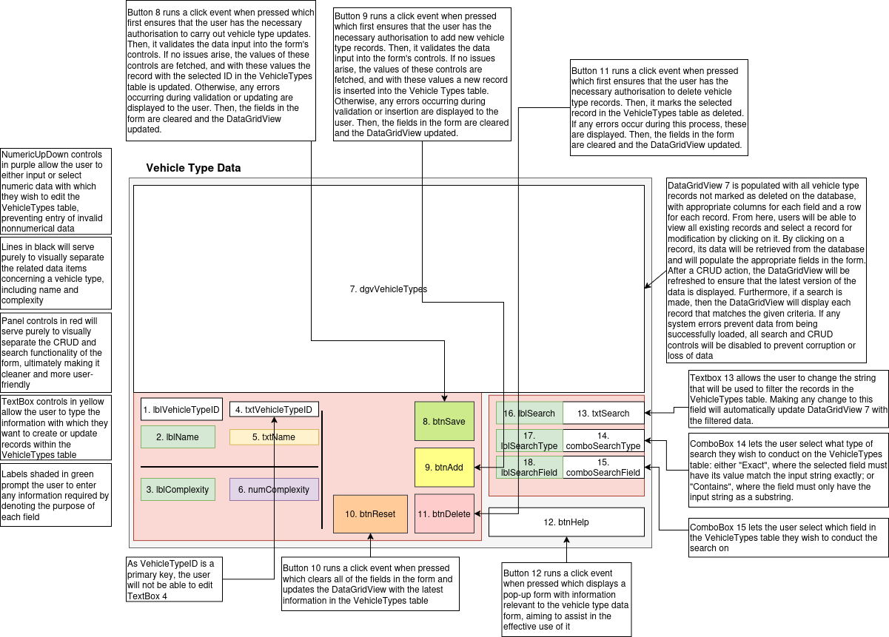
Drawing

Explanation
Planned to be accessible by technical and administrative staff, this form will serve as an interface for the VehicleTypes table. Most notably, there is only one field other than name which is complexity. Each record in the Vehicles table will have at least one vehicle type associated with it. When calculating the duration of an appointment, the duration of the services carried out will be summed, then the appointment’s duration will be multiplied by the vehicle’s complexity. It is important to note deleting a vehicle type will not be possible is there are vehicles of that type

Pseudocode and diagrams
Form event listener | Pseudocode
btnDelete_Click | CHECK PERMISSION  IF permissionError IS NOT null THEN  DISPLAY permissionError  EXIT process  ENDIF  CHECK A VEHICLE TYPE HAS BEEN SELECTED  IF NOT  OUTPUT “Select a vehicle type to delete.”  END PROCESS  END IF  DISPLAY A CONFIRMATION PROMPT  IF CONFIRMED  CHECK IF ANY VEHICLES IN Vehicles ARE OF THAT VEHICLE TYPE  IF THERE ARE  OUTPUT “Vehicle Type is in use and cannot be deleted.”  END PROCESS  END IF  TRY  DELETE THE VEHICLE TYPE  CATCH  OUTPUT ERROR MESSAGE  END TRY  END IF  LOG THE DELETE  RESET FORM

Validation and error-trapping
- If statements will be used to ensure:
  - Vehicle Type ID is positive
  - Name is not empty
  - Name does not exceed 50 characters
  - Complexity is zero or positive but does not exceed 5
- Try-catch statements will surround all database operations to handle errors and provide user feedback
- Try-catch statements executed during loading of the form will ensure that the form is locked down in the event of a database error
- If statements will be used to ensure that a valid VehicleType has been selected for manipulation

Input specifications
Field / Control | Data Type | Validation Rules | Purpose
txtVehicleTypeID | Integer (TextBox) | Must be >= 0; 0 for new records, >0 for existing records | Identifies the vehicle type in the database
txtVehicleTypeName | Text | Required; cannot be blank; max 50 characters | Name of the vehicle type
numComplexity | NumericUpDown (double) | Required; >= 0; cannot exceed 5 | Complexity rating of the vehicle type (0–5)

User requirements met: 6d, 7, 8, 9, 10, 11, 12, 13, 14, 15, 16d, 23, 24, 26

frmServiceAppointments

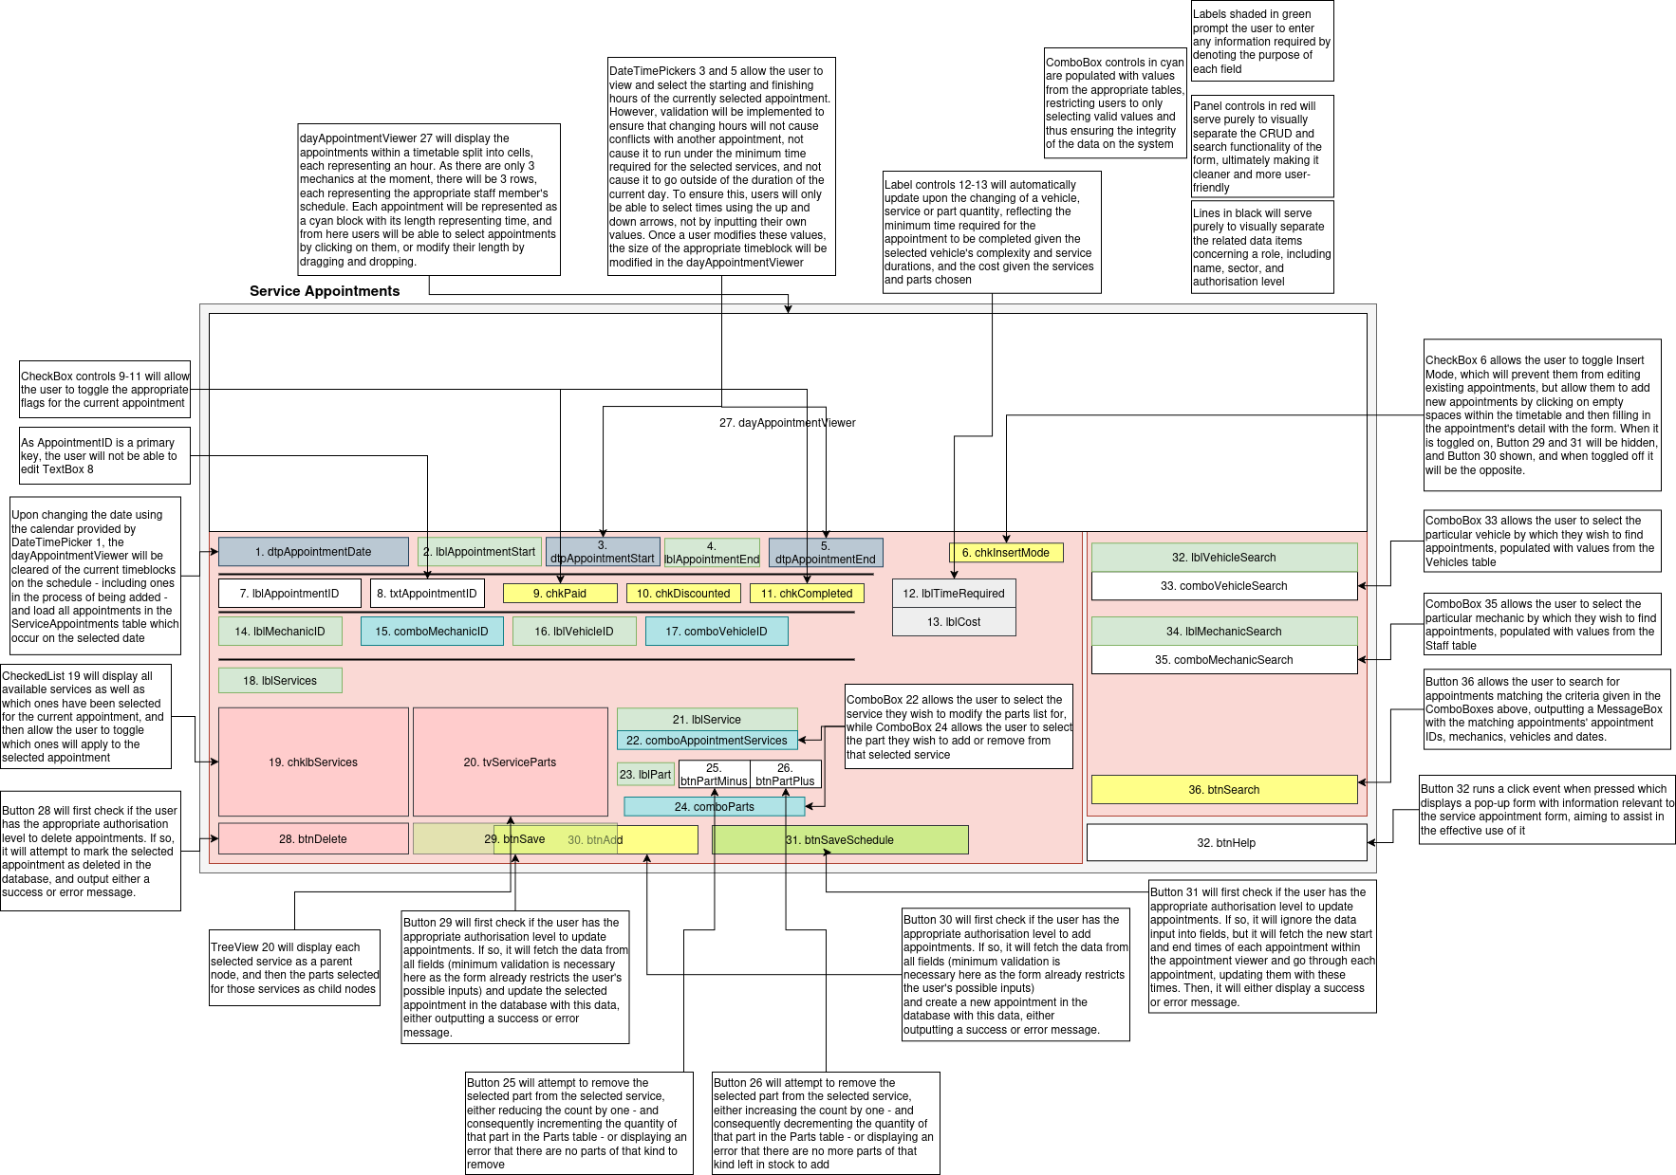
Drawing

Explanation
The main focus of the program, this form - which will be accessible by administrative and technical staff - allows for the modification and creation of service appointments. Most notably, a custom control will have to be implemented for the actual appointment viewer, as much of the drawing and mouse logic would be significantly easier to manage through its encapsulation. A substantial amount of validation will have to be implemented to ensure that only valid appointments can be created, and as such the effects of a change on a booking - such as the removal of a service or the servicing of a different car - will have to be immediately calculated upon attempting to change an appointment. Furthermore, most of the fields within the form limit the possible input of the user through the use of ComboBox controls populated with the existing values from other tables, ensuring referential integrity within a table that would contain so many foreign keys. Lastly, the search functionality aims to make it easier for the user to find a particular booking when only one day can be viewed at a time, thus making the user’s experience less tedious.

Pseudocode and diagrams
Form event listener | Pseudocode
DayAppointments_Load | DETERMINE THE HEIGHT AND WIDTH OF THE ENTIRE SCHEDULE AND EACH CELL  IN PIXELS  RETRIEVE ALL APPOINTMENTS, AND GROUP BY MECHANIC FOR STORAGE IN MEMORY  DRAW THE APPOINTMENTS FOR THE CURRENT DAY
DrawAppointment | DRAW THE LABELS DENOTING THE START OF EACH WORKING HOUR AT THE TOP OF THE VIEWING PANEL, SEPARATED BY THE WIDTH OF A CELL  DRAW THE TIME SLOTS FOR EACH MECHANIC, REPRESENTED AS EQUALLY SIZED RECTANGLES  DRAW EACH MECHANICS NAME AT THE START OF THEIR ALLOCATED ROW OF TIME SLOTS  CLEAR THE OLD LIST OF CALCULATED TIMEBLOCK COORDINATES  FOR EACH APPOINTMENT OCCURRING ON THE SELECTED DAY  CALCULATE THE WIDTH OF THE APPOINTMENT’S TIMEBLOCK USING THE  DIFFERENCE IN START AND END TIME  DETERMINE THE POSITION OF THE START OF THE TIMEBLOCK  IF THE CURRENT TIMEBLOCK IS BEING MOVED, ADJUST ITS STARTING  POSITION AND LENGTH ACCORDINGLY  DRAW THE TIMEBLOCK USING THE INFORMATION CALCULATED  END FOR
SetQueryDate | UPDATE THE SELECTED DATE IN MEMORY  CLEAR ALL SCHEDULE DATA IN MEMORY, AND RETRIEVE NEW DATA FROM APPROPRIATE TABLES  RERUN DrawAppointment

IsValidTimeSet | 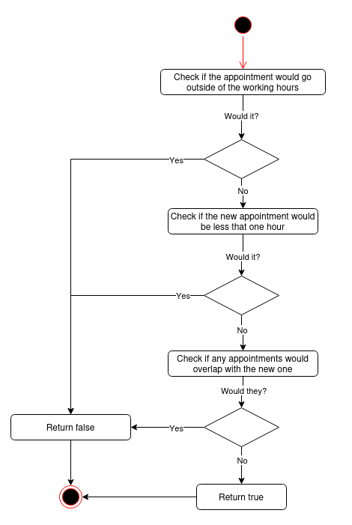

dtpAppointmentDate_ValueChanged | CHECK IF THE CHOSEN DATE OCCURS DURING THE WEEKEND  IF IT DOES  OUTPUT "We're closed during the weekend!"  SET THE DATE BACK TO ITS ORIGINAL VALUE  END PROCESS  END IF  RUN DrawAppointments WITH THE NEW DATE
frmServiceAppointments_Load | FETCH ALL STAFF FROM THE Staff TABLE  VALIDATE THAT NO SYSTEM ERRORS OCCURRED DURING FETCHING  FILTER STAFF BY ROLE TO RETRIEVE ONLY MECHANICS  ADD EACH MECHANIC TO THE MECHANIC COMBOBOX CONTAINING THE MECHANIC’S ID AND NAME  FETCH ALL VEHICLES FROM THE Vehicles TABLE  VALIDATE THAT NO SYSTEM ERRORS OCCURRED DURING FETCHING  FOREACH VEHICLE  IF THE VEHICLE HAS AN OWNER  ADD THE VEHICLE’S ID, NAME AND THE OWNER’S NAME TO THE  VEHICLE COMBOBOX  ELSE  ADD THE VEHICLE’S ID AND NAME TO THE VEHICLE COMBOBOX  END IF  END FOR  FETCH ALL SERVICES FROM THE Services TABLE  VALIDATE THAT NO SYSTEM ERRORS OCCURRED DURING FETCHING  ADD EACH SERVICE AND ITS PRICE TO THE CHECKEDLISTBOX  FETCH ALL PARTS FROM THE Parts TABLE  VALIDATE THAT NO SYSTEM ERRORS OCCURRED DURING FETCHING  ADD EACH PART, ITS PRICE AND QUANTITY TO THE PART COMBOBOX

PopulateAppointmentDetails | RETRIEVE APPOINTMENT FROM ServiceAppointments TABLE USING ITS ID  POPULATE BASIC FIELDS DIRECTLY (Appointment Start, Appointment End, Appointment ID, Paid, Completed, Discounted)  FIND THE APPROPRIATE MECHANIC IN THE COMBOBOX AND SET THEM AS THE SELECTED ITEM  FIND THE APPROPRIATE VEHICLE IN THE COMBOBOX AND SET IT AS THE SELECTED ITEM  GO THROUGH EACH SERVICE AND CHECK IT IN THE CHECKEDLISTBOX, THEN ADD EACH SERVICE TO THE SERVICE COMBOBOX
btnSaveScheduleOnly_Click | DISPLAY A CONFIRMATION MESSAGE  TRY  FOR EACH APPOINTMENT IN DayAppointmentViewer  FETCH ITS ID  UPDATE ONLY THE START AND END DATE OF THE APPOINTMENT IN  ServiceAppointments  END FOR  CATCH  OUTPUT ERROR MESSAGE  END TRY
btnPartMinus_Click | IF NO SERVICE HAS BEEN CHOSEN IN THE COMBOBOX  OUTPUT "No service has been chosen to remove a part from."  END PROCESS  END IF  IF NO PART HAS BEEN CHOSEN IN THE COMBOBOX  OUTPUT "No part has been chosen to remove from the service."  END PROCESS  END IF  IF THE SERVICE-PARTS LIST DOES NOT CONTAIN ANY PARTS FOR THE SERVICE  OUTPUT "The current service doesn't have any of the selected item!"  END PROCESS  END IF  INCREMENT THE NUMBER OF PARTS OF THE CHOSEN KIND ASSOCIATED WITH THAT SERVICE

btnPartPlus_Click | IF NO SERVICE HAS BEEN CHOSEN IN THE COMBOBOX  OUTPUT "No service has been chosen to remove a part from."  END PROCESS  END IF  IF NO PART HAS BEEN CHOSEN IN THE COMBOBOX  OUTPUT "No part has been chosen to remove from the service."  END PROCESS  END IF  IF THE Parts TABLE HAS A Quantity FOR THAT PART LESS THAN THE NEW PART COUNT WOULD BE  OUTPUT "You don't have enough of this part in stock!"  END PROCESS  END IF  DECREMENT THE NUMBER OF PARTS OF THE CHOSEN KIND ASSOCIATED WITH THAT SERVICE

Validation and error-trapping
- If statements will be used to ensure:
  - Vehicle ID is greater than zero
  - Staff ID is greater than zero
  - Appointment end is after appointment start
  - Appointment starts and ends on the same day
  - The appointment duration is sufficient for the selected services
- Try-catch statements will surround all database operations to handle errors and provide user feedback
- Try-catch statements executed during loading of the form will ensure that the form is locked down in the event of a database error
- If statements will be used to ensure that a valid service and part have been selected for manipulation
- If statements will check that mechanic and vehicle selections do not cause overlapping appointments
- If statements will check stock availability when adding parts to services
- If statements will ensure weekend appointments are blocked

Input specifications
Field / Control | Data Type | Validation Rules | Purpose
txtAppointmentID | Integer (TextBox) | Must be >= 0; 0 for new records, >0 for existing records | Identifies the appointment in the database
dtpAppointmentDate | DateTime | Must be not fall on a weekend | Day on which an appointment falls
dtpAppointmentStart | DateTime | Must be less than end; must be on same date as end; must be greater than the start of day | Time at which appointment starts
dtpAppointmentEnd | DateTime | Must be greater than start; must be on same date as start; must be less than end of day | Time at which appointment ends
chkPaid | Checkbox | Boolean | If appointment has been paid for
chkDiscounted | Checkbox | Boolean | If appointment has been discounted
chkCompleted | Checkbox | Boolean | If appointment has been completed
comboMechanicID | ComboBox (integer) | Must be >= 0; must exist in Staff table | Mechanic carrying out appointment
comboVehicleID | ComboBox (integer) | Must be >= 0; must exist in Vehicles table | Vehicle being serviced
chklbServices | CheckedListBox (integer) | Must be >= 0; must exist in Services table; sum of times must not exceed allocated time | Services carried out during appointment
comboParts | ComboBox (integer) | Must be >= 0; must exist in Parts table; total amount of part used must not exceed amount in stock | Parts used in services during appointment

User requirements met: 6h, 7, 8, 9, 10, 11, 12, 13, 14, 15, 18, 19, 20, 22, 23, 24, 26

frmServiceData

Drawing
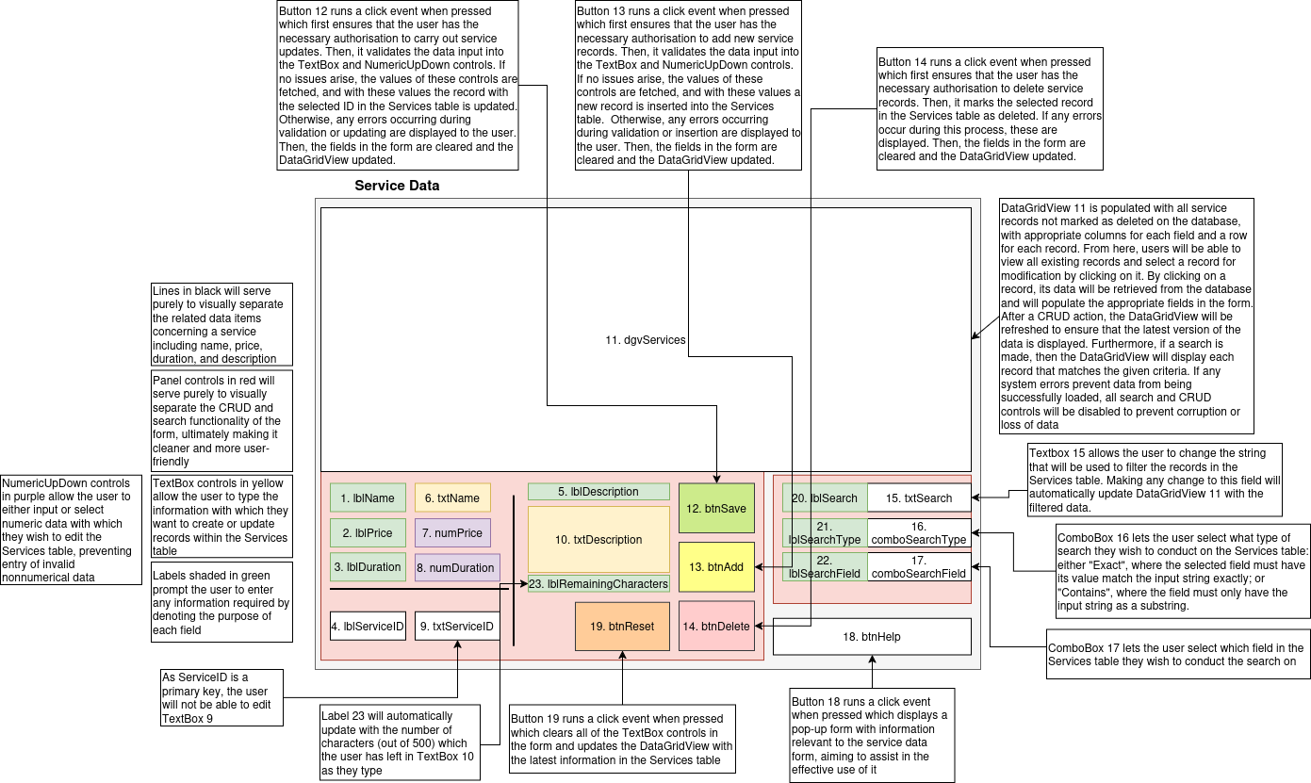

Explanation
Accessible by administrative and technical staff, this form will allow users to modify the values within the Services table. Little is unique to this form bar the description fields, which allows users to write the specific details of a service in prose. Provided with this field is a remaining character count, which ensures that users do not exceed the limit provided to them. The details of a service will be used to calculate the cost and duration of an appointment. It is important to note deleting services is not possible if they are used within any appointment.

Pseudocode and diagrams
Form event listener | Pseudocode
btnDelete_Click | CHECK PERMISSION  IF permissionError IS NOT null THEN  DISPLAY permissionError  EXIT process  ENDIF  CHECK A SERVICE HAS BEEN SELECTED  IF NOT  OUTPUT “Select a service to delete.”  END PROCESS  END IF  DISPLAY A CONFIRMATION PROMPT  IF CONFIRMED  CHECK IF ANY SERVICE APPOINTMENTS IN ServiceAppointments USE THAT  SERVICE  IF THEY DO  OUTPUT “Service is currently used in service appointments and cannot be deleted”.  END PROCESS  END IF  TRY  DELETE THE SERVICE  CATCH  OUTPUT ERROR MESSAGE  END TRY  END IF  LOG THE DELETE  RESET FORM
txtDescription_TextChanged | CALCULATE 500 - THE NEW LENGTH OF THE STRING IN txtDescription  SET THE TEXT OF lblRemainingCharacters EQUAL TO “Remaining characters: “ APPENDED WITH THE CALULCATED VALUE

Validation and error-trapping
- If statements will be used to ensure:
  - Service ID is positive
  - Service name is not empty and does not exceed 50 characters
  - Description does not exceed 500 characters
  - Duration is between 1 and 10 hours
  - Price is zero or positive
- Try-catch statements will surround all database operations to handle errors and provide user feedback
- Try-catch statements executed during loading of the form will ensure that the form is locked down in the event of a database error
- If statements will be used to ensure that a valid part has been selected for manipulation

Input specifications
Field / Control | Data Type | Validation Rules | Description / Purpose
txtServiceID | Integer (TextBox) | Required; >= 0; auto-populated when selecting a service | Unique identifier for the service
txtName | String (TextBox) | Required; non-empty; max 50 characters | Name of the service
txtDescription | String (TextBox) | Optional; max 500 characters | Description of the service
numDuration | Integer (NumericUpDown) | Required; 1-10 | Duration of the service in hours
numPrice | Decimal (NumericUpDown) | Required; >= 0 | Price of the service

User requirements met: 6g, 7, 8, 9, 10, 11, 12, 13, 14, 15, 16g, 23, 24, 26

frmPartData

Drawing
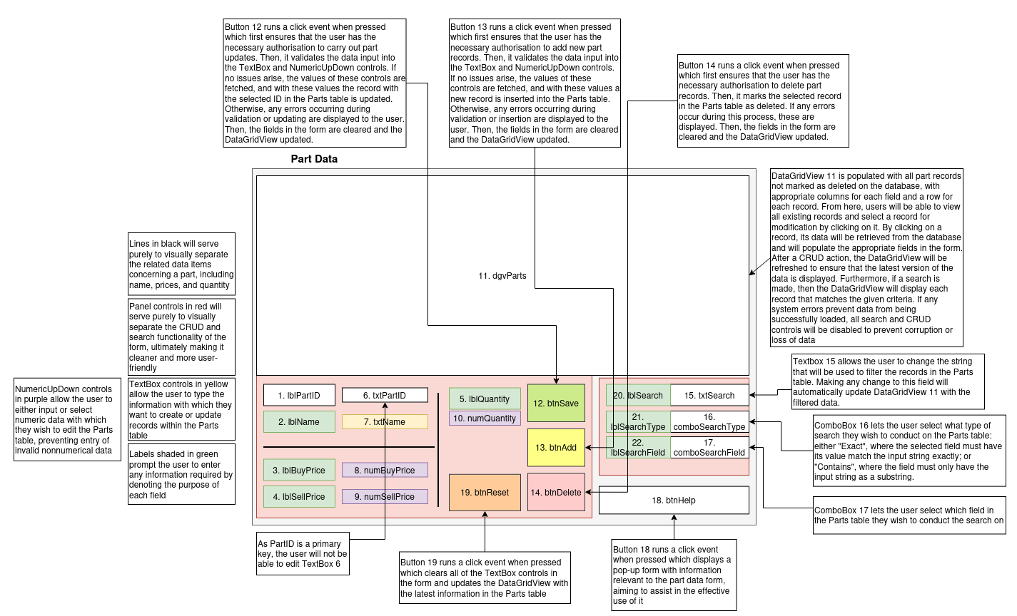

Explanation
Accessible by administrative and technical staff, this form will allow users to modify the Parts table. The cost of a part will make up part of the total cost of an appointment. It is important to note that deleting a part will not be possible if it is part of an existing appointment.

Pseudocode and diagrams
Form event listener | Pseudocode
btnDelete_Click | CHECK PERMISSION  IF permissionError IS NOT null THEN  DISPLAY permissionError  EXIT process  ENDIF  CHECK A SERVICE HAS BEEN SELECTED  IF NOT  OUTPUT “Select a service to delete.”  END PROCESS  END IF  DISPLAY A CONFIRMATION PROMPT  IF CONFIRMED  CHECK IF ANY SERVICE APPOINTMENTS IN ServiceAppointments USE THAT  SERVICE  IF THEY DO  OUTPUT “Service is currently used in service appointments and cannot be deleted”.  END PROCESS  END IF  TRY  DELETE THE SERVICE  CATCH  OUTPUT ERROR MESSAGE  END TRY  END IF  LOG THE DELETE  RESET FORM

Validation and error-trapping
- If statements will be used to ensure:
  - Part ID is positive
  - Part name is not empty and does not exceed 50 characters
  - Buy price is zero or positive
  - Sell price is zero or positive
  - Quantity is zero or positive
- Try-catch statements will surround all database operations to handle errors and provide user feedback
- Try-catch statements executed during loading of the form will ensure that the form is locked down in the event of a database error
- If statements will be used to ensure that a valid part has been selected for manipulation

Input specifications

Field / Control | Data Type | Validation Rules | Purpose
txtPartID | Integer (TextBox) | Must be >= 0; auto-populated for new parts | Identifies the part; used for edits or deletes
txtName | Text | Required; cannot be blank; max 50 characters | Part name
numBuyPrice | NumericUpDown (decimal) | >= 0 | Purchase price of the part
numSellPrice | NumericUpDown (decimal) | >= 0 | Sale price of the part
numQuantity | NumericUpDown (integer) | >= 0 | Quantity in stock

User requirements met: 6e, 7, 8, 9, 10, 11, 12, 13, 14, 15, 16, 23, 24, 26

frmRoleData

Drawing
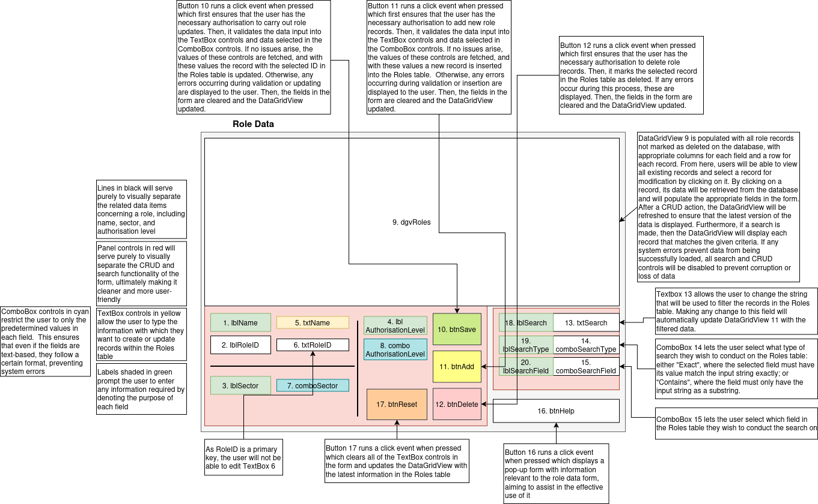

Explanation
This form will allow users to modify the Roles table. Due to the inherent risk of unauthorised users gaining access to key parts of the system by modifying the details of their role, only administrative staff will be able to access this form. At the moment, there are a limited number of sectors (these being administrative, HR, technical, customer Service, and finance) and as such the sector ComboBox will be hard-coded with these values. When the business eventually expands and requires a more sophisticated sector system, a separate table could be implemented and the same logic used that populates ComboBox controls in other forms. Similarly, there are only 3 authorisation levels - 0 being read-only, 1 being restricted write, and 2 being unrestricted write - and these will be hardcoded as well. Roles will not be stored as objects on the system when a user logs in, and instead the table will be queried when role data is required to ensure that only the latest permitted forms and permissions are displayed. It is important to note that deleting roles will not be possible if there are staff members of that role

Pseudocode and diagrams
Form event listener | Pseudocode
btnDelete_Click | CHECK PERMISSION  IF permissionError IS NOT null THEN  DISPLAY permissionError  EXIT process  ENDIF  CHECK A ROLE HAS BEEN SELECTED  IF NOT  OUTPUT “Select a role to delete.”  END PROCESS  END IF  DISPLAY A CONFIRMATION PROMPT  IF CONFIRMED  CHECK IF ANY STAFF MEMBERS IN Staff ARE OF THAT ROLE  IF THEY DO  OUTPUT “Role is assigned to staff members and cannot be  deleted”  END PROCESS  END IF  TRY  DELETE THE ROLE  CATCH  OUTPUT ERROR MESSAGE  END TRY  END IF  LOG THE DELETE  RESET FORM

Validation and error-trapping
- If statements are used to ensure:
  - Role ID is positive
  - Role name is not empty and does not exceed 50 characters
  - Sector is not empty and does not exceed 50 characters
  - Authorisation level is zero or positive
- Try-catch statements will surround all database operations to handle errors and provide user feedback
- Try-catch statements executed during loading of the form will ensure that the form is locked down in the event of a database error
- If statements will be used to ensure that a valid role has been selected for manipulation

Input specifications
Field / Control | Data Type | Constraints / Validation Rules | Description / Purpose
txtRoleID | Integer (TextBox) | Required; >= 0; auto-populated when selecting a role | Unique identifier for the role
txtName | String (TextBox) | Required; non-empty; max 50 characters | Name of the role
comboAuthorisationLevel | Integer (ComboBox) | 0–2 (0 = Read-only, 1 = Restricted write, 2 = Unrestricted write) | Role permission level; determines access rights
comboSector | String (ComboBox) | Required; non-empty; max 50 characters | Sector the role belongs to

User requirements met: 6f, 7, 8, 9, 10, 11, 12, 13, 14, 15, 16f, 23, 24, 26

frmReports

Drawing
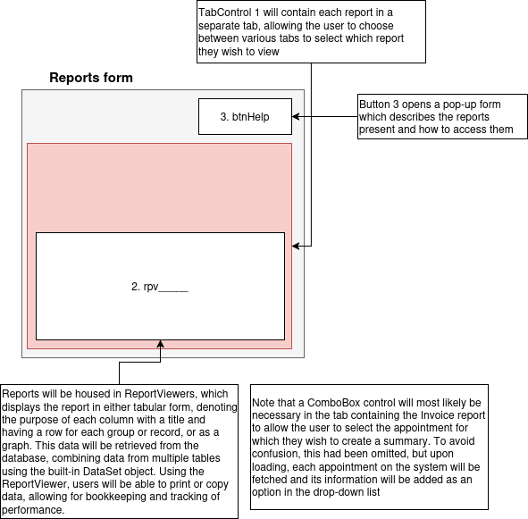

Explanation
Accessible by customer service, administrative and finance staff, this form will display reports derived from the data stored within the database. In particular, the following reports are to be implemented: monthly profits due to service appointments grouped by mechanic (i.e. the summation of the price of those paid and completed, minus the cost of the parts); overall profits due to car sales, grouped by vehicle type (once again, sell price minus buy price summed); invoices for these appointments to allow staff to easily determine how much a customer is due to pay the business; customer interest by vehicle type (i.e., the total number of vehicles owned by customers grouped by vehicle type); missed appointments; and vehicle stock (the number of cars owned by dealership by vehicle type). With each of these reports, the ReportViewer control will allow for convenient saving or printing of the information produced, thus allowing for the keeping of records or external analysis. Note that the invoices tab may require a ComboBox element to select the specific appointment they wish to generate an overview for, and this will be handled by fetching all appointments from the database and parsing their appointment IDs, adding them as options.

Pseudocode and diagrams
As most functionality - from rendering reports and calculating values, to changing and displaying tabs - is handled by built-in methods, and only binding the reports is required on my end (which is rather mundane) no pseudocode will be provided. The aforementioned ComboBox would require parsing and population logic, but similar logic is handled in the CRUD forms and will not be included for the sake of brevity.

Validation and error-trapping
- If statements will be used when loading data from external sources to ensure that it was successfully retrieved before attempting to parse it

User requirements met: 15, 21

frmLogs

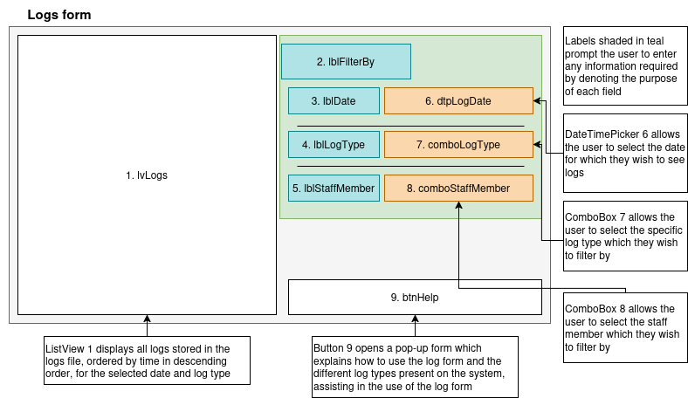
Drawing

Explanation
Accessible by HR and administrative staff, the logs form will display all logs accumulated in an external file, thus allowing these staff to know when each staff member performed what kind of action on which data, adding a form of accountability to the system. All relevant buttons on the system (CRUD, login and form access buttons) will be linked to the logging system, and clicking these will trigger an event which will save an appropriate message to an external file. These will be parsed by frmLogs on loading, and logs written on the chosen date (or the current date by default) will be displayed in the ListView control. It is important to note that no facilities are provided to modify the logs file, preventing any malicious users from covering up their tracks by editing or deleting logs. At the moment, 6 log types are to be considered - read, write, delete, access, successful login, unsuccessful login (i.e. login attempt).

Pseudocode and diagrams
Form event listener | Pseudocode
UpdateLogs | FETCH THE CHOSEN DATE, LOG TYPE AND STAFF MEMBER  CLEAR ALL PREVIOUS LOADED LOGS  LOAD THE LOG FILE INTO MEMORY  FOREACH LOG IN THE FILE  CHECK THAT THE DATE SEGMENT IS PROPERLY FORMATTED  IF IT ISN’T  CONTINUE  END IF  PARSE THE DATE  CHECK THAT THE LOG TYPE SEGMENT IS PROPERLY FORMATTED  IF IT ISN’T  CONTINUE  END IF  MATCH THE LOG TYPE NUMBER TO THE APPROPRIATE LOG TYPE  REMOVE THE LOG TYPE NUMBER TO PRODUCE A CLEANED STRING FOR  DISPLAY TO THE USER  CREATE A NEW ListViewItem OBJECT USING DATE, LOG TYPE AND STRING  END FOREACH  FILTER BY THE CRITERIA GIVEN  ADD ALL VALID ListViewItems TO THE ListView CONTROL

Validation and error-trapping
- If statements will ensure that if the log file does not exist in the expected location, a blank list is returned rather than attempting to load the nonexistent file
- Try-catch statements will be used during the parsing of logs to ensure that malformed logs are skipped
- If statements will be used during the parsing of logs to ensure that they are of the expected format
- Try-catch statements will be used while parsing log data such as dates and log types to ensure invalid values are ignored
- Default values will be used in switch statements to ensure that unexpected values are properly handled

User requirements met: 2, 15, 25

frmHelp____

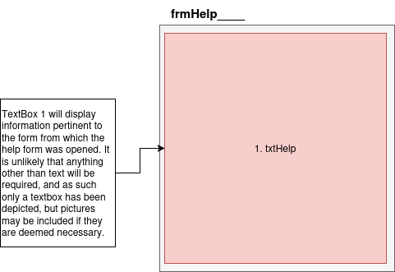
Drawing

Explanation
Accessible from every form bar frmStartingMainMenuForm and frmLogin, the help forms will provide the user with information regarding the usage of the appropriate part of the system. A key focus will be any behaviours of the system that would not be intuitive. For example, the password field in frmStaffData being empty may not make sense to a first-time user, but the help form would explain this and provide valid reasoning as to why this is the case. Help will be predominantly textual, though images may be provided and are to be expected for the rather visual frmServiceAppointments.

Pseudocode and diagrams
There is no functionality for which high-level representations can be created

Validation and error-trapping
Forms of this type will not have dynamic data input or output, and thus require no validation.
User requirements met: 26

Program flow
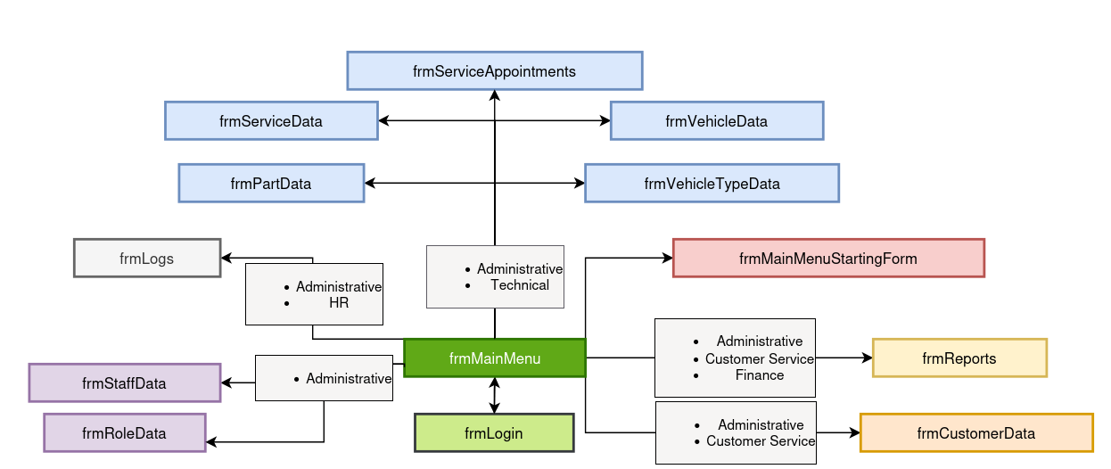
The following is a diagram representation of the navigation flow within the program: the forms available for a user to access from other forms through click events. Attached to each flow arrow - bar the one connecting frmMainMenu to frmMainMenuStartingForm - is a list of role sectors which are able to access the respective forms.

All buttons on frmMainMenu will be disabled by default. Upon loading the form, the sector of the logged-in user’s role will be fetched. Using this information, the appropriate navigation buttons will be enabled. As previously mentioned, forms will not be opened separately to frmMainMenu, but will instead be instantiated and inserted into a panel within frmMainMenu by clearing all of its controls, docking it and bringing it to the front. Ultimately, this reduces complexity when using the program and improves its continuity.

Omitted for clarity are the help forms present in every form except frmMainMenuStartingForm and frmLogin. Only one form can be open in the foreground at any time to prevent any unexpected behaviour occurring - with this usually being frmMainMenu - but help forms will open in conjunction with the form they belong to to assist the user with that particular form.

On logging out, all of the previous user’s information is cleared from memory, ensuring that no states are carried over, thus allowing a new user to log in and use the system without any bugs.

Normalisation

As previously discussed, Doherty Cars already have their own (albeit ineffective) systems in place to record appointments, and as such they have their own representations of the entities pertaining to their business, forming the basis of the new database system. However, upon inspection of an old appointment sheet, it was identified that an appointment had nested repeating groups: an appointment has many services and a service has many parts. This structure introduces redundancy and complicates data management, making it unsuitable for a robust, scalable solution.

To address these issues, normalisation was applied to reorganise the data, minimising redundancy, improving data integrity, and simplifying the eventual implementation of the database system, ensuring a more elegant and maintainable design.

0NF
This represents the way the appointments were originally stored. The nested repeating groups enclosed by the curly brackets would compromise any relational database system attempting to directly implement this representation.

ServiceAppointments(AppointmentID, AppointmentStart, AppointmentEnd, Paid, Completed, Discounted, StaffID, StaffName, StaffUsername, StaffPassword, RoleID, RoleName, RoleAuthorisationLevel, RoleSector, VehicleID, VehicleTypeID, VehicleTypeName, VehicleComplexity, Model, Make, Year, VIN, LicensePlate, Condition, Available, Inspected, VehicleBuyPrice, VehicleSellPrice, VehicleStorageLocation, CustomerID, CustomerName, CustomerEmail, CustomerPhoneNumber, {ServiceID, ServiceName, ServiceDescription, ServiceDurationHours, ServicePrice {PartID, PartName, PartBuyPrice, PartSellPrice, PartQuantityInStock, PartQuantityUsed}})

1NF
With repeating groups removed through the primary-foreign key mechanism, the representation is now viable. Still, partial dependencies increase data redundancy.

ServiceAppointments(AppointmentID, AppointmentStart, AppointmentEnd, Paid, Completed, Discounted, StaffID, StaffFirstname, StaffSurname, StaffUsername, StaffPassword, RoleID, RoleName, RoleAuthorisationLevel, RoleSector, VehicleID, VehicleTypeID, VehicleTypeName, VehicleComplexity, Model, Make, Year, VIN, LicensePlate, Condition, Available, Inspected, VehicleBuyPrice, VehicleSellPrice, VehicleStorageLocation, CustomerID, CustomerFirstname, CustomerSurname, CustomerEmail, CustomerPhoneNumber)

ServiceAppointmentsServices(AppointmentID*, ServiceID, ServiceName, ServiceDescription, ServiceDurationHours, ServicePrice)

ServiceAppointmentsServicesParts(AppointmentID*, ServiceID*, PartID, PartName, PartBuyPrice, PartSellPrice, PartQuantityInStock, PartQuantityUsed)
2NF
With partial dependencies removed, the representation has less redundancy concerning appointments. However, transitive dependencies remain an issue.

ServiceAppointments(AppointmentID, AppointmentStart, AppointmentEnd, Paid, Completed, Discounted, StaffID, StaffFirstname, StaffSurname, StaffUsername, StaffPassword, RoleID, RoleName, RoleAuthorisationLevel, RoleSector, VehicleID, VehicleTypeID, VehicleTypeName, VehicleComplexity, Model, Year, VIN, LicensePlate, Condition, Available, Inspected, VehicleBuyPrice, VehicleSellPrice, VehicleStorageLocation, CustomerID, CustomerFirstname, CustomerSurname, CustomerEmail, CustomerPhoneNumber)

ServiceAppointmentsServices(AppointmentID*, ServiceID*)

Services(ServiceID, Name, Description, DurationHours, Price)

ServiceAppointmentsServicesParts(AppointmentID*, ServiceID*, PartID*)

Parts(PartID, Name, BuyPrice, SellPrice, Quantity)

3NF
Now in 3NF, the model is fit for implementation.

ServiceAppointments(AppointmentID, AppointmentStart, AppointmentEnd, Paid, Completed, Discounted, StaffID*, VehicleID*)

ServiceAppointmentsServices(AppointmentID*, ServiceID*)

ServiceAppointmentsServicesParts(AppointmentID*, ServiceID*, PartID*, Quantity)

Parts(PartID, Name, BuyPrice, SellPrice, Quantity)

Staff(StaffID, RoleID*, Firstname, Surname, Username, Password)

Roles(RoleID, Name, AuthorisationLevel, Sector)

Services(ServiceID, Name, Description, DurationHours, Price)

Vehicles(VehicleID, CustomerID*, VehicleTypeID*, Model, Make, Year, VIN, LicensePlate, Condition, Available, Inspected, BuyPrice, SellPrice, StorageLocation)

VehicleTypes(VehicleTypeID, Name, Complexity)

Customers(CustomerID, Firstname, Surname, Email, PhoneNumber)
Note that each table will have a DateDeleted field for soft deletes which has not been included in the normalisation

ER diagram

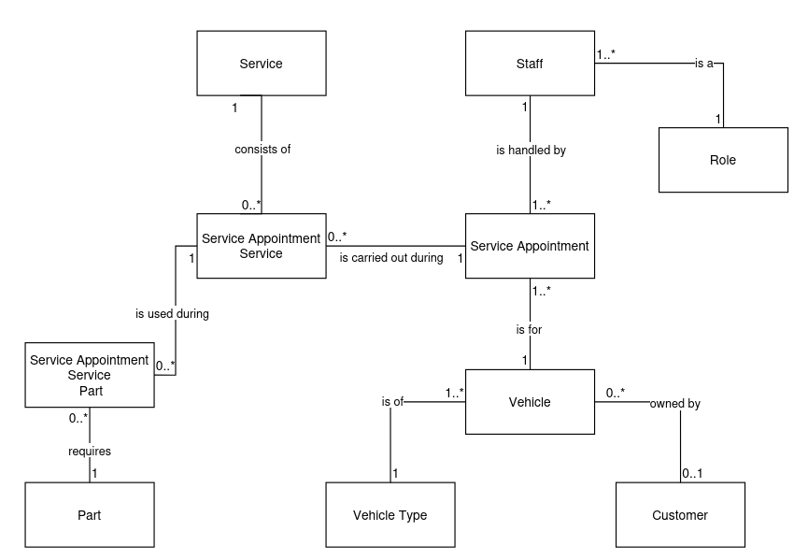
With the model now normalised, an ER diagram would both visually confirm that redundancy has been removed and directly guide the creation of the database.

Note that the optionality of certain foreign keys can be represented through cardinality in an ER diagram, unlike during the normalisation process. Particularly, a vehicle does not necessarily need to be owned by a customer (such as cars held in stock), and nor does a customer need to own a car (such as if they are a potential buyer). Furthermore, an appointment does not need a service (for example, in the event of an inspection), and nor does an appointment’s service necessarily need parts.

Regardless, it is evident that the entities in the system and their relationships have been rigorously and correctly defined, and the model is now fit for implementation within a relational database.

Final database design
To comply with the user requirements and ensure soft deletes, a “DateDeleted” field has been added. Upon inserting a record, this will be set to NULL, indicating that the record exists on the system. However, once the record is deleted, this date will be set to the exact time of deletion, ensuring that the system can identify which records to ignore but that all information can be restored when required.

Customers
Represents clients of the business; any potential or former buyers. External validation will ensure that any emails inserted into the table follow the expected format “name@domain.com”

Field Name | Type of Key | Data Type | NULL/NOT NULL | Constraints
CustomerID | PK | INT | NOT NULL | IDENTITY(1,1)
Firstname |  | NVARCHAR(50) | NOT NULL
Surname |  | NVARCHAR(50) | NOT NULL
Email |  | NVARCHAR(50) | NULL
DateDeleted |  | DATETIME | NULL | DEFAULT NULL
PhoneNumber |  | VARCHAR(15) | NULL

Parts
Represents parts used when carrying out a service. No validation will be implemented to ensure that parts are sold at a profit in the event the business wants a loss leader.

Field Name | Type of Key | Data Type | NULL/NOT NULL | Constraints
PartID | PK | INT | NOT NULL | IDENTITY(1,1)
Name |  | NVARCHAR(50) | NOT NULL
BuyPrice |  | MONEY | NOT NULL
SellPrice |  | MONEY | NOT NULL
Quantity |  | INT | NOT NULL
DateDeleted |  | DATETIME | NULL | DEFAULT NULL

ServiceAppointments
Represents appointments that are to be carried out by a mechanic on a particular car.

Field Name | Type of Key | Data Type | NULL/NOT NULL | Constraints
AppointmentID | PK | INT | NOT NULL | IDENTITY(1,1)
VehicleID | FK | INT | NOT NULL | REFERENCES Vehicles(VehicleID)
StaffID | FK | INT | NOT NULL | REFERENCES Staff(StaffID)
AppointmentStart |  | DATETIME | NOT NULL
AppointmentEnd |  | DATETIME | NOT NULL
Paid |  | BIT | NOT NULL | DEFAULT 0
Completed |  | BIT | NOT NULL | DEFAULT 0
Discounted |  | BIT | NOT NULL | DEFAULT 0
DateDeleted |  | DATETIME | NULL | DEFAULT NULL

ServiceAppointmentsServices
Represents the services that are carried out during a particular appointment, accommodated using a composite key made up of foreign keys.

Field Name | Type of Key | Data Type | NULL/NOT NULL | Constraints
AppointmentID | PK, FK | INT | NOT NULL | REFERENCES ServiceAppointments(AppointmentID)
ServiceID | PK, FK | INT | NOT NULL | REFERENCES Services(ServiceID)
DateDeleted |  | DATETIME | NULL | DEFAULT NULL

ServiceAppointmentsServicesParts
Represents the parts that are to be used during a particular instance of a service during a particular appointment. Accommodated using a triple composite key of foreign keys.

Field Name | Type of Key | Data Type | NULL/NOT NULL | Constraints
AppointmentID | PK, FK | INT | NOT NULL | REFERENCES ServiceAppointmentsServices(AppointmentID, ServiceID)
ServiceID | PK, FK | INT | NOT NULL | REFERENCES ServiceAppointmentsServices(AppointmentID, ServiceID)
PartID | PK, FK | INT | NOT NULL | REFERENCES Parts(PartID)
Quantity |  | INT | NOT NULL
DateDeleted |  | DATETIME | NULL | DEFAULT NULL

Services
Represents the services that can be carried out on vehicles during appointments. No limit is set on the duration, as it will change depending on the vehicle’s complexity during appointment length calculation, and rigorous checks will be performed to ensure appointments are of a valid length.

Field Name | Type of Key | Data Type | NULL/NOT NULL | Constraints
ServiceID | PK | INT | NOT NULL | IDENTITY(1,1)
Name |  | NVARCHAR(50) | NOT NULL
Description |  | NVARCHAR(500) | NOT NULL
DurationHours |  | INT | NOT NULL
Price |  | DECIMAL(10,2) | NOT NULL
DateDeleted |  | DATETIME | NULL | DEFAULT NULL

Staff
Represents a member of staff who is able to interact with the system. As previously discussed, the password field will contain a hash as opposed to the plain text of a password.

Field Name | Type of Key | Data Type | NULL/NOT NULL | Constraints
StaffID | PK | INT | NOT NULL | IDENTITY(1,1)
Firstname |  | NVARCHAR(50) | NOT NULL
Surname |  | NVARCHAR(50) | NOT NULL
Username |  | NVARCHAR(50) | NOT NULL
Password |  | NVARCHAR(255) | NOT NULL
RoleID | FK | INT | NOT NULL | REFERENCES Roles(RoleID), DEFAULT 1
DateDeleted |  | DATETIME | NULL | DEFAULT NULL

Vehicles
Represents vehicles both stored by the dealership and sold to customers. In addition to the VehicleID, the VIN field will serve as a unique identifier of each vehicle which translates to the physical world, ensuring that the correct vehicles are modified in the database in the event of identical cars.

Field Name | Type of Key | Data Type | NULL/NOT NULL | Constraints
VehicleID | PK | INT | NOT NULL | IDENTITY(1,1)
VehicleTypeID | FK | INT | NOT NULL | REFERENCES VehicleTypes(VehicleTypeID)
CustomerID | FK | INT | NULL | REFERENCES Customers(CustomerID)
Make |  | NVARCHAR(50) | NOT NULL
Model |  | NVARCHAR(50) | NOT NULL
Year |  | INT | NULL
VIN |  | NVARCHAR(50) | NOT NULL | UNIQUE
LicensePlate |  | NVARCHAR(20) | NULL
Condition |  | NVARCHAR(50) | NOT NULL
Available |  | BIT | NOT NULL
Inspected |  | BIT | NOT NULL
BuyPrice |  | DECIMAL(10,2) | NULL
SellPrice |  | DECIMAL(10,2) | NULL
StorageLocation |  | NVARCHAR(50) | NULL
DateDeleted |  | DATETIME | NULL | DEFAULT NULL

VehicleTypes
Represents the type or build of a vehicle, determining the time taken for it to be serviced. This is determined by the complexity field, which serves as a scalar multiplier for the base time taken for an appointment when considering its services.

Field Name | Type of Key | Data Type | NULL/NOT NULL | Constraints
VehicleTypeID | PK | INT | NOT NULL | IDENTITY(1,1)
Name |  | NVARCHAR(50) | NOT NULL
Complexity |  | DECIMAL(2,1) | NOT NULL | DEFAULT 1
DateDeleted |  | DATETIME | NULL | DEFAULT NULL

Data requirements
For the system to properly interact with the database, entities must also be abstracted and implemented as classes and objects which can be instantiated during the loading of data. Seen below are high-level descriptions of the classes that will exist on the system.

ComboBoxItem (ComboBoxItem.cs)
Will be added to ComboBox controls as an Item when displaying data that requires a human-readable label to be understandable but an underlying identifier to be processable.

Property Name | Data Type | Description
DisplayValue | string | The text seen by the user in the ComboBox dropdown, returned when running the .ToString() method
HiddenValue | string | The underlying value associated with the item. Typically an ID or a key, this will be used internally for form logic or database operations, but not explicitly shown to the user.

CurrentUser (CurrentUser.cs)
Will be used to statically store the user who is currently logged in to ensure that their data can be easily retrieved, particularly when attempting actions that require authorisation or checking if they are authenticated for a certain form.

Property Name | Data Type | Description
DisplayValue | string | The text seen by the user in the ComboBox dropdown, returned when running the .ToString() method

Customer (Customer.cs)
Represents a record in the “Customers” table.

Property Name | Data Type | Description
CustomerID | int | The primary key field of the loaded record in the Customers table i.e. the record’s unique identifier
Firstname | string | The customer’s first name
Surname | string | The customer’s surname
Email | string | The customer’s email
PhoneNumber | string | The customer’s personal phone number

DBConnect (DBConnect.cs)
This class will not contain any properties, but rather will contain a static method to provide a connection string to the database, abstracting the interaction with the database and consequently preventing the need for complex code.

Logging (Logging.cs)
Encapsulates logging behaviour so that forms can statically call it to write logs to the system. In addition to the property below, it will contain both a method to write logs to the external logs file and a method to parse those logs for display in frmLogs.

Property Name | Data Type | Description
LogType | enum | Contains each type of log in the system as an enum, allowing for easy comparison and assignment when parsing and viewing logs

MechanicSchedule (MechanicSchedule.cs)
Represents a particular mechanic’s schedule, allowing for easy access of all the appointments associated with them, as well as keeping record of the particular way it is represented within frmServiceAppointments

Property Name | Data Type | Description
MechanicStaffID | int | The primary key of the mechanic whose schedule is represented by the object
MechanicName | string | The mechanic’s name as displayed in frmServiceAppointments
Timeblocks | List<Timeblock> | A list of all appointments stored under the mechanic’s ID in ServiceAppointments converted into Timeblock objects
Index | int | The zero-indexed row in which the current mechanic’s timeblocks are drawn in frmserviceAppointments

Part (Part.cs)
Represents a record in the “Parts” table

Property Name | Data Type | Description
PartID | int | The primary key of the loaded part record
Name | string | The name of the part
BuyPrice | decimal | The price at which a part is bought from the supplier
SellPrice | decimal | The price at which a part is sold to customers
Quantity | int | The number of parts of the type loaded which are in stock at the dealership

Role (Role.cs)
Represents a staff role in the “Roles” table.

Property Name | Data Type | Description
RoleID | int | The primary key of the loaded role record
Name | string | The name of the role
AuthorisationLevel | int | The extent of permissions given to the role. As discussed previously, there will be level 0 (can only read records), level 1 (can perform CRUD actions of relatively little risk) and level 2 (can perform CRUD actions of a high risk i.e. that can compromise the security of the system if maliciously used)
Sector | string | The sector of the staff role. As discussed, currently there will be administrative, technical, HR, finance and customer service

Service (Service.cs)
Represents a service in the “Services” table.

Property Name | Data Type | Description
ServiceID | int | The primary key of the loaded service record
Name | string | The name of the service
Description | string | A longer, free-form description of the purpose and details of the service
DurationHours | int | The time taken for the service in whole hours. Minutes are not considered as Doherty Cars outlined that mechanics are only expected to complete a few appointments per day, and as such there is little need to provide facilities to start storing appointment lengths and - by extension - service lengths by the minute.
Price | decimal | The price charged to an appointment’s customer for carrying out a service

ServiceAppointments (ServiceAppointments.cs)
Represents a service appointment as represented in the “ServiceAppointments”, “ServiceAppointmentsServices” and “ServiceAppointmentsServicesParts” tables

Property Name | Data Type | Description
AppointmentID | int | The primary key of the loaded appointment record
VehicleID | int | The primary key of the vehicle being serviced
StaffID | int | The primary key of the staff member carrying out the services
AppointmentStart | DateTime | The starting time of the appointment
AppointmentEnd | DateTime | The ending time of the appointment
Paid | bool | Whether the customer has paid for the appointment yet
Completed | bool | Whether the services have been carried out on the vehicle yet
Discounted | bool | Whether a discount will be applied to the appointment
ServiceIDsAndRequiredPartIDs | Dictionary<int, Dictionary<int,int>> | Stores the service ID as a key, and the dictionary which maps part ID to quantity as a value.

Staff (Staff.cs)
Represents a record in the “Staff” table.

Property Name | Data Type | Description
StaffID | int | The primary key of the loaded staff record
Firstname | string | The first name of the staff member
Surname | string | The last name of the staff member
Username | string | The identifier used for authenticating the staff member during the login process
Password | string | The hash of the password used to authenticate the staff member during the login process
RoleID | int | The primary key of the role associated with the staff member

Timeblock (Timeblock.cs)
Used to represent the block of time occupied by a service appointment. Note that no additional fields or methods will be provided, but the class will serve as an abstraction of an actual appointment for faster and easier processing.

Property Name | Data Type | Description
AppointmentID | int | The primary key of the appointment which the Timeblock object represents
AppointmentStart | DateTime | The time at which the Timeblock starts
AppointmentEnd | DateTime | The time at which the Timeblock ends

Validation (Validation.cs)
This class will not contain any properties, but will contain public validation methods that are deemed useful globally as opposed to the unique methods that many forms require. Due to the early stage in development, it is difficult to determine what would be required in this class at this stage.

Vehicle (Vehicle.cs)
Represents a record in the “Vehicles” table.

Property Name | Data Type | Description
VehicleID | int | The primary key of the loaded vehicle record
VehicleTypeID | int | The primary key of the vehicle’s type
CustomerID | int | The primary key of the vehicle’s owner
Make | string | The name of the vehicle’s manufacturer
Model | string | The name of the particular model that the car is
VIN | string | The vehicle identification number, used to identify the individual vehicle in the event that those with identical details are stored
LicensePlate | string | The license plate number registered to the vehicle, if it has one
Condition | string | The description of the condition in which the vehicle is considered to be
StorageLocation | string | The name of the location in the dealership where the vehicle is currently stored, if it has not been sold yet
Year | int? | The year the vehicle was manufactured, if this is known
Available | bool | Whether the vehicle is available for sale as a result of being ordered and the necessary prerequisite processes being carried out
Inspected | bool | Whether the vehicle has been inspected as part of the process carried out before a vehicle is put out for sale
BuyPrice | double? | The price at which the vehicle was bought by the dealership
SellPrice | double? | The price at which the vehicle will be or has been sold to a customer

VehicleTypes (VehicleTypes.cs)
Represents a record in the “VehicleTypes” table.

Property Name | Data Type | Description
VehicleTypeID | int | The primary key of the loaded vehicle type record
Name | string | The name of the vehicle type
Complexity | decimal | The scalar multiplier used when calculating the duration of a service appointment carried out on vehicles of the particular type

Logs (logs.txt)
Stores each log as a line in the file. Parsing and editing will be defined by the Logging class, but the file is planned to be structured as

[DATE] - [USER] [ACTION] [LOGTYPE]

With:
- [DATE] as the date and time of the action down to seconds
- [USER] the username of the user on the system
- [ACTION] being a description of the action executed by the user, with further information depending on the type of action (e.g. update actions will contain the record ID and old name)
- [LOGTYPE] being the number of the type of action as defined in the Logging enum order

When parsing, each line will be parsed individually, with the date parsed using the DateTime class, the appropriate LogType value allocated to the log object depending on the number provided, and then the display text stored as the entire line minus the number at the end

Class diagram
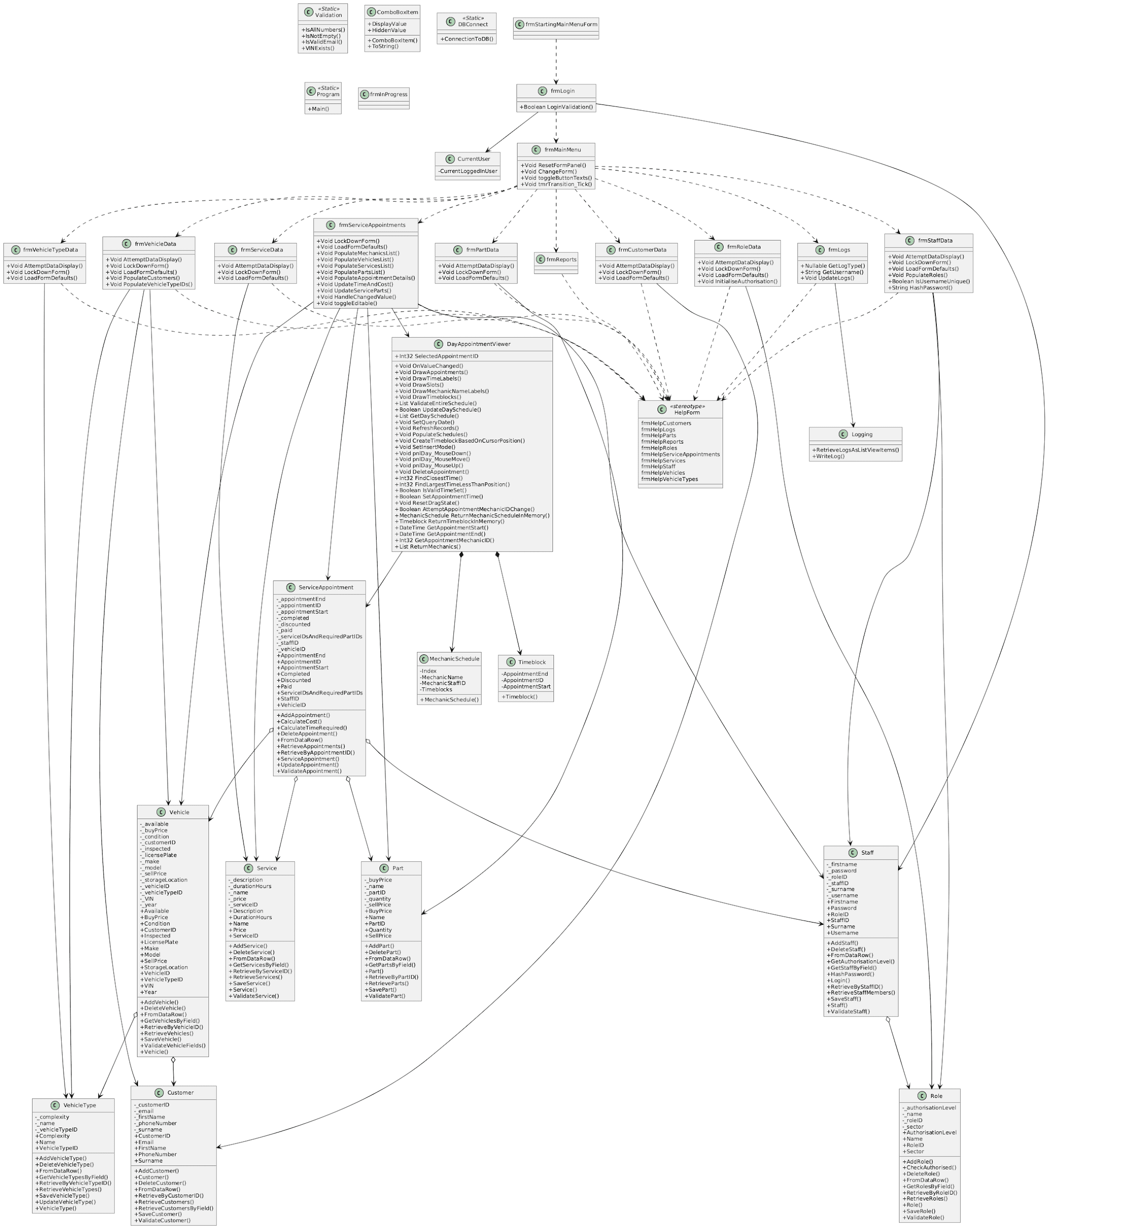

Report specifications

rptAppointmentMonthlyProfitsByMechanic

Purpose
The report will calculate the monthly profit generated per mechanic by combining the service revenue and parts revenue of their appointments, applying discounts (which, at the moment, are at a fixed rate of 10%), and subtracting parts costs. Ultimately, the aim is to help management track the performance of the mechanics, as well as the profitability of certain executive decisions such as the implementation of discounts.

Data Sources
As the report will require mechanic, service, appointment etc. data all combined, the following tables will be combined using “LEFT JOIN” statements as some appointments may not have parts or services:
- ServiceAppointments (sa) - for appointments, completion status, payments, and discounts. Only completed and paid appointments will be considered.
- ServiceAppointmentsServices (sas) - link the services available to appointments
- Services (s) - for service pricing
- ServiceAppointmentsServicesParts (sasp) - link parts used in each service for each appointment
- Parts (p) - contains parts buy and sell prices
- Staff (s) - contains mechanic details (firstname, surname).

Content/Fields
Using the tables previously mentioned, the following fields will be generated:
- StaffID - unique staff identifier
- AppointmentMonth - the month of the appointment (formatted as YYYY-MM-01 for homogeneity)
- Firstname - the mechanic’s first name
- Surname - the mechanic’s surname.
- MonthlyProfit - the profit for that staff member in that month, calculated as (services + partsrevenue) * 0.9 if discounted - partscost

Design
The report will be in the form of a clustered bar graph. As this is directly provided through the ReportViewer package in Visual Studio, no sketch must be provided.

rptCustomerInterest

Purpose
The report will track the number of vehicles sold per vehicle type by the dealership, thus helping management understand sales distribution by vehicle type and identify which types are performing best.

Data Sources
The following tables will be inner joined when querying the database:
- Vehicles (v) - contains individual vehicle records
- VehicleTypes (vt) - contains vehicle type details (e.g., Sedan, SUV, Truck).

Content/Fields
- VehiclesSold - number of vehicles sold of a particular type (i.e. count of the number of vehicles of a particular type which have a customer associated with them)
- VehicleTypeName - name of the vehicle type

Design
The report will be in the form of a bar graph. As this is directly provided through the ReportViewer package in Visual Studio, no sketch must be provided.

rptInvoices

Purpose
This report provides a detailed summary for a single service appointment, showing services, parts, discounts, and totals, allowing for the dealership to effectively execute billing, customer communication, and internal record-keeping all through a single report.

Data Sources
Multiple tables will have to be retrieved and combined using “LEFT JOIN” statements (as some appointments may not have associated customers, services or parts) and “WITH” statements to treat any calculations such as sums and counts as objects to be queried:
- ServiceAppointments (sa) - appointment details including date, staff, vehicle, and discount status
- ServiceAppointmentsServices (sas) - links services to appointments
- Services (s) - service pricing
- ServiceAppointmentsServicesParts (sasp) - links parts to appointments
- Parts (p) - part prices
- Staff (st) - staff details
- Roles (r) - staff roles
- Vehicles (v) - vehicle details
- Customers (c) - customer details

Content
- Appointment details: AppointmentID, AppointmentStart, AppointmentEnd, Discounted
- Staff details: StaffFirstname, StaffSurname, StaffRole
- Vehicle details: Make, Model, Year, LicensePlate
- Customer details: CustomerFirstname, CustomerSurname, Email, PhoneNumber
- Financials:
  - SubtotalServices - total cost of services
  - SubtotalParts - total cost of parts
  - RawTotal - sum of services and parts before discount
  - TotalSavings - discount applied (if any)
  - GrandTotal - final amount after discount
- Item details: ItemType, ItemName, Quantity, UnitPrice, LineTotal

Design
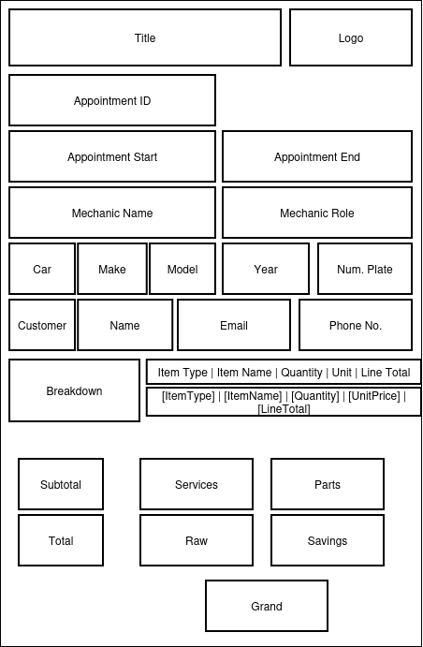
The report will be structured like a regular invoice, with fields populated with details as necessary on selecting a specific appointment

rptMissedAppointments

Purpose
This report lists overdue or missed service appointments i.e. those that were not completed and whose end time has passed, thus helping management track staff performance and prioritise follow-ups with customers.

Data Sources
The following tables must be inner joined:
- ServiceAppointments (sa) - appointment details including completion status and start/end times
- Staff (s) - staff details (firstname, surname)
- Vehicles (v) - vehicle make and model

Content
- AppointmentID
- Mechanic - full name of the assigned staff member (concatenated Firstname + Surname)
- Car - vehicle make and model (concatenated Make + Model)
- AppointmentStart - start time/date of the appointment

Design
This report will be implemented as a basic table, so no additional design is necessary.

rptVehicleStock

Purpose
This report shows the number of vehicles currently in stock (unsold) for each vehicle type, allowing management to monitor inventory and identify which vehicle types may need promotion.

Data Sources
The following tables will be inner joined:
- Vehicles (v) - records of all vehicles
- VehicleTypes (vt) - vehicle type details (e.g., Sedan, SUV, Truck).

Content
- VehicleCount - number of unsold vehicles per type
- VehicleTypeName - name of the vehicle type

Design
This will be implemented as a bar chart, so no further design is necessary.

rptVehicleTypeProfits

Purpose
This report calculates total profit earned per vehicle type by subtracting the purchase price from the selling price for sold vehicles, helping management identify which vehicle types generate the most profit.

Data Sources
The following tables will be inner joined:
- Vehicles (v) - vehicle records
- VehicleTypes (vt) - vehicle type details (e.g., Sedan, SUV, Truck)

Content
- TotalProfits - total profit per vehicle type
- VehicleType - name of the vehicle type

Design
This report will be implemented as a pie chart, so no further design is necessary.

Testing

Testing

Purpose of testing
Thorough testing is essential in improving the system’s alignment with user requirements by identifying missing functionality and eliminating errors in the source code. A well-tested program ensures robustness, efficiency and effectiveness, ultimately fostering a more seamless and reliable user experience. This means easy access to precise and trustworthy information for all staff members, enhancing decision-making and efficiency.

Types of testing undergone
- White box testing – analysing the internal logic of the program to identify flaws in program flow
- Unit testing – verifying that individual modules function correctly in isolation, catching defects early in development
- Integration testing – ensuring that groups of modules interact correctly, communicating effectively
- System testing – evaluating the overall performance and reliability of the software under real-world conditions, ensuring it meets user requirements

Types of test data used
- Null - this will ensure that the system can cope when no data is entered or selected
- Valid data - this will ensure that the system operates as expected with normal data
- Invalid data - ensures that the system can process unexpected or unwanted data and does not crash when such is entered
- Extreme data - used to test that the system can cope with values on the boundary of what is considered “valid”, such as largest and smallest numbers in a validation check

Items to be tested

- frmLogin  - frmMainMenu  - frmStartingMainMenuForm  - frmCustomerData  - frmStaffData  - frmRoleData  - frmVehicleData | - frmVehicleTypeData  - frmPartData  - frmServiceData  - frmServiceAppointments  - frmLogs  - Logging  - frmReports

frmLogin
Test ID | Test item | Description | Test data | Expected outcome | Actual (observed) outcome | Pass/Fail | User requirement
1.1.1 | btnLogin | Ensures that, upon pressing the button, the input credentials are processed and validated correctly and the username and hashed password attempted to be matched to a valid staff record. If a match is found, the appropriate staff member is to be loaded into memory and the main menu opened, and if any errors occur an appropriate message is shown to the user. | Valid:  patdoh  Password1. | The user’s details will be stored in memory, frmLogin will be closed, and frmMainMenu opened. | The user’s details are stored in memory - as evidenced by frmStartingMainMenuForm updating - frmLogin is closed, and frmMainMenu is opened. | Pass | 1, 2
1.1.2 | btnLogin |  | Valid (enter key pressed):  patdoh  Password1. |  |  | Pass | 1, 2
1.1.3 | btnLogin |  | Valid (username randomly capitalised):  pAtDoh  Password1. |  |  | Pass | 1, 2
1.1.4 | btnLogin |  | Valid (username has leading and trailing spaces):  patdoh  Password1. |  |  | Pass | 1, 2
1.1.5 | btnLogin |  | Valid (password has leading and trailing spaces):  patdoh  Password1. |  |  | Pass | 1, 2
1.1.6 | btnLogin |  | Valid (logging out and logging back in - same account):  patdoh  Password1.  patdoh  Password1. |  |  | Pass | 1, 2, 3
1.1.7 | btnLogin |  | Valid (logging out and logging back in - different account):  patdoh  Password1.  ethanh1  h3110w0r1d |  |  | Pass | 1, 2, 3
1.1.8 | btnLogin |  | Invalid (incorrect password):  patdoh  password | A message box will be displayed with the message "Incorrect username or password, please try again.", the fields will be cleared, and the username field focused | A message box is displayed with the message "Incorrect username or password, please try again.", fields cleared, and username field focused | Pass | 1, 23
1.1.9 | btnLogin |  | Invalid (password wrongly uppercased):  patdoh  PaSSword1. |  |  | Pass | 1, 23
1.1.10 | btnLogin |  | Invalid (mismatched credentials):  ethanh1  Password1. |  |  | Pass | 1, 23
1.1.11 | btnLogin |  | Invalid (inputting encoded password hash):  patdoh  wwmgrLMQlq3GDymT1xDuBjL1ExxO+we/FdbH1X1hMh33eLKs |  |  | Pass | 1, 23
1.1.12 | btnLogin |  | Null:  empty  empty | A message box will be displayed with the text "Sorry, you cannot leave username and password blank." No further action will be taken. | A message box is displayed with the text "Sorry, you cannot leave username and password blank." No further action is taken. | Pass | 1, 23
1.1.13 | btnLogin |  | Null (no password):  patdoh  empty | A message box will be displayed with the text "Sorry, you cannot leave password blank." No further action will be taken. | A message box is displayed with the text "Password must be between 8 and 128 characters." No further action is taken. | Fail | 1, 23
1.1.14 | btnLogin |  | Null (no username):  empty  Password1. | A message box will be displayed with the text "Sorry, you cannot leave username blank." No further action will be taken. | A message box is displayed with the text "Username can only contain letters, numbers, underscores and full stops." No further action is taken. | Fail | 1, 23
1.1.15 | btnLogin |  | Invalid  (username is less than 3 characters)  pa  Password1. | A message box will be displayed with the text "Username must be between 3 and 50 characters." No further action will be taken. | A message box is displayed with the text "Username must be between 3 and 50 characters." No further action is taken. | Pass | 1, 23
1.1.16 | btnLogin |  | Invalid (username is more than 50 characters):  patdohpatdohpatdohpatdohpatdohpatdohpatdohpatdohpatdoh  Password1. |  |  | Pass | 1, 23
1.1.17 | btnLogin |  | Extreme (username is 3 characters):  eth  password | The user’s details will be stored in memory, frmLogin will be closed, and frmMainMenu opened. | The user’s details are stored in memory - as evidenced by frmStartingMainMenuForm updating - frmLogin is closed, and frmMainMenu is opened. | Pass | 1, 2
1.1.18 | btnLogin |  | Extreme (username is 50 characters):  ethethethethethethethethethethethethethethethethet  password |  |  | Pass | 1, 2
1.1.19 | btnLogin |  | Invalid  (password less than 8 characters):  patdoh  pass | A message box will be displayed with the text "Password must be between 8 and 128 characters." No further action will be taken. | A message box is displayed with the text "Password must be between 8 and 128 characters." No further action is taken. | Pass | 1, 23
1.1.20 | btnLogin |  | Invalid  (password more than 128 characters):  patdoh  passwordpasswordpasswordpasswordpasswordpasswordpasswordpasswordpasswordpasswordpasswordpasswordpasswordpasswordpasswordpasswordpassword |  |  | Pass | 1, 23
1.1.21 | btnLogin |  | Extreme (password is 8 characters):  eth  password | The user’s details will be stored in memory, frmLogin will be closed, and frmMainMenu opened. | The user’s details are stored in memory - as evidenced by frmStartingMainMenuForm updating - frmLogin is closed, and frmMainMenu is opened. | Pass | 1, 2
1.1.22 | btnLogin |  | Extreme (password is 128 characters):  eth  passwordpasswordpasswordpasswordpasswordpasswordpasswordpasswordpasswordpasswordpasswordpasswordpasswordpasswordpasswordpassword |  |  | Pass | 1, 2
1.1.23 | btnLogin |  | Invalid (username does not contain only alphanumeric characters, underscores or fullstops)  p£tdoh  Password1. | A message box will be displayed with the text "Username can only contain letters, numbers, underscores and full stops." No further action will be taken. | A message box is displayed with the text "Username can only contain letters, numbers, underscores and full stops." No further action is taken. | Pass | 1, 23
1.1.24 | btnLogin |  | Null (Staff table missing):  patdoh  Password1. | An error message will be displayed as a result of being unable to load user details, the fields in the form will be cleared, and the username field focused | A message box is displayed with the message "Incorrect username or password, please try again.", fields cleared, and username field focused | Fail | 1, 23
1.2.1 | chkToggleHide | Ensures that the checkbox toggles obfuscation of the password, showing it as plain text or replacing it with asterisks as appropriate. | Click event (while password obfuscated) | txtPassword’s text will be revealed as plain text | txtPassword’s text is revealed as plain text | Pass | 1
1.2.2 | chkToggleHide |  | Click event (while password unobfuscated) | txtPassword’s text will be hidden, with each character replaced with an asterisk | txtPassword’s text is hidden, with each character replaced with an asterisk | Pass | 1

frmMainMenu
Test ID | Test item | Description | Test data | Expected outcome | Actual (observed) outcome | Pass/Fail | User requirement
2.1.1 | frmMainMenu | Ensures that, upon loading, the form ensures that the user has accessed the form through a valid login action. Then, it ensures that the user is only able to access forms that they have been allocated. | Load event with valid user patdoh | The form will successfully load, with buttons dynamically updating based on the user’s sector | The form successfully loads, with buttons updating based on the user’s sector | Pass | 2, 4, 5
2.1.2 | frmMainMenu |  | Load event with null user  No user loaded into memory | A message box will be shown with the message "Session expired. Please log in again." before the main menu is closed and the login form opened. | A message box is shown with the message "Session expired. Please log in again." before the main menu is closed and the login form opened. | Pass | 5, 24
2.1.3 | frmMainMenu |  | Load event with valid user but unexpected sector Administratived | A message box will be shown with the message "Role configuration error.", with no buttons authorised. No further action will be taken. | A message box is shown with the message "Role configuration error.", with no buttons authorised. No further action is taken. | Pass | 2, 4, 5, 23
2.1.4 | frmMainMenu |  | Load event with valid user with sector None | Form will load with no buttons authorised. No further action will be taken. | Form loads with no buttons authorised. No further action is taken. | Pass | 2, 4, 5
2.1.5 | frmMainMenu |  | Load event with valid user with sector  Administrative | Form will load with all buttons authorised. No further action will be taken. | Form loads with all buttons authorised. No further action is taken. | Pass | 2, 4, 5
2.1.6 | frmMainMenu |  | Load event with valid user with sector Customer Service | Form will load with customer data, reports and enquiries buttons authorised. No further action will be taken. | Form loads with customer data, reports and enquiries buttons authorised. No further action is taken. | Pass | 2, 4, 5
2.1.7 | frmMainMenu |  | Load event with valid user with sector Technical | Form will load with service appointments, services, vehicles, parts, vehicle types, test drive appointments and point of sale buttons authorised. No further action will be taken. | Form loads with service appointments, services, vehicles, parts, vehicle types, test drive appointments and point of sale buttons authorised. No further action is taken. | Pass | 2, 4, 5
2.1.8 | frmMainMenu |  | Load event with valid user with sector Finance | Form will load with reports and point of sale buttons authorised. No further action will be taken. | Form loads with reports and point of sale buttons authorised. No further action is taken. | Pass | 2, 4, 5
2.1.9 | frmMainMenu |  | Load event with valid user with sector HR | Form will load with logs and enquiries buttons authorised. No further action will be taken. | Form loads with logs and enquiries buttons authorised. No further action is taken. | Pass | 2, 4, 5
2.2.1 | pnlButtons | Ensures that, upon a hover event, the panel is animated as expected, with it expanding when hovered over and collapsing when the mouse is moved away. | Mouse hover event over panel while panel in initial state | The panel and buttons contained within the panel will horizontally expand to the right until they reach a maximum width, at which point the descriptory text of the buttons within the panel will appear | Panel and buttons contained within panel horizontally expand to the right until they reach a maximum width, at which point the descriptory text of the buttons within the panel appears | Pass
2.2.2 | pnlButtons |  | Mouse hover event over buttons while panel in initial state |  |  | Pass
2.2.3 | pnlButtons |  | Mouse moved out of panel while panel fully expanded | The descriptory text of the buttons in the panel will disappear, and the panel and buttons contained within the panel will horizontally collapse to the left until they reach a minimum width | The descriptory text of the buttons in the panel disappears, and the panel and buttons contained within the panel horizontally collapse to the left until they reach a minimum width | Pass
2.2.4 | pnlButtons |  | Mouse moved out of buttons while panel fully expanded |  |  | Pass
2.2.5 | pnlButtons |  | Mouse moved out of panel/buttons while panel is expanding | The panel and buttons contained within the panel will stop expanding and immediately begin collapsing horizontally to the left until they reach a minimum width, with button text being hidden if necessary | The panel and buttons contained within the panel stop expanding and immediately begin collapsing horizontally to the left until they reach a minimum width, with button text being hidden if necessary | Pass
2.2.6 | pnlButtons |  | Mouse hover event over panel/buttons while panel is collapsing | The panel and buttons contained within the panel will stop collapsing and immediately begin expanding horizontally to the right until they reach a maximum width, at which point the buttons’ descriptory text will appear | The panel and buttons contained within the panel stop collapsing and immediately begin expanding horizontally to the right until they reach a maximum width, at which point the buttons’ descriptory text will appear | Pass
2.3.1 | btnStaffData | Ensures that the button allows the user to access frmStaffData if permitted | Click event while authorised | The form in the viewing panel will be closed, and frmStaffData opened in its place. | The form in the viewing panel is closed, and frmStaffData opened in its place. | Pass | 2, 4, 5, 8
2.3.2 | btnStaffData |  | Click event while unauthorised | No further action will be taken. | No further action is taken. | Pass | 2, 4, 5, 8
2.4.1 | btnCustomer  Data | Ensures that the button allows the user to access frmCustomerData if permitted | Click event while authorised | The form in the viewing panel will be closed, and frmCustomerData opened in its place. | The form in the viewing panel is closed, and frmCustomerData opened in its place. | Pass | 2, 4, 5, 8
2.4.2 | btnCustomer  Data |  | Click event while unauthorised | No further action will be taken. | No further action is taken. | Pass | 2, 4, 5, 8
2.5.1 | btnVehicleData | Ensures that the button allows the user to access frmVehicleData if permitted | Click event while authorised | The form in the viewing panel will be closed, and frmVehicleData opened in its place. | The form in the viewing panel is closed, and frmVehicleData opened in its place. | Pass | 2, 4, 5, 8
2.5.2 | btnVehicleData |  | Click event while unauthorised | No further action will be taken. | No further action is taken. | Pass | 2, 4, 5, 8
2.6.1 | btnVehicleTypeData | Ensures that the button allows the user to access frmVehicleTypeData if permitted | Click event while authorised | The form in the viewing panel will be closed, and frmVehicleTypeData opened in its place. | The form in the viewing panel is closed, and frmVehicleTypeData opened in its place. | Pass | 2, 4, 5, 8
2.6.2 | btnVehicleTypeData |  | Click event while unauthorised | No further action will be taken. | No further action is taken. | Pass | 2, 4, 5, 8
2.7.1 | btnService  Appointments | Ensures that the button allows the user to access frmServiceAppointments if permitted | Click event while authorised | The form in the viewing panel will be closed, and frmServiceAppointments opened in its place. | The form in the viewing panel is closed, and frmServiceAppointments opened in its place. | Pass | 2, 4, 5, 8
2.7.2 | btnService  Appointments |  | Click event while unauthorised | No further action will be taken. | No further action is taken. | Pass | 2, 4, 5, 8
2.8.1 | btnServiceData | Ensures that the button allows the user to access frmServiceData if permitted | Click event while authorised | The form in the viewing panel will be closed, and frmServiceData opened in its place. | The form in the viewing panel is closed, and frmServiceData opened in its place. | Pass | 2, 4, 5, 8
2.8.2 | btnServiceData |  | Click event while unauthorised | No further action will be taken. | No further action is taken. | Pass | 2, 4, 5, 8
2.9.1 | btnPartData | Ensures that the button allows the user to access frmPartData if permitted | Click event while authorised | The form in the viewing panel will be closed, and frmPartData opened in its place. | The form in the viewing panel is closed, and frmPartData opened in its place. | Pass | 2, 4, 5, 8
2.9.2 | btnPartData |  | Click event while unauthorised | No further action will be taken. | No further action is taken. | Pass | 2, 4, 5, 8
2.10.1 | btnRoleData | Ensures that the button allows the user to access frmRoleData if permitted | Click event while authorised | The form in the viewing panel will be closed, and frmRoleData opened in its place. | The form in the viewing panel is closed, and frmRoleData opened in its place. | Pass | 2, 4, 5, 8
2.10.2 | btnRoleData |  | Click event while unauthorised | No further action will be taken. | No further action is taken. | Pass | 2, 4, 5, 8
2.11.1 | btnReports | Ensures that the button allows the user to access frmReports if permitted | Click event while authorised | The form in the viewing panel will be closed, and frmReports opened in its place. | The form in the viewing panel is closed, and frmReports opened in its place. | Pass | 2, 4, 5, 21
2.11.2 | btnReports |  | Click event while unauthorised | No further action will be taken. | No further action is taken. | Pass | 2, 4, 5, 21
2.12.1 | btnLogs | Ensures that the button allows the user to access frmLogs if permitted | Click event while authorised | The form in the viewing panel will be closed, and frmLogs opened in its place. | The form in the viewing panel is closed, and frmLogs opened in its place. | Pass | 2, 4, 5, 25
2.12.2 | btnLogs |  | Click event while unauthorised | No further action will be taken. | No further action is taken. | Pass | 2, 4, 5, 25
2.13.1 | btnEnquiries | Ensures that the button allows the user to access frmInProgress if permitted | Click event while authorised | The form in the viewing panel will be closed, and frmInProgress opened in its place. | The form in the viewing panel is closed, and frmInProgress opened in its place. | Pass | 2, 4, 5
2.13.2 | btnEnquiries |  | Click event while unauthorised | No further action will be taken. | No further action is taken. | Pass | 2, 4, 5
2.14.1 | btnTestDrive  Appointments |  | Click event while authorised | The form in the viewing panel will be closed, and frmInProgress opened in its place. | The form in the viewing panel is closed, and frmInProgress opened in its place. | Pass | 2, 4, 5
2.14.2 | btnTestDrive  Appointments |  | Click event while unauthorised | No further action will be taken. | No further action is taken. | Pass | 2, 4, 5
2.15.1 | btnPointOfSale |  | Click event while authorised | The form in the viewing panel will be closed, and frmInProgress opened in its place. | The form in the viewing panel is closed, and frmInProgress opened in its place. | Pass | 2, 4, 5
2.15.2 | btnPointOfSale |  | Click event while unauthorised | No further action will be taken. | No further action is taken. | Pass | 2, 4, 5
2.16.1 | btnMainMenu | Ensures that the button allows the user to access frmStartingMainMenuForm | Click event | The form in the viewing panel will be closed, and frmStartingMainMenuForm opened in its place. | The form in the viewing panel is closed, and frmStartingMainMenuForm opened in its place. | Pass | 5
2.17.1 | btnLogOut | Ensures that the button allows the user to access frmLogin, clearing the user’s details from memory in doing so | Click event | frmMainMenu will be closed, and frmLogin displayed, with the current user’s details removed from memory | frmMainMenu is closed, and frmLogin displayed, with the current user’s details removed from memory | Pass | 3
2.18.1 | pnlFormDisplay | Ensures that the panel serves as a working interface for the rest of the forms present within the system | Interaction with panel while a form has been loaded:  frmStaffData | Form will behave as if it were opened regularly, accepting key and mouse inputs | Form behaves as if it were opened regularly, accepting key and mouse inputs | Pass | 5
2.18.2 | pnlFormDisplay |  | Returning to a form after closing it:  frmStaffData  Staff record modified  frmVehicleData  frmStaffData | Reopened form will display the latest version of the data stored in the database after a change was made initially | Form displays the latest version of the data stored in the database after being reopened, reflecting the change made initially | Pass | 5

frmStartingMainMenuForm
Test ID | Test item | Description | Test data | Expected outcome | Actual (observed) outcome | Pass/Fail | User requirement
3.1.1 | frmStartingMainMenuForm | Ensures that the form properly greets the user on loading, handling missing details gracefully | Load event with valid user:  Patrick  Administrator | lblWelcomeMessage will display the text “Welcome, Patrick”  lblDate will display the text “It is “ followed by the current date written out in long form  lblRole will display the text “You are logged in as a(n) Administrator” | lblWelcomeMessage displays the text “Welcome, Patrick”  lblDate displays the text “It is “ followed by the current date written out in long form  lblRole displays the text “You are logged in as a(n) Administrator” | Pass | 2
3.1.2 | frmStartingMainMenuForm |  | Load event with no valid user:  No user present | A message box will be displayed with the text "Your name could not be retrieved. Please ensure you have logged in correctly.” No further action will be taken. | A message box is displayed with the text "Your name could not be retrieved. Please ensure you have logged in correctly.” The system crashes. | Fail | 2

frmCustomerData
Test ID | Test item | Description | Test data | Expected outcome | Actual (observed) outcome | Pass/Fail | User requirement
4.1.1 | frmCustomerData | Ensures that customer details are loaded and displayed properly on access, handling missing data gracefully | Load event | dgvCustomers will be populated with the customer records stored on the database. No further action will be taken. | dgvCustomers is populated with the customer records stored on the database. No further action is taken. | Pass | 6a, 8
4.1.2 | frmCustomerData |  | Load event with no Customers table present | A message box will be displayed with the text "Error retrieving customers: " followed by an appropriate error message, followed by another with the text "There was an error when attempting to load customer data. Please amend erroneous data in the database before proceeding." before all CRUD and search controls are disabled. | A message box is displayed with the text "Error retrieving customers: " followed by an appropriate error message, followed by another with the text "There was an error when attempting to load customer data. Please amend erroneous data in the database before proceeding." before all CRUD and search controls are disabled. The program crashes. | Fail | 15, 23
4.2.1 | dgvCustomers | Ensures that the user is able to select customer records for editing or deleting | Click event on a record | The customer’s details are populated in the correct field, with their first name, surname, email, and phone number inserted into the correct textboxes. | The customer’s details are populated in the correct field, with their first name, surname, email, and phone number inserted into the correct textboxes. | Pass | 6a, 8, 11
4.2.2 | dgvCustomers |  | Click event on a record after reset |  |  | Pass | 6a, 8, 11
4.2.3 | dgvCustomers |  | Click event on a newly added record |  |  | Pass | 6a, 8, 11
4.2.4 | dgvCustomers |  | Click updated record | The new customer’s details are populated in the correct field, with their first name, surname, email, and phone number inserted into the correct textboxes. | The new customer’s details are populated in the correct field, with their first name, surname, email, and phone number inserted into the correct textboxes. | Pass | 6a, 8, 11
4.3.1 | btnSave | Ensures that the user is able to save updated customer details to the database, preventing unauthorised or invalid data entry | Invalid:  Click event - not permitted (user has authorisation level 0) | A message box will be displayed with the text “This action requires “Restricted write” permission, but you have “Read-only.” No further action will be taken. | A message box is displayed with the text “This action requires “Restricted write” permission, but you have “Read-only.” No further action is taken. | Pass | 2, 7, 12, 23
4.3.2 | btnSave |  | Extreme:  Click event - just permitted (user has authorisation level 1) | A dialog will be displayed with the text "Are you sure that you want to overwrite changes?" - the user is allowed to update the customer | A dialog is displayed with the text "Are you sure that you want to overwrite changes?" - the user is allowed to update the customer | Pass | 2, 7, 12, 24
4.3.3 | btnSave |  | Valid:  Click event - just permitted (user has authorisation level 2) |  |  | Pass | 2, 7, 12, 24
4.3.4 | btnSave |  | Click event - no customer chosen  1  Dennis  Kleveckas  dklev@gmail.com  1 | A message box will be displayed with the text “Choose a customer to edit.” No further action will be taken | A message box is displayed with the text “Choose a customer to edit.” No further action is taken | Pass | 9, 12, 23
4.3.5 | btnSave |  | Click event after a reset |  |  | Pass | 9, 12, 14, 23
4.3.6 | btnSave |  | Valid (“Yes” clicked at dialog):  1  Johnn  Yossarian  catch22@pianosa.com  07221984421 | A dialog will be displayed with the text "Are you sure that you want to overwrite changes?" On clicking “Yes”, the new details will be stored to the database, a message box with the text "Successfully updated customer" displayed, and the form refreshed with the new data. | A dialog is displayed with the text "Are you sure that you want to overwrite changes?" On clicking “Yes”, the new details are stored to the database, a message box with the text "Successfully updated customer" displayed, and the form refreshed with the new data. | Pass | 9, 12, 14, 24
4.3.7 | btnSave |  | Valid (“No” clicked at dialog):  1  Johnn  Yossarian  catch22@pianosa.com  07221984421 | A dialog will be displayed with the text "Are you sure that you want to overwrite changes?" On clicking “No”, no further action will be taken. | A dialog is displayed with the text "Are you sure that you want to overwrite changes?" On clicking “No”, no further action is taken. | Pass | 9, 12, 24
4.3.8 | btnSave |  | Valid (Same customer updated again):  1  Johnnn  Yossarian  catch22@pianosa.com  07221984421 | A dialog will be displayed with the text "Are you sure that you want to overwrite changes?" On clicking “Yes”, the latest details will be stored to the database, a message box with the text "Successfully updated customer" displayed, and the form refreshed with the new data. | A dialog is displayed with the text "Are you sure that you want to overwrite changes?" On clicking “Yes”, the latest details are stored to the database, a message box with the text "Successfully updated customer" displayed, and the form refreshed with the new data. | Pass | 9, 12, 14, 24
4.3.9 | btnSave |  | Null (first name blank):  1  empty  Yossarian  catch22@pianosa.com  07221984421 | A message box of errors will be displayed with the message “First name cannot be empty.” | A message box of errors is displayed with the message “First name cannot be empty.” | Pass | 9, 12, 14, 23
4.3.10 | btnSave |  | Null (first name is whitespace):  1  Yossarian  catch22@pianosa.com  07221984421 |  |  | Pass | 9, 12, 14, 23
4.3.11 | btnSave |  | Valid (first name has leading spaces):  1  John  Yossarian  catch22@pianosa.com  07221984421 | A dialog will be displayed with the text "Are you sure that you want to overwrite changes?" On clicking “Yes”, the new details will be stored to the database, a message box with the text "Successfully updated customer" displayed, and the form refreshed with the new data. The first name will have been trimmed of its whitespace. | A dialog is displayed with the text "Are you sure that you want to overwrite changes?" On clicking “Yes”, the new details are stored to the database, a message box with the text "Successfully updated customer" displayed, and the form refreshed with the new data. The first name has been trimmed of its whitespace. | Pass | 9, 12, 14, 24
4.3.12 | btnSave |  | Valid (first name has trailing spaces):  1  John  Yossarian  catch22@pianosa.com  07221984421 |  |  | Pass | 9, 12, 14, 24
4.3.13 | btnSave |  | Invalid (first name longer than 50 characters):  1  JohnJohnJohnJohnJohnJohnJohnJohnJohnJohnJohnJohnJohn  Yossarian  catch22@pianosa.com  07221984421 | A message box of errors will be displayed with the message "First name cannot be longer than 50 characters" | A message box of errors is displayed with the message "First name cannot be longer than 50 characters" | Pass | 9, 12, 14, 23
4.3.14 | btnSave |  | Extreme (first name is 50 characters):  1  JohnJohnJohnJohnJohnJohnJohnJohnJohnJohnJohnJohnJo  Yossarian  catch22@pianosa.com  07221984421 | A dialog will be displayed with the text "Are you sure that you want to overwrite changes?" On clicking “Yes”, the new details will be stored to the database, a message box with the text "Successfully updated customer" displayed, and the form refreshed with the new data. | A dialog is displayed with the text "Are you sure that you want to overwrite changes?" On clicking “Yes”, the new details are stored to the database, a message box with the text "Successfully updated customer" displayed, and the form refreshed with the new data. | Pass | 9, 12, 14, 24
4.3.15 | btnSave |  | Null (surname blank):  1  John  empty  catch22@pianosa.com  07221984421 | A message box of errors will be displayed with the message “Surname cannot be empty.” | A message box of errors is displayed with the message “Surname cannot be empty.” | Pass | 9, 12, 14, 23
4.3.16 | btnSave |  | Null (surname is whitespace):  1  John  catch22@pianosa.com  07221984421 |  |  | Pass | 9, 12, 14, 23
4.3.17 | btnSave |  | Invalid (surname longer than 50 characters):  1  John  JohnJohnJohnJohnJohnJohnJohnJohnJohnJohnJohnJohnJohn  catch22@pianosa.com  07221984421 | A message box of errors will be displayed with the message "Surname cannot be longer than 50 characters" | A message box of errors is displayed with the message "Surname cannot be longer than 50 characters" | Pass | 9, 12, 14, 23
4.3.18 | btnSave |  | Extreme  (surname is 50 characters):  1  John  JohnJohnJohnJohnJohnJohnJohnJohnJohnJohnJohnJohnJo  catch22@pianosa.com  07221984421 | A dialog will be displayed with the text "Are you sure that you want to overwrite changes?" On clicking “Yes”, the new details will be stored to the database, a message box with the text "Successfully updated customer" displayed, and the form refreshed with the new data. | A dialog is displayed with the text "Are you sure that you want to overwrite changes?" On clicking “Yes”, the new details are stored to the database, a message box with the text "Successfully updated customer" displayed, and the form refreshed with the new data. | Pass | 9, 12, 14, 24
4.3.19 | btnSave |  | Null (email blank):  1  John  Yossarian  empty  07221984421 | A dialog will be displayed with the text "Are you sure that you want to overwrite changes?" On clicking “Yes”, the new details will be stored to the database, a message box with the text "Successfully updated customer" displayed, and the form refreshed with the new data. The email field for the selected customer will now be blank. | A dialog is displayed with the text "Are you sure that you want to overwrite changes?" On clicking “Yes”, the new details are stored to the database, a message box with the text "Successfully updated customer" displayed, and the form refreshed with the new data. The email field for the selected customer is now blank. | Pass | 9, 12, 14, 24
4.3.20 | btnSave |  | Invalid (email not properly formatted):  1  John  Yossarian  catch22pianosa.com  07221984421 | A message box of errors will be displayed with the message “Email must be properly formatted.” | A message box of errors is displayed with the message “Email must be properly formatted.” | Pass | 9, 12, 14, 23
4.3.21 | btnSave |  | Valid (email has special characters):  1  John  Yossarian  catch+22@pianosa.com  07221984421 | A dialog will be displayed with the text "Are you sure that you want to overwrite changes?" On clicking “Yes”, the new details will be stored to the database, a message box with the text "Successfully updated customer" displayed, and the form refreshed with the new data. | A dialog is displayed with the text "Are you sure that you want to overwrite changes?" On clicking “Yes”, the new details are stored to the database, a message box with the text "Successfully updated customer" displayed, and the form refreshed with the new data. | Pass | 9, 12, 14, 24
4.3.22 | btnSave |  | Invalid (email longer than 50 characters):  1  John  Yossarian  catchcatchcatchcatchcatchcatchcatchcatchcatchcatch@pianosa.com  07221984421 | A message box of errors will be displayed with the message "Email cannot be longer than 50 characters." | A message box of errors is displayed with the message "Email cannot be longer than 50 characters." | Pass | 9, 12, 14, 23
4.3.23 | btnSave |  | Extreme (email is 50 characters):  1  John  Yossarian  aaaaaaaaaaaaaaaaaaaaaaaaaaaaaaaaaaaaaa@pianosa.com  07221984421 | A dialog will be displayed with the text "Are you sure that you want to overwrite changes?" On clicking “Yes”, the new details will be stored to the database, a message box with the text "Successfully updated customer" displayed, and the form refreshed with the new data. | A dialog is displayed with the text "Are you sure that you want to overwrite changes?" On clicking “Yes”, the new details are stored to the database, a message box with the text "Successfully updated customer" displayed, and the form refreshed with the new data. | Pass | 9, 12, 14, 24
4.3.24 | btnSave |  | Null (email and phone number only whitespace):  1  John  Yossarian | A dialog will be displayed with the text "Are you sure that you want to overwrite changes?" On clicking “Yes”, the new details will be stored to the database, a message box with the text "Successfully updated customer" displayed, and the form refreshed with the new data. Both email and phone number will be stored as null. | A dialog is displayed with the text "Are you sure that you want to overwrite changes?" On clicking “Yes”, the new details are stored to the database, a message box with the text "Successfully updated customer" displayed, and the form refreshed with the new data. Both email and phone number are stored as null. | Pass | 9, 12, 14, 24
4.3.25 | btnSave |  | Null (phone number empty):  1  John  Yossarian  catch22@pianosa.com  empty | A dialog will be displayed with the text "Are you sure that you want to overwrite changes?" On clicking “Yes”, the new details will be stored to the database, a message box with the text "Successfully updated customer" displayed, and the form refreshed with the new data. Phone number will be stored as null. | A dialog is displayed with the text "Are you sure that you want to overwrite changes?" On clicking “Yes”, the new details are stored to the database, a message box with the text "Successfully updated customer" displayed, and the form refreshed with the new data. Phone number is stored as null. | Pass | 9, 12, 14, 24
4.3.26 | btnSave |  | Invalid (phone number greater than 15 characters):  1  John  Yossarian  catch22@pianosa.com  1111111111111111 | A message box of errors will be displayed with the message “Phone number cannot be longer than 15 characters" | A message box of errors is displayed with the message “Phone number cannot be longer than 15 characters" | Pass | 9, 12, 14, 23
4.3.27 | btnSave |  | Extreme (phone number is 15 characters):  1  John  Yossarian  catch22@pianosa.com  111111111111111 | A dialog will be displayed with the text "Are you sure that you want to overwrite changes?" On clicking “Yes”, the new details will be stored to the database, a message box with the text "Successfully updated customer" displayed, and the form refreshed with the new data. | A dialog is displayed with the text "Are you sure that you want to overwrite changes?" On clicking “Yes”, the new details are stored to the database, a message box with the text "Successfully updated customer" displayed, and the form refreshed with the new data. | Pass | 9, 12, 14, 24
4.3.28 | btnSave |  | Valid (SQL injection attempt):  1  ; DROP TABLE Customers;  Yossarian  catch22@pianosa.com  07221984421 | A dialog will be displayed with the text "Are you sure that you want to overwrite changes?" On clicking “Yes”, the new details will be stored to the database, a message box with the text "Successfully updated customer" displayed, and the form refreshed with the new data. The database will not be affected. | A dialog is displayed with the text "Are you sure that you want to overwrite changes?" On clicking “Yes”, the new details are stored to the database, a message box with the text "Successfully updated customer" displayed, and the form refreshed with the new data. The database is not affected. | Pass | 9, 12, 14, 24
4.4.1 | btnAdd | Ensures that the user is able to add new customer details to the database, preventing unauthorised or invalid data entry | Invalid:  Click event - not permitted (user has authorisation level 0) | A message box will be displayed with the text “This action requires “Restricted write” permission, but you have “Read-only.” No further action will be taken. | A message box is displayed with the text “This action requires “Restricted write” permission, but you have “Read-only.” No further action is taken. | Pass | 2, 7, 10, 23
4.4.2 | btnAdd |  | Extreme:  Click event - just permitted (user has authorisation level 1) | The adding logic will be executed as expected. | The adding logic is executed as expected. | Pass | 2, 7, 10, 24
4.4.3 | btnAdd |  | Valid:  Click event - just permitted (user has authorisation level 2) | The adding logic will be executed as expected. | The adding logic is executed as expected. | Pass | 2, 7, 10, 24
4.4.4 | btnAdd |  | Click event after a reset  empty  empty  empty  empty  empty | A message box of errors will be displayed with the text  “  - First name cannot be empty  - Surname cannot be empty  “ | A message box of errors is displayed with the text  “  - First name cannot be empty  - Surname cannot be empty  “ | Pass | 9, 10, 14, 23
4.4.5 | btnAdd |  | Valid:  1  Alex  Cooper  ac@proton.me  07223424421 | A message box will be displayed with the text “Customer has been added successfully”, and the table will be refreshed with the data containing the new record. | A message box will be displayed with the text “Customer has been added successfully”, and the table will be refreshed with the data containing the new record. | Pass | 9, 10, 14, 24
4.4.6 | btnAdd |  | Valid (Same details added again):  1  Alex  Cooper  ac@proton.me  07223424421 |  |  | Pass | 9, 10, 14, 24
4.4.7 | btnAdd |  | Null (first name blank):  1  empty  Yossarian  catch22@pianosa.com  07221984421 | A message box of errors will be displayed with the message “First name cannot be empty.” | A message box of errors is displayed with the message “First name cannot be empty.” | Pass | 9, 10, 14, 23
4.4.8 | btnAdd |  | Null (first name is whitespace):  1  Yossarian  catch22@pianosa.com  07221984421 |  |  | Pass | 9, 10, 14, 23
4.4.9 | btnAdd |  | Valid (first name has leading spaces):  1  John  Yossarian  catch22@pianosa.com  07221984421 | A message box will be displayed with the text “Customer has been added successfully”, and the table will be refreshed with the data containing the new record. The first name will have the whitespace trimmed off. | A message box will be displayed with the text “Customer has been added successfully”, and the table will be refreshed with the data containing the new record. The first name has the whitespace trimmed off. | Pass | 9, 10, 14, 24
4.4.10 | btnAdd |  | Valid (first name has trailing spaces):  1  John  Yossarian  catch22@pianosa.com  07221984421 |  |  | Pass | 9, 10, 14, 24
4.4.11 | btnAdd |  | Invalid (first name longer than 50 characters):  1  JohnJohnJohnJohnJohnJohnJohnJohnJohnJohnJohnJohnJohn  Yossarian  catch22@pianosa.com  07221984421 | A message box of errors will be displayed with the message "First name cannot be longer than 50 characters" | A message box of errors is displayed with the message "First name cannot be longer than 50 characters" | Pass | 9, 10, 14, 23
4.4.12 | btnAdd |  | Extreme (first name is 50 characters):  1  JohnJohnJohnJohnJohnJohnJohnJohnJohnJohnJohnJohnJo  Yossarian  catch22@pianosa.com  07221984421 | A message box will be displayed with the text “Customer has been added successfully”, and the table will be refreshed with the data containing the new record. | A message box will be displayed with the text “Customer has been added successfully”, and the table will be refreshed with the data containing the new record. | Pass | 9, 10, 14, 24
4.4.13 | btnAdd |  | Null (surname blank):  1  John  empty  catch22@pianosa.com  07221984421 | A message box of errors will be displayed with the message “Surname cannot be empty.” | A message box of errors is displayed with the message “Surname cannot be empty.” | Pass | 9, 10, 14, 23
4.4.14 | btnAdd |  | Null (surname is whitespace):  1  John  catch22@pianosa.com  07221984421 |  |  | Pass | 9, 10, 14, 23
4.4.15 | btnAdd |  | Invalid (surname longer than 50 characters):  1  John  JohnJohnJohnJohnJohnJohnJohnJohnJohnJohnJohnJohnJohn  catch22@pianosa.com  07221984421 | A message box of errors will be displayed with the message "Surname cannot be longer than 50 characters" | A message box of errors is displayed with the message "Surname cannot be longer than 50 characters" | Pass | 9, 10, 14, 23
4.4.16 | btnAdd |  | Extreme  (surname is 50 characters):  1  John  JohnJohnJohnJohnJohnJohnJohnJohnJohnJohnJohnJohnJo  catch22@pianosa.com  07221984421 | A message box will be displayed with the text “Customer has been added successfully”, and the table will be refreshed with the data containing the new record. | A message box will be displayed with the text “Customer has been added successfully”, and the table will be refreshed with the data containing the new record. | Pass | 9, 10, 14, 24
4.4.17 | btnAdd |  | Null (email blank):  1  John  Yossarian  empty  07221984421 | A message box will be displayed with the text “Customer has been added successfully”, and the table will be refreshed with the data containing the new record. The email field will be left null. | A message box will be displayed with the text “Customer has been added successfully”, and the table will be refreshed with the data containing the new record. The email field is left null. | Pass | 9, 10, 14, 24
4.4.18 | btnAdd |  | Invalid (email not properly formatted):  1  John  Yossarian  catch22pianosa.com  07221984421 | A message box of errors will be displayed with the message “Email must be properly formatted.” | A message box of errors is displayed with the message “Email must be properly formatted.” | Pass | 9, 10, 14, 23
4.4.19 | btnAdd |  | Valid (email has special characters):  1  John  Yossarian  catch+22@pianosa.com  07221984421 | A message box will be displayed with the text “Customer has been added successfully”, and the table will be refreshed with the data containing the new record. | A message box will be displayed with the text “Customer has been added successfully”, and the table will be refreshed with the data containing the new record. | Pass | 9, 10, 14, 24
4.4.20 | btnAdd |  | Invalid (email longer than 50 characters):  1  John  Yossarian  catchcatchcatchcatchcatchcatchcatchcatchcatchcatch@pianosa.com  07221984421 | A message box of errors will be displayed with the message "Email cannot be longer than 50 characters." | A message box of errors is displayed with the message "Email cannot be longer than 50 characters." | Pass | 9, 10, 14, 23
4.4.21 | btnAdd |  | Extreme (email is 50 characters):  1  John  Yossarian  aaaaaaaaaaaaaaaaaaaaaaaaaaaaaaaaaaaaaa@pianosa.com  07221984421 | A message box will be displayed with the text “Customer has been added successfully”, and the table will be refreshed with the data containing the new record. | A message box will be displayed with the text “Customer has been added successfully”, and the table will be refreshed with the data containing the new record. | Pass | 9, 10, 14, 24
4.4.22 | btnAdd |  | Null (email and phone number only spaces):  1  John  Yossarian | A message box will be displayed with the text “Customer has been added successfully”, and the table will be refreshed with the data containing the new record. Both email and phone number will be stored as null. | A message box will be displayed with the text “Customer has been added successfully”, and the table will be refreshed with the data containing the new record. Both email and phone number are stored as null. | Pass | 9, 10, 14, 24
4.4.23 | btnAdd |  | Null (phone number empty):  1  John  Yossarian  catch22@pianosa.com  empty | A message box will be displayed with the text “Customer has been added successfully”, and the table will be refreshed with the data containing the new record. Phone number will be stored as null. | A message box will be displayed with the text “Customer has been added successfully”, and the table will be refreshed with the data containing the new record. Phone number is stored as null. | Pass | 9, 10, 14, 24
4.4.24 | btnAdd |  | Invalid (phone number greater than 15 characters):  1  John  Yossarian  catch22@pianosa.com  1111111111111111 | A message box of errors will be displayed with the message “Phone number cannot be longer than 15 characters" | A message box of errors is displayed with the message “Phone number cannot be longer than 15 characters" | Pass | 9, 10, 14, 23
4.4.25 | btnAdd |  | Extreme (phone number is 15 characters):  1  John  Yossarian  catch22@pianosa.com  111111111111111 | A message box will be displayed with the text “Customer has been added successfully”, and the table will be refreshed with the data containing the new record. | A message box will be displayed with the text “Customer has been added successfully”, and the table will be refreshed with the data containing the new record. | Pass | 9, 10, 14, 24
4.4.26 | btnAdd |  | Valid (SQL injection attempt):  1  ; DROP TABLE Customers;  Yossarian  catch22@pianosa.com  07221984421 | A message box will be displayed with the text “Customer has been added successfully”, and the table will be refreshed with the data containing the new record. The database will not be affected | A message box will be displayed with the text “Customer has been added successfully”, and the table will be refreshed with the data containing the new record. The database has not been affected | Pass | 9, 10, 14, 24
4.5.1 | btnDelete | Ensures that the user is allowed to mark records as deleted in the database, preventing future loading and consideration | Invalid:  Click event - not permitted (user has authorisation level 1) | A message box will be displayed with the text “This action requires “Unrestricted write” permission, but you have “Restricted write.” No further action will be taken. | A message box is displayed with the text “This action requires “Unrestricted write” permission, but you have “Restricted write.” No further action is taken. | Pass | 2, 7, 13, 23
4.5.2 | btnDelete |  | Extreme:  Click event - just permitted (user has authorisation level 2) | The delete logic will be executed as expected. | The delete logic executes as expected. | Pass | 2, 7, 13, 24
4.5.3 | btnDelete |  | Click event - (“No” clicked at dialog)  1 | No further action will be taken. | No further action is taken. | Pass | 13, 24
4.5.4 | btnDelete |  | Click event - (“Yes” clicked at dialog)  1 | The selected user will be marked as deleted from the database, and this will be indicated with the table updating with the latest version of the data, excluding the deleted record. | The selected user is marked as deleted from the database, and this is indicated with the absence of the record in the table. | Pass | 13, 14, 24
4.5.5 | btnDelete |  | Click event - no customer selected | A message box will be displayed with the text “Select a customer to delete.” No further action will be taken. | A message box is displayed with the text “Select a customer to delete.” No further action is taken. | Pass | 9, 13, 23
4.5.6 | btnDelete |  | Click event - after resetting |  |  | Pass | 9, 13, 23
4.5.7 | btnDelete |  | Click event - customer has a vehicle associated with them  Customer ID:  1  Vehicle ID:  29 | The selected customer will be marked as deleted from the database, and this will be indicated with the table updating with the latest version of the data, excluding the deleted record. The same applies for the associated vehicle in the vehicle data form. | The selected customer is marked as deleted from the database, and this is indicated with the absence of the record in the table. The vehicle has also been removed from the vehicle data form. | Pass | 13, 14, 16a, 24
4.5.8 | btnDelete |  | Click event - customer has a vehicle associated with them, which itself has a service appointment associated with it  Customer ID:  6  Vehicle ID:  27  Appointment ID:  18 | The selected customer will be marked as deleted from the database, and this will be indicated with the table updating with the latest version of the data, excluding the deleted record. The same applies for the associated vehicle in the vehicle data form, and its associated appointment in the service appointment data form. | The selected customer is marked as deleted from the database, and this is indicated with the absence of the record in the table. The vehicle has also been removed from the vehicle data form, and the appointment from the service appointment data form. | Pass | 13, 14, 16a, 24
4.6.1 | comboSearchField | Ensures that the user can select which field they wish to search the database against | Selected item changed from “First name” to “Surname” | Any searches on the table will be with respect to the “Surname” field | All searches are now with respect to the “Surname” field | Pass | 8
4.6.2 | comboSearchField |  | Selected item changed back to “First name” from “Surname” | Any searches on the table will be with respect to the “First name” field | All searches are now with respect to the “First name” field | Pass | 8
4.7.1 | btnReset | Ensures that the user is able to clear all fields in the form and deselect the currently selected customer, preparing the form for new data entry | Click event - values had been typed in | All fields will be cleared, and any customers will be unselected | All fields have been cleared, and the selected customer has been unselected | Pass | 14
4.7.2 | btnReset |  | Click event - values had been populated after selecting a customer |  |  | Pass | 14
4.8.1 | btnHelp | Ensures that the user is able to access the help form for details regarding the usage of the current form | Click event | frmHelpCustomers will be opened on top of frmCustomerData | frmHelpCustomers is opened on top of frmCustomerData | Pass | 26
4.8.2 | btnHelp |  | Click event away from frmHelp  Customers | frmHelpCustomers will be closed | frmHelpCustomers is closed | Pass | 26
4.9.1 | txtSearch | Ensures that the user is able to search the database using the selected search type, search field and provided search substring | Text input after form initially loads. “Contains” and  “Customer ID” appear selected  6 | The table will be updated to display only records which contain the digit “6” in their ID | The table is updated to display only records which contain the digit “6” in their ID | Pass | 8
4.9.2 | txtSearch |  | “Exact” and “Customer ID” are selected  6 | The table will be updated to display only the record with “6” as its ID | The table is updated to display only the record with “6” as its ID | Pass | 8
4.9.3 | txtSearch |  | Click event - btnReset is clicked while a search has been input | The table will display all records on the system, ignoring the search until it is updated again | The table displays all records on the system, ignoring the search. When the search is updated again, the table is filtered once more. | Pass | 8
4.9.4 | txtSearch |  | Invalid:  “Exact” and “Customer ID” are selected  a | The table will be empty | The table is empty | Pass | 8, 9
4.9.5 | txtSearch |  | Null:  “Contains” and “Customer ID” are selected  empty | The table will display all records present in the database | The table displays all records present in the database | Pass | 8

frmStaffData
Test ID | Test item | Description | Test data | Expected outcome | Actual (observed) outcome | Pass/Fail | User requirement
5.1.1 | frmStaffData | Ensures that staff details are loaded and displayed properly on access, handling missing data gracefully | Load event | dgvStaff will be populated with the staff records stored on the database. No further action will be taken. | dgvStaff is populated with the staff records stored on the database. No further action is taken. | Pass | 6b, 8
5.1.2 | frmStaffData |  | Load event with no Staff table present | A message box will be displayed with the text "Error retrieving staff records: " followed by an appropriate error message, followed by another with the text "There was an error attempting to load staff data. Please amend erroneous data in the database before proceeding." All controls associated with searching and data entry will be disabled. No further action will be taken. | A message box is displayed with the text "Error retrieving staff records: " followed by an appropriate error message, followed by another with the text "There was an error attempting to load staff data. Please amend erroneous data in the database before proceeding." All controls associated with searching and data entry are disabled. No further action is taken. | Pass | 15, 23
5.1.3 | frmStaffData |  | Load event with no Roles table present | A message box will be displayed with the text "Error retrieving role records: " followed by an appropriate error message, followed by another with the text "Error loading roles." All controls associated with searching and data entry will be disabled. The staff table will be loaded for reading only. No further action will be taken. | A message box is displayed with the text "Error retrieving role records: " followed by an appropriate error message, followed by another with the text "Error loading roles." All controls associated with searching and data entry are disabled. The staff table is loaded for reading only. No further action is taken. | Pass | 15, 23
5.2.1 | dgvStaff | Ensures that the user is able to select staff records for editing or deleting | Click event on a record | The details for that record will be populated in the appropriate fields, with the exception of password which will remain blank | The details for that record are populated in the appropriate fields, with the password remaining blank | Pass | 6b, 8, 11
5.2.2 | dgvStaff |  | Click event on a record after reset |  |  | Pass | 6b, 8, 11
5.2.3 | dgvStaff |  | Click event on a newly added record |  |  | Pass | 6b, 8, 11
5.2.4 | dgvStaff |  | Click event on an updated record | The most recent details for that record will be populated in the appropriate fields, with the exception of password which will remain blank | The most recent details for that record are populated in the appropriate fields, with the password remaining blank | Pass | 6b, 8, 11
5.3.1 | btnSave | Ensures that the user is able to save updated staff details to the database, preventing unauthorised or invalid data entry | Invalid:  Click event - not permitted (user has authorisation level 0) | A message box will be displayed with the text “This action requires “Restricted write” permission, but you have “Read-only.” No further action will be taken. | A message box is displayed with the text “This action requires “Restricted write” permission, but you have “Read-only.” No further action is taken. | Pass | 2, 7, 12, 23
5.3.2 | btnSave |  | Extreme:  Click event - just permitted (user has authorisation level 1) | The save logic will be executed as expected. | The save logic executes as expected. | Pass | 2, 7, 12, 24
5.3.3 | btnSave |  | Valid:  Click event - just permitted (user has authorisation level 2) | The save logic will be executed as expected. | The save logic executes as expected. | Pass | 2, 7, 12, 24
5.3.4 | btnSave |  | Click event - no staff member selected  1  Patrick  Doherty  patdoh  password  2 | A message box will be displayed with the text "Choose a staff member to edit." No further action will be taken | A message box is displayed with the text "Choose a staff member to edit." No further action will be taken | Pass | 9, 12, 23
5.3.5 | btnSave |  | Click event after reset |  |  | Pass | 9, 12, 23
5.3.6 | btnSave |  | Valid (“Yes” clicked at dialog):  1  Patri  Doherty  patdoh  password  2 | A dialog will be displayed with the text "Are you sure that you want to overwrite changes?" On clicking “Yes”, the new details will be stored to the database, a message box with the text "Successfully updated staff" displayed, and the form refreshed with the new data. | A dialog is displayed with the text "Are you sure that you want to overwrite changes?" On clicking “Yes”, the new details are stored to the database, a message box with the text "Successfully updated staff” displayed, and the form refreshed with the new data. | Pass | 9, 12, 24, 27
5.3.7 | btnSave |  | Valid (same staff updated):  1  Patric  Doherty  patdoh  Password  3 |  |  | Pass | 9, 12, 24, 27
5.3.8 | btnSave |  | Valid (“No” clicked at dialog):  1  Patrick  Doherty  patdoh  password  5 | A dialog will be displayed with the text "Are you sure that you want to overwrite changes?" On clicking “No”, no further action will be taken. | A dialog is displayed with the text "Are you sure that you want to overwrite changes?" On clicking “No”, no further action is taken. | Pass | 9, 12, 23
5.3.9 | btnSave |  | Null (first name blank)  1  empty  Doherty  patdoh  password  2 | A message box of errors will be displayed with the message “First name cannot be empty.” | A message box of errors is displayed with the message “First name cannot be empty.” | Pass | 9, 12, 23
5.3.10 | btnSave |  | Null (first name is whitespace)  1  Doherty  patdoh  password  2 |  |  | Pass | 9, 12, 23
5.3.11 | btnSave |  | Valid (first name has leading spaces):  1  Patrick  Doherty  patdoh.  password  2 | A dialog will be displayed with the text "Are you sure that you want to overwrite changes?" On clicking “Yes”, the new details will be stored to the database, a message box with the text "Successfully updated staff" displayed, and the form refreshed with the new data. The first name will be trimmed of any whitespace. | A dialog is displayed with the text "Are you sure that you want to overwrite changes?" On clicking “Yes”, the new details are stored to the database, a message box with the text "Successfully updated staff” displayed, and the form refreshed with the new data. The first name is trimmed of any whitespace. | Pass | 9, 12, 24, 27
5.3.12 | btnSave |  | Valid (first name has trailing spaces):  1  Patrick  Doherty  patdoh_  password  2 |  |  | Pass | 9, 12, 24, 27
5.3.13 | btnSave |  | Invalid (first name longer than 50 characters):  1  PatrickPatrickPatrickPatrickPatrickPatrickPatrickPa  Doherty  patdoh  password  2 | A message box of errors will be displayed with the message “First name cannot be longer than 50 characters.” | A message box of errors is displayed with the message “First name cannot be longer than 50 characters.” | Pass | 9, 12, 23
5.3.14 | btnSave |  | Extreme (first name is 50 characters):  1  PatrickPatrickPatrickPatrickPatrickPatrickPatrickP  Doherty  patdoh  password  2 | A dialog will be displayed with the text "Are you sure that you want to overwrite changes?" On clicking “Yes”, the new details will be stored to the database, a message box with the text "Successfully updated staff" displayed, and the form refreshed with the new data. | A dialog is displayed with the text "Are you sure that you want to overwrite changes?" On clicking “Yes”, the new details are stored to the database, a message box with the text "Successfully updated staff” displayed, and the form refreshed with the new data. | Pass | 9, 12, 24, 27
5.3.15 | btnSave |  | Null (surname blank)  1  Patrick  empty  patdoh  password  2 | A message box of errors will be displayed with the message “Surname cannot be empty.” | A message box of errors is displayed with the message “Surname cannot be empty.” | Pass | 9, 12, 23
5.3.16 | btnSave |  | Null (surname is whitespace)  1  Patrick  patdoh  password  2 |  |  | Pass | 9, 12, 23
5.3.17 | btnSave |  | Invalid (surname longer than 50 characters):  1  Patrick  DohertyDohertyDohertyDohertyDohertyDohertyDohertyDo  patdoh  password  2 | A message box of errors will be displayed with the message “Surname cannot be longer than 50 characters.” | A message box of errors is displayed with the message “Surname cannot be longer than 50 characters.” | Pass | 9, 12, 23
5.3.18 | btnSave |  | Extreme (surname is 50 characters):  1  Patrick  DohertyDohertyDohertyDohertyDohertyDohertyDohertyD  patdoh  password  2 | A dialog will be displayed with the text "Are you sure that you want to overwrite changes?" On clicking “Yes”, the new details will be stored to the database, a message box with the text "Successfully updated staff" displayed, and the form refreshed with the new data. | A dialog is displayed with the text "Are you sure that you want to overwrite changes?" On clicking “Yes”, the new details are stored to the database, a message box with the text "Successfully updated staff” displayed, and the form refreshed with the new data. | Pass | 9, 12, 24, 27
5.3.19 | btnSave |  | Click event - all fields blank  empty  empty  empty  empty  2 | A message box of errors will be displayed with the message  “  - First name cannot be empty  - Surname cannot be empty  - Username cannot be empty  ” | A message box of errors is displayed with the message  “  - First name cannot be empty  - Surname cannot be empty  - Username cannot be empty  ” | Pass | 9, 12, 23
5.3.20 | btnSave |  | Invalid (username is not purely alphanumeric, with underscores or periods)  1  Patrick  Doherty  pat£doh  password  2 | A message box of errors will be displayed with the message "Username can only contain letters, numbers, underscores, or full stops." | A message box of errors is displayed with the message "Username can only contain letters, numbers, underscores, or full stops." | Pass | 9, 12, 23
5.3.21 | btnSave |  | Invalid (username is less than 3 characters)  1  Patrick  Doherty  pa  password  2 | A message box of errors will be displayed with the message "Username must be at least 3 characters." | A message box of errors is displayed with the message "Username must be at least 3 characters." | Pass | 9, 12, 23
5.3.22 | btnSave |  | Extreme (username is 3 characters)  1  Patrick  Doherty  pat  password  2 | A dialog will be displayed with the text "Are you sure that you want to overwrite changes?" On clicking “Yes”, the new details will be stored to the database, a message box with the text "Successfully updated staff" displayed, and the form refreshed with the new data. | A dialog is displayed with the text "Are you sure that you want to overwrite changes?" On clicking “Yes”, the new details are stored to the database, a message box with the text "Successfully updated staff” displayed, and the form refreshed with the new data. | Pass | 9, 12, 24, 27
5.3.23 | btnSave |  | Extreme (username is 50 characters)  1  Patrick  Doherty  patpatpatpatpatpatpatpatpatpatpatpatpatpatpatpatpa  password  2 |  |  | Pass | 9, 12, 24, 27
5.3.24 | btnSave |  | Invalid (username more than 50 characters)  1  Patrick  Doherty  patpatpatpatpatpatpatpatpatpatpatpatpatpatpatpatpatpat  password  2 | A message box of errors will be displayed with the message "Username cannot be longer than 50 characters." | A message box of errors is displayed with the message "Username cannot be longer than 50 characters." | Pass | 9, 12, 23
5.3.25 | btnSave |  | Invalid (username already exists on the system and does not already belong to the selected user)  1  Patrick  Doherty  ethanh1  password  2 | A message box will be displayed with the text "Username already exists. Choose a different username.” | A message box is displayed with the text "Username already exists. Choose a different username.” | Pass | 9, 12, 23
5.3.26 | btnSave |  | Invalid (password shorter than 8 characters):  1  Patrick  Doherty  patdoh  passwor  2 | A message box of errors will be displayed with the message "Password must be at least 8 characters." | A message box of errors is displayed with the message "Password must be at least 8 characters." | Pass | 9, 12, 23
5.3.27 | btnSave |  | Extreme (password is 8 characters):  1  Patrick  Doherty  patdoh  password  2 | A dialog will be displayed with the text "Are you sure that you want to overwrite changes?" On clicking “Yes”, the new details will be stored to the database, a message box with the text "Successfully updated staff" displayed, and the form refreshed with the new data. | A dialog is displayed with the text "Are you sure that you want to overwrite changes?" On clicking “Yes”, the new details are stored to the database, a message box with the text "Successfully updated staff” displayed, and the form refreshed with the new data. | Pass | 9, 12, 24, 27
5.3.28 | btnSave |  | Extreme (password is 128 characters):  1  Patrick  Doherty  patdoh  passwordpasswordpasswordpasswordpasswordpasswordpasswordpasswordpasswordpasswordpasswordpasswordpasswordpasswordpassword  2 |  |  | Pass | 9, 12, 24, 27
5.3.29 | btnSave |  | Invalid (password more than 128 characters):  1  Patrick  Doherty  patdoh  passwordpasswordpasswordpasswordpasswordpasswordpasswordpasswordpasswordpasswordpasswordpasswordpasswordpasswordpasswordpasswordpasswordpassword  2 | A message box of errors will be displayed with the message "Password cannot be longer than 128 characters." | A message box of errors is displayed with the message "Password cannot be longer than 128 characters." | Pass | 9, 12, 23
5.3.30 | btnSave |  | Valid (password kept the same):  1  Patrick  Doherty  patdoh  empty  2 | A dialog will be displayed with the text "Are you sure that you want to overwrite changes?" On clicking “Yes”, the new details will be stored to the database, a message box with the text "Successfully updated staff" displayed, and the form refreshed with the new data. The password hash will remain the same in the table | A dialog is displayed with the text "Are you sure that you want to overwrite changes?" On clicking “Yes”, the new details are stored to the database, a message box with the text "Successfully updated staff” displayed, and the form refreshed with the new data. The password hash remains the same in the table. | Pass | 9, 12, 24, 27
5.3.31 | btnSave |  | Valid (currently logged-in user modified)  1  Patric  Doherty  patdoh  Password  3  Logged in as patdoh | A dialog will be displayed with the text "Are you sure that you want to overwrite changes?" On clicking “Yes”, the new details will be stored to the database, a message box with the text "Successfully updated staff" displayed, and the form refreshed with the new data. The user details in memory will have also been updated as evidenced by the change in permission. | A dialog is displayed with the text "Are you sure that you want to overwrite changes?" On clicking “Yes”, the new details are stored to the database, a message box with the text "Successfully updated staff” displayed, and the form refreshed with the new data. The user details in memory have been updated as evidenced by the change in permission when attempting to interact with the form. | Pass | 9, 12, 24, 27
5.3.32 | btnSave |  | Valid (SQL injection attempt)  1  ; DROP TABLE Staff ;  Doherty  patdoh  Password  3 | A dialog will be displayed with the text "Are you sure that you want to overwrite changes?" On clicking “Yes”, the new details will be stored to the database, a message box with the text "Successfully updated staff" displayed, and the form refreshed with the new data. The table will not be affected. | A dialog will be displayed with the text "Are you sure that you want to overwrite changes?" On clicking “Yes”, the new details will be stored to the database, a message box with the text "Successfully updated staff" displayed, and the form refreshed with the new data. The table is not affected. | Pass | 9, 12, 24, 27
5.4.1 | btnAdd | Ensures that the user is able to add new staff details to the database, preventing unauthorised or invalid data entry | Invalid:  Click event - not permitted (user has authorisation level 1) | A message box will be displayed with the text “This action requires “Unrestricted write” permission, but you have “Restricted write.” No further action will be taken. | A message box is displayed with the text “This action requires “Unrestricted write” permission, but you have “Restricted write.” No further action will be taken. | Pass | 2, 7, 10, 23
5.4.2 | btnAdd |  | Extreme:  Click event - just permitted (user has authorisation level 2) | The add logic will execute as expected. | The add logic executes as expected. | Pass | 2, 7, 10, 24
5.4.3 | btnAdd |  | Click event after reset  empty  empty  empty  empty  1 | A message box of errors will be displayed with the text  “  - First name cannot be empty  - Surname cannot be empty  - Username cannot be empty  - Username must be at least 3 characters  - Password cannot be empty  “ | A message box of errors is displayed with the text  “  - First name cannot be empty  - Surname cannot be empty  - Username cannot be empty  - Username must be at least 3 characters  - Password cannot be empty  “ | Pass | 9, 10, 14, 23
5.4.4 | btnAdd |  | Valid:  empty  Patri  Doherty  patdoh..  password  2 | A message box will be displayed with the text “Staff member has been added successfully” before the table is updated with the latest version of the data including the new record | A message box is displayed with the text “Staff member has been added successfully” before the table is updated with the latest version of the data including the new record | Pass | 9, 10, 14, 17, 24, 27
5.4.5 | btnAdd |  | Invalid (same details added again):  empty  Patri  Doherty  patdoh..  password  2 | A message box will be displayed with the text “Username already exists. Choose a different username.” No further action will be taken. | A message box is displayed with the text “Username already exists. Choose a different username.” No further action is taken. | Pass | 9, 10, 14, 23
5.4.6 | btnAdd |  | Null (first name blank)  1  empty  Doherty  patdoh  password  2 | A message box of errors will be displayed with the message “First name cannot be empty.” | A message box of errors is displayed with the message “First name cannot be empty.” | Pass | 9, 10, 14, 23
5.4.7 | btnAdd |  | Null (first name is whitespace)  1  Doherty  patdoh  password  2 |  |  | Pass | 9, 10, 14, 23
5.4.8 | btnAdd |  | Valid (first name has leading spaces):  1  Patrick  Doherty  patdoh7  password  2 | A message box will be displayed with the text “Staff member has been added successfully” before the table is updated with the latest version of the data including the new record. First name will have whitespace trimmed off. | A message box is displayed with the text “Staff member has been added successfully” before the table is updated with the latest version of the data including the new record. First name has whitespace trimmed off. | Pass | 9, 10, 14, 17, 24, 27
5.4.9 | btnAdd |  | Valid (first name has trailing spaces):  1  Patrick  Doherty  patdoh8  password  2 |  |  | Pass | 9, 10, 14, 17, 24, 27
5.4.10 | btnAdd |  | Invalid (first name longer than 50 characters):  1  PatrickPatrickPatrickPatrickPatrickPatrickPatrickPa  Doherty  patdoh  password  2 | A message box of errors will be displayed with the message “First name cannot be longer than 50 characters.” | A message box of errors is displayed with the message “First name cannot be longer than 50 characters.” | Pass | 9, 10, 14, 23
5.4.11 | btnAdd |  | Extreme (first name is 50 characters):  1  PatrickPatrickPatrickPatrickPatrickPatrickPatrickP  Doherty  patdoh9  password  2 | A message box will be displayed with the text “Staff member has been added successfully” before the table is updated with the latest version of the data including the new record | A message box is displayed with the text “Staff member has been added successfully” before the table is updated with the latest version of the data including the new record | Pass | 9, 10, 14, 17, 24, 27
5.4.12 | btnAdd |  | Null (surname blank)  1  Patrick  empty  patdoh  password  2 | A message box of errors will be displayed with the message “Surname cannot be empty.” | A message box of errors is displayed with the message “Surname cannot be empty.” | Pass | 9, 10, 14, 23
5.4.13 | btnAdd |  | Null (surname is whitespace)  1  Patrick  patdoh  password  2 |  |  | Pass | 9, 10, 14, 23
5.4.14 | btnAdd |  | Invalid (surname longer than 50 characters):  1  Patrick  DohertyDohertyDohertyDohertyDohertyDohertyDohertyDo  patdoh  password  2 | A message box of errors will be displayed with the message “Surname cannot be longer than 50 characters.” | A message box of errors is displayed with the message “Surname cannot be longer than 50 characters.” | Pass | 9, 10, 14, 23
5.4.15 | btnAdd |  | Extreme (surname is 50 characters):  1  Patrick  DohertyDohertyDohertyDohertyDohertyDohertyDohertyD  patdoh11  password  2 | A message box will be displayed with the text “Staff member has been added successfully” before the table is updated with the latest version of the data including the new record | A message box is displayed with the text “Staff member has been added successfully” before the table is updated with the latest version of the data including the new record | Pass | 9, 10, 14, 17, 24, 27
5.4.16 | btnAdd |  | Click event - all fields blank  empty  empty  empty  empty  2 | A message box of errors will be displayed with the message  “  - First name cannot be empty  - Surname cannot be empty  - Username cannot be empty  - Password cannot be empty  ” | A message box of errors is displayed with the message  “  - First name cannot be empty  - Surname cannot be empty  - Username cannot be empty  - Username must be at least 3 characters  - Password cannot be empty  ” | Pass | 9, 10, 14, 23
5.4.17 | btnAdd |  | Invalid (username is not purely alphanumeric, with underscores or periods)  1  Patrick  Doherty  pat£doh  password  2 | A message box of errors will be displayed with the message "Username can only contain letters, numbers, underscores, or full stops." | A message box of errors is displayed with the message "Username can only contain letters, numbers, underscores, or full stops." | Pass | 9, 10, 14, 23
5.4.18 | btnAdd |  | Invalid (username is less than 3 characters)  1  Patrick  Doherty  pa  password  2 | A message box of errors will be displayed with the message "Username must be at least 3 characters." | A message box of errors is displayed with the message "Username must be at least 3 characters." | Pass | 9, 10, 14, 23
5.4.19 | btnAdd |  | Extreme (username is 3 characters)  1  Patrick  Doherty  pat  password  2 | A message box will be displayed with the text “Staff member has been added successfully” before the table is updated with the latest version of the data including the new record | A message box is displayed with the text “Staff member has been added successfully” before the table is updated with the latest version of the data including the new record | Pass | 9, 10, 14, 17, 24, 27
5.4.20 | btnAdd |  | Extreme (username is 50 characters)  1  Patrick  Doherty  patpatpatpatpatpatpatpatpatpatpatpatpatpatpatpatpa  password  2 |  |  | Pass | 9, 10, 14, 17, 24, 27
5.4.21 | btnAdd |  | Invalid (username more than 50 characters)  1  Patrick  Doherty  patpatpatpatpatpatpatpatpatpatpatpatpatpatpatpatpatpat  password  2 | A message box of errors will be displayed with the message "Username cannot be longer than 50 characters." | A message box of errors is displayed with the message "Username cannot be longer than 50 characters." | Pass | 9, 10, 14, 23
5.4.22 | btnAdd |  | Invalid (username already exists on the system)  1  Patrick  Doherty  patdoh  password  2 | A message box will be displayed with the text "Username already exists. Choose a different username.” | A message box is displayed with the text "Username already exists. Choose a different username.” | Pass | 9, 10, 14, 23
5.4.23 | btnAdd |  | Invalid (password shorter than 8 characters):  1  Patrick  Doherty  patdoh  passwor  2 | A message box of errors will be displayed with the message "Password must be at least 8 characters." | A message box of errors is displayed with the message "Password must be at least 8 characters." | Pass | 9, 10, 14, 23
5.4.24 | btnAdd |  | Extreme (password is 8 characters):  1  Patrick  Doherty  patdoh17  password  2 | A message box will be displayed with the text “Staff member has been added successfully” before the table is updated with the latest version of the data including the new record | A message box is displayed with the text “Staff member has been added successfully” before the table is updated with the latest version of the data including the new record | Pass | 9, 10, 14, 17, 24, 27
5.4.25 | btnAdd |  | Extreme (password is 128 characters):  1  Patrick  Doherty  patdoh  passwordpasswordpasswordpasswordpasswordpasswordpasswordpasswordpasswordpasswordpasswordpasswordpasswordpasswordpassword  2 |  |  | Pass | 9, 10, 14, 17, 24, 27
5.4.26 | btnAdd |  | Invalid (password more than 128 characters):  1  Patrick  Doherty  patdoh  passwordpasswordpasswordpasswordpasswordpasswordpasswordpasswordpasswordpasswordpasswordpasswordpasswordpasswordpasswordpasswordpassword  2 | A message box of errors will be displayed with the message "Password cannot be longer than 128 characters." | A message box of errors is displayed with the message "Password cannot be longer than 128 characters." | Pass | 9, 10, 14, 23
5.4.27 | btnAdd |  | Null (password left blank):  1  Patrick  Doherty  patdoh  empty  2 | A message box will be displayed with the message “Password cannot be empty.” No further action will be taken. | A message box is displayed with the message “Password cannot be empty.” No further action is taken. | Pass | 9, 10, 14, 23
5.4.28 | btnAdd |  | Valid (SQL injection attempt)  1  ; DROP TABLE Staff ;  Doherty  patdoh1121  Password  3 | A message box will be displayed with the text “Staff member has been added successfully” before the table is updated with the latest version of the data including the new record. The table will not be affected. | A message box is displayed with the text “Staff member has been added successfully” before the table is updated with the latest version of the data including the new record. The table is not affected. | Pass | 9, 10, 14, 17, 24, 27
5.5.1 | btnDelete | Ensures that the user is allowed to mark records as deleted in the database, preventing future loading and consideration | Invalid:  Click event - not permitted (user has authorisation level 1) | A message box will be displayed with the text “This action requires “Unrestricted write” permission, but you have “Restricted write.” No further action will be taken. | A message box is displayed with the text “This action requires “Unrestricted write” permission, but you have “Restricted write.” No further action is taken. | Pass | 2, 7, 13, 23
5.5.2 | btnDelete |  | Extreme:  Click event - just permitted (user has authorisation level 2) | The delete logic will be executed as expected. | The delete logic executes as expected. | Pass | 2, 7, 13, 24
5.5.3 | btnDelete |  | Click event - (“No” clicked at dialog)  7 | No further action will be taken. | No further action is taken. | Pass | 13, 24
5.5.4 | btnDelete |  | Click event - (“Yes” clicked at dialog)  7 | The selected staff member will be marked as deleted from the database, and this will be indicated with the table updating with the latest version of the data, excluding the deleted record. | The selected staff member is marked as deleted from the database, and this is indicated with the absence of the record in the table. | Pass | 13, 14, 24
5.5.5 | btnDelete |  | Click event - no staff member selected | A message box will be displayed with the text “Select a user to delete.” No further action will be taken. | A message box is displayed with the text “Select a user to delete.” No further action is taken. | Pass | 9, 13, 23
5.5.6 | btnDelete |  | Click event - after resetting |  |  | Pass | 9, 13, 23
5.5.7 | btnDelete |  | Click event - while the selected user has appointments associated with them | A message box will appear with the text “Staff delete unsuccessful: - Staff member is assigned to service appointments and cannot be deleted.” No further action will be taken. | A message box appears with the text “Staff delete unsuccessful: - Staff member is assigned to service appointments and cannot be deleted.” No further action is taken. | Pass | 13, 14, 16c, 23
5.5.8 | btnDelete |  | Click event - with the currently logged-in user selected | A message box will appear with the text “You cannot delete the user that is currently logged in.” No further action will be taken. | A message box appears with the text “You cannot delete the user that is currently logged in.” No further action is taken. | Pass | 9, 13, 23
5.6.1 | comboSearchField | Ensures that the user can select which field they wish to search the database against | Selected item changed from “First name” to “Surname” | Any searches on the table will be with respect to the “Surname” field | All searches are now with respect to the “Surname” field | Pass | 8
5.6.2 | comboSearchField |  | Selected item changed back to “First name” from “Surname” | Any searches on the table will be with respect to the “First name” field | All searches are now with respect to the “First name” field | Pass | 8
5.7.1 | btnReset | Ensures that the user is able to clear all fields in the form and deselect the currently selected staff member, preparing the form for new data entry | Click event - values had been typed in | All fields will be cleared, and any staff members will be unselected | All fields have been cleared, and the selected staff member has been unselected | Pass | 14
5.7.2 | btnReset |  | Click event - values had been populated after selecting a staff member |  |  | Pass | 14
5.8.1 | btnHelp | Ensures that the user is able to access the help form for details regarding the usage of the current form | Click event | frmHelpStaff will be opened on top of frmStaffData | frmHelpStaff is opened on top of frmStaffData | Pass | 26
5.8.2 | btnHelp |  | Click event away from frmHelpStaff | frmHelpStaff will be closed | frmHelpStaff is closed | Pass | 26
5.9.1 | txtSearch | Ensures that the user is able to search the database using the selected search type, search field and provided search substring | Text input after form initially loads. “Contains” and  “Staff ID” appear selected  6 | The table will be updated to display only records which contain the digit “6” in their ID | The table is updated to display only records which contain the digit “6” in their ID | Pass | 8
5.9.2 | txtSearch |  | “Exact” and “Staff ID” are selected  6 | The table will be updated to display only the record with “6” as its ID | The table is updated to display only the record with “6” as its ID | Pass | 8
5.9.3 | txtSearch |  | Click event - btnReset is clicked while a search has been input | The table will display all records on the system, ignoring the search until it is updated again | The table displays all records on the system, ignoring the search. When the search is updated again, the table is filtered once more. | Pass | 8
5.9.4 | txtSearch |  | Invalid:  “Exact” and “Staff ID” are selected  a | The table will be empty | The table is empty | Pass | 8, 9
5.9.5 | txtSearch |  | Null:  “Contains” and “Staff ID” are selected  empty | The table will display all records present in the database | The table displays all records present in the database | Pass | 8

frmRoleData
Test ID | Test item | Description | Test data | Expected outcome | Actual (observed) outcome | Pass/Fail | User requirement
6.1.1 | frmRoleData | Ensures that role details are loaded and displayed properly on access, handling missing data gracefully | Load event | dgvRoles will be populated with the role records stored on the database. No further action will be taken. | dgvCustomers is populated with the role records stored on the database. No further action is taken. | Pass | 6f, 8
6.1.2 | frmRoleData |  | Load event - no Roles table present | A message box will be displayed with the text "Error retrieving role records: " followed by an appropriate error message, followed by another with the text "There was an error attempting to load roles. Please amend erroneous data in the database before proceeding." before all CRUD and search controls are disabled. | A message box is displayed with the text "Error retrieving role records: " followed by an appropriate error message, followed by another with the text "There was an error attempting to load roles. Please amend erroneous data in the database before proceeding." before all CRUD and search controls are disabled. | Pass | 15, 23
6.2.1 | dgvRoles | Ensures that the user is able to select role records for editing or deleting | Click event on a record | The details for that record will be populated in the appropriate fields | The details for that record are populated in the appropriate fields | Pass | 6f, 8, 11
6.2.2 | dgvRoles |  | Click event on a record after a reset |  |  | Pass | 6f, 8, 11
6.2.3 | dgvRoles |  | Click event on a recently added record |  |  | Pass | 6f, 8, 11
6.2.4 | dgvRoles |  | Click event on a record that has been updated | The most recent details for that record will be populated in the appropriate fields | The most recent details for that record are populated in the appropriate fields | Pass | 6f, 8, 11
6.3.1 | btnSave | Ensures that the user is able to save updated role details to the database, preventing unauthorised or invalid data entry | Invalid:  Click event - not permitted (user has authorisation level 0) | A message box will be displayed with the text “This action requires “Restricted write” permission, but you have “Read-only.” No further action will be taken. | A message box is displayed with the text “This action requires “Restricted write” permission, but you have “Read-only.” No further action is taken. | Pass | 2, 7, 12, 23
6.3.2 | btnSave |  | Extreme:  Click event - just permitted (user has authorisation level 1) | The save logic will be executed as expected. | The save logic executes as expected. | Pass | 2, 7, 12, 24
6.3.3 | btnSave |  | Valid:  Click event - just permitted (user has authorisation level 2) | The save logic will be executed as expected. | The save logic executes as expected. | Pass | 2, 7, 12, 24
6.3.4 | btnSave |  | Click event - no role selected  empty  Flibulator  Administrative  2 | A message box will be displayed with the text "Select a role to edit." No further action will be taken. | A message box is displayed with the text "Select a role to edit." No further action is taken. | Pass | 9, 12, 23
6.3.5 | btnSave |  | Click event after a reset |  |  | Pass | 9, 12, 14, 23
6.3.6 | btnSave |  | Valid (“No” clicked at dialog):  1  Flibulator  None  0 | A dialog will be displayed with the text "Are you sure that you want to overwrite changes?" On clicking “No”, no further action will be taken. | A dialog is displayed with the text "Are you sure that you want to overwrite changes?" On clicking “No”, no further action is taken. | Pass | 9, 12, 24
6.3.7 | btnSave |  | Valid (“Yes” clicked at dialog):  2  Mega Flibulator  Administrative  2 | A dialog will be displayed with the text "Are you sure that you want to overwrite changes?" On clicking “Yes”, the new details will be stored to the database, a message box with the text "Successfully updated role" displayed, and the form refreshed with the new data. | A dialog is displayed with the text "Are you sure that you want to overwrite changes?" On clicking “Yes”, the new details are stored to the database, a message box with the text "Successfully updated role” displayed, and the form refreshed with the new data. | Pass | 9, 12, 14, 24
6.3.8 | btnSave |  | Valid (same role updated again):  2  MEGA MEGA Flibulator  Administrative  2 |  |  | Pass | 9, 12, 14, 24
6.3.9 | btnSave |  | Null (role name is empty)  1  empty  None  1 | A message box of errors will be displayed with the text “Role name cannot be empty.” No further action will be taken. | A message box of errors is displayed with the text “Role name cannot be empty.” No further action is taken. | Pass | 9, 12, 14, 23
6.3.10 | btnSave |  | Null (role name is whitespace)  3  Customer Service  2 |  |  | Pass | 9, 12, 14, 23
6.3.11 | btnSave |  | Valid (role name has leading spaces)  3  Bloobus  Administrative  2 | A dialog will be displayed with the text "Are you sure that you want to overwrite changes?" On clicking “Yes”, the new details will be stored to the database, a message box with the text "Successfully updated role" displayed, and the form refreshed with the new data. The role name will be trimmed of its whitespace. | A dialog is displayed with the text "Are you sure that you want to overwrite changes?" On clicking “Yes”, the new details are stored to the database, a message box with the text "Successfully updated role” displayed, and the form refreshed with the new data. The role name is trimmed of its whitespace. | Pass | 9, 12, 14, 24
6.3.12 | btnSave |  | Valid (role name has leading spaces)  3  Bloobus2  Administrative  2 |  |  | Pass | 9, 12, 14, 24
6.3.13 | btnSave |  | Extreme (role name is 50 characters)  4  getoutofmyheadgetoutofmyheadgetoutofmyheadgetoutof  Technical  1 | A dialog will be displayed with the text "Are you sure that you want to overwrite changes?" On clicking “Yes”, the new details will be stored to the database, a message box with the text "Successfully updated role" displayed, and the form refreshed with the new data. | A dialog is displayed with the text "Are you sure that you want to overwrite changes?" On clicking “Yes”, the new details are stored to the database, a message box with the text "Successfully updated role” displayed, and the form refreshed with the new data. | Pass | 9, 12, 14, 24
6.3.14 | btnSave |  | Invalid (role name is more than 50 characters)  4  getoutofmyheadgetoutofmyheadgetoutofmyheadgetoutofmyhead  Technical  1 | A message box of errors will be displayed with the text “Role name cannot be longer than 50 characters.” No further action will be taken. | A message box of errors is displayed with the text “Role name cannot be longer than 50 characters.” No further action is taken. | Pass | 9, 12, 14, 23
6.3.15 | btnSave |  | Valid (authorisation level 0 selected):  1  Evil1  None  0 | A dialog will be displayed with the text "Are you sure that you want to overwrite changes?" On clicking “Yes”, the new details will be stored to the database, a message box with the text "Successfully updated role" displayed, and the form refreshed with the new data. | A dialog is displayed with the text "Are you sure that you want to overwrite changes?" On clicking “Yes”, the new details are stored to the database, a message box with the text "Successfully updated role” displayed, and the form refreshed with the new data. | Pass | 9, 12, 14, 24
6.3.16 | btnSave |  | Valid (authorisation level 1 selected):  1  Evil2  None  1 |  |  | Pass | 9, 12, 14, 24
6.3.17 | btnSave |  | Valid (authorisation level 2 selected):  1  Evil3  None  2 |  |  | Pass | 9, 12, 14, 24
6.3.18 | btnSave |  | Valid (SQL injection attempt)  1  ; DROP TABLE Roles ;  None  2 | A dialog will be displayed with the text "Are you sure that you want to overwrite changes?" On clicking “Yes”, the new details will be stored to the database, a message box with the text "Successfully updated role" displayed, and the form refreshed with the new data. The table will not be affected. | A dialog is displayed with the text "Are you sure that you want to overwrite changes?" On clicking “Yes”, the new details are stored to the database, a message box with the text "Successfully updated role” displayed, and the form refreshed with the new data. The table is not affected. | Pass | 9, 12, 14, 24
6.4.1 | btnAdd | Ensures that the user is able to add new role details to the database, preventing unauthorised or invalid data entry | Invalid:  Click event - not permitted (user has authorisation level 0) | A message box will be displayed with the text “This action requires “Restricted write” permission, but you have “Read-only.” No further action will be taken. | A message box is displayed with the text “This action requires “Restricted write” permission, but you have “Read-only.” No further action is taken. | Pass | 2, 7, 10, 23
6.4.2 | btnAdd |  | Extreme:  Click event - just permitted (user has authorisation level 1) | The add logic will be executed as expected. | The add logic executes as expected. | Pass | 2, 7, 10, 24
6.4.3 | btnAdd |  | Valid:  Click event - just permitted (user has authorisation level 2) | The add logic will be executed as expected. | The add logic executes as expected. | Pass | 2, 7, 10, 24
6.4.4 | btnAdd |  | Click event after a reset  empty  empty  None  0 | A message box of errors will be displayed with the text “Role name cannot be empty.” No further action will be taken. | A message box of errors is displayed with the text “Role name cannot be empty.” No further action is taken. | Pass | 9, 10, 14, 23
6.4.5 | btnAdd |  | Valid  2  Mega Flibulator  Administrative  2 | A message box will be displayed with the text “Role added successfully” before the table is updated with the latest version of the data including the new record | A message box is displayed with the text “Role added successfully” before the table is updated with the latest version of the data including the new record | Pass | 9, 10, 14, 24
6.4.6 | btnAdd |  | Valid (same details added again):  2  Mega Flibulator  Administrative  2 |  |  | Pass | 9, 10, 14, 24
6.4.7 | btnAdd |  | Null (role name is empty)  1  empty  None  1 | A message box of errors will be displayed with the text “Role name cannot be empty.” No further action will be taken. | A message box of errors is displayed with the text “Role name cannot be empty.” No further action is taken. | Pass | 9, 10, 14, 23
6.4.8 | btnAdd |  | Null (role name is whitespace)  3  Customer Service  2 |  |  | Pass | 9, 10, 14, 23
6.4.9 | btnAdd |  | Valid (role name has leading spaces)  3  Bloobus  Administrative  2 | A message box will be displayed with the text “Role added successfully” before the table is updated with the latest version of the data including the new record. The role name will have been stripped of its whitespace. | A message box is displayed with the text “Role added successfully” before the table is updated with the latest version of the data including the new record. The role name has been stripped of its whitespace. | Pass | 9, 10, 14, 24
6.4.10 | btnAdd |  | Valid (role name has leading spaces)  3  Bloobus2  Administrative  2 |  |  | Pass | 9, 10, 14, 24
6.4.11 | btnAdd |  | Extreme (role name is 50 characters)  4  getoutofmyheadgetoutofmyheadgetoutofmyheadgetoutof  Technical  1 | A message box will be displayed with the text “Role added successfully” before the table is updated with the latest version of the data including the new record | A message box is displayed with the text “Role added successfully” before the table is updated with the latest version of the data including the new record | Pass | 9, 10, 14, 24
6.4.12 | btnAdd |  | Invalid (role name is more than 50 characters)  4  getoutofmyheadgetoutofmyheadgetoutofmyheadgetoutofmyhead  Technical  1 | A message box of errors will be displayed with the text “Role name cannot be longer than 50 characters.” No further action will be taken. | A message box of errors is displayed with the text “Role name cannot be longer than 50 characters.” No further action is taken. | Pass | 9, 10, 14, 23
6.4.13 | btnAdd |  | Valid (authorisation level 0 selected):  1  Evil1  None  0 | A message box will be displayed with the text “Role added successfully” before the table is updated with the latest version of the data including the new record | A message box is displayed with the text “Role added successfully” before the table is updated with the latest version of the data including the new record | Pass | 9, 10, 14, 24
6.4.14 | btnAdd |  | Valid (authorisation level 1 selected):  1  Evil2  None  1 |  |  | Pass | 9, 10, 14, 24
6.4.15 | btnAdd |  | Valid (authorisation level 2 selected):  1  Evil3  None  2 |  |  | Pass | 9, 10, 14, 24
6.4.16 | btnAdd |  | Valid (SQL injection attempt)  1  ; DROP TABLE Roles ;  None  2 | A message box will be displayed with the text “Role added successfully” before the table is updated with the latest version of the data including the new record. The table will not be affected. | A message box is displayed with the text “Role added successfully” before the table is updated with the latest version of the data including the new record. The table is not affected. | Pass | 9, 10, 14, 24
6.5.1 | btnDelete | Ensures that the user is allowed to mark records as deleted in the database, preventing future loading and consideration | Invalid:  Click event - not permitted (user has authorisation level 0) | A message box will be displayed with the text “This action requires “Restricted write” permission, but you have “Read-only.” No further action will be taken. | A message box is displayed with the text “This action requires “Restricted write” permission, but you have “Read-only.” No further action is taken. | Pass | 2, 7, 13, 23
6.5.2 | btnDelete |  | Extreme:  Click event - just permitted (user has authorisation level 1) | The delete logic will be executed as expected. | The delete logic executes as expected. | Pass | 2, 7, 13, 24
6.5.3 | btnDelete |  | Valid:  Click event - just permitted (user has authorisation level 2) | The delete logic will be executed as expected. | The delete logic executes as expected. | Pass | 2, 7, 13, 24
6.5.4 | btnDelete |  | Click event - (“No” clicked at dialog)  7 | No further action will be taken. | No further action is taken. | Pass | 13, 24
6.5.5 | btnDelete |  | Valid:  Click event (role selected)  7 | The selected role will be marked as deleted from the database, and this will be indicated with the table updating with the latest version of the data, excluding the deleted record. | The selected role is marked as deleted from the database, and this is indicated with the absence of the record in the table. | Pass | 13, 14, 24
6.5.6 | btnDelete |  | Invalid:  Click event (no role selected) | A message box will be displayed with the text “Select a user to delete.” No further action will be taken. | A message box is displayed with the text “Select a user to delete.” No further action is taken. | Pass | 9, 13, 23
6.5.7 | btnDelete |  | Invalid:  Click event (after adding a new record) |  |  | Pass | 9, 13, 23
6.5.8 | btnDelete |  | Invalid:  Click event (after saving a record) |  |  | Pass | 9, 13, 23
6.5.9 | btnDelete |  | Invalid:  Click event (after resetting record) |  |  | Pass | 9, 13, 23
6.5.10 | btnDelete |  | Invalid:  Click event (role selected is associated with staff members)  2 | A message box will be displayed with the text “Role delete unsuccessful: Role is assigned to staff members and cannot be deleted.” No further action will be taken. | A message box is displayed with the text “Role delete unsuccessful: Role is assigned to staff members and cannot be deleted.” No further action is taken. | Pass | 13, 14, 16f, 23
6.6.1 | comboSearch  Field | Ensures that the user can select which field they wish to search the database against | Selected item changed from “Name” to “Sector” | Any searches on the table will be with respect to the “Sector” field | All searches are now with respect to the “Sector” field | Pass | 8
6.6.2 | comboSearch  Field |  | Selected item changed back to “Sector” from “Name” | Any searches on the table will be with respect to the “Name” field | All searches are now with respect to the “Name” field | Pass | 8
6.7.1 | btnReset | Ensures that the user is able to clear all fields in the form and deselect the currently selected role, preparing the form for new data entry | Click event - values had been typed in | All fields will be cleared, and any roles will be unselected | All fields have been cleared, and the role has been unselected | Pass | 14
6.7.2 | btnReset |  | Click event - values had been populated after selecting a staff member | All fields will be cleared, and any roles will be unselected |  | Pass | 14
6.8.1 | btnHelp | Ensures that the user is able to access the help form for details regarding the usage of the current form | Click event | frmHelpRoles will be opened on top of frmRoleData | frmHelpRole is opened on top of frmRoleData | Pass | 26
6.8.2 | btnHelp |  | Click event away from frmHelpRoles | frmHelpRoles will be closed | frmHelpRoles is closed | Pass | 26
6.9.1 | txtSearch | Ensures that the user is able to search the database using the selected search type, search field and provided search substring | Text input after form initially loads. “Contains” and  “Role ID” appear selected  6 | The table will be updated to display only records which contain the digit “6” in their ID | The table is updated to display only records which contain the digit “6” in their ID | Pass | 8
6.9.2 | txtSearch |  | “Exact” and “Role ID” are selected  6 | The table will be updated to display only the record with “6” as its ID | The table is updated to display only the record with “6” as its ID | Pass | 8
6.9.3 | txtSearch |  | Click event - btnReset is clicked while a search has been input | The table will display all records on the system, ignoring the search until it is updated again | The table displays all records on the system, ignoring the search. When the search is updated again, the table is filtered once more. | Pass | 8
6.9.4 | txtSearch |  | Invalid:  “Exact” and “Role ID” are selected  a | The table will be empty | The table is empty | Pass | 8, 9
6.9.5 | txtSearch |  | Null:  “Contains” and “Role ID” are selected  empty | The table will display all records present in the database | The table displays all records present in the database | Pass | 8

frmVehicleData
Test ID | Test item | Description | Test data | Expected outcome | Actual (observed) outcome | Pass/Fail | User requirement
7.1.1 | frmVehicleData | Ensures that vehicle details are loaded and displayed properly on access, handling missing data gracefully | Load event | dgvVehicles will be populated with the vehicle records stored on the database. No further action will be taken. | dgvVehicles is populated with the vehicle records stored on the database. No further action is taken. | Pass | 6c, 8
7.1.2 | frmVehicleData |  | Load event - no Vehicles table present | A message box will be displayed with the text "An error occurred while retrieving vehicle data:" followed by an appropriate error message, followed by another with the text "There was an error when attempting to load vehicle data. Please amend erroneous data in the database before proceeding." before all CRUD and search controls are disabled. | A message box is displayed with the text "An error occurred while retrieving vehicle data:" followed by an appropriate error message, followed by another with the text "There was an error when attempting to load vehicle data. Please amend erroneous data in the database before proceeding." before all CRUD and search controls are disabled. | Pass | 15, 23
7.1.3 | frmVehicleData |  | Load event - no Customers table present | A message box will be displayed with the text "Error retrieving customers: " followed by an appropriate error message, followed by another with the text "No customers could be loaded." before all CRUD and search controls are disabled. Vehicles and vehicle types will be loaded, but will be read-only | A message box is displayed with the text "Error retrieving customers: " followed by an appropriate error message, followed by another with the text "No customers could be loaded." before all CRUD and search controls are disabled. Vehicles and vehicle types are loaded, but are read-only | Pass | 15, 23
7.1.4 | frmVehicleData |  | Load event - no VehicleTypes table present | A message box will be displayed with the text "Error retrieving vehicle types: " followed by an appropriate error message, followed by another with the text “No vehicle types could be loaded.” before all CRUD and search controls are disabled. Vehicles and customers will be loaded, but will be read-only. | A message box is displayed with the text "Error retrieving vehicle types: " followed by an appropriate error message, followed by another with the text “No vehicle types could be loaded.” before all CRUD and search controls are disabled. Vehicles and customers are loaded, but are read-only. | Pass | 15, 23
7.2.1 | dgvVehicles | Ensures that the user is able to select vehicle records for editing or deleting | Click event on a record | The details for that record will be populated in the appropriate fields | The details for that record are populated in the appropriate fields | Pass | 6c, 8, 11
7.2.2 | dgvVehicles |  | Click event on a record after a reset |  |  | Pass | 6c, 8, 11
7.2.3 | dgvVehicles |  | Click event on a recently added record |  |  | Pass | 6c, 8, 11
7.2.4 | dgvVehicles |  | Click event on a record that has been updated | The most recent details for that record will be populated in the appropriate fields | The most recent details for that record are populated in the appropriate fields | Pass | 6c, 8, 11
7.3.1 | btnSave | Ensures that the user is able to save updated vehicle details to the database, preventing unauthorised or invalid data entry | Invalid:  Click event - not permitted (user has authorisation level 0) | A message box will be displayed with the text “This action requires “Restricted write” permission, but you have “Read-only.” No further action will be taken. | A message box is displayed with the text “This action requires “Restricted write” permission, but you have “Read-only.” No further action is taken. | Pass | 2, 7, 12, 23
7.3.2 | btnSave |  | Extreme:  Click event - just permitted (user has authorisation level 1) | The save logic will be executed as expected. | The save logic executes as expected. | Pass | 2, 7, 12, 24
7.3.3 | btnSave |  | Valid:  Click event - just permitted (user has authorisation level 2) | The save logic will be executed as expected. | The save logic executes as expected. | Pass | 2, 7, 12, 24
7.3.4 | btnSave |  | Click event - no vehicle selected  empty  1  Honda  Civic  2  2C3CCAAG2EH118886  VU02GFI  2  None  2006  Fair  1200  2200  False  True | A message box will be displayed with the text "Choose a vehicle to edit." No further action will be taken. | A message box is displayed with the text "Choose a vehicle to edit." No further action is taken. | Pass | 9, 12, 23
7.3.5 | btnSave |  | Click event after a reset |  |  | Pass | 9, 12, 14, 23
7.3.6 | btnSave |  | Valid (“No” clicked at dialog):  4  1  Hondas  Civic  2C3CCAAG2EH118886  VU02GFI  2  None  2006  Fair  1200  2200  False  True | A dialog will be displayed with the text "Are you sure that you want to overwrite changes?" On clicking “No”, no further action will be taken. | A dialog is displayed with the text "Are you sure that you want to overwrite changes?" On clicking “No”, no further action is taken. | Pass | 9, 12, 24
7.3.7 | btnSave |  | Valid (“Yes” clicked at dialog):  4  1  Hondas  Civic  2C3CCAAG2EH118886  VU02GFI  2  None  2006  Fair  1200  2200  False  True | A dialog will be displayed with the text "Are you sure that you want to overwrite changes?" On clicking “Yes”, the new details will be stored to the database, a message box with the text "Successfully updated vehicle" displayed, and the form refreshed with the new data. | A dialog is displayed with the text "Are you sure that you want to overwrite changes?" On clicking “Yes”, the new details are stored to the database, a message box with the text "Successfully updated vehicle” displayed, and the form refreshed with the new data. | Pass | 9, 12, 14, 24
7.3.8 | btnSave |  | Valid (same vehicle updated again):  4  1  Honda  Civic  2C3CCAAG2EH118886  VU02GFI  2  None  2006  Fair  1200  2200  False  True |  |  | Pass | 9, 12, 14, 24
7.3.9 | btnSave |  | Null (all fields left blank)  4  1  empty  empty  empty  empty  No customer  None  Unknown  Fair  empty  empty  False  False | A message box of errors will be displayed with the text  “  - Make cannot be empty  - Model cannot be empty  - VIN cannot be empty  ”  No further action will be taken. | A message box of errors has been displayed with the text  “  - Make cannot be empty  - Model cannot be empty  - VIN cannot be empty  ”  No further action has been taken. | Pass | 9, 12, 14, 23
7.3.10 | btnSave |  | Null (make is empty)  4  1  empty  Civic  2C3CCAAG2EH118886  VU02GFI  2  None  2006  Fair  1200  2200  False  True | A message box of errors will be displayed with the text “Make cannot be empty.” No further action will be taken. | A message box of errors is displayed with the text “Make cannot be empty.” No further action is taken. | Pass | 9, 12, 14, 23
7.3.11 | btnSave |  | Null (make is whitespace)  4  1  Civic  2C3CCAAG2EH118886  VU02GFI  2  None  2006  Fair  1200  2200  False  True |  |  | Pass | 9, 12, 14, 23
7.3.12 | btnSave |  | Valid (make has leading spaces)  4  1  Honda  Civic  2C3CCAAG2EH118886  VU02GFI  2  None  2006  Fair  1200  2200  False  True | A dialog will be displayed with the text "Are you sure that you want to overwrite changes?" On clicking “Yes”, the new details will be stored to the database, a message box with the text "Successfully updated vehicle" displayed, and the form refreshed with the new data. Make will be stripped of its whitespace. | A dialog is displayed with the text "Are you sure that you want to overwrite changes?" On clicking “Yes”, the new details are stored to the database, a message box with the text "Successfully updated vehicle” displayed, and the form refreshed with the new data. Make is stripped of its whitespace. | Pass | 9, 12, 14, 24
7.3.13 | btnSave |  | Valid (make has trailing spaces)  4  1  Honda  Civic  2C3CCAAG2EH118886  VU02GFI  2  None  2006  Fair  1200  2200  False  True |  |  | Pass | 9, 12, 14, 24
7.3.14 | btnSave |  | Extreme (make has 50 characters)  4  1  HondaHondaHondaHondaHondaHondaHondaHondaHondaHonda  Civic  2C3CCAAG2EH118886  VU02GFI  2  None  2006  Fair  1200  2200  False  True | A dialog will be displayed with the text "Are you sure that you want to overwrite changes?" On clicking “Yes”, the new details will be stored to the database, a message box with the text "Successfully updated vehicle" displayed, and the form refreshed with the new data. | A dialog is displayed with the text "Are you sure that you want to overwrite changes?" On clicking “Yes”, the new details are stored to the database, a message box with the text "Successfully updated vehicle” displayed, and the form refreshed with the new data. | Pass | 9, 12, 14, 24
7.3.15 | btnSave |  | Invalid (make has more than 50 characters)  4  1  HondaHondaHondaHondaHondaHondaHondaHondaHondaHondaH  Civic  2C3CCAAG2EH118886  VU02GFI  2  None  2006  Fair  1200  2200  False  True | A message box of errors will be displayed with the text “Make cannot be longer than 50 characters.” No further action will be taken. | A message box of errors is displayed with the text “Make cannot be longer than 50 characters.” No further action is taken. | Pass | 9, 12, 14, 23
7.3.16 | btnSave |  | Null (model is empty)  4  1  Honda  empty  2C3CCAAG2EH118886  VU02GFI  2  None  2006  Fair  1200  2200  False  True | A message box of errors will be displayed with the text “Model cannot be empty.” No further action will be taken. | A message box of errors is displayed with the text “Model cannot be empty.” No further action is taken. | Pass | 9, 12, 14, 23
7.3.17 | btnSave |  | Null (model is whitespace)  4  1  Honda  2C3CCAAG2EH118886  VU02GFI  2  None  2006  Fair  1200  2200  False  True |  |  | Pass | 9, 12, 14, 23
7.3.18 | btnSave |  | Valid (model has leading spaces)  4  1  Honda  Civic  2C3CCAAG2EH118886  VU02GFI  2  None  2006  Fair  1200  2200  False  True | A dialog will be displayed with the text "Are you sure that you want to overwrite changes?" On clicking “Yes”, the new details will be stored to the database, a message box with the text "Successfully updated vehicle" displayed, and the form refreshed with the new data. Model will be stripped of its whitespace. | A dialog is displayed with the text "Are you sure that you want to overwrite changes?" On clicking “Yes”, the new details are stored to the database, a message box with the text "Successfully updated vehicle” displayed, and the form refreshed with the new data. Model is stripped of its whitespace. | Pass | 9, 12, 14, 24
7.3.19 | btnSave |  | Valid (model has trailing spaces)  4  1  Honda  Civic  2C3CCAAG2EH118886  VU02GFI  2  None  2006  Fair  1200  2200  False  True |  |  | Pass | 9, 12, 14, 24
7.3.20 | btnSave |  | Extreme (model is 50 characters)  4  1  Honda  CivicCivicCivicCivicCivicCivicCivicCivicCivicCivic  2C3CCAAG2EH118886  VU02GFI  2  None  2006  Fair  1200  2200  False  True | A dialog will be displayed with the text "Are you sure that you want to overwrite changes?" On clicking “Yes”, the new details will be stored to the database, a message box with the text "Successfully updated vehicle" displayed, and the form refreshed with the new data. | A dialog is displayed with the text "Are you sure that you want to overwrite changes?" On clicking “Yes”, the new details are stored to the database, a message box with the text "Successfully updated vehicle” displayed, and the form refreshed with the new data. | Pass | 9, 12, 14, 24
7.3.21 | btnSave |  | Invalid (model is more than 50 characters)  4  1  Honda  CivicCivicCivicCivicCivicCivicCivicCivicCivicCivicC  2C3CCAAG2EH118886  VU02GFI  2  None  2006  Fair  1200  2200  False  True | A message box of errors will be displayed with the text “Model cannot be longer than 50 characters.” No further action will be taken. | A message box of errors is displayed with the text “Model cannot be longer than 50 characters.” No further action is taken. | Pass | 9, 12, 14, 23
7.3.22 | btnSave |  | Null (year is unknown)  4  1  Honda  Civic  2C3CCAAG2EH118886  VU02GFI  2  None  Unknown  Fair  1200  2200  False  True | A dialog will be displayed with the text "Are you sure that you want to overwrite changes?" On clicking “Yes”, the new details will be stored to the database, a message box with the text "Successfully updated vehicle" displayed, and the form refreshed with the new data. Year will be represented with a null value. | A dialog is displayed with the text "Are you sure that you want to overwrite changes?" On clicking “Yes”, the new details are stored to the database, a message box with the text "Successfully updated vehicle” displayed, and the form refreshed with the new data. Year is represented with a null value. | Pass | 9, 12, 14, 24
7.3.23 | btnSave |  | Extreme (year is 1800)  4  1  Honda  Civic  2C3CCAAG2EH118886  VU02GFI  2  None  1800  Fair  1200  2200  False  True | A dialog will be displayed with the text "Are you sure that you want to overwrite changes?" On clicking “Yes”, the new details will be stored to the database, a message box with the text "Successfully updated vehicle" displayed, and the form refreshed with the new data. | A dialog is displayed with the text "Are you sure that you want to overwrite changes?" On clicking “Yes”, the new details are stored to the database, a message box with the text "Successfully updated vehicle” displayed, and the form refreshed with the new data. | Pass | 9, 12, 14, 24
7.3.24 | btnSave |  | Extreme (year is 2050)  4  1  Honda  Civic  2C3CCAAG2EH118886  VU02GFI  2  None  2050  Fair  1200  2200  False  True |  |  | Pass | 9, 12, 14, 24
7.3.25 | btnSave |  | Invalid (VIN already exists and doesn’t belong to the current car)  4  1  Honda  Civic  JH2KF3500LK000012  VU02GFI  2  None  2020  Fair  1200  2200  False  True | A message box of errors will be displayed with the text "VIN must be unique." No further action will be taken. | A message box of errors is displayed with the text "VIN must be unique." No further action is taken. | Pass | 9, 12, 14, 23
7.3.26 | btnSave |  | Null (VIN is empty)  4  1  Honda  Civic  empty  VU02GFI  2  None  2020  Fair  1200  2200  False  True | A message box of errors will be displayed with the text "VIN cannot be empty." No further action will be taken. | A message box of errors is displayed with the text "VIN cannot be empty." No further action is taken. | Pass | 9, 12, 14, 23
7.3.27 | btnSave |  | Null (VIN is whitespace)  4  1  Honda  Civic  VU02GFI  2  None  2020  Fair  1200  2200  False  True |  |  | Pass | 9, 12, 14, 23
7.3.28 | btnSave |  | Valid (VIN has leading spaces)  4  1  Honda  Civic  2C3CCAAG2EH118886  VU02GFI  2  None  2020  Fair  1200  2200  False  True | A dialog will be displayed with the text "Are you sure that you want to overwrite changes?" On clicking “Yes”, the new details will be stored to the database, a message box with the text "Successfully updated vehicle" displayed, and the form refreshed with the new data. VIN will be stripped of its whitespace. | A dialog is displayed with the text "Are you sure that you want to overwrite changes?" On clicking “Yes”, the new details are stored to the database, a message box with the text "Successfully updated vehicle” displayed, and the form refreshed with the new data. VIN is stripped of its whitespace. | Pass | 9, 12, 14, 24
7.3.29 | btnSave |  | Valid (VIN has trailing spaces)  4  1  Honda  Civic  2C3CCAAG2EH118886  VU02GFI  2  None  2020  Fair  1200  2200  False  True |  |  | Pass | 9, 12, 14, 24
7.3.30 | btnSave |  | Extreme (VIN is 50 characters long)  4  1  Honda  Civic  7F3K9L2X8M4ZQ1R6T5V8Y2N4C7B9H3J6P2D8S4A1E5G7W9U3K6  VU02GFI  2  None  2020  Fair  1200  2200  False  True | A dialog will be displayed with the text "Are you sure that you want to overwrite changes?" On clicking “Yes”, the new details will be stored to the database, a message box with the text "Successfully updated vehicle" displayed, and the form refreshed with the new data. | A dialog is displayed with the text "Are you sure that you want to overwrite changes?" On clicking “Yes”, the new details are stored to the database, a message box with the text "Successfully updated vehicle” displayed, and the form refreshed with the new data. | Pass | 9, 12, 14, 24
7.3.31 | btnSave |  | Invalid (VIN is more than 50 characters long)  4  1  Honda  Civic  7F3K9L2X8M4ZQ1R6T5V8Y2N4C7B9H3J6P2D8S4A1E5G7W9U3K6AB  VU02GFIF  2  None  2020  Fair  1200  2200  False  True | A message box of errors will be displayed with the text "VIN cannot be longer than 50 characters." No further action will be taken. | A message box of errors is displayed with the text "VIN cannot be longer than 50 characters." No further action is taken. | Pass | 9, 12, 14, 23
7.3.32 | btnSave |  | Null (license plate is empty)  4  1  Honda  Civic  2C3CCAAG2EH118886  empty  2  None  2020  Fair  1200 | A dialog will be displayed with the text "Are you sure that you want to overwrite changes?" On clicking “Yes”, the new details will be stored to the database, a message box with the text "Successfully updated vehicle" displayed, and the form refreshed with the new data. License plate will be stored as a null value. | A dialog is displayed with the text "Are you sure that you want to overwrite changes?" On clicking “Yes”, the new details are stored to the database, a message box with the text "Successfully updated vehicle” displayed, and the form refreshed with the new data. License plate is stored as a null value. | Pass | 9, 12, 14, 24
7.3.33 | btnSave |  | Extreme (license plate is 20 characters)  4  1  Honda  Civic  2C3CCAAG2EH118886  BX23KLM9RT56YQ81ZV4P  2  None  2006  Fair  1200  2200  False  True | A dialog will be displayed with the text "Are you sure that you want to overwrite changes?" On clicking “Yes”, the new details will be stored to the database, a message box with the text "Successfully updated vehicle" displayed, and the form refreshed with the new data. | A dialog is displayed with the text "Are you sure that you want to overwrite changes?" On clicking “Yes”, the new details are stored to the database, a message box with the text "Successfully updated vehicle” displayed, and the form refreshed with the new data. | Pass | 9, 12, 14, 24
7.3.34 | btnSave |  | Invalid (license plate is more than 20 characters)  4  1  Honda  Civic  2C3CCAAG2EH118886  BX23KLM9RT56YQ81ZV4PP  2  None  2006  Fair  1200  2200  False  True | A message box of errors will be displayed with the text "License plate cannot be longer than 20 characters." No further action will be taken. | A message box of errors is displayed with the text "License plate cannot be longer than 20 characters." No further action is taken. | Pass | 9, 12, 14, 23
7.3.35 | btnSave |  | Valid (license plate has leading spaces)  4  1  Hondas  Civic  2C3CCAAG2EH118886  VU02GFI  2  None  2006  Fair  1200  2200  False | A dialog will be displayed with the text "Are you sure that you want to overwrite changes?" On clicking “Yes”, the new details will be stored to the database, a message box with the text "Successfully updated vehicle" displayed, and the form refreshed with the new data. License plate will be stripped of its whitespace. | A dialog is displayed with the text "Are you sure that you want to overwrite changes?" On clicking “Yes”, the new details are stored to the database, a message box with the text "Successfully updated vehicle” displayed, and the form refreshed with the new data. License plate is stripped of its whitespace. | Pass | 9, 12, 14, 24
7.3.36 | btnSave |  | Valid (license plate has trailing spaces)  4  1  Hondas  Civic  2C3CCAAG2EH118886  VU02GFI  2  None  2006  Fair  1200  2200  False |  |  | Pass | 9, 12, 14, 24
7.3.37 | btnSave |  | Null (customer and location not chosen)  4  1  Hondas  Civic  2C3CCAAG2EH118886  VU02GFI  No customer  None  2006  Fair  1200  2200  False | A dialog will be displayed with the text "Are you sure that you want to overwrite changes?" On clicking “Yes”, the new details will be stored to the database, a message box with the text "Successfully updated vehicle" displayed, and the form refreshed with the new data. Both location and customer ID will be stored as null. | A dialog is displayed with the text "Are you sure that you want to overwrite changes?" On clicking “Yes”, the new details are stored to the database, a message box with the text "Successfully updated vehicle” displayed, and the form refreshed with the new data. Both location and customer ID are stored as null. | Pass | 9, 12, 14, 24
7.3.38 | btnSave |  | Valid (SQL injection attempt)  4  1  ; DROP TABLE Vehicles;  Civic  2C3CCAAG2EH118886  VU02GFI  No customer  None  2006  Fair  1200  2200  False | A dialog will be displayed with the text "Are you sure that you want to overwrite changes?" On clicking “Yes”, the new details will be stored to the database, a message box with the text "Successfully updated vehicle" displayed, and the form refreshed with the new data. The table will be unaffected. | A dialog will be displayed with the text "Are you sure that you want to overwrite changes?" On clicking “Yes”, the new details will be stored to the database, a message box with the text "Successfully updated vehicle" displayed, and the form refreshed with the new data. The table is unaffected. | Pass | 9, 12, 14, 24
7.4.1 | btnAdd | Ensures that the user is able to add new vehicle details to the database, preventing unauthorised or invalid data entry | Invalid:  Click event - not permitted (user has authorisation level 0) | A message box will be displayed with the text “This action requires “Restricted write” permission, but you have “Read-only.” No further action will be taken. | A message box is displayed with the text “This action requires “Restricted write” permission, but you have “Read-only.” No further action is taken. | Pass | 2, 7, 10, 23
7.4.2 | btnAdd |  | Extreme:  Click event - just permitted (user has authorisation level 1) | The add logic will be executed as expected. | The add logic executes as expected. | Pass | 2, 7, 10, 24
7.4.3 | btnAdd |  | Valid:  Click event - just permitted (user has authorisation level 2) | The add logic will be executed as expected. | The add logic executes as expected. | Pass | 2, 7, 10, 24
7.4.4 | btnAdd |  | Click event after a reset  empty  1  empty  empty  empty  empty  No customer  1800  Fair  0  0  False  False | A message box of errors will be displayed with the text  “  - Make cannot be empty  - Model cannot be empty  - VIN cannot be empty  ”  No further action will be taken. | A message box of errors has been displayed with the text  “  - Make cannot be empty  - Model cannot be empty  - VIN cannot be empty  ”  No further action has been taken. | Pass | 9, 10, 14, 23
7.4.5 | btnAdd |  | Invalid (attempt to add already existing details):  4  1  Honda  Civic  2C3CCAAG2EH118886  VU02GFI  2  None  2006  Fair  1200  2200  False  True | A message box of errors will be displayed with the text "VIN must be unique." No further action will be taken. | A message box of errors is displayed with the text "VIN must be unique." No further action is taken. | Pass | 9, 10, 14, 23
7.4.6 | btnAdd |  | Valid:  4  1  Honda  Civic  1HGCM82633A482719  VU02GFI  2  None  2006  Fair  1200  2200  False  True | A message box will be displayed with the text “Vehicle has been added successfully” before the table is updated with the latest version of the data including the new record | A message box is displayed with the text “Vehicle has been added successfully” before the table is updated with the latest version of the data including the new record | Pass | 9, 10, 14, 24
7.4.7 | btnAdd |  | Null (make is empty)  4  1  empty  Civic  3VWFE21C04M000001  VU02GFI  2  None  2006  Fair  1200  2200  False  True | A message box of errors will be displayed with the text “Make cannot be empty.” No further action will be taken. | A message box of errors is displayed with the text “Make cannot be empty.” No further action is taken. | Pass | 9, 10, 14, 23
7.4.8 | btnAdd |  | Null (make is whitespace)  4  1  Civic  3VWFE21C04M000001  VU02GFI  2  None  2006  Fair  1200  2200  False  True |  |  | Pass | 9, 10, 14, 23
7.4.9 | btnAdd |  | Valid (make has leading spaces)  4  1  Honda  Civic  3VWFE21C04M000001  VU02GFI  2  None  2006  Fair  1200  2200  False  True | A message box will be displayed with the text “Vehicle has been added successfully” before the table is updated with the latest version of the data including the new record Make will be stripped of its whitespace. | A message box is displayed with the text “Vehicle has been added successfully” before the table is updated with the latest version of the data including the new record Make is stripped of its whitespace. | Pass | 9, 10, 14, 24
7.4.10 | btnAdd |  | Valid (make has trailing spaces)  4  1  Honda  Civic  JH4KA9650MC012345  VU02GFI  2  None  2006  Fair  1200  2200  False  True |  |  | Pass | 9, 10, 14, 24
7.4.11 | btnAdd |  | Extreme (make has 50 characters)  4  1  HondaHondaHondaHondaHondaHondaHondaHondaHondaHonda  Civic  1N4AL11D75C109151  VU02GFI  2  None  2006  Fair  1200  2200  False  True | A message box will be displayed with the text “Vehicle has been added successfully” before the table is updated with the latest version of the data including the new record | A message box is displayed with the text “Vehicle has been added successfully” before the table is updated with the latest version of the data including the new record | Pass | 9, 10, 14, 24
7.4.12 | btnAdd |  | Invalid (make has more than 50 characters)  4  1  HondaHondaHondaHondaHondaHondaHondaHondaHondaHondaH  Civic  KM8JM12D97U123456  VU02GFI  2  None  2006  Fair  1200  2200  False  True | A message box of errors will be displayed with the text “Make cannot be longer than 50 characters.” No further action will be taken. | A message box of errors is displayed with the text “Make cannot be longer than 50 characters.” No further action is taken. | Pass | 9, 10, 14, 23
7.4.13 | btnAdd |  | Null (model is empty)  4  1  Honda  empty  KM8JM12D97U123456  VU02GFI  2  None  2006  Fair  1200  2200  False  True | A message box of errors will be displayed with the text “Model cannot be empty.” No further action will be taken. | A message box of errors is displayed with the text “Model cannot be empty.” No further action is taken. | Pass | 9, 10, 14, 23
7.4.14 | btnAdd |  | Null (model is whitespace)  4  1  Honda  KM8JM12D97U123456  VU02GFI  2  None  2006  Fair  1200  2200  False  True |  |  | Pass | 9, 10, 14, 23
7.4.15 | btnAdd |  | Valid (model has leading spaces)  4  1  Honda  Civic  KM8JM12D97U123456  VU02GFI  2  None  2006  Fair  1200  2200  False  True | A message box will be displayed with the text “Vehicle has been added successfully” before the table is updated with the latest version of the data including the new record. Model will be stripped of its whitespace. | A message box is displayed with the text “Vehicle has been added successfully” before the table is updated with the latest version of the data including the new record. Model is stripped of its whitespace. | Pass | 9, 10, 14, 24
7.4.16 | btnAdd |  | Valid (model has trailing spaces)  4  1  Honda  Civic  SALTY124X8A123456  VU02GFI  2  None  2006  Fair  1200  2200  False  True |  |  | Pass | 9, 10, 14, 24
7.4.17 | btnAdd |  | Extreme (model is 50 characters)  4  1  Honda  CivicCivicCivicCivicCivicCivicCivicCivicCivicCivic  WAUZZZ8K9AA000001  VU02GFI  2  None  2006  Fair  1200  2200  False  True | A message box will be displayed with the text “Vehicle has been added successfully” before the table is updated with the latest version of the data including the new record | A message box is displayed with the text “Vehicle has been added successfully” before the table is updated with the latest version of the data including the new record | Pass | 9, 10, 14, 24
7.4.18 | btnAdd |  | Invalid (model is more than 50 characters)  4  1  Honda  CivicCivicCivicCivicCivicCivicCivicCivicCivicCivicC  VF1BG0B0H12345678  VU02GFI  2  None  2006  Fair  1200  2200  False  True | A message box of errors will be displayed with the text “Model cannot be longer than 50 characters.” No further action will be taken. | A message box of errors is displayed with the text “Model cannot be longer than 50 characters.” No further action is taken. | Pass | 9, 10, 14, 23
7.4.19 | btnAdd |  | Null (year is unknown)  4  1  Honda  Civic  1C4RJFAG0FC625478  VU02GFI  2  None  Unknown  Fair  1200  2200  False  True | A message box will be displayed with the text “Vehicle has been added successfully” before the table is updated with the latest version of the data including the new record. Year will be stored as null in the table | A message box is displayed with the text “Vehicle has been added successfully” before the table is updated with the latest version of the data including the new record. Year is stored as null in the table | Pass | 9, 10, 14, 24
7.4.20 | btnAdd |  | Extreme (year is 1800)  4  1  Honda  Civic  2HGFB2F50DH512394  VU02GFI  2  None  1800  Fair  1200  2200  False  True | A message box will be displayed with the text “Vehicle has been added successfully” before the table is updated with the latest version of the data including the new record | A message box is displayed with the text “Vehicle has been added successfully” before the table is updated with the latest version of the data including the new record | Pass | 9, 10, 14, 24
7.4.21 | btnAdd |  | Extreme (year is 2050)  4  1  Honda  Civic  3FA6P0H73DR256819  VU02GFI  2  None  2050  Fair  1200  2200  False  True |  |  | Pass | 9, 10, 14, 24
7.4.22 | btnAdd |  | Null (VIN is empty)  4  1  Honda  Civic  empty  VU02GFI  2  None  2020  Fair  1200  2200  False  True | A message box of errors will be displayed with the text "VIN cannot be empty." No further action will be taken. | A message box of errors is displayed with the text "VIN cannot be empty." No further action is taken. | Pass | 9, 10, 14, 23
7.4.23 | btnAdd |  | Null (VIN is whitespace)  4  1  Honda  Civic  VU02GFI  2  None  2020  Fair  1200  2200  False  True |  |  | Pass | 9, 10, 14, 23
7.4.24 | btnAdd |  | Valid (VIN has leading spaces)  4  1  Honda  Civic  JTDKN3DU0A0123456  VU02GFI  2  None  2020  Fair  1200  2200  False  True | A message box will be displayed with the text “Vehicle has been added successfully” before the table is updated with the latest version of the data including the new record. VIN will be stripped of its whitespace. | A message box is displayed with the text “Vehicle has been added successfully” before the table is updated with the latest version of the data including the new record. VIN is stripped of its whitespace. | Pass | 9, 10, 14, 24
7.4.25 | btnAdd |  | Valid (VIN has trailing spaces)  4  1  Honda  Civic  5NPEB4AC4DH789123  VU02GFI  2  None  2020  Fair  1200  2200  False  True |  |  | Pass | 9, 10, 14, 24
7.4.26 | btnAdd |  | Extreme (VIN is 50 characters long)  4  1  Honda  Civic  7F3K9L2X8M4ZQ1R6T5V8Y2N4C7B9H3J6P2D8S4A1E5G7W9U3K6  VU02GFI  2  None  2020  Fair  1200  2200  False  True | A message box will be displayed with the text “Vehicle has been added successfully” before the table is updated with the latest version of the data including the new record | A message box is displayed with the text “Vehicle has been added successfully” before the table is updated with the latest version of the data including the new record | Pass | 9, 10, 14, 24
7.4.27 | btnAdd |  | Invalid (VIN is more than 50 characters long)  4  1  Honda  Civic  7F3K9L2X8M4ZQ1R6T5V8Y2N4C7B9H3J6P2D8S4A1E5G7W9U3K6AB  VU02GFIF  2  None  2020  Fair  1200  2200  False  True | A message box of errors will be displayed with the text "VIN cannot be longer than 50 characters." No further action will be taken. | A message box of errors is displayed with the text "VIN cannot be longer than 50 characters." No further action is taken. | Pass | 9, 10, 14, 23
7.4.28 | btnAdd |  | Null (license plate is empty)  4  1  Honda  Civic  1FTFW1ET5EKE12345  empty  2  None  2020  Fair  1200 | A message box will be displayed with the text “Vehicle has been added successfully” before the table is updated with the latest version of the data including the new record. License plate will be stored as a null value. | A message box is displayed with the text “Vehicle has been added successfully” before the table is updated with the latest version of the data including the new record. License plate is stored as a null value. | Pass | 9, 10, 14, 24
7.4.29 | btnAdd |  | Extreme (license plate is 20 characters)  4  1  Honda  Civic  KMHD35LH6GU123789  BX23KLM9RT56YQ81ZV4P  2  None  2006  Fair  1200  2200  False  True | A message box will be displayed with the text “Vehicle has been added successfully” before the table is updated with the latest version of the data including the new record | A message box is displayed with the text “Vehicle has been added successfully” before the table is updated with the latest version of the data including the new record | Pass | 9, 10, 14, 24
7.4.30 | btnAdd |  | Invalid (license plate is more than 20 characters)  4  1  Honda  Civic  WBA3A5C58CF123456  BX23KLM9RT56YQ81ZV4PP  2  None  2006  Fair  1200  2200  False  True | A message box of errors will be displayed with the text "License plate cannot be longer than 20 characters." No further action will be taken. | A message box of errors is displayed with the text "License plate cannot be longer than 20 characters." No further action is taken. | Pass | 9, 10, 14, 23
7.4.31 | btnAdd |  | Valid (license plate has leading spaces)  4  1  Hondas  Civic  ZFF65LJA4E0203045  VU02GFI  2  None  2006  Fair  1200  2200  False | A message box will be displayed with the text “Vehicle has been added successfully” before the table is updated with the latest version of the data including the new record. License plate will be stripped of its whitespace | A message box is displayed with the text “Vehicle has been added successfully” before the table is updated with the latest version of the data including the new record. License plate is stripped of its whitespace | Pass | 9, 10, 14, 24
7.4.32 | btnAdd |  | Valid (license plate has trailing spaces)  4  1  Hondas  Civic  1GNEK13ZX3R298765  VU02GFI  2  None  2006  Fair  1200  2200  False |  |  | Pass | 9, 10, 14, 24
7.4.33 | btnAdd |  | Null (customer and location not chosen)  4  1  Hondas  Civic  3N1AB7AP4FY345678  VU02GFI  No customer  None  2006  Fair  1200  2200  False | A message box will be displayed with the text “Vehicle has been added successfully” before the table is updated with the latest version of the data including the new record. Both location and customer ID will be stored as null. | A message box is displayed with the text “Vehicle has been added successfully” before the table is updated with the latest version of the data including the new record. Both location and customer ID are stored as null. | Pass | 9, 10, 14, 24
7.4.34 | btnAdd |  | Valid (SQL injection attempt)  4  1  ; DROP TABLE Vehicles;  Civic  JHMFA16586S012345  VU02GFI  No customer  None  2006  Fair  1200  2200  False | A message box will be displayed with the text “Vehicle has been added successfully” before the table is updated with the latest version of the data including the new record. The table will be unaffected. | A message box is displayed with the text “Vehicle has been added successfully” before the table is updated with the latest version of the data including the new record. The table is unaffected. | Pass | 9, 10, 14, 24
7.5.1 | btnDelete | Ensures that the user is allowed to mark records as deleted in the database, preventing future loading and consideration | Invalid:  Click event - not permitted (user has authorisation level 0) | A message box will be displayed with the text “This action requires “Restricted write” permission, but you have “Read-only.” No further action will be taken. | A message box is displayed with the text “This action requires “Restricted write” permission, but you have “Read-only.” No further action is taken. | Pass | 2, 7, 13, 23
7.5.2 | btnDelete |  | Extreme:  Click event - just permitted (user has authorisation level 1) | The delete logic will be executed as expected. | The delete logic executes as expected. | Pass | 2, 7, 13, 24
7.5.3 | btnDelete |  | Valid:  Click event - just permitted (user has authorisation level 2) | The delete logic will be executed as expected. | The delete logic executes as expected. | Pass | 2, 7, 13, 24
7.5.4 | btnDelete |  | Click event - (“No” clicked at dialog)  29 | No further action will be taken. | No further action is taken. | Pass | 13, 24
7.5.5 | btnDelete |  | Valid:  Click event (vehicle selected)  29 | The selected vehicle will be marked as deleted from the database, and this will be indicated with the table updating with the latest version of the data, excluding the deleted record. | The selected vehicle is marked as deleted from the database, and this is indicated with the absence of the record in the table. | Pass | 13, 14, 24
7.5.6 | btnDelete |  | Invalid:  Click event (after adding a new record) | A message box will be displayed with the text “Select a vehicle to delete.” No further action will be taken. | A message box is displayed with the text “Select a vehicle to delete.” No further action is taken. | Pass | 9, 13, 24
7.5.7 | btnDelete |  | Invalid:  Click event (after saving a record) |  |  | Pass | 9, 13, 24
7.5.8 | btnDelete |  | Invalid:  Click event (after resetting record) |  |  | Pass | 9, 13, 24
7.5.9 | btnDelete |  | Valid:  Click event (vehicle is associated with appointments)  Vehicle ID:  4  Appointment ID:  17 | The selected vehicle will be marked as deleted from the database, and this will be indicated with the table updating with the latest version of the data, excluding the deleted record. Furthermore, the associated appointment will no longer be visible in frmServiceAppointments | The selected vehicle will be marked as deleted from the database, and this will be indicated with the table updating with the latest version of the data, excluding the deleted record. The associated appointment is not visible in frmServiceAppointments either | Pass | 13, 14, 16b, 24
7.6.1 | comboSearchField | Ensures that the user can select which field they wish to search the database against | Selected item changed from “Make” to “License Plate” | Any searches on the table will be with respect to the “License Plate” field | All searches are now with respect to the “License Plate” field | Pass | 8
7.6.2 | comboSearchField |  | Selected item changed back to “Make” from “License Plate” | Any searches on the table will be with respect to the “Make” field | All searches are now with respect to the “Make” field | Pass | 8
7.7.1 | btnReset | Ensures that the user is able to clear all fields in the form and deselect the currently selected vehicle, preparing the form for new data entry | Click event - values had been typed in | All fields will be cleared, and any vehicles will be unselected | All fields have been cleared, and the vehicle has been unselected | Pass | 14
7.7.2 | btnReset |  | Click event - values had been populated after selecting a vehicle |  |  | Pass | 14
7.8.1 | btnHelp | Ensures that the user is able to access the help form for details regarding the usage of the current form | Click event | frmHelpVehicles will be opened on top of frmVehicleData | frmHelpVehicles is opened on top of frmVehicleData | Pass | 26
7.8.2 | btnHelp |  | Click event away from frmHelp  Vehicles | frmHelpVehicles will be closed | frmHelpVehicles is closed | Pass | 26
7.9.1 | txtSearch | Ensures that the user is able to search the database using the selected search type, search field and provided search substring | Text input after form initially loads. “Contains” and  “Vehicle ID” appear selected  6 | The table will be updated to display only records which contain the digit “6” in their ID | The table is updated to display only records which contain the digit “6” in their ID | Pass | 8
7.9.2 | txtSearch |  | “Exact” and “Vehicle ID” are selected  26 | The table will be updated to display only the record with “26” as its ID | The table is updated to display only the record with “26” as its ID | Pass | 8
7.9.3 | txtSearch |  | Click event - btnReset is clicked while a search has been input | The table will display all records on the system, ignoring the search until it is updated again | The table displays all records on the system, ignoring the search. When the search is updated again, the table is filtered once more. | Pass | 8
7.9.4 | txtSearch |  | Invalid:  “Exact” and “Vehicle ID” are selected  a | The table will be empty | The table is empty | Pass | 8, 9
7.9.5 | txtSearch |  | Null:  “Contains” and “Vehicle ID” are selected  empty | The table will display all records present in the database | The table displays all records present in the database | Pass | 8
7.10.1 | numYear | Ensures that the user can only input valid years of manufacture | Invalid (attempting to input a year below 1800):  Attempt to click to and type 1799 | When clicked, no further action will be taken. When typed in, the year will go to the minimum of 1800. | When clicked, no further action is taken. When typed in, the year goes to the minimum of 1800. | Pass | 9
7.10.2 | numYear |  | Invalid (attempting to input a year above 2050):  Attempt to click to and type 2051 | When clicked, no further action will be taken. When typed in, the year will go to the maximum of 2050. | When clicked, no further action is taken. When typed in, the year goes to the maximum of 2050. | Pass | 9
7.10.3 | numYear |  | Valid:  2020  Click event up then down | Year will go up to 2021, then back to 2020. | Year goes up to 2021, then back to 2020 | Pass | 9
7.10.4 | numYear |  | Valid:  2020  Year typed in | Year will be set to 2020 | Year is set to 2020 | Pass | 9
7.11.1 | numBuyPrice | Ensures that the user can only input valid vehicle buy prices | Invalid (attempting to input a negative number):  Attempting to click to and type  -1 | When clicked, no further action will be taken. When typed in, the price will go to the minimum of 0. | When clicked, no further action is taken. When typed in, the price goes to the minimum of 0. | Pass | 9
7.11.2 | numBuyPrice |  | Valid:  5  Click event up then down | Price will go up to 6, and then back to 5. | Price goes up to 6, and then back to 5. | Pass | 9
7.11.3 | numBuyPrice |  | Valid:  5  Price typed in | Price will be set to 5 | Price is set to 5 | Pass | 9
7.11.4 | numBuyPrice |  | Invalid:  (attempting to overflow the integer value)  Attempting to click to and type  2147483648 | When clicked, no further action will be taken. When typed in, the price will go to the maximum of 2147483647. | When clicked, no further action is taken. When typed in, the price goes to the maximum of 2147483647. | Pass | 9
7.12.1 | numSellPrice | Ensures that the user can only input valid vehicle sell prices | Invalid (attempting to input a negative number):  Attempting to click to and type  -1 | When clicked, no further action will be taken. When typed in, the price will go to the minimum of 0. | When clicked, no further action is taken. When typed in, the price goes to the minimum of 0. | Pass | 9
7.12.2 | numSellPrice |  | Valid:  5  Click event up then down | Price will go up to 6, and then back to 5. | Price goes up to 6, and then back to 5. | Pass | 9
7.12.3 | numSellPrice |  | Valid:  5  Price typed in | Price will be set to 5 | Price is set to 5 | Pass | 9
7.12.4 | numSellPrice |  | Invalid:  (attempting to overflow the integer value)  Attempting to click to and type  2147483648 | When clicked, no further action will be taken. When typed in, the price will go to the maximum of 2147483647. | When clicked, no further action is taken. When typed in, the price goes to the maximum of 2147483647. | Pass | 9

frmVehicleTypeData
Test ID | Test item | Description | Test data | Expected outcome | Actual (observed) outcome | Pass/Fail | User requirement
8.1.1 | frmVehicleType  Data | Ensures that vehicle type details are loaded and displayed properly on access, handling missing data gracefully | Load event | dgvVehicleTypes will be populated with the vehicle records stored on the database. No further action will be taken. | dgvVehicleTypes is populated with the vehicle records stored on the database. No further action is taken. | Pass | 6d, 8
8.1.2 | frmVehicleType  Data |  | Load event - no VehicleTypes table present | A message box will be displayed with the text "Error retrieving vehicle types:" followed by an appropriate error message, followed by another with the text "There was an error attempting to load vehicle type data." before all CRUD and search controls are disabled. | A message box is displayed with the text "An error occurred while retrieving vehicle type data:" followed by an appropriate error message, followed by another with the text "There was an error attempting to load vehicle type data." before all CRUD and search controls are disabled. | Pass | 15, 23
8.2.1 | dgvVehicleTypes | Ensures that the user is able to select vehicle type records for editing or deleting | Click event on a record | The details for that record will be populated in the appropriate fields | The details for that record are populated in the appropriate fields | Pass | 6d, 8, 11
8.2.2 | dgvVehicleTypes |  | Click event on a record after a reset |  |  | Pass | 6d, 8, 11
8.2.3 | dgvVehicleTypes |  | Click event on a recently added record |  |  | Pass | 6d, 8, 11
8.2.4 | dgvVehicleTypes |  | Click event on a record that has been updated | The most recent details for that record will be populated in the appropriate fields | The most recent details for that record are populated in the appropriate fields | Pass | 6d, 8, 11
8.3.1 | btnSave | Ensures that the user is able to save updated vehicle type details to the database, preventing unauthorised or invalid data entry | Invalid:  Click event - not permitted (user has authorisation level 0) | A message box will be displayed with the text “This action requires “Restricted write” permission, but you have “Read-only.” No further action will be taken. | A message box is displayed with the text “This action requires “Restricted write” permission, but you have “Read-only.” No further action is taken. | Pass | 2, 7, 12, 23
8.3.2 | btnSave |  | Extreme:  Click event - just permitted (user has authorisation level 1) | The save logic will be executed as expected. | The save logic executes as expected. | Pass | 2, 7, 12, 24
8.3.3 | btnSave |  | Valid:  Click event - just permitted (user has authorisation level 2) | The save logic will be executed as expected. | The save logic executes as expected. | Pass | 2, 7, 12, 24
8.3.4 | btnSave |  | Click event - no vehicle type selected  empty  Sedan  1.0 | A message box will be displayed with the text "Choose a vehicle type to edit." No further action will be taken. | A message box is displayed with the text "Choose a vehicle type to edit." No further action is taken. | Pass | 9, 12, 23
8.3.5 | btnSave |  | Click event after a reset |  |  | Pass | 9, 12, 14, 23
8.3.6 | btnSave |  | Valid (“No” clicked at dialog):  1  Sedan  1.2 | A dialog will be displayed with the text "Are you sure that you want to overwrite changes?" On clicking “No”, no further action will be taken. | A dialog is displayed with the text "Are you sure that you want to overwrite changes?" On clicking “No”, no further action is taken. | Pass | 9, 12, 24
8.3.7 | btnSave |  | Valid (“Yes” clicked at dialog):  1  Sedan  1.2 | A dialog will be displayed with the text "Are you sure that you want to overwrite changes?" On clicking “Yes”, the new details will be stored to the database, a message box with the text "Successfully updated vehicle type" displayed, and the form refreshed with the new data. | A dialog is displayed with the text "Are you sure that you want to overwrite changes?" On clicking “Yes”, the new details are stored to the database, a message box with the text "Successfully updated vehicle type” displayed, and the form refreshed with the new data. | Pass | 9, 12, 14, 24
8.3.8 | btnSave |  | Valid (same vehicle type updated again):  1  Sedans  1.2 |  |  | Pass | 9, 12, 14, 24
8.3.9 | btnSave |  | Null (all fields left blank)  1  empty  empty | A message box of errors will be displayed with the text “Vehicle type name cannot be empty.” No further action will be taken. | A message box of errors is displayed with the text “Vehicle type name cannot be empty.” No further action is taken. | Pass | 9, 12, 14, 23
8.3.10 | btnSave |  | Null (name is empty)  1  empty  1.0 |  |  | Pass | 9, 12, 14, 23
8.3.11 | btnSave |  | Null (name is whitespace)  1  1.0 |  |  | Pass | 9, 12, 14, 23
8.3.12 | btnSave |  | Valid (name has leading spaces)  1  Sedane  1.0 | A dialog will be displayed with the text "Are you sure that you want to overwrite changes?" On clicking “Yes”, the new details will be stored to the database, a message box with the text "Successfully updated vehicle type" displayed, and the form refreshed with the new data. Vehicle type name will be stripped of whitespace. | A dialog is displayed with the text "Are you sure that you want to overwrite changes?" On clicking “Yes”, the new details are stored to the database, a message box with the text "Successfully updated vehicle type” displayed, and the form refreshed with the new data. Vehicle type name is stripped of whitespace. | Pass | 9, 12, 14, 24
8.3.13 | btnSave |  | Valid (name has trailing spaces)  1  Sedanv  1.0 |  |  | Pass | 9, 12, 14, 24
8.3.14 | btnSave |  | Extreme (name is 50 characters)  1  SedanSedanSedanSedanSedanSedanSedanSedanSedanSedan  1.0 | A dialog will be displayed with the text "Are you sure that you want to overwrite changes?" On clicking “Yes”, the new details will be stored to the database, a message box with the text "Successfully updated vehicle type" displayed, and the form refreshed with the new data. | A dialog is displayed with the text "Are you sure that you want to overwrite changes?" On clicking “Yes”, the new details are stored to the database, a message box with the text "Successfully updated vehicle type” displayed, and the form refreshed with the new data. | Pass | 9, 12, 14, 24
8.3.15 | btnSave |  | Invalid (name is longer than 50 characters)  1  SedanSedanSedanSedanSedanSedanSedanSedanSedanSedanSedan  1.0 | A message box of errors will be displayed with the text “Vehicle type name cannot be longer than 50 characters.” No further action will be taken. | A message box of errors is displayed with the text “Vehicle type name cannot be longer than 50 characters.” No further action is taken. | Pass | 9, 12, 14, 23
8.3.16 | btnSave |  | Valid (SQL injection attempt)  1  ; DROP TABLE VehicleTypes;  1.0 | A dialog will be displayed with the text "Are you sure that you want to overwrite changes?" On clicking “Yes”, the new details will be stored to the database, a message box with the text "Successfully updated vehicle type" displayed, and the form refreshed with the new data. The table will not be affected. | A dialog is displayed with the text "Are you sure that you want to overwrite changes?" On clicking “Yes”, the new details are stored to the database, a message box with the text "Successfully updated vehicle type” displayed, and the form refreshed with the new data. The table is not affected. | Pass | 9, 12, 14, 24
8.4.1 | btnAdd | Ensures that the user is able to add new vehicle type details to the database, preventing unauthorised or invalid data entry | Invalid:  Click event - not permitted (user has authorisation level 0) | A message box will be displayed with the text “This action requires “Restricted write” permission, but you have “Read-only.” No further action will be taken. | A message box is displayed with the text “This action requires “Restricted write” permission, but you have “Read-only.” No further action is taken. | Pass | 2, 7, 10, 23
8.4.2 | btnAdd |  | Extreme:  Click event - just permitted (user has authorisation level 1) | The add logic will be executed as expected. | The add logic executes as expected. | Pass | 2, 7, 10, 24
8.4.3 | btnAdd |  | Valid:  Click event - just permitted (user has authorisation level 2) | The add logic will be executed as expected. | The add logic executes as expected. | Pass | 2, 7, 10, 24
8.4.4 | btnAdd |  | Click event after a reset  empty  empty  0.0 | A message box of errors will be displayed with the text “Vehicle type name cannot be empty.” No further action will be taken. | A message box of errors is displayed with the text “Vehicle type name cannot be empty.” No further action is taken. | Pass | 9, 10, 14, 23
8.4.5 | btnAdd |  | Valid:  1  Hatchie  1.2 | A message box will be displayed with the text “Vehicle type has been added successfully” before the table is updated with the latest version of the data including the new record. | A message box is displayed with the text “Vehicle type has been added successfully” before the table is updated with the latest version of the data including the new record. | Pass | 9, 10, 14, 24
8.4.6 | btnAdd |  | Valid (existing details added):  1  Hatchie  1.2 |  |  | Pass | 9, 10, 14, 24
8.4.7 | btnAdd |  | Null (name is empty)  1  empty  1.0 | A message box of errors will be displayed with the text “Vehicle type name cannot be empty.” No further action will be taken. | A message box of errors is displayed with the text “Vehicle type name cannot be empty.” No further action is taken. | Pass | 9, 10, 14, 23
8.4.8 | btnAdd |  | Null (name is whitespace)  1  1.0 |  |  | Pass | 9, 10, 14, 23
8.4.9 | btnAdd |  | Valid (name has leading spaces)  1  Sedane  1.0 | A message box will be displayed with the text “Vehicle type has been added successfully” before the table is updated with the latest version of the data including the new record. The vehicle type name will be stripped of its whitespace. | A message box is displayed with the text “Vehicle type has been added successfully” before the table is updated with the latest version of the data including the new record. The vehicle type name is stripped of its whitespace. | Pass | 9, 10, 14, 24
8.4.10 | btnAdd |  | Valid (name has trailing spaces)  1  Sedanv  1.0 |  |  | Pass | 9, 10, 14, 24
8.4.11 | btnAdd |  | Extreme (name is 50 characters)  1  SedanSedanSedanSedanSedanSedanSedanSedanSedanSedan  1.0 | A message box will be displayed with the text “Vehicle type has been added successfully” before the table is updated with the latest version of the data including the new record. | A message box is displayed with the text “Vehicle type has been added successfully” before the table is updated with the latest version of the data including the new record. | Pass | 9, 10, 14, 24
8.4.12 | btnAdd |  | Invalid (name is longer than 50 characters)  1  SedanSedanSedanSedanSedanSedanSedanSedanSedanSedanSedan  1.0 | A message box of errors will be displayed with the text “Vehicle type name cannot be longer than 50 characters.” No further action will be taken. | A message box of errors is displayed with the text “Vehicle type name cannot be longer than 50 characters.” No further action is taken. | Pass | 9, 10, 14, 23
8.4.13 | btnAdd |  | Valid (SQL injection attempt)  1  ; DROP TABLE VehicleTypes;  1.0 | A message box will be displayed with the text “Vehicle type has been added successfully” before the table is updated with the latest version of the data including the new record. The table will not be affected. | A message box is displayed with the text “Vehicle type has been added successfully” before the table is updated with the latest version of the data including the new record. The table is not affected. | Pass | 9, 10, 14, 24
8.5.1 | btnDelete | Ensures that the user is allowed to mark records as deleted in the database, preventing future loading and consideration | Invalid:  Click event - not permitted (user has authorisation level 0) | A message box will be displayed with the text “This action requires “Restricted write” permission, but you have “Read-only.” No further action will be taken. | A message box is displayed with the text “This action requires “Restricted write” permission, but you have “Read-only.” No further action is taken. | Pass | 2, 7, 13, 23
8.5.2 | btnDelete |  | Extreme:  Click event - just permitted (user has authorisation level 1) | The delete logic will be executed as expected. | The delete logic executes as expected. | Pass | 2, 7, 13, 24
8.5.3 | btnDelete |  | Valid:  Click event - just permitted (user has authorisation level 2) | The delete logic will be executed as expected. | The delete logic executes as expected. | Pass | 2, 7, 13, 24
8.5.4 | btnDelete |  | Click event - (“No” clicked at dialog)  18 | No further action will be taken. | No further action is taken. | Pass | 13, 24
8.5.5 | btnDelete |  | Valid:  Click event (vehicle type selected)  18 | The selected vehicle will be marked as deleted from the database, and this will be indicated with the table updating with the latest version of the data, excluding the deleted record. | The selected vehicle is marked as deleted from the database, and this is indicated with the absence of the record in the table. | Pass | 13, 14, 24
8.5.6 | btnDelete |  | Invalid:  Click event (after adding a new record) | A message box will be displayed with the text “Select a vehicle to delete.” No further action will be taken. | A message box is displayed with the text “Select a vehicle to delete.” No further action is taken. | Pass | 9, 13, 23
8.5.7 | btnDelete |  | Invalid:  Click event (after saving a record) |  |  | Pass | 9, 13, 23
8.5.8 | btnDelete |  | Invalid:  Click event (after resetting record) |  |  | Pass | 9, 13, 23
8.5.9 | btnDelete |  | Invalid:  Click event (vehicle type associated with existing vehicles)  1 | A message box will be displayed with the text “Vehicle type delete unsuccessful: Vehicle type is in use and cannot be deleted” No further action will be taken. | A message box is displayed with the text “Vehicle type delete unsuccessful: Vehicle type is in use and cannot be deleted” No further action is taken. | Pass | 13, 14, 16d, 23
8.6.1 | comboSearch  Field | Ensures that the user can select which field they wish to search the database against | Selected item changed from “Name” to “Complexity” | Any searches on the table will be with respect to the “Complexity” field | All searches are now with respect to the “Complexity” field | Pass | 8
8.6.2 | comboSearch  Field |  | Selected item changed back to “Name” from “Complexity” | Any searches on the table will be with respect to the “Name” field | All searches are now with respect to the “Name” field | Pass | 8
8.7.1 | btnReset | Ensures that the user is able to clear all fields in the form and deselect the currently selected vehicle type, preparing the form for new data entry | Click event - values had been typed in | All fields will be cleared, and any vehicle types will be unselected | All fields have been cleared, and the vehicle type has been unselected | Pass | 14
8.7.2 | btnReset |  | Click event - values had been populated after selecting a vehicle type |  |  | Pass | 14
8.8.1 | btnHelp | Ensures that the user is able to access the help form for details regarding the usage of the current form | Click event | frmHelpVehicleTypes will be opened on top of frmVehicleTypeData | frmHelpVehicleTypes is opened on top of frmVehicleTypeData | Pass | 26
8.8.2 | btnHelp |  | Click event away from frmHelp  VehicleTypes | frmHelpVehicleTypes will be closed | frmHelpVehicleTypes is closed | Pass | 26
8.9.1 | txtSearch | Ensures that the user is able to search the database using the selected search type, search field and provided search substring | Text input after form initially loads. “Contains” and  “Vehicle Type ID” appear selected  6 | The table will be updated to display only records which contain the digit “6” in their ID | The table is updated to display only records which contain the digit “6” in their ID | Pass | 8
8.9.2 | txtSearch |  | “Exact” and “Vehicle Type ID” are selected  6 | The table will be updated to display only the record with “6” as its ID | The table is updated to display only the record with “6” as its ID | Pass | 8
8.9.3 | txtSearch |  | Click event - btnReset is clicked while a search has been input | The table will display all records on the system, ignoring the search until it is updated again | The table displays all records on the system, ignoring the search. When the search is updated again, the table is filtered once more. | Pass | 8
8.9.4 | txtSearch |  | Invalid:  “Exact” and “Vehicle Type ID” are selected  a | The table will be empty | The table is empty | Pass | 8, 9
8.9.5 | txtSearch |  | Null:  “Contains” and “Vehicle Type ID” are selected  empty | The table will display all records present in the database | The table displays all records present in the database | Pass | 8
8.10.1 | numComplexity | Ensures that the user can only input valid vehicle type complexities | Invalid (attempting to input a complexity less than 0):  Attempt to click to and type -0.1 | When clicked, no further action will be taken. When typed in, the complexity will go to the minimum of 0.0. | When clicked, no further action is taken. When typed in, the complexity goes to the minimum of 0.0. | Pass | 9
8.10.2 | numComplexity |  | Invalid (attempting to input a complexity above 5):  Attempt to click to and type 5.1 | When clicked, no further action will be taken. When typed in, the complexity will go to the maximum of 5.0. | When clicked, no further action is taken. When typed in, the complexity goes to the maximum of 5.0. | Pass | 9
8.10.3 | numComplexity |  | Valid:  2.0  Click event up then down | Complexity will go up to 2.1, then back to 2.0. | Complexity goes up to 2.1, then back to 2.0 | Pass | 9
8.10.4 | numComplexity |  | Valid:  3.1  Complexity typed in | Complexity will be set to 3.1 | Complexity is set to 3.1 | Pass | 9

frmPartData
Test ID | Test item | Description | Test data | Expected outcome | Actual (observed) outcome | Pass/Fail | User requirement
9.1.1 | frmPartData | Ensures that part details are loaded and displayed properly on access, handling missing data gracefully | Load event | dgvParts will be populated with the part records stored on the database. No further action will be taken. | dgvParts is populated with the part records stored on the database. No further action is taken. | Pass | 6e, 8
9.1.2 | frmPartData |  | Load event - no Parts table present | A message box will be displayed with the text "Error retrieving parts: " followed by an appropriate error message, followed by another with the text "Error loading parts. Please contact the administrator." before all CRUD and search controls are disabled. | A message box is displayed with the text "Error retrieving parts:" followed by an appropriate error message, followed by another with the text "Error loading parts. Please contact the administrator." before all CRUD and search controls are disabled. | Pass | 15, 23
9.2.1 | dgvParts | Ensures that the user is able to select part records for editing or deleting | Click event on a record | The details for that record will be populated in the appropriate fields | The details for that record are populated in the appropriate fields | Pass | 6e, 8, 11
9.2.2 | dgvParts |  | Click event on a record after a reset |  |  | Pass | 6e, 8, 11
9.2.3 | dgvParts |  | Click event on a recently added record |  |  | Pass | 6e, 8, 11
9.2.4 | dgvParts |  | Click event on a record that has been updated | The most recent details for that record will be populated in the appropriate fields | The most recent details for that record are populated in the appropriate fields | Pass | 6e, 8, 11
9.3.1 | btnSave | Ensures that the user is able to save updated part details to the database, preventing unauthorised or invalid data entry | Invalid:  Click event - not permitted (user has authorisation level 0) | A message box will be displayed with the text “This action requires “Restricted write” permission, but you have “Read-only.” No further action will be taken. | A message box is displayed with the text “This action requires “Restricted write” permission, but you have “Read-only.” No further action is taken. | Pass | 2, 7, 12, 23
9.3.2 | btnSave |  | Extreme:  Click event - just permitted (user has authorisation level 1) | The save logic will be executed as expected. | The save logic executes as expected. | Pass | 2, 7, 12, 24
9.3.3 | btnSave |  | Valid:  Click event - just permitted (user has authorisation level 2) | The save logic will be executed as expected. | The save logic executes as expected. | Pass | 2, 7, 12, 24
9.3.4 | btnSave |  | Click event - no part selected  empty  Engine Oil (3L)  22.00  35.00  40 | A message box will be displayed with the text "Select a part to edit." No further action will be taken. | A message box is displayed with the text "Select a part to edit." No further action is taken. | Pass | 9, 12, 23
9.3.5 | btnSave |  | Click event after a reset |  |  | Pass | 9, 12, 14, 23
9.3.6 | btnSave |  | Valid (“No” clicked at dialog):  1  Engine Oil (5L)  22.00  38.00  40 | A dialog will be displayed with the text "Are you sure that you want to overwrite changes?" On clicking “No”, no further action will be taken. | A dialog is displayed with the text "Are you sure that you want to overwrite changes?" On clicking “No”, no further action is taken. | Pass | 9, 12, 24
9.3.7 | btnSave |  | Valid (“Yes” clicked at dialog):  1  Engine Oil (5L)  22.00  38.00  40 | A dialog will be displayed with the text "Are you sure that you want to overwrite changes?" On clicking “Yes”, the new details will be stored to the database, a message box with the text "Successfully updated part" displayed, and the form refreshed with the new data. | A dialog is displayed with the text "Are you sure that you want to overwrite changes?" On clicking “Yes”, the new details are stored to the database, a message box with the text "Successfully updated part” displayed, and the form refreshed with the new data. | Pass | 9, 12, 14, 24
9.3.8 | btnSave |  | Valid (same part updated again):  1  Engine Oil (10L)  22.00  38.00  40 |  |  | Pass | 9, 12, 14, 24
9.3.9 | btnSave |  | All fields blank  1  empty  empty  empty  empty | A message box of errors will be displayed with the text “Part name cannot be empty.” No further action will be taken. | A message box of errors is displayed with the text “Part name cannot be empty.” No further action is taken. | Pass | 9, 12, 14, 23
9.3.10 | btnSave |  | Null (name is empty)  1  empty  22.00  38.00  40 |  |  | Pass | 9, 12, 14, 23
9.3.11 | btnSave |  | Null (name is whitespace)  1  22.00  38.00  40 |  |  | Pass | 9, 12, 14, 23
9.3.12 | btnSave |  | Valid (name has leading spaces)  1  Engine Oil (30L)  22.00  38.00  40 | A dialog will be displayed with the text "Are you sure that you want to overwrite changes?" On clicking “Yes”, the new details will be stored to the database, a message box with the text "Successfully updated vehicle type" displayed, and the form refreshed with the new data. Part name will be stripped of whitespace. | A dialog is displayed with the text "Are you sure that you want to overwrite changes?" On clicking “Yes”, the new details are stored to the database, a message box with the text "Successfully updated vehicle type” displayed, and the form refreshed with the new data. Part name is stripped of whitespace. | Pass | 9, 12, 14, 24
9.3.13 | btnSave |  | Valid (name has trailing spaces)  1  Engine Oil (40L)  22.00  38.00  40 |  |  | Pass | 9, 12, 14, 24
9.3.14 | btnSave |  | Extreme (name is 50 characters)  1  marcopolomarcopolomarcopolomarcopolomarcopolomarco  22.00  38.00  40 | A dialog will be displayed with the text "Are you sure that you want to overwrite changes?" On clicking “Yes”, the new details will be stored to the database, a message box with the text "Successfully updated vehicle type" displayed, and the form refreshed with the new data. | A dialog is displayed with the text "Are you sure that you want to overwrite changes?" On clicking “Yes”, the new details are stored to the database, a message box with the text "Successfully updated vehicle type” displayed, and the form refreshed with the new data. | Pass | 9, 12, 14, 24
9.3.15 | btnSave |  | Invalid (name is longer than 50 characters)  1  marcopolomarcopolomarcopolomarcopolomarcopolomarcopolomarcopolomarcopolo  22.00  38.00  40 | A message box of errors will be displayed with the text “Part name cannot be longer than 50 characters.” No further action will be taken. | A message box of errors is displayed with the text “Part name cannot be longer than 50 characters.” No further action is taken. | Pass | 9, 12, 14, 23
9.3.16 | btnSave |  | Valid (SQL injection attempt)  1  ; DROP TABLE Parts;  22.00  38.00  40 | A dialog will be displayed with the text "Are you sure that you want to overwrite changes?" On clicking “Yes”, the new details will be stored to the database, a message box with the text "Successfully updated vehicle type" displayed, and the form refreshed with the new data. The table will be unaffected. | A dialog will be displayed with the text "Are you sure that you want to overwrite changes?" On clicking “Yes”, the new details will be stored to the database, a message box with the text "Successfully updated vehicle type" displayed, and the form refreshed with the new data. The table is unaffected. | Pass | 9, 12, 14, 24
9.4.1 | btnAdd | Ensures that the user is able to add new part details to the database, preventing unauthorised or invalid data entry | Invalid:  Click event - not permitted (user has authorisation level 0) | A message box will be displayed with the text “This action requires “Restricted write” permission, but you have “Read-only.” No further action will be taken. | A message box is displayed with the text “This action requires “Restricted write” permission, but you have “Read-only.” No further action is taken. | Pass | 2, 7, 10, 23
9.4.2 | btnAdd |  | Extreme:  Click event - just permitted (user has authorisation level 1) | The add logic will be executed as expected. | The add logic executes as expected. | Pass | 2, 7, 10, 24
9.4.3 | btnAdd |  | Valid:  Click event - just permitted (user has authorisation level 2) | The add logic will be executed as expected. | The add logic executes as expected. | Pass | 2, 7, 10, 24
9.4.4 | btnAdd |  | Click event after a reset  empty  empty  0.0  0.0  0 | A message box of errors will be displayed with the text “Part name cannot be empty.” No further action will be taken. | A message box of errors is displayed with the text “Part name cannot be empty.” No further action is taken. | Pass | 9, 10, 14, 23
9.4.5 | btnAdd |  | Valid:  1  Engine Oi (5L)  22.00  38.00  40 | A message box will be displayed with the text “Part added successfully” before the table is updated with the latest version of the data including the new record. | A message box is displayed with the text “Part added successfully” before the table is updated with the latest version of the data including the new record. | Pass | 9, 10, 14, 24
9.4.6 | btnAdd |  | Valid (existing details added):  1  Engine Oi (5L)  22.00  38.00  40 |  |  | Pass | 9, 10, 14, 24
9.4.7 | btnAdd |  | Null (name is empty)  1  empty  22.00  38.00  40 | A message box of errors will be displayed with the text “Part name cannot be empty.” No further action will be taken. | A message box of errors is displayed with the text “Part name cannot be empty.” No further action is taken. | Pass | 9, 10, 14, 23
9.4.8 | btnAdd |  | Null (name is whitespace)  1  22.00  38.00  40 |  |  | Pass | 9, 10, 14, 23
9.4.9 | btnAdd |  | Valid (name has leading spaces)  1  Engine Oil (30L)  22.00  38.00  40 | A message box will be displayed with the text “Part added successfully” before the table is updated with the latest version of the data including the new record. Whitespace will be stripped off the name. | A message box is displayed with the text “Part added successfully” before the table is updated with the latest version of the data including the new record. Whitespace is stripped off the name. | Pass | 9, 10, 14, 24
9.4.10 | btnAdd |  | Valid (name has trailing spaces)  1  Engine Oil (40L)  22.00  38.00  40 |  |  | Pass | 9, 10, 14, 24
9.4.11 | btnAdd |  | Extreme (name is 50 characters)  1  marcopolomarcopolomarcopolomarcopolomarcopolomarco  22.00  38.00  40 | A message box will be displayed with the text “Part added successfully” before the table is updated with the latest version of the data including the new record. | A message box is displayed with the text “Part added successfully” before the table is updated with the latest version of the data including the new record. | Pass | 9, 10, 14, 24
9.4.12 | btnAdd |  | Invalid (name is longer than 50 characters)  1  marcopolomarcopolomarcopolomarcopolomarcopolomarcopolomarcopolomarcopolo  22.00  38.00  40 | A message box of errors will be displayed with the text “Part name cannot be longer than 50 characters.” No further action will be taken. | A message box of errors is displayed with the text “Part name cannot be longer than 50 characters.” No further action is taken. | Pass | 9, 10, 14, 23
9.4.13 | btnAdd |  | Valid (SQL injection attempt)  1  ; DROP TABLE Parts;  22.00  38.00  40 | A message box will be displayed with the text “Part added successfully” before the table is updated with the latest version of the data including the new record. The table will be unaffected. | A message box is displayed with the text “Part added successfully” before the table is updated with the latest version of the data including the new record. The table is unaffected. | Pass | 9, 10, 14, 24
9.5.1 | btnDelete | Ensures that the user is allowed to mark records as deleted in the database, preventing future loading and consideration | Invalid:  Click event - not permitted (user has authorisation level 0) | A message box will be displayed with the text “This action requires “Restricted write” permission, but you have “Read-only.” No further action will be taken. | A message box is displayed with the text “This action requires “Restricted write” permission, but you have “Read-only.” No further action is taken. | Pass | 2, 7, 13, 23
9.5.2 | btnDelete |  | Extreme:  Click event - just permitted (user has authorisation level 1) | The delete logic will be executed as expected. | The delete logic executes as expected. | Pass | 2, 7, 13, 24
9.5.3 | btnDelete |  | Valid:  Click event - just permitted (user has authorisation level 2) | The delete logic will be executed as expected. | The delete logic executes as expected. | Pass | 2, 7, 13, 24
9.5.4 | btnDelete |  | Click event - (“No” clicked at dialog)  17 | No further action will be taken. | No further action is taken. | Pass | 13, 24
9.5.5 | btnDelete |  | Valid:  Click event (part selected)  17 | The selected part will be marked as deleted from the database, and this will be indicated with the table updating with the latest version of the data, excluding the deleted record. | The selected part is marked as deleted from the database, and this is indicated with the absence of the record in the table. | Pass | 13, 14, 24
9.5.6 | btnDelete |  | Invalid:  Click event (after adding a new record) | A message box will be displayed with the text “Select a part to delete.” No further action will be taken. | A message box is displayed with the text “Select a part to delete.” No further action is taken. | Pass | 9, 13, 23
9.5.7 | btnDelete |  | Invalid:  Click event (after saving a record) |  |  | Pass | 9, 13, 23
9.5.8 | btnDelete |  | Invalid:  Click event (after resetting record) |  |  | Pass | 9, 13, 23
9.5.9 | btnDelete |  | Invalid:  Click event (part associated with existing appointments)  1 | A message box will be displayed with the text “Part delete unsuccessful: part is used in service appointments and cannot be deleted” No further action will be taken. | A message box is displayed with the text “Part delete unsuccessful: part is used in service appointments and cannot be deleted” No further action is taken. | Pass | 13, 14, 16e, 23
9.6.1 | comboSearchField | Ensures that the user can select which field they wish to search the database against | Selected item changed from “Part Name” to “Quantity” | Any searches on the table will be with respect to the “Quantity” field | All searches are now with respect to the “Quantity” field | Pass | 8
9.6.2 | comboSearchField |  | Selected item changed back to “Part Name” from “Quantity” | Any searches on the table will be with respect to the “Part Name” field | All searches are now with respect to the “Part Name” field | Pass | 8
9.7.1 | btnReset | Ensures that the user is able to clear all fields in the form and deselect the currently selected part, preparing the form for new data entry | Click event - values had been typed in | All fields will be cleared, and any parts will be unselected | All fields have been cleared, and the part has been unselected | Pass | 14
9.7.2 | btnReset |  | Click event - values had been populated after selecting a part | All fields will be cleared, and any parts will be unselected |  | Pass | 14
9.8.1 | btnHelp | Ensures that the user is able to access the help form for details regarding the usage of the current form | Click event | frmHelpParts will be opened on top of frmPartData | frmHelpParts is opened on top of frmPartData | Pass | 26
9.8.2 | btnHelp |  | Click event away from frmHelpParts | frmHelpParts will be closed | frmHelpParts is closed | Pass | 26
9.9.1 | txtSearch | Ensures that the user is able to search the database using the selected search type, search field and provided search substring | Text input after form initially loads. “Contains” and  “Part ID” appear selected  6 | The table will be updated to display only records which contain the digit “6” in their ID | The table is updated to display only records which contain the digit “6” in their ID | Pass | 8
9.9.2 | txtSearch |  | “Exact” and “Part ID” are selected  6 | The table will be updated to display only the record with “6” as its ID | The table is updated to display only the record with “6” as its ID | Pass | 8
9.9.3 | txtSearch |  | Click event - btnReset is clicked while a search has been input | The table will display all records on the system, ignoring the search until it is updated again | The table displays all records on the system, ignoring the search. When the search is updated again, the table is filtered once more. | Pass | 8
9.9.4 | txtSearch |  | Invalid:  “Exact” and “Part ID” are selected  a | The table will be empty | The table is empty | Pass | 8, 9
9.9.5 | txtSearch |  | Null:  “Contains” and “Part ID” are selected  empty | The table will display all records present in the database | The table displays all records present in the database | Pass | 8
9.10.1 | numBuyPrice | Ensures that the user can only input valid part buy prices | Invalid (attempting to input a negative number):  Attempting to click to and type  -1 | When clicked, no further action will be taken. When typed in, the price will go to the minimum of 0. | When clicked, no further action is taken. When typed in, the price goes to the minimum of 0. | Pass | 9
9.10.2 | numBuyPrice | Ensures that the user can only input valid part buy prices | Valid:  5.00  Click event up then down | Price will go up to 6, and then back to 5. | Price goes up to 6, and then back to 5. | Pass | 9
9.10.3 | numBuyPrice | Ensures that the user can only input valid part buy prices | Valid:  5.47  Price typed in | Price will be set to 5.47 | Price is set to 5.47 | Pass | 9
9.10.4 | numBuyPrice | Ensures that the user can only input valid part buy prices | Invalid:  (attempting to overflow the integer value)  Attempting to click to and type  2147483648 | When clicked, no further action will be taken. When typed in, the price will go to the maximum of 2147483647. | When clicked, no further action is taken. When typed in, the price goes to the maximum of 2147483647. | Pass | 9
9.11.1 | numSellPrice | Ensures that the user can only input valid part sell prices | Invalid (attempting to input a negative number):  Attempting to click to and type  -1 | When clicked, no further action will be taken. When typed in, the price will go to the minimum of 0. | When clicked, no further action is taken. When typed in, the price goes to the minimum of 0. | Pass | 9
9.11.2 | numSellPrice | Ensures that the user can only input valid part sell prices | Valid:  5  Click event up then down | Price will go up to 6, and then back to 5. | Price goes up to 6, and then back to 5. | Pass | 9
9.11.3 | numSellPrice | Ensures that the user can only input valid part sell prices | Valid:  5.48  Price typed in | Price will be set to 5.48 | Price is set to 5.48 | Pass | 9
9.11.4 | numSellPrice | Ensures that the user can only input valid part sell prices | Invalid:  (attempting to overflow the integer value)  Attempting to click to and type  2147483648 | When clicked, no further action will be taken. When typed in, the price will go to the maximum of 2147483647. | When clicked, no further action is taken. When typed in, the price goes to the maximum of 2147483647. | Pass | 9
9.12.1 | numQuantity | Ensures that the user can only input valid part quantities | Invalid (attempting to input a negative number):  Attempting to click to and type  -1 | When clicked, no further action will be taken. When typed in, the quantity will go to the minimum of 0. | When clicked, no further action is taken. When typed in, the quantity goes to the minimum of 0. | Pass | 9
9.12.2 | numQuantity | Ensures that the user can only input valid part quantities | Valid:  5  Click event up then down | Quantity will go up to 6, and then back to 5. | Price goes up to 6, and then back to 5. | Pass | 9
9.12.3 | numQuantity | Ensures that the user can only input valid part quantities | Valid:  5  Price typed in | Price will be set to 5 | Price is set to 5 | Pass | 9
9.12.4 | numQuantity | Ensures that the user can only input valid part quantities | Invalid:  (attempting to overflow the integer value)  Attempting to click to and type  2147483648 | When clicked, no further action will be taken. When typed in, the price will go to the maximum of 2147483647. | When clicked, no further action is taken. When typed in, the price goes to the maximum of 2147483647. | Pass | 9

frmServiceData
Test ID | Test item | Description | Test data | Expected outcome | Actual (observed) outcome | Pass/Fail | User requirement
10.1.1 | frmServiceData | Ensures that service details are loaded and displayed properly on access, handling missing data gracefully | Load event | dgvServices will be populated with the part records stored on the database. No further action will be taken. | dgvServices is populated with the part records stored on the database. No further action is taken. | Pass | 6g, 8
10.1.2 | frmServiceData |  | Load event - no Services table present | A message box will be displayed with the text "There was an error retrieving services: " followed by an appropriate error message, followed by another with the text "There was an error attempting to load service data. Please amend erroneous data in the database before proceeding." before all CRUD and search controls are disabled. | A message box is displayed with the text "There was an error retrieving services: " followed by an appropriate error message, followed by another with the text "There was an error attempting to load service data. Please amend erroneous data in the database before proceeding." before all CRUD and search controls are disabled. | Pass | 15, 23
10.2.1 | dgvServices | Ensures that the user is able to select service records for editing or deleting | Click event on a record | The details for that record will be populated in the appropriate fields | The details for that record are populated in the appropriate fields | Pass | 6g, 8, 11
10.2.2 | dgvServices |  | Click event on a record after a reset |  |  | Pass | 6g, 8, 11
10.2.3 | dgvServices |  | Click event on a recently added record |  |  | Pass | 6g, 8, 11
10.2.4 | dgvServices |  | Click event on a record that has been updated | The most recent details for that record will be populated in the appropriate fields | The most recent details for that record are populated in the appropriate fields | Pass | 6g, 8, 11
10.3.1 | btnSave | Ensures that the user is able to save updated service details to the database, preventing unauthorised or invalid data entry | Invalid:  Click event - not permitted (user has authorisation level 0) | A message box will be displayed with the text “This action requires “Restricted write” permission, but you have “Read-only.” No further action will be taken. | A message box is displayed with the text “This action requires “Restricted write” permission, but you have “Read-only.” No further action is taken. | Pass | 2, 7, 12, 23
10.3.2 | btnSave |  | Extreme:  Click event - just permitted (user has authorisation level 1) | The save logic will be executed as expected. | The save logic executes as expected. | Pass | 2, 7, 12, 24
10.3.3 | btnSave |  | Valid:  Click event - just permitted (user has authorisation level 2) | The save logic will be executed as expected. | The save logic executes as expected. | Pass | 2, 7, 12, 24
10.3.4 | btnSave |  | Click event - no service selected  empty  Minor Service  120  2  “Basic maintenance including oil change, filter checks, fluid top-up, and safety inspection.” | A message box will be displayed with the text "Choose a service to edit." No further action will be taken. | A message box is displayed with the text "Choose a service to edit." No further action is taken. | Pass | 9, 12, 23
10.3.5 | btnSave |  | Click event after a reset |  |  | Pass | 9, 12, 14, 23
10.3.6 | btnSave |  | Valid (“No” clicked at dialog):  3  Minor Service  130  2  “Basic maintenance including oil change, filter checks, fluid top-up, and safety inspection.” | A dialog will be displayed with the text "Are you sure that you want to overwrite changes?" On clicking “No”, no further action will be taken. | A dialog is displayed with the text "Are you sure that you want to overwrite changes?" On clicking “No”, no further action is taken. | Pass | 9, 12, 24
10.3.7 | btnSave |  | Valid (“Yes” clicked at dialog):  3  Minor Service  130  2  “Basic maintenance including oil change, filter checks, fluid top-up, and safety inspection.” | A dialog will be displayed with the text "Are you sure that you want to overwrite changes?" On clicking “Yes”, the new details will be stored to the database, a message box with the text "Successfully updated service" displayed, and the form refreshed with the new data. | A dialog is displayed with the text "Are you sure that you want to overwrite changes?" On clicking “Yes”, the new details are stored to the database, a message box with the text "Successfully updated service” displayed, and the form refreshed with the new data. | Pass | 9, 12, 14, 24
10.3.8 | btnSave |  | Valid (same service updated again):  3  Minor Service  150  2  “Basic maintenance including oil change, filter checks, fluid top-up, and safety inspection.” |  |  | Pass | 9, 12, 14, 24
10.3.9 | btnSave |  | Null (name is empty)  3  empty  150  2  “Basic maintenance including oil change, filter checks, fluid top-up, and safety inspection.” | A message box of errors will be displayed with the text “Service name cannot be empty.” No further action will be taken. | A message box of errors is displayed with the text “Service name cannot be empty.” No further action is taken. | Pass | 9, 12, 14, 23
10.3.10 | btnSave |  | Null (name is whitespace)  3  150  2  “Basic maintenance including oil change, filter checks, fluid top-up, and safety inspection.” |  |  | Pass | 9, 12, 14, 23
10.3.11 | btnSave |  | Valid (name has leading spaces)  3  Minor Services  150  2  “Basic maintenance including oil change, filter checks, fluid top-up, and safety inspection.” | A dialog will be displayed with the text "Are you sure that you want to overwrite changes?" On clicking “Yes”, the new details will be stored to the database, a message box with the text "Successfully updated service" displayed, and the form refreshed with the new data. The whitespace will be trimmed from the name. | A dialog is displayed with the text "Are you sure that you want to overwrite changes?" On clicking “Yes”, the new details are stored to the database, a message box with the text "Successfully updated service” displayed, and the form refreshed with the new data. The whitespace is trimmed from the name. | Pass | 9, 12, 14, 24
10.3.12 | btnSave |  | Valid (name has trailing spaces)  3  Minor Servic  150  2  “Basic maintenance including oil change, filter checks, fluid top-up, and safety inspection.” |  |  | Pass | 9, 12, 14, 24
10.3.13 | btnSave |  | Extreme (name is 50 characters)  3  blehblehblehblehblehblehblehblehblehblehblehblehbl  150  2  “Basic maintenance including oil change, filter checks, fluid top-up, and safety inspection.” | A dialog will be displayed with the text "Are you sure that you want to overwrite changes?" On clicking “Yes”, the new details will be stored to the database, a message box with the text "Successfully updated service" displayed, and the form refreshed with the new data. | A dialog is displayed with the text "Are you sure that you want to overwrite changes?" On clicking “Yes”, the new details are stored to the database, a message box with the text "Successfully updated service” displayed, and the form refreshed with the new data. | Pass | 9, 12, 14, 24
10.3.14 | btnSave |  | Invalid (name more than 50 characters)  3  blehblehblehblehblehblehblehblehblehblehblehblehbleh  150  2  “Basic maintenance including oil change, filter checks, fluid top-up, and safety inspection.” | A message box of errors will be displayed with the text “Service name cannot exceed 50 characters.” No further action will be taken. | A message box of errors is displayed with the text “Service name cannot exceed 50 characters.” No further action is taken. | Pass | 9, 12, 14, 23
10.3.15 | btnSave |  | Null (description empty)  3  Minor Service  150  2  empty | A dialog will be displayed with the text "Are you sure that you want to overwrite changes?" On clicking “Yes”, the new details will be stored to the database, a message box with the text "Successfully updated service" displayed, and the form refreshed with the new data. Description will be stored as an empty string. | A dialog is displayed with the text "Are you sure that you want to overwrite changes?" On clicking “Yes”, the new details are stored to the database, a message box with the text "Successfully updated service” displayed, and the form refreshed with the new data. Description is stored as an empty string. | Pass | 9, 12, 14, 24
10.3.16 | btnSave |  | Valid (description has leading spaces)  3  Minor Service  150  2  “ Basic maintenance” | A dialog will be displayed with the text "Are you sure that you want to overwrite changes?" On clicking “Yes”, the new details will be stored to the database, a message box with the text "Successfully updated service" displayed, and the form refreshed with the new data. Description will be trimmed of its whitespace. | A dialog is displayed with the text "Are you sure that you want to overwrite changes?" On clicking “Yes”, the new details are stored to the database, a message box with the text "Successfully updated service” displayed, and the form refreshed with the new data. Description is trimmed of its whitespace. | Pass | 9, 12, 14, 24
10.3.17 | btnSave |  | Valid (description has trailing spaces)  3  Minor Service  150  2  “Basic maintenance ” |  |  | Pass | 9, 12, 14, 24
10.3.18 | btnSave |  | Extreme (description is 500 characters)  3  Minor Service  150  2  “dummy dummy dummy dummy dummy dummy dummy dummy dummy dummy dummy dummy dummy dummy dummy dummy dummy dummy dummy dummy dummy dummy dummy dummy dummy dummy dummy dummy dummy dummy dummy dummy dummy dummy dummy dummy dummy dummy dummy dummy dummy dummy dummy dummy dummy dummy dummy dummy dummy dummy dummy dummy dummy dummy dummy dummy dummy dummy dummy dummy dummy dummy dummy dummy dummy dummy dummy dummy dummy dummy dummy dummy dummy dummy dummy dummy dummy dummy dummy dummy dummy dummy dummy du” | A dialog will be displayed with the text "Are you sure that you want to overwrite changes?" On clicking “Yes”, the new details will be stored to the database, a message box with the text "Successfully updated service" displayed, and the form refreshed with the new data. | A dialog is displayed with the text "Are you sure that you want to overwrite changes?" On clicking “Yes”, the new details are stored to the database, a message box with the text "Successfully updated service” displayed, and the form refreshed with the new data. | Pass | 9, 12, 14, 24
10.3.19 | btnSave |  | Invalid (description is more than 500 characters)  3  Minor Service  150  2  “dummy dummy dummy dummy dummy dummy dummy dummy dummy dummy dummy dummy dummy dummy dummy dummy dummy dummy dummy dummy dummy dummy dummy dummy dummy dummy dummy dummy dummy dummy dummy dummy dummy dummy dummy dummy dummy dummy dummy dummy dummy dummy dummy dummy dummy dummy dummy dummy dummy dummy dummy dummy dummy dummy dummy dummy dummy dummy dummy dummy dummy dummy dummy dummy dummy dummy dummy dummy dummy dummy dummy dummy dummy dummy dummy dummy dummy dummy dummy dummy dummy dummy dummy dummy” | A message box of errors will be displayed with the text “Description cannot exceed 500 characters.” No further action will be taken. | A message box of errors is displayed with the text “Description cannot exceed 500 characters.” No further action is taken. | Pass | 9, 12, 14, 23
10.3.20 | btnSave |  | Valid (SQL injection attempt)  3  ; DROP TABLE Services;  150  2  “Basic maintenance including oil change, filter checks, fluid top-up, and safety inspection.” | A dialog will be displayed with the text "Are you sure that you want to overwrite changes?" On clicking “Yes”, the new details will be stored to the database, a message box with the text "Successfully updated service" displayed, and the form refreshed with the new data. The table will not be affected. | A dialog is displayed with the text "Are you sure that you want to overwrite changes?" On clicking “Yes”, the new details are stored to the database, a message box with the text "Successfully updated service” displayed, and the form refreshed with the new data. The table is not affected. | Pass | 9, 12, 14, 24
10.4.1 | btnAdd | Ensures that the user is able to add new service details to the database, preventing unauthorised or invalid data entry | Invalid:  Click event - not permitted (user has authorisation level 0) | A message box will be displayed with the text “This action requires “Restricted write” permission, but you have “Read-only.” No further action will be taken. | A message box is displayed with the text “This action requires “Restricted write” permission, but you have “Read-only.” No further action is taken. | Pass | 2, 7, 10, 23
10.4.2 | btnAdd |  | Extreme:  Click event - just permitted (user has authorisation level 1) | The add logic will be executed as expected. | The add logic executes as expected. | Pass | 2, 7, 10, 24
10.4.3 | btnAdd |  | Valid:  Click event - just permitted (user has authorisation level 2) | The add logic will be executed as expected. | The add logic executes as expected. | Pass | 2, 7, 10, 24
10.4.4 | btnAdd |  | Click event after a reset  empty  empty  0  1  “” | A message box of errors will be displayed with the text “Service name cannot be empty.” No further action will be taken. | A message box of errors is displayed with the text “Service name cannot be empty.” No further action is taken. | Pass | 9, 10, 14, 23
10.4.5 | btnAdd |  | Valid:  3  Minor Service  130  2  “Basic maintenance including oil change, filter checks, fluid top-up, and safety inspection.” | A message box will be displayed with the text “Service has added successfully” before the table is updated with the latest version of the data including the new record. | A message box is displayed with the text “Service has added successfully” before the table is updated with the latest version of the data including the new record. | Pass | 9, 10, 14, 24
10.4.6 | btnAdd |  | Valid (existing details added):  3  Minor Service  150  2  “Basic maintenance including oil change, filter checks, fluid top-up, and safety inspection.” |  |  | Pass | 9, 10, 14, 24
10.4.7 | btnAdd |  | Null (name is empty)  3  empty  150  2  “Basic maintenance including oil change, filter checks, fluid top-up, and safety inspection.” | A message box of errors will be displayed with the text “Service name cannot be empty.” No further action will be taken. | A message box of errors is displayed with the text “Service name cannot be empty.” No further action is taken. | Pass | 9, 10, 14, 23
10.4.8 | btnAdd |  | Null (name is whitespace)  3  150  2  “Basic maintenance including oil change, filter checks, fluid top-up, and safety inspection.” |  |  | Pass | 9, 10, 14, 23
10.4.9 | btnAdd |  | Valid (name has leading spaces)  3  Minor Services  150  2  “Basic maintenance including oil change, filter checks, fluid top-up, and safety inspection.” | A message box will be displayed with the text “Service has added successfully” before the table is updated with the latest version of the data including the new record. The whitespace will be trimmed from the name. | A message box is displayed with the text “Service has added successfully” before the table is updated with the latest version of the data including the new record. The whitespace is trimmed from the name. | Pass | 9, 10, 14, 24
10.4.10 | btnAdd |  | Valid (name has trailing spaces)  3  Minor Servic  150  2  “Basic maintenance including oil change, filter checks, fluid top-up, and safety inspection.” |  |  | Pass | 9, 10, 14, 24
10.4.11 | btnAdd |  | Extreme (name is 50 characters)  3  blehblehblehblehblehblehblehblehblehblehblehblehbl  150  2  “Basic maintenance including oil change, filter checks, fluid top-up, and safety inspection.” | A message box will be displayed with the text “Service has added successfully” before the table is updated with the latest version of the data including the new record. | A message box is displayed with the text “Service has added successfully” before the table is updated with the latest version of the data including the new record. | Pass | 9, 10, 14, 24
10.4.12 | btnAdd |  | Invalid (name more than 50 characters)  3  blehblehblehblehblehblehblehblehblehblehblehblehbleh  150  2  “Basic maintenance including oil change, filter checks, fluid top-up, and safety inspection.” | A message box of errors will be displayed with the text “Service name cannot exceed 50 characters.” No further action will be taken. | A message box of errors is displayed with the text “Service name cannot exceed 50 characters.” No further action is taken. | Pass | 9, 10, 14, 23
10.4.13 | btnAdd |  | Null (description empty)  3  Minor Service  150  2  empty | A message box will be displayed with the text “Service has added successfully” before the table is updated with the latest version of the data including the new record. Description will be stored as an empty string. | A message box is displayed with the text “Service has added successfully” before the table is updated with the latest version of the data including the new record. Description is stored as an empty string. | Pass | 9, 10, 14, 24
10.4.14 | btnAdd |  | Valid (description has leading spaces)  3  Minor Service  150  2  “ Basic maintenance” | A message box will be displayed with the text “Service has added successfully” before the table is updated with the latest version of the data including the new record. Description will have its whitespace trimmed. | A message box is displayed with the text “Service has added successfully” before the table is updated with the latest version of the data including the new record. Description has its whitespace trimmed. | Pass | 9, 10, 14, 24
10.4.15 | btnAdd |  | Valid (description has trailing spaces)  3  Minor Service  150  2  “Basic maintenance ” |  |  | Pass | 9, 10, 14, 24
10.4.16 | btnAdd |  | Extreme (description is 500 characters)  3  Minor Service  150  2  “dummy dummy dummy dummy dummy dummy dummy dummy dummy dummy dummy dummy dummy dummy dummy dummy dummy dummy dummy dummy dummy dummy dummy dummy dummy dummy dummy dummy dummy dummy dummy dummy dummy dummy dummy dummy dummy dummy dummy dummy dummy dummy dummy dummy dummy dummy dummy dummy dummy dummy dummy dummy dummy dummy dummy dummy dummy dummy dummy dummy dummy dummy dummy dummy dummy dummy dummy dummy dummy dummy dummy dummy dummy dummy dummy dummy dummy dummy dummy dummy dummy dummy dummy du” | A message box will be displayed with the text “Service has added successfully” before the table is updated with the latest version of the data including the new record. | A message box is displayed with the text “Service has added successfully” before the table is updated with the latest version of the data including the new record. | Pass | 9, 10, 14, 24
10.4.17 | btnAdd |  | Invalid (description is more than 500 characters)  3  Minor Service  150  2  “dummy dummy dummy dummy dummy dummy dummy dummy dummy dummy dummy dummy dummy dummy dummy dummy dummy dummy dummy dummy dummy dummy dummy dummy dummy dummy dummy dummy dummy dummy dummy dummy dummy dummy dummy dummy dummy dummy dummy dummy dummy dummy dummy dummy dummy dummy dummy dummy dummy dummy dummy dummy dummy dummy dummy dummy dummy dummy dummy dummy dummy dummy dummy dummy dummy dummy dummy dummy dummy dummy dummy dummy dummy dummy dummy dummy dummy dummy dummy dummy dummy dummy dummy dummy” | A message box of errors will be displayed with the text “Description cannot exceed 500 characters.” No further action will be taken. | A message box of errors is displayed with the text “Description cannot exceed 500 characters.” No further action is taken. | Pass | 9, 10, 14, 23
10.4.18 | btnAdd |  | Valid (SQL injection attempt)  3  ; DROP TABLE Services;  150  2  “Basic maintenance including oil change, filter checks, fluid top-up, and safety inspection.” | A message box will be displayed with the text “Service has added successfully” before the table is updated with the latest version of the data including the new record. The table will not be affected. | A message box is displayed with the text “Service has added successfully” before the table is updated with the latest version of the data including the new record. The table is not affected. | Pass | 9, 10, 14, 24
10.5.1 | btnDelete | Ensures that the user is allowed to mark records as deleted in the database, preventing future loading and consideration | Invalid:  Click event - not permitted (user has authorisation level 0) | A message box will be displayed with the text “This action requires “Restricted write” permission, but you have “Read-only.” No further action will be taken. | A message box is displayed with the text “This action requires “Restricted write” permission, but you have “Read-only.” No further action is taken. | Pass | 2, 7, 13, 23
10.5.2 | btnDelete |  | Extreme:  Click event - just permitted (user has authorisation level 1) | The delete logic will be executed as expected. | The delete logic executes as expected. | Pass | 2, 7, 13, 24
10.5.3 | btnDelete |  | Valid:  Click event - just permitted (user has authorisation level 2) | The delete logic will be executed as expected. | The delete logic executes as expected. | Pass | 2, 7, 13, 24
10.5.4 | btnDelete |  | Click event - (“No” clicked at dialog)  9 | No further action will be taken. | No further action is taken. | Pass | 13, 24
10.5.5 | btnDelete |  | Valid:  Click event (part selected)  9 | The selected service will be marked as deleted from the database, and this will be indicated with the table updating with the latest version of the data, excluding the deleted record. | The selected service is marked as deleted from the database, and this is indicated with the absence of the record in the table. | Pass | 13, 14, 24
10.5.6 | btnDelete |  | Invalid:  Click event (after adding a new record) | A message box will be displayed with the text “Select a service to delete.” No further action will be taken. | A message box is displayed with the text “Select a service to delete.” No further action is taken. | Pass | 9, 13, 23
10.5.7 | btnDelete |  | Invalid:  Click event (after saving a record) |  |  | Pass | 9, 13, 23
 | btnDelete |  | Invalid:  Click event (after resetting record) |  |  | Pass | 9, 13, 23
10.5.8 | btnDelete |  | Invalid:  Click event (service associated with existing appointments)  1 | A message box will be displayed with the text “Service delete unsuccessful: Service is currently used in service appointments and cannot be deleted.” No further action will be taken. | A message box is displayed with the text “Service delete unsuccessful: Service is currently used in service appointments and cannot be deleted.” No further action is taken. | Pass | 13, 14, 16g, 23
10.6.1 | comboSearch  Field | Ensures that the user can select which field they wish to search the database against | Selected item changed from “Name” to “Description” | Any searches on the table will be with respect to the “Description” field | All searches are now with respect to the “Description” field | Pass | 8
10.6.2 | comboSearch  Field |  | Selected item changed back to “Name” from “Description” | Any searches on the table will be with respect to the “Name” field | All searches are now with respect to the “Name” field | Pass | 8
10.7.1 | btnReset | Ensures that the user is able to clear all fields in the form and deselect the currently selected service, preparing the form for new data entry | Click event - values had been typed in | All fields will be cleared, and any services will be unselected | All fields have been cleared, and the service has been unselected | Pass | 14
10.7.2 | btnReset |  | Click event - values had been populated after selecting a service |  |  | Pass | 14
10.8.1 | btnHelp | Ensures that the user is able to access the help form for details regarding the usage of the current form | Click event | frmHelpServices will be opened on top of frmServiceData | frmHelpServices is opened on top of frmServiceData | Pass | 26
10.8.2 | btnHelp |  | Click event away from frmHelp  Services | frmHelpServices will be closed | frmHelpServices is closed | Pass | 26
10.9.1 | txtSearch | Ensures that the user is able to search the database using the selected search type, search field and provided search substring | Text input after form initially loads. “Contains” and  “Service ID” appear selected  6 | The table will be updated to display only records which contain the digit “6” in their ID | The table is updated to display only records which contain the digit “6” in their ID | Pass | 8
10.9.2 | txtSearch |  | “Exact” and “Service ID” are selected  6 | The table will be updated to display only the record with “6” as its ID | The table is updated to display only the record with “6” as its ID | Pass | 8
10.9.3 | txtSearch |  | Click event - btnReset is clicked while a search has been input | The table will display all records on the system, ignoring the search until it is updated again | The table displays all records on the system, ignoring the search. When the search is updated again, the table is filtered once more. | Pass | 8
10.9.4 | txtSearch |  | Invalid:  “Exact” and “Service ID” are selected  a | The table will be empty | The table is empty | Pass | 8, 9
10.9.5 | txtSearch |  | Null:  “Contains” and “Service ID” are selected  empty | The table will display all records present in the database | The table displays all records present in the database | Pass | 8
10.10.1 | numPrice | Ensures that the user can only input valid service prices | Invalid (attempting to input a negative number):  Attempting to click to and type  -1 | When clicked, no further action will be taken. When typed in, the price will go to the minimum of 0. | When clicked, no further action is taken. When typed in, the price goes to the minimum of 0. | Pass | 9
10.10.2 | numPrice | Ensures that the user can only input valid service prices | Valid:  5  Click event up then down | Price will go up to 6, and then back to 5. | Price goes up to 6, and then back to 5. | Pass | 9
10.10.3 | numPrice | Ensures that the user can only input valid service prices | Valid:  5  Price typed in | Price will be set to 5 | Price is set to 5 | Pass | 9
10.10.4 | numPrice | Ensures that the user can only input valid service prices | Invalid:  (attempting to overflow the integer value)  Attempting to click to and type  2147483648 | When clicked, no further action will be taken. When typed in, the price will go to the maximum of 2147483647. | When clicked, no further action is taken. When typed in, the price goes to the maximum of 2147483647. | Pass | 9
10.11.1 | numDuration | Ensures that the user can only input valid service durations (between 1 and 10 hours inclusive) | Invalid (attempting to input a number less than 1):  Attempting to click to and type  0 | When clicked, no further action will be taken. When typed in, the duration will go to the minimum of 1. | When clicked, no further action is taken. When typed in, the duration goes to the minimum of 1. | Pass | 9
10.11.2 | numDuration |  | Invalid (attempting to input a number greater than 10):  Attempting to click to and type  11 | When clicked, no further action will be taken. When typed in, the duration will go to the maximum of 10. | When clicked, no further action is taken. When typed in, the duration goes to the maximum of 10. | Pass | 9
10.11.3 | numDuration |  | Valid:  5  Click event up then down | Duration will go up to 6, and then back to 5. | Duration goes up to 6, and then back to 5. | Pass | 9
10.11.4 | numDuration |  | Valid:  5  Duration typed in | Duration will be set to 5 | Duration is set to 5 | Pass | 9
10.11.5 | numDuration |  | Invalid:  (attempting to overflow the integer value)  Attempting to click to and type  2147483648 | When clicked, no further action will be taken. When typed in, the duration will go to the maximum of 2147483647. | When clicked, no further action is taken. When typed in, the duration goes to the maximum of 2147483647. | Pass | 9
10.12.1 | lblRemainingCharacters | Ensures that the label dynamically updates as the user types text into the description textbox, indicating how many of the allocated 500 characters they have remaining | Valid (character typed into description) | The label text will become “Remaining characters: “ followed by one less than the previous value of the label text | The label text becomes“Remaining characters: “ followed by one less than the previous value of the label text | Pass
10.12.2 | lblRemainingCharacters |  | Valid (character removed from description) | The label text will become “Remaining characters: “ followed by one more than the previous value of the label text | The label text becomes“Remaining characters: “ followed by one more than the previous value of the label text | Pass
10.12.3 | lblRemainingCharacters |  | Extreme (description is empty) | The label text will become “Remaining characters: 500“ | The label text becomes “Remaining characters: 500“ | Pass
10.12.4 | lblRemainingCharacters |  | Extreme (description is 501 characters) | The label text will become “Remaining characters: -1“ | The label text becomes “Remaining characters: -1“ | Pass

frmServiceAppointments
Test ID | Test item | Description | Test data | Expected outcome | Actual (observed) outcome | Pass/Fail | User requirement
11.1.1 | frmServiceAppointments | Ensures that the form displays the most up-to-date version of the service appointments in the database, preventing any interaction in the event of missing data | Load event | dtpAppointmentDate will be set to the first valid date (whether it be the current day or the next workday), all CRUD controls will be disabled, and no appointment will be selected. No further action will be taken. | dtpAppointmentDate is set to the first valid date (in this case, the next workday), all CRUD controls are disabled, and no appointment is selected. No further action is taken. | Pass | 6h, 8
11.1.2 | frmServiceAppointments |  | Load event - no Service  Appointments table present | A sequence of message boxes with the text “Error retrieving appointments: “ followed by an appropriate error message will be displayed. After these, a final message box will be displayed with the text "No appointments could be loaded for any mechanics. Please manually insert at least one appointment for a mechanic before attempting to load their appointments." All CRUD and search functionality will be disabled, and the appointment viewer will be removed. | A sequence of message boxes with the text “Error retrieving appointments: “ followed by an appropriate error message are displayed. After these, a final message box is displayed with the text "No appointments could be loaded for any mechanics. Please manually insert at least one appointment for a mechanic before attempting to load their appointments." All CRUD and search functionality is disabled, and the appointment viewer is removed. | Pass | 15, 23
11.1.3 | frmServiceAppointments |  | Load event - no Vehicles table present | A message box will be displayed with the text “An error occurred while retrieving vehicle data:” followed by an appropriate error message, followed by another with the text "No vehicles could be loaded. Please check the vehicles table before proceeding." All CRUD and search functionality will be disabled, and the appointment viewer will be removed. | A message box is displayed with the text “An error occurred while retrieving vehicle data:” followed by an appropriate error message, followed by another with the text "No vehicles could be loaded. Please check the vehicles table before proceeding." All CRUD and search functionality is disabled, and the appointment viewer is removed. | Pass | 15, 23
11.1.4 | frmServiceAppointments |  | Load event - no Services table present | A message box will be displayed with the text "There was an error retrieving services:” followed by an appropriate error message, followed by another with the text "No services could be loaded. Please check the services table before proceeding." All CRUD and search functionality will be disabled, and the appointment viewer will be removed. | A message box is displayed with the text "There was an error retrieving services:” followed by an appropriate error message, followed by another with the text "No services could be loaded. Please check the services table before proceeding." All CRUD and search functionality is disabled, and the appointment viewer is removed. | Pass | 15, 23
11.1.5 | frmServiceAppointments |  | Load event - no Parts table present | A sequence of message boxes will be displayed with the text "Error retrieving parts:” followed by an appropriate error message, followed by a single message box with the text "No parts could be loaded. Please check the parts table before proceeding." All CRUD and search functionality will be disabled, and the appointment viewer will be removed. | A sequence of message boxes is displayed with the text "Error retrieving parts:” followed by an appropriate error message, followed by a single message box with the text "No parts could be loaded. Please check the parts table before proceeding." All CRUD and search functionality is disabled, and the appointment viewer is removed. | Pass | 15, 23
11.1.6 | frmServiceAppointments |  | Load event - on a Saturday (21st of March) | dtpAppointmentDate will be set to the first valid date (the 23rd of March), all CRUD controls will be disabled, and no appointment will be selected. No further action will be taken. | dtpAppointmentDate is set to the first valid date (the 23rd of March), all CRUD controls are disabled, and no appointment is selected. No further action is taken. | Pass | 6h, 8, 20
11.1.7 | frmServiceAppointments |  | Load event - on a Saturday (22nd of March) |  |  | Pass | 6h, 8, 20
11.1.8 | frmServiceAppointments |  | Load event - reloading after modifying mechanic names in frmStaffData | The form will load as expected, with the new mechanic’s name displayed on the left side of the timetable. | The form loads as expected, with the new mechanic’s name displayed on the left side of the timetable. | Pass | 6h, 8
11.2.1 | pnlViewer | Ensures that the provided panel allows the user to effectively manipulate timeblocks - both existing and new - and select appointments for editing, preventing invalid operations | Valid:  Click event on an appointment | The form’s fields will be populated with the selected appointment’s details as found on the database, including the parts used for each service | The form’s fields are populated with the selected appointment’s details as found on the database, including the parts used for each service | Pass | 8, 11, 18
11.2.2 | pnlViewer |  | Valid:  Click event on a different appointment |  |  | Pass | 8, 11, 18
11.2.3 | pnlViewer |  | Valid:  Click event on an appointment not belonging to the current user (mechanic has authorisation level 2) |  |  | Pass | 2, 7, 8, 11, 18
11.2.4 | pnlViewer |  | Invalid:  Click event on an unauthorised appointment (mechanic has authorisation level 1, and clicks on an appointment that’s not theirs) | A message box will be displayed with the text “You are not permitted to edit your colleagues’ appointments.” No further action will be taken. | A message box is displayed with the text “You are not permitted to edit your colleagues’ appointments.” No further action is taken. | Pass | 2, 7, 8, 11, 18, 23
11.2.5 | pnlViewer |  | Invalid:  Click event on an unauthorised empty space (mechanic has authorisation level 1, and clicks on an empty space that’s not theirs) |  |  | Pass | 2, 7, 8, 11, 18, 23
11.2.6 | pnlViewer |  | Invalid:  Click event on an authorised empty space after having selected an appointment | No further action will be taken. | No further action is taken. | Pass | 8, 11, 18
11.2.7 | pnlViewer |  | Invalid:  Click event on an empty space after a reset | No further action will be taken. | No further action is taken. | Pass | 8, 11, 14, 18
11.2.8 | pnlViewer |  | Invalid:  Click event on where an appointment used to be (after changing times) | No further action will be taken. | No further action is taken. | Pass | 8, 11, 18
11.2.9 | pnlViewer |  | Invalid:  Click event on where an appointment used to be (after deleting) | No further action will be taken. | No further action is taken. | Pass | 8, 11, 18
11.2.10 | pnlViewer |  | Invalid:  Click event on where an appointment used to be (after changing its mechanic) | No further action will be taken. | No further action is taken. | Pass | 8, 11, 18
11.2.11 | pnlViewer |  | Invalid:  Click event above the timetable (appointment present directly underneath) | No further action will be taken. | No further action is taken. | Pass | 8, 11, 18
11.2.12 | pnlViewer |  | Invalid:  Click event to the left of the timetable (appointment present directly to the right) | No further action will be taken. | No further action is taken. | Pass | 8, 11, 18
11.2.13 | pnlViewer |  | Invalid:  Click event to the right of the timetable (appointment present directly to the left) | No further action will be taken. | No further action is taken. | Pass | 8, 11, 18
11.2.14 | pnlViewer |  | Invalid:  Click event underneath the timetable (appointment present directly above) | No further action will be taken. | The program crashes. | Fail | 8, 11, 18
11.2.15 | pnlViewer |  | Valid:  Clicking on an authorised empty space in insert mode (left half of empty space) | A new appointment will be created - a timeblock coloured orange - of length 1 hour contained entirely within the clicked cell. The appointment will be automatically selected, but no further action will be taken. | A new appointment is created - a timeblock coloured orange - of length 1 hour contained entirely within the clicked cell. The appointment is automatically selected, but no further action is taken. | Pass | 8, 10, 18
11.2.16 | pnlViewer |  | Valid:  Clicking on an authorised empty space in insert mode (right half of empty space) |  |  | Pass | 8, 10, 18
11.2.17 | pnlViewer |  | Valid:  Clicking on a new appointment in insert mode | No further action will be taken. | No further action is taken. | Pass | 8, 10, 18
11.2.18 | pnlViewer |  | Invalid:  Clicking on an existing appointment in insert mode | No further action will be taken. | No further action is taken. | Pass | 8, 10, 18
11.2.19 | pnlViewer |  | Invalid:  Click event above the timetable in insert mode (appointment present directly underneath) | No further action will be taken. | No further action is taken. | Pass | 8, 10, 18
11.2.20 | pnlViewer |  | Invalid:  Click event above the timetable in insert mode (appointment not present directly underneath) | No further action will be taken. | No further action is taken. | Pass | 8, 10, 18
11.2.21 | pnlViewer |  | Invalid:  Click event to the left of the timetable in insert mode (appointment present directly to the right) | No further action will be taken. | A new appointment is created - a timeblock coloured orange - of length 1 hour contained entirely within the leftmost cell. The appointment is automatically selected, but no further action is taken. | Fail | 8, 10, 18
11.2.22 | pnlViewer |  | Invalid:  Click event to the left of the timetable in insert mode (appointment not present directly to the right) | A new appointment will be created - a timeblock coloured orange - of length 1 hour contained entirely within the leftmost cell. The appointment will be automatically selected, but no further action will be taken. | A new appointment is created - a timeblock coloured orange - of length 1 hour contained entirely within the leftmost cell. The appointment is automatically selected, but no further action is taken. | Pass | 8, 10, 18
11.2.23 | pnlViewer |  | Invalid:  Click event to the right of the timetable in insert mode (appointment present directly to the left) | No further action will be taken. | No further action is taken. | Pass | 8, 10, 18
11.2.24 | pnlViewer |  | Invalid:  Click event to the right of the timetable in insert mode (appointment not present directly to the left) | No further action will be taken. | No further action is taken. | Pass | 8, 10, 18
11.2.25 | pnlViewer |  | Invalid:  Click event underneath the timetable in insert mode (appointment present directly above) | No further action will be taken. | No further action is taken. | Pass | 8, 10, 18
11.2.26 | pnlViewer |  | Invalid:  Click event underneath the timetable in insert mode (appointment not present directly above) | No further action will be taken. | No further action is taken. | Pass | 8, 10, 18
11.2.27 | pnlViewer |  | Invalid:  Click event on an unauthorised space in insert mode (mechanic clicks on a schedule that isn’t theirs, and they have authorisation level 1) | A message box will be displayed with the text “You are not permitted to edit your colleagues’ appointments.” No further action will be taken. | A message box is displayed with the text “You are not permitted to edit your colleagues’ appointments.” No further action is taken. | Pass | 2, 7, 8, 10, 18, 23
11.2.28 | pnlViewer |  | Invalid:  Click event on an authorised space in insert mode when a new appointment already exists | No further action will be taken. | No further action is taken. | Pass | 8, 10, 18
11.2.29 | pnlViewer |  | Invalid:  Click event on an existing appointment in insert mode | No further action will be taken. | No further action is taken. | Pass | 8, 10, 18
11.2.30 | pnlViewer |  | Valid:  Dragging the left side of an appointment | When moving the cursor left, the left end of the appointment moves left, and when moving the cursor right, the left end of the appointment moves right | When moving the cursor left, the left end of the appointment moves left, and when moving the cursor right, the left end of the appointment moves right | Pass | 8, 12, 18
11.2.31 | pnlViewer |  | Valid:  Dragging the left side of a new appointment |  |  | Pass | 8, 10, 18
11.2.32 | pnlViewer |  | Valid:  Dragging the right side of an appointment | When moving the cursor left, the right end of the appointment moves left, and when moving the cursor right, the right end of the appointment moves right | When moving the cursor left, the right end of the appointment moves left, and when moving the cursor right, the right end of the appointment moves right | Pass | 8, 12, 18
11.2.33 | pnlViewer |  | Valid:  Dragging the right side of a new appointment |  |  | Pass | 8, 10, 18
11.2.34 | pnlViewer |  | Valid:  Dropping the right side of an appointment on the left half of an empty space as to snap down | The right end of the appointment will snap down to the closest time (in this case, 10:00AM) and this change will be reflected in the date-time picker controls and the appointment viewer | The right end of the appointment snaps down to the closest time (in this case, 10:00AM) and this change is reflected in the date-time picker controls and the appointment viewer | Pass | 8, 12, 18
11.2.35 | pnlViewer |  | Valid:  Dropping the right side of an appointment on the right half of an empty space as to snap up | The right end of the appointment will snap up to the closest time (in this case, 11:00AM) and this change will be reflected in the date-time picker controls and the appointment viewer | The right end of the appointment snaps to the closest time (in this case, 11:00AM) and this change is reflected in the date-time picker controls and the appointment viewer | Pass | 8, 12, 18
11.2.36 | pnlViewer |  | Valid:  Dropping the left side of an appointment on the left half of an empty space as to snap down | The left end of the appointment will snap down to the closest time (in this case, 10:00AM) and this change will be reflected in the date-time picker controls and the appointment viewer | The left end of the appointment snaps down to the closest time (in this case, 10:00AM) and this change is reflected in the date-time picker controls and the appointment viewer | Pass | 8, 12, 18
11.2.37 | pnlViewer |  | Valid:  Dropping the left side of an appointment on the right half of an empty space as to snap up | The left end of the appointment will snap up to the closest time (in this case, 11:00AM) and this change will be reflected in the date-time picker controls and the appointment viewer | The left end of the appointment snaps to the closest time (in this case, 11:00AM) and this change is reflected in the date-time picker controls and the appointment viewer | Pass | 8, 12, 18
11.2.38 | pnlViewer |  | Valid:  Dropping the right side of a new appointment on the left half of an empty space as to snap down | The right end of the appointment will snap down to the closest time (in this case, 10:00AM) and this change will be reflected in the date-time picker controls and the appointment viewer | The right end of the appointment snaps down to the closest time (in this case, 10:00AM) and this change is reflected in the date-time picker controls and the appointment viewer | Pass | 8, 10, 18
11.2.39 | pnlViewer |  | Valid:  Dropping the right side of a new appointment on the right half of an empty space as to snap up | The right end of the appointment will snap up to the closest time (in this case, 11:00AM) and this change will be reflected in the date-time picker controls and the appointment viewer | The right end of the appointment snaps to the closest time (in this case, 11:00AM) and this change is reflected in the date-time picker controls and the appointment viewer | Pass | 8, 10, 18
11.2.40 | pnlViewer |  | Valid:  Dropping the left side of a new appointment on the left half of an empty space as to snap down | The left end of the appointment will snap down to the closest time (in this case, 10:00AM) and this change will be reflected in the date-time picker controls and the appointment viewer | The left end of the appointment snaps down to the closest time (in this case, 10:00AM) and this change is reflected in the date-time picker controls and the appointment viewer | Pass | 8, 10, 18
11.2.41 | pnlViewer |  | Valid:  Dropping the left side of a new appointment on the right half of an empty space as to snap up | The left end of the appointment will snap up to the closest time (in this case, 11:00AM) and this change will be reflected in the date-time picker controls and the appointment viewer | The left end of the appointment snaps to the closest time (in this case, 11:00AM) and this change is reflected in the date-time picker controls and the appointment viewer | Pass | 8, 10, 18
11.2.42 | pnlViewer |  | Invalid:  Dragging and dropping the right side of an appointment as to cause it to snap down to length 0 | A message box will be displayed with the message “You cannot have an appointment of length 0!” before the state of the appointment viewer and fields is reverted back to how they were before dragging was initiated. | A message box is displayed with the message “You cannot have an appointment of length 0!” before the state of the appointment viewer and fields is reverted back to how they were before dragging was initiated. | Pass | 8, 9, 12, 18, 20, 23
11.2.43 | pnlViewer |  | Invalid:  Dragging and dropping the left side of an appointment as to cause it to snap up to length 0 |  |  | Pass | 8, 9, 12, 18, 20, 23
11.2.44 | pnlViewer |  | Invalid:  Dragging and dropping the right side of a new appointment as to cause it to snap down to length 0 |  |  | Pass | 8, 9, 10, 18, 20, 23
11.2.45 | pnlViewer |  | Invalid:  Dragging and dropping the left side of a new appointment as to cause it to snap up to length 0 |  |  | Pass | 8, 9, 10, 18, 20, 23
11.2.46 | pnlViewer |  | Invalid: attempting to drop the left side of an appointment onto an existing one | A message box will be displayed with the text "New time must not cause the appointment to go beyond the working hours, nor overlap with other appointments" before the state of the appointment viewer and fields is reverted back to how they were before dragging was initiated. | A message box is displayed with the message "New time must not cause the appointment to go beyond the working hours, nor overlap with other appointments" before the state of the appointment viewer and fields is reverted back to how they were before dragging was initiated. | Pass | 8, 9, 12, 18, 20, 23
11.2.47 | pnlViewer |  | Invalid: attempting to drop the right side of an appointment onto an existing one |  |  | Pass | 8, 9, 12, 18, 20, 23
11.2.48 | pnlViewer |  | Invalid: attempting to drop the left side of a new appointment onto an existing one |  |  | Pass | 8, 9, 10, 18, 20, 23
11.2.49 | pnlViewer |  | Invalid: attempting to drop the right side of a new appointment onto an existing one |  |  | Pass | 8, 9, 10, 18, 20, 23
11.2.50 | pnlViewer |  | Valid: attempting to drop the left side of an appointment outside the timetable | The left end of the appointment will snap up to the earliest time (in this case, 8:00AM) and this change will be reflected in the date-time picker controls and the appointment viewer | The left end of the appointment snaps to the earliest time (in this case, 8:00AM) and this change is reflected in the date-time picker controls and the appointment viewer | Pass | 8, 9, 12, 18, 20
11.2.51 | pnlViewer |  | Valid: attempting to drop the right side of an appointment outside the timetable | The right end of the appointment will snap down to the latest time (in this case, 5:00PM) and this change will be reflected in the date-time picker controls and the appointment viewer | The right end of the appointment snaps to the latest time (in this case, 5:00PM) and this change is reflected in the date-time picker controls and the appointment viewer | Pass | 8, 9, 12, 18, 20
11.2.51 | pnlViewer |  | Valid: attempting to drop the left side of a new appointment outside the timetable | The left end of the appointment will snap up to the earliest time (in this case, 8:00AM) and this change will be reflected in the date-time picker controls and the appointment viewer | The left end of the appointment snaps to the earliest time (in this case, 8:00AM) and this change is reflected in the date-time picker controls and the appointment viewer | Pass | 8, 9, 10, 18, 20
11.2.53 | pnlViewer |  | Valid: attempting to drop the right side of a new appointment outside the timetable | The right end of the appointment will snap down to the latest time (in this case, 5:00PM) and this change will be reflected in the date-time picker controls and the appointment viewer | The right end of the appointment snaps to the latest time (in this case, 5:00PM) and this change is reflected in the date-time picker controls and the appointment viewer | Pass | 8, 9, 10, 18, 20
11.2.54 | pnlViewer |  | Mouse move event after dropping an appointment | No further action will be taken. | No further action is taken. | Pass | 18
11.3.1 | dtpAppointmentDate | Ensures that the user is able to select the date for which they wish to see appointments, preventing the viewing of weekends and displaying the most up-to-date version of the data available | Valid:  Change event to a workday with no appointments | An empty timetable will be shown, the last appointment unselected and all CRUD functionality disabled. | An empty timetable is shown, the last appointment unselected and all CRUD functionality disabled. | Pass | 6h, 8, 14
11.3.2 | dtpAppointmentDate |  | Valid:  Change event to a workday where one mechanic has appointments | The timetable will be populated with the appointments of the mechanic, maintaining the same mechanic order as before. | The timetable is populated with the appointments of the mechanic, maintaining the same mechanic order as before. | Pass | 6h, 8, 14
11.3.3 | dtpAppointmentDate |  | Valid:  Change event to a workday where two mechanics have appointments | The timetable will be populated with the appointments of the 2 mechanics, maintaining the same mechanic order as before. | The timetable is populated with the appointments of the 2 mechanics, maintaining the same mechanic order as before. | Pass | 6h, 8, 14
11.3.4 | dtpAppointmentDate |  | Valid:  Change event to a workday where three mechanics have appointments | The timetable will be populated with the appointments of all 3 mechanics, maintaining the same mechanic order as before. | The timetable is populated with the appointments of all 3 mechanics, maintaining the same mechanic order as before. | Pass | 6h, 8, 14
11.3.5 | dtpAppointmentDate |  | Invalid:  Change event to a Saturday | A message box will be displayed with the error “We’re closed during the weekend!” before the appointment date is set to the next workday i.e. the next Monday, with the appointments loaded for that day. | A message box is displayed with the error “We’re closed during the weekend!” before the appointment date is set to the next workday i.e. the next Monday, with the appointments loaded for that day. | Pass | 6h, 8, 14, 20
11.3.6 | dtpAppointmentDate |  | Invalid:  Change event to a Sunday |  |  | Pass | 6h, 8, 14, 20
11.3.7 | dtpAppointmentDate |  | Valid:  Change event with an appointment already selected | The appointments for the selected date will be loaded, the last appointment unselected and all CRUD functionality disabled. | The appointments for the selected date are loaded, the last appointment unselected and all CRUD functionality disabled. | Pass | 6h, 8, 14
11.3.8 | dtpAppointmentDate |  | Valid:  Change event in insert mode with a new appointment present | The appointments for the selected date will be loaded, the last appointment unselected, insert mode disabled and all CRUD functionality disabled. | The appointments for the selected date are loaded, the last appointment unselected, insert mode disabled and all CRUD functionality disabled. | Pass | 6h, 8, 14
11.3.9 | dtpAppointmentDate |  | Valid:  Change event to the same date in insert mode with a new appointment present | No further action will be taken. | No further action is taken. | Pass | 6h, 8
11.3.10 | dtpAppointmentDate |  | Valid:  Change event back to same date when some appointments have modified times | The appointments for the selected date will be loaded, the last appointment unselected and all CRUD functionality disabled. The times in the database will be shown instead of the modified times. | The appointments for the selected date are loaded, the last appointment unselected and all CRUD functionality disabled. The times in the database are shown instead of the modified times. | Pass | 6h, 8, 14
11.3.11 | dtpAppointmentDate |  | Valid:  Change event back to the same date after deleting some appointments | The appointments for the selected date will be loaded, the last appointment unselected and all CRUD functionality disabled. The deleted appointments will not be visible. | The appointments for the selected date are loaded, the last appointment unselected and all CRUD functionality disabled. The deleted appointments are not visible. | Pass | 6h, 8, 14
11.3.12 | dtpAppointmentDate |  | Invalid:  Attempting to change the date by scrolling | No further action will be taken. | No further action is taken. | Pass | 6h, 8
11.4.1 | dtpAppointmentStart | Ensures that the user can input valid appointment start times, preventing appointments from exceeding the provided time bounds and clashing with other appointments | Invalid:  Attempting to type a time in with an appointment selected | No further action will be taken. | No further action is taken. | Pass | 20
11.4.2 | dtpAppointmentStart |  | Valid:  Clicking up on the control with an appointment selected  10:00 | The time will be set to 11:00, and this will be indicated by the left end of the appointment’s timeblock moving up one cell | The time is set to 11:00, and this is indicated by the left end of the appointment’s timeblock moving up one cell | Pass | 12, 18
11.4.3 | dtpAppointmentStart |  | Valid:  Clicking down on the control with an appointment selected  11:00 | The time will be set to 10:00, and this will be indicated by the left end of the appointment’s timeblock moving down one cell | The time is set to 10:00, and this is indicated by the left end of the appointment’s timeblock moving down one cell | Pass | 12, 18
11.4.4 | dtpAppointmentStart |  | Invalid:  Attempting to click down when the time is already at the start of the day | A message box will be displayed with the text "New time must not cause the appointment to go beyond the working hours, nor overlap with other appointments." No further action will be taken. | A message box is displayed with the text "New time must not cause the appointment to go beyond the working hours, nor overlap with other appointments." No further action is taken. | Pass | 9, 12, 18, 20
11.4.5 | dtpAppointmentStart |  | Invalid:  Attempting to click up to cause an appointment to be of length 0 |  |  | Pass | 9, 12, 18, 20
11.4.6 | dtpAppointmentStart |  | Valid:  Click event on an appointment in pnlViewer after modifying its starting time | The start time for the appointment will be displayed as the modified time. | The start time for the appointment is displayed as the modified time. | Pass | 12, 18
11.4.7 | dtpAppointmentStart |  | Valid:  Click event on a different appointment in pnlViewer | The start time for the appointment will be displayed as that appointment’s starting time. | The start time for the appointment is displayed as that appointment’s starting time. | Pass | 12, 18
11.4.8 | dtpAppointmentStart |  | Valid:  Clicking up on the control with a new appointment selected  10:00 | The time will be set to 11:00, and this will be indicated by the left end of the appointment’s timeblock moving up one cell | The time is set to 11:00, and this is indicated by the left end of the appointment’s timeblock moving up one cell | Pass | 10, 18
11.4.9 | dtpAppointmentStart |  | Valid:  Clicking down on the control with a new appointment selected  11:00 | The time will be set to 10:00, and this will be indicated by the left end of the appointment’s timeblock moving down one cell | The time is set to 10:00, and this is indicated by the left end of the appointment’s timeblock moving down one cell | Pass | 10, 18
11.4.10 | dtpAppointmentStart |  | Invalid:  Attempting to click down when the time is already at the start of the day with a new appointment selected | A message box will be displayed with the text "New time must not cause the appointment to go beyond the working hours, nor overlap with other appointments." No further action will be taken. | A message box is displayed with the text "New time must not cause the appointment to go beyond the working hours, nor overlap with other appointments." No further action is taken. | Pass | 9, 10, 18, 20
11.4.11 | dtpAppointmentStart |  | Invalid:  Attempting to click up to cause a new appointment to be of length 0 |  |  | Pass | 9, 10, 18, 20
11.4.12 | dtpAppointmentStart |  | Valid:  Click event on an new appointment in pnlViewer after modifying its starting time | The start time for the appointment will be displayed as the modified time. | The start time for the appointment is displayed as the modified time. | Pass | 10, 18
11.4.13 | dtpAppointmentStart |  | Invalid:  Click event on a different appointment in pnlViewer in insert mode | No further action will be taken. | No further action is taken. | Pass | 10, 18
11.4.14 | dtpAppointmentStart |  | Invalid:  Click event down in order to attempt to cause the appointment to overlap with another | A message box will be displayed with the text "New time must not cause the appointment to go beyond the working hours, nor overlap with other appointments." No further action will be taken. | A message box is displayed with the text "New time must not cause the appointment to go beyond the working hours, nor overlap with other appointments." No further action is taken. | Pass | 9, 12, 18, 20
11.4.15 | dtpAppointmentStart |  | Invalid:  Click event down in order to attempt to cause a new appointment to overlap with another |  |  | Pass | 9, 10, 18, 20
11.5.1 | dtpAppointmentEnd | Ensures that the user can input valid appointment end times, preventing appointments from exceeding the provided time bounds and clashing with other appointments | Invalid:  Attempting to type a time in | No further action will be taken. | No further action is taken. | Pass | 20
11.5.2 | dtpAppointmentEnd |  | Valid:  Clicking up on the control with an appointment selected  10:00 | The time will be set to 11:00, and this will be indicated by the right end of the appointment’s timeblock moving up one cell | The time is set to 11:00, and this is indicated by the right end of the appointment’s timeblock moving up one cell | Pass | 12, 18
11.5.3 | dtpAppointmentEnd |  | Valid:  Clicking down on the control with an appointment selected  11:00 | The time will be set to 10:00, and this will be indicated by the right end of the appointment’s timeblock moving down one cell | The time is set to 10:00, and this is indicated by the right end of the appointment’s timeblock moving down one cell | Pass | 12, 18
11.5.4 | dtpAppointmentEnd |  | Invalid:  Attempting to click up when the time is already at the end of the day | A message box will be displayed with the text "New time must not cause the appointment to go beyond the working hours, nor overlap with other appointments." No further action will be taken. | A message box is displayed with the text "New time must not cause the appointment to go beyond the working hours, nor overlap with other appointments." No further action is taken. | Pass | 9, 12, 18, 20
11.5.5 | dtpAppointmentEnd |  | Invalid:  Attempting to click down to cause an appointment to be of length 0 |  |  | Pass | 9, 12, 18, 20
11.5.6 | dtpAppointmentEnd |  | Valid:  Click event on an appointment in pnlViewer after modifying its starting time | The end time for the appointment will be displayed as the modified time. | The end time for the appointment is displayed as the modified time. | Pass | 12, 18
11.5.7 | dtpAppointmentEnd |  | Valid:  Click event on a different appointment in pnlViewer | The end time for the appointment will be displayed as that appointment’s ending time. | The end time for the appointment is displayed as that appointment’s ending time. | Pass | 12, 18
11.5.8 | dtpAppointmentEnd |  | Valid:  Clicking up on the control with a new appointment selected  10:00 | The time will be set to 11:00, and this will be indicated by the right end of the appointment’s timeblock moving up one cell | The time is set to 11:00, and this is indicated by the right end of the appointment’s timeblock moving up one cell | Pass | 10, 18
11.5.9 | dtpAppointmentEnd |  | Valid:  Clicking down on the control with a new appointment selected  11:00 | The time will be set to 10:00, and this will be indicated by the right end of the appointment’s timeblock moving down one cell | The time is set to 10:00, and this is indicated by the right end of the appointment’s timeblock moving down one cell | Pass | 10, 18
11.5.10 | dtpAppointmentEnd |  | Invalid:  Attempting to click up when the time is already at the end of the day with a new appointment selected | A message box will be displayed with the text "New time must not cause the appointment to go beyond the working hours, nor overlap with other appointments." No further action will be taken. | A message box is displayed with the text "New time must not cause the appointment to go beyond the working hours, nor overlap with other appointments." No further action is taken. | Pass | 9, 10, 18, 20
11.5.11 | dtpAppointmentEnd |  | Invalid:  Attempting to click down to cause a new appointment to be of length 0 |  |  | Pass | 9, 10, 18, 20
11.5.12 | dtpAppointmentEnd |  | Valid:  Click event on an new appointment in pnlViewer after modifying its starting time | The start time for the appointment will be displayed as the modified time. | The start time for the appointment is displayed as the modified time. | Pass | 10, 18
11.5.13 | dtpAppointmentEnd |  | Invalid:  Click event on a different appointment in pnlViewer in insert mode | No further action will be taken. | No further action is taken. | Pass | 10, 18
11.5.14 | dtpAppointmentEnd |  | Invalid:  Click event up in order to attempt to cause the appointment to overlap with another | A message box will be displayed with the text "New time must not cause the appointment to go beyond the working hours, nor overlap with other appointments." No further action will be taken. | A message box is displayed with the text "New time must not cause the appointment to go beyond the working hours, nor overlap with other appointments." No further action is taken. | Pass | 9, 12, 18, 20
11.5.15 | dtpAppointmentEnd |  | Invalid:  Click event up in order to attempt to cause a new appointment to overlap with another |  |  | Pass | 9, 10, 18, 20
11.6.1 | comboMechanicID | Ensures that the user can appropriately allocate a mechanic to an appointment, preventing appointments from clashing with existing appointments for that mechanic and unauthorised allocation | Valid:  Changing to a mechanic with a free slot in the valid position when authorised | The appointment’s mechanic will change, as evidenced by the appointment having the same details - including time - but moving into the chosen mechanic’s row | The appointment’s mechanic changes, as evidenced by the appointment having the same details - including time - but moving into the chosen mechanic’s row | Pass | 12, 18
11.6.2 | comboMechanicID |  | Invalid:  Attempting to change mechanic when unauthorised (a slot that doesn’t belong to the user when they are of authorisation level 1) | A message box will be displayed with the text “You can’t give your colleague an appointment!” No further action will be taken. | A message box is displayed with the text “You can’t give your colleague an appointment!” No further action is taken. | Pass | 2, 7, 12, 18, 23
11.6.3 | comboMechanicID |  | Invalid:  Attempting to change mechanic when it would cause clashes with existing appointments | A message box will be displayed with the text “Sorry, this would overlap with an existing appointment belonging to this mechanic.” No further action will be taken. | A message box is displayed with the text “Sorry, this would overlap with an existing appointment belonging to this mechanic.” No further action is taken. | Pass | 9, 12, 18, 20
11.6.4 | comboMechanicID |  | Valid:  Attempting to change to the same mechanic | No further action will be taken. | No further action is taken. | Pass | 12, 18
11.7.1 | comboVehicleID | Ensures that the user can allocate a vehicle to an appointment, with the displayed appointment time dynamically changing to represent the vehicle’s complexity | Valid:  Changing to a different vehicle  From 33 (complexity 1.3) to 34 (complexity 1.0)  “Full Service” selected (4 hours base time) | The time required for the appointment as displayed in lblTimeRequiredValue updates to show the base time of the appointment (i.e. the sum of the service durations) multiplied by the new vehicle’s complexity, which will be “4 hours” | The label displays “4 hours” | Pass | 18, 22
11.8.1 | chkDiscounted | Ensures that the user can mark an appointment as discounted, toggling whether the appointment’s price is reduced by 10% | Check event  £250.00 | The cost will be multiplied by 0.9 and displayed in lblCostValue (text will be £225.00) | The label displays “£225.00” | Pass | 18, 22
11.8.2 | chkDiscounted |  | Uncheck event  £225.00 | The cost will be updated to its original value in lblCostValue (text will be £250.00) | The label displays “£250.00” | Pass | 18, 22
11.9.1 | chklbServices | Ensures that the user can allocate and deallocate services from an appointment, with their presence, cost and time taken all represented in the appropriate controls | Check event on a service that has not been selected  “Full Service”  4 hours  £250.00 | The service will be added to the tree view as a new node with no parts associated. Furthermore, the service’s time and cost will be added on to the running totals and this will be reflected in the updated label values. | The service is added to the tree view as a new node with no parts associated. The service’s time and cost is added on and this is reflected in the updated label values. | Pass | 18, 19, 22
11.9.2 | chklbServices |  | Unchecking a service that is selected  “Full Service”  4 hours  £250.00 | The service will be removed from the tree view and the service’s time and cost will be removed from the running totals, with this reflected in the updated label values. | The service will be removed from the tree view and the service’s time and cost will be removed from the running totals, with this reflected in the updated label values. | Pass | 18, 19, 22
11.9.3 | chklbServices |  | Rechecking a service that had parts  “Full Service”  4 hours  £250.00  Engine Oil (5L) | The service and its parts will be removed from memory initially, as indicated by the price and time going down, and on rechecking the service will be added to the tree view as a new node with no parts associated. Furthermore, the service’s time and cost will be added on to the running totals and this will be reflected in the updated label values. | The service and its parts are removed from memory initially, as indicated by the price and time going down, and on rechecking the service is added to the tree view as a new node with no parts associated. Furthermore, the service’s time and cost are added on to the running totals and this is reflected in the updated label values. | Pass | 18, 19, 22
11.10.1 | chkInsertMode | Ensures that the user can effectively switch between adding new appointments and editing existing ones | Check event when no appointment is selected | All CRUD controls will be disabled, the “Save” and “Save New Schedule” buttons hidden, and the “Add” button shown | All CRUD controls are disabled, the “Save” and “Save New Schedule” buttons hidden, and the “Add” button shown | Pass | 10, 14, 18
11.10.2 | chkInsertMode |  | Check event when an appointment is selected | The current appointment will be unselected, all CRUD controls will be disabled, the “Save” and “Save New Schedule” buttons hidden, and the “Add” button shown | The current appointment is unselected, all CRUD controls are disabled, the “Save” and “Save New Schedule” buttons hidden, and the “Add” button shown | Pass | 10, 14, 18
11.10.3 | chkInsertMode |  | Unchecked event when no appointment has been created | CRUD controls will remain disabled, the “Add” button will be hidden, and the “Save” and “Save New Schedule” buttons shown | CRUD controls remain disabled, the “Add” button is hidden, and the “Save” and “Save New Schedule” buttons shown | Pass | 10, 14, 18
11.10.4 | chkInsertMode |  | Unchecked event when a temporary appointment is created | The appointment will be deleted, CRUD controls will become disabled, the “Add” button will be hidden, and the “Save” and “Save New Schedule” buttons shown. | The appointment is deleted, CRUD controls become disabled, the “Add” button is hidden, and the “Save” and “Save New Schedule” buttons shown | Pass | 10, 14, 18
11.11.1 | btnPartPlus | Ensures that the user can add parts to the selected service, with their cost represented in the appropriate controls | Invalid:  Click event (no service has been chosen) | A message box will be displayed with the text “No service has been chosen to add a part to.” No further action will be taken. | A message box will be displayed with the text “No service has been chosen to add a part to.” No further action will be taken. | Pass | 9, 18, 19, 22, 23
11.11.2 | btnPartPlus |  | Invalid:  Click event (no part has been chosen)  “Full Service” | A message box will be displayed with the text “No part has been chosen to add to a service.” No further action will be taken. | A message box will be displayed with the text “No part has been chosen to add to a service.” No further action will be taken. | Pass | 9, 18, 19, 22, 23
11.11.3 | btnPartPlus |  | Valid:  Click event (part already existed in service and is in stock)  “Full Service”  Engine Oil (5L)  1 | The part node belonging to the “Full Service” node will be updated to have the text “Engine Oil (5L) - 2” to indicate another part has been added. | The part node now has the text “Engine Oil (5L) - 2” | Pass | 18, 19, 22
11.11.4 | btnPartPlus |  | Valid:  Click event (part did not exist in service and is in stock)  “Full Service”  Engine Oil (5L) | A new node will be added to the “Full Service” node with the text “Engine Oil (5L) - 1” to indicate one part of that type is now associated with that service. | A new node is added to the “Full Service” node with the text “Engine Oil (5L) - 1” | Pass | 18, 19, 22
11.11.5 | btnPartPlus |  | Valid:  Click event (part already existed in service and is not in stock as a result of that appointment)  “Full Service”  Engine Oil (5L)  40 | A message box will be displayed with the text “You don’t have enough of this part in stock!” No further action is taken. | A message box is displayed with the text “You don’t have enough of this part in stock!” No further action is taken. | Pass | 18, 19, 22
11.11.6 | btnPartPlus |  | Valid:  Click event (part already existed in service and is not in stock as a result of multiple appointments)  “Full Service”  Engine Oil (5L)  22  “Minor Service”  Engine Oil (5L)  18 |  |  | Pass | 18, 19, 22
11.11.7 | btnPartPlus |  | Valid:  Click event (part did not exist in service and is not in stock) |  |  | Pass | 18, 19, 22
11.12.1 | btnPartMinus | Ensures that the user can remove parts from the selected service, with their cost deduction represented in the appropriate controls | Invalid:  Click event (no service has been chosen) | A message box will be displayed with the text “No service has been chosen to remove a part from.” No further action will be taken. | A message box will be displayed with the text “No service has been chosen to remove a part from.” No further action will be taken. | Pass | 9, 18, 19, 22, 23
11.12.2 | btnPartMinus |  | Invalid:  Click event (no part has been chosen)  “Full Service” | A message box will be displayed with the text “No part has been chosen to remove from the service.” No further action will be taken. | A message box will be displayed with the text “No part has been chosen to remove from the service.” No further action will be taken. | Pass | 9, 18, 19, 22, 23
11.12.3 | btnPartMinus |  | Valid:  Click event (part already existed in service and had more than 1 present)  “Full Service”  Engine Oil (5L)  2 | The part node belonging to the “Full Service” node will be updated to have the text “Engine Oil (5L) - 1” to indicate a part has been removed. | The part node now has the text “Engine Oil (5L) - 1” | Pass | 18, 19, 22
11.12.4 | btnPartMinus |  | Valid:  Click event (part already existed in service and had 1 present)  “Full Service”  Engine Oil (5L)  1 | The part node belonging to the “Full Service” node will be removed to indicate no part of that kind remains. | The part node is removed. | Pass | 18, 19, 22
11.12.5 | btnPartMinus |  | Invalid:  Click event (part was not present in service)  “Full Service”  Engine Oil (5L) | A message box will be displayed with the text “The current service doesn’t have any of that item!” No further action is taken. | A message box is displayed with the text “The current service doesn’t have any of that item!” No further action is taken. | Pass | 9, 18, 19, 22, 23
11.13.1 | btnDelete | Ensures that the user can delete the selected appointment from the database, preventing further loading into the timetable | Valid:  Click event (“No” selected at dialog)  51 | No further action will be taken. | No further action is taken. | Pass | 13, 18, 24
11.13.2 | btnDelete |  | Valid:  Click event  (“Yes” selected at dialog)  51 | All CRUD functionality will be disabled, and the appointment and all of its satellite data regarding services and parts marked as deleted from the database as indicated by the updated timetable no longer displaying the selected appointment. | All CRUD functionality is disabled, and the appointment and all of its satellite data regarding services and parts marked as deleted from the database as indicated by the updated timetable no longer displaying the selected appointment. | Pass | 13, 18, 24
11.13.3 | btnDelete |  | Valid:  Click event in insert mode  0 | The new appointment will be deleted from memory as indicated by its disappearance from the timetable, all CRUD functionality will be disabled, and insert mode will be disabled. | The new appointment is deleted from memory as indicated by its disappearance from the timetable, all CRUD functionality is disabled, and insert mode is disabled. | Pass | 13, 18, 24
11.14.1 | btnAdd | Ensures that the user can add a new appointment to the database with valid details, becoming a permanent addition to the timetable | Valid:  Monday 21st March, 2026  11:00  16:00  False  True  False  3  36  Full Service  - Engine Oil (5L) x 2  - Battery  Wheel Alignment  - Wheel Alignment Bolt | A message box will be displayed with the message “Appointment has been added successfully.” The new appointment will be added to the database with all of the input details, as indicated by the new appointment becoming blue and the input details being populated into the forms’ fields when clicking the appointment. | A message box is displayed with the message “Appointment has been added successfully.” The appointment is added to the database, the temporary timeblock becomes blue to indicate its addition to the timetable, and clicking on the appointment displays the same details input | Pass | 10, 14, 18, 24
11.14.2 | btnAdd |  | Invalid (time allocated less than required time)  Monday 2nd February, 2026  9:00  10:00  False  False  False  3  4  Full Service | A message box will be displayed with the text "It is impossible (or at least very unlikely) the appointment will be completed in the allotted time. Either remove some services, or service a less complex car." No further action will be taken. | A message box is displayed with the text "It is impossible (or at least very unlikely) the appointment will be completed in the allotted time. Either remove some services, or service a less complex car." No further action is taken. | Pass | 9, 10, 18, 20, 23
11.14.3 | btnAdd |  | Valid (no services allocated)  Monday 2nd February, 2026  9:00  10:00  False  False  False  3  4 | A message box will be displayed with the message “Appointment has been added successfully.” The new appointment will be added to the database with all of the input details, as indicated by the new appointment becoming blue and the input details being populated into the forms’ fields when clicking the appointment. | A message box is displayed with the message “Appointment has been added successfully.” The appointment is added to the database, the temporary timeblock becomes blue to indicate its addition to the timetable, and clicking on the appointment displays the same details input | Pass | 10, 14, 18, 24
11.14.4 | btnAdd |  | Valid (multiple services require the same parts)  Wednesday 4th February, 2026  8:00  16:00  True  False  True  6  33  Full Service  - Engine Oil (5L) x 2  Minor Service  - Engine Oil (5L) x 2 |  |  | Pass | 10, 14, 18, 24
11.15.1 | btnSave | Ensures that the user can add a save new details to an existing appointment, preventing invalid details from being input | Valid (“No” selected at dialog)  Wednesday 4th February, 2026  8:00  17:00  True  True  True  6  33  Full Service  - Engine Oil (5L) x 3  Minor Service | No further action will be taken. | No further action is taken. | Pass | 12, 24
11.15.2 | btnSave |  | Valid (“Yes” selected at dialog)  Wednesday 4th February, 2026  8:00  17:00  True  True  True  6  33  Full Service  - Engine Oil (5L) x 3  Minor Service | A message box will be displayed with the message “Save successful.” The new details will be stored under the same appointment, as indicated by them populating the forms’ fields when the appointment is selected | A message box is displayed with the message “Save successful.” The new details is stored under the same appointment, as indicated by them populating the forms’ fields when the appointment is selected | Pass | 9, 12, 18, 20, 24
11.15.3 | btnSave |  | Invalid (time allocated less than required time)  Wednesday 4th February, 2026  8:00  12:00  True  True  True  6  33  Full Service  - Engine Oil (5L) x 3  Minor Service | A message box will be displayed with the text "It is impossible (or at least very unlikely) the appointment will be completed in the allotted time. Either remove some services, or service a less complex car." No further action will be taken. | A message box is displayed with the text "It is impossible (or at least very unlikely) the appointment will be completed in the allotted time. Either remove some services, or service a less complex car." No further action is taken. | Pass | 9, 12, 18, 20, 23
11.15.4 | btnSave |  | Valid (no services allocated)  Wednesday 4th February, 2026  8:00  12:00  True  True  True  6  33 | A message box will be displayed with the message “Save successful.” The new details will be stored under the same appointment, as indicated by them populating the forms’ fields when the appointment is selected | A message box is displayed with the message “Save successful.” The new details is stored under the same appointment, as indicated by them populating the forms’ fields when the appointment is selected | Pass | 9, 12, 18, 20, 24
11.16.1 | btnSaveScheduleOnly | Ensures that the user can save only the new times of existing appointments, seeing which appointments need additional time in the event of invalid time allocated | Valid (“No” selected at dialog) | No further action will be taken. | No further action is taken. | Pass | 12, 24
11.16.2 | btnSaveScheduleOnly |  | Valid (“Yes” selected at dialog) | All the modified appointment times will be saved to the database for the appropriate appointments, as indicated by the times remaining when the same date is reselected. No further details will be saved. | All the modified appointment times are saved to the database for the appropriate appointments, as indicated by the times remaining when the same date is reselected. No further details are saved. | Pass | 9, 12, 18, 20, 24
11.16.3 | btnSaveScheduleOnly |  | Valid (times not affected) | Although times are saved to the database, no change will be visible. | No change is visible. | Pass | 9, 12, 18, 20, 24
11.16.4 | btnSaveScheduleOnly |  | Invalid (multiple appointments not allocated enough time) | A message box will be displayed with the text “The following timeblocks need amended” followed by each appointment’s ID, mechanic and required additional time. No further action will be taken. | A message box is displayed with the text “The following timeblocks need amended” followed by each appointment’s ID, mechanic and required additional time. No further action is taken. | Pass | 9, 12, 18, 20, 23
11.17.1 | btnHelp | Ensures that the user is able to access the help form for details regarding the usage of the current form | Click event | frmHelpServiceAppointments will be displayed over frmServiceAppointments | frmHelpServiceAppointments is displayed over frmServiceAppointments | Pass | 26
11.17.2 | btnHelp |  | Click event away from frmHelp  Service  Appointments | frmHelpServiceAppointments will be closed | frmHelpServiceAppointments is closed | Pass | 26
11.18.1 | btnSearch | Ensures that the user is able to query the database with the selected vehicle or mechanic, outputting each appointment’s details in the event of a match | Click event (neither field has been selected) | A message box will be displayed with the text “You must select something to search” No further action will be taken. | A message box is displayed with the text “You must select something to search” No further action is taken. | Pass | 8
11.18.2 | btnSearch |  | Click event (a mechanic has been chosen)  3 | A message box will be displayed with the appointment ID, date and completion status of each appointment matching the search criteria | A message box is displayed with the appointment ID, date and completion status of each appointment matching the search criteria | Pass | 8
11.18.3 | btnSearch |  | Click event (a vehicle has been chosen)  27 |  |  | Pass | 8
11.18.4 | btnSearch |  | Click event (both a mechanic and vehicle have been chosen)  6  27 |  |  | Pass | 8
11.18.5 | btnSearch |  | Valid (no appointments match)  3  27 | A message box will be displayed with the text “No appointments were found with the given criteria.” No further action will be taken. | A message box is displayed with the text “No appointments were found with the given criteria.” No further action is taken. | Pass | 8
11.18.6 | btnSearch |  | Click event (setting mechanic back to “None”)  27 | A message box will be displayed with the appointment ID, date and completion status of each appointment matching the search criteria. The criteria will no longer include the mechanic. | A message box is displayed with the appointment ID, date and completion status of each appointment matching the search criteria. The criteria no longer includes the mechanic. | Pass | 8
11.18.7 | btnSearch |  | Click event (setting vehicle back to “None”)  3 | A message box will be displayed with the appointment ID, date and completion status of each appointment matching the search criteria. The criteria will no longer include the vehicle. | A message box is displayed with the appointment ID, date and completion status of each appointment matching the search criteria. The criteria no longer includes the vehicle. | Pass | 8

frmLogs
Test ID | Test item | Description | Test data | Expected outcome | Actual (observed) outcome | Pass/Fail | User requirement
12.1.1 | frmLogs | Ensures that logs for the current day are loaded and displayed properly on access, handling missing data gracefully | Load event | Each staff member will be added as a filtering option to the combo box, and the logs for the current date will be displayed. | Each staff member is added as a filtering option to the combo box, and the logs for the current date are displayed. | Pass | 6b, 25
12.1.2 | frmLogs |  | Load event - no Staff table present | A message box will be displayed with the text “Error retrieving staff records: ", followed by an error message, then another with the text "No staff members could be loaded.” and the logs for the current date will be displayed. | A message box is displayed with the text “Error retrieving staff records: ", followed by an error message, then another with the text "No staff members could be loaded.” and the logs for the current date are displayed. | Pass | 23
12.2.1 | btnHelp | Ensures that the user is able to access the help form for details regarding the usage of the current form | Click event | frmHelpLogs is displayed above frmLogs | frmHelpLogs is displayed above frmLogs | Pass | 26
12.2.2 | btnHelp |  | Click event away from frmHelpLogs | frmHelpLogs is closed | frmHelpLogs is closed | Pass | 26
12.3.1 | dtpLogData | Ensures that the user is able to change the date for which they wish to view logs, displaying appropriate data when changed | Date changed to one with logs | All the logs for that date will be displayed in descending time order, with the log types removed from the end | All the logs for that date are displayed in descending time order, with the log types removed from the end | Pass | 25
12.3.2 | dtpLogData |  | Date changed to one without logs | Nothing will be displayed | Nothing is displayed | Pass | 25
12.3.3 | dtpLogData |  | Date changed while filtering by staff and log type | All the logs for that date will be displayed in descending time order, with the filter still active and with the log types removed from the end | All the logs for that date are displayed in descending time order, with the filter still active and with the log types removed from the end | Pass | 25
12.4.1 | comboLogType | Ensures that the user is able to filter the type of log which they wish to see for the selected day, updating the log list as appropriate | “None” selected | All logs for the selected date, irrespective of log type, will be displayed | All logs for the selected date, irrespective of log type, are displayed | Pass | 25
12.4.2 | comboLogType |  | “LoginAttempt” selected | All logs for the selected date marked as a login attempt will be displayed | All logs for the selected date marked as a login attempt are displayed | Pass | 25
12.4.3 | comboLogType |  | “Login” selected | All logs for the selected date marked as a successful login will be displayed | All logs for the selected date marked as a successful login are displayed | Pass | 25
12.4.4 | comboLogType |  | “Access” selected | All logs for the selected date marked as a form access event will be displayed | All logs for the selected date marked as a form access event are displayed | Pass | 25
12.4.5 | comboLogType |  | “Create” selected | All logs for the selected date marked as a record creation will be displayed | All logs for the selected date marked as a record creation are displayed | Pass | 25
12.4.6 | comboLogType |  | “Update” selected | All logs for the selected date marked as a record update action will be displayed | All logs for the selected date marked as a record update action are displayed | Pass | 25
12.4.7 | comboLogType |  | “Delete” selected | All logs for the selected date marked as a record deletion will be displayed | All logs for the selected date marked as a record deletion are displayed | Pass | 25
12.4.8 | comboLogType |  | “Delete” selected - no “Delete” logs for that day | Nothing will be displayed | Nothing is displayed | Pass | 25
12.4.9 | comboLogType |  | “Delete” selected with user “patdoh” | All logs for the selected date marked as a record deletion carried out by “patdoh” will be displayed | All logs for the selected date marked as a record deletion carried out by “patdoh” are displayed | Pass | 25
12.5.1 | comboStaffMember | Ensures that the user is able to filter the staff member which they wish to see for the selected day, updating the log list as appropriate | “None” selected | All logs for the selected date, irrespective of staff member, will be displayed | All logs for the selected date, irrespective of staff member, are displayed | Pass | 25
12.5.2 | comboStaffMember |  | Staff member “patdoh” selected | All logs for the selected date attributed to “patdoh” will be displayed | All logs for the selected date attributed to “patdoh” are displayed | Pass | 25
12.5.3 | comboStaffMember |  | Staff member changed to “ethanh1” from “patdoh” | All logs for the selected date attributed to “ethanh1” will be displayed | All logs for the selected date attributed to “ethanh1” are displayed | Pass | 25
12.5.4 | comboStaffMember |  | “None” reselected from “ethanh1” | All logs for the selected date, irrespective of staff member, will be displayed | All logs for the selected date, irrespective of staff member, are displayed | Pass | 25
12.6.1 | lvLogs | Ensures that the log list displays only valid logs, handling improper data gracefully | No logs present for given filters | Nothing will be displayed | Nothing is displayed | Pass | 25
12.6.2 | lvLogs |  | Log malformed - date unparsable (contains character ‘a’) | The log will not be displayed | The log is not displayed | Pass | 25
12.6.3 | lvLogs |  | Log malformed - invalid type (34) | The log will not be displayed | The log is not displayed | Pass | 25
12.6.4 | lvLogs |  | Log malformed - brackets not in correct positions (around name instead of date) | The log will not be displayed | The log is not displayed | Pass | 25

Logging
Test ID | Test item | Description | Test data | Expected outcome | Actual (observed) outcome | Pass/Fail | User requirement
13.1.1 | WriteLog | Ensures that the system is able to write logs externally for relevant user actions, dynamically saving appropriate details depending on the log type | Login attempt:  patdoh  password | A log will be written to logs.txt with the following message:  [current date/time] - User patdoh had an unsuccessful login attempt [1] | A log is written to logs.txt with the following message:  [current date/time] - User patdoh had an unsuccessful login attempt [1] | Pass | 2, 25
13.1.2 | WriteLog |  | Login:  patdoh  Password1. | A log will be written to logs.txt with the following message:  [current date/time] - User patdoh logged in [2] | A log is written to logs.txt with the following message:  [current date/time] - User patdoh logged in [2] | Pass | 2, 25
13.1.3 | WriteLog |  | Access to form frmStaffData by patdoh | A log will be written to logs.txt with the following message:  [current date/time] - User patdoh accessed the Staff Data form [3] | A log is written to logs.txt with the following message:  [current date/time] - User patdoh accessed the Staff Data form [3] | Pass | 2, 25
13.1.4 | WriteLog |  | New vehicle type record created by patdoh:  Minibus  1.2 | A log will be written to logs.txt with the following message:  [current date/time] - User patdoh added a new vehicle type (Minibus) [4] | A log is written to logs.txt with the following message:  [current date/time] - User patdoh added a new vehicle type (Minibus) [4] | Pass | 2, 25
13.1.5 | WriteLog |  | Vehicle type record updated by patdoh:  18  Minibus  1.2  →  18  Megabus  2.0 | A log will be written to logs.txt with the following message:  [current date/time] - User patdoh modified vehicle type 18 (Megabus) [5] | A log is written to logs.txt with the following message:  [current date/time] - User patdoh modified vehicle type 18 (Megabus) [5] | Pass | 2, 25
13.1.6 | WriteLog |  | Vehicle type record deleted by patdoh:  18  Megabus  2.0 | A log will be written to logs.txt with the following message:  [current date/time] - User patdoh deleted vehicle type 18 (Megabus) [6] | A log is written to logs.txt with the following message:  [current date/time] - User patdoh deleted vehicle type 18 (Megabus) [6] | Pass | 2, 25
13.1.7 | WriteLog |  | Login attempt:  patdoh  password  logs.txt not present | A new logs.txt file will be created, and the following message appended:  [current date/time] - User patdoh had an unsuccessful login attempt [1] | A new logs.txt file is created, and the following message appended:  [current date/time] - User patdoh had an unsuccessful login attempt [1] | Pass | 2, 25

frmReports
Test ID | Test item | Description | Test data | Expected outcome | Actual (observed) outcome | Pass/Fail | User requirement
14.1.1 | frmReports | Ensures that, on loading, the reports in the form are appropriately initialised, with each report successfully fetching and displaying the appropriate data | Load event | The combobox in the “Invoices” tab will be populated with a list of all service appointments in the database, and all report viewer have their respective report loaded and displayed | The combobox in the “Invoices” tab is populated with all the service appointments in the database, and the report viewer display their respective reports as expected | Pass | 6h, 21
14.2.1 | btnHelp | Ensures that the user is able to access the help form for details regarding the usage of the current form | Click event | frmHelpReports will open and display over frmReports | frmHelpReports opens and displays over frmReports | Pass | 26
14.2.2 | btnHelp |  | Click event away from frmHelpReports | frmHelpReports will close | frmHelpReports closes | Pass | 26
14.3.1 | tabReports | Ensures that the user is able to effectively switch between reports in the form through the use of tabs | Click events  Invoices →  Mechanic Monthly Profits → Profits by Vehicle Types → Vehicle Stock → Customer Interest → Missed Appointments | After each click event, the displayed tab will change to the appropriate tab, rendering the report contained within the tab | After each click event, the appropriate tab is displayed, with the report within the tab rendered properly | Pass | 21
14.4.1 | tabInvoices | Ensures that the user is able to generate an invoice displaying appropriate information for an appointment when selecting a specific appointment | Load event | No data will be initially displayed. | No data is initially displayed. | Pass | 6a, 6b, 6c, 6e, 6f, 6g, 6h, 21
14.4.2 | tabInvoices |  | Appointment selected after loading | The details for that appointment are displayed in a report, including the appointment’s ID, start and end; mechanic’s name and role; vehicle’s make, model, year and license plate number; customer’s name, email and phone number; a list of services and parts used; and a breakdown of individual costs, raw total cost, savings and grand total. | The details for that appointment are displayed, with all of the aforementioned information included. | Pass | 6a, 6b, 6c, 6e, 6f, 6g, 6h, 21
14.4.3 | tabInvoices |  | Different appointment selected from current appointment | The details for the previous appointment are cleared, and replaced with the details for the new appointment | The details for the previous appointment are cleared, and replaced with the details for the new appointment | Pass | 6a, 6b, 6c, 6e, 6f, 6g, 6h, 21
14.4.4 | tabInvoices |  | Appointment selected with no customer associated with the vehicle | All of the aforementioned details will be displayed, with the exception of customer data, which will be left blank | All of the aforementioned details are displayed, with customer data left blank | Pass | 6a, 6b, 6c, 6e, 6f, 6g, 6h, 21
14.4.5 | tabInvoices |  | Appointment selected again after making a change to it | The details of the appointment in the invoice will have updated to reflect the latest version in the database | The details in the invoice have updated to reflect the latest version in the database | Pass | 6a, 6b, 6c, 6e, 6f, 6g, 6h, 21
14.5.1 | tabAppointmentMonthlyProfitsByMechanic | Ensures that the user is able to view the profits generated from appointments, grouped by mechanic and then by month | Load event | The total profits generated by each mechanic during each month as a result of their appointments are displayed in a clustered bar chart | The total profits generated by each mechanic during each month as a result of their appointments are displayed in a clustered bar chart | Pass | 6b, 6e, 6g, 6h, 21
14.5.2 | tabAppointmentMonthlyProfitsByMechanic |  | Load event after the profits generated in appointments are modified | The new total profits generated by each mechanic during each month as a result of their appointments are displayed | The new total profits generated by each mechanic during each month as a result of their appointments are displayed | Pass | 6b, 6e, 6g, 6h, 21
14.6.1 | tabVehicleTypeProfits | Ensures that the user is able to view the profits generated from each type of vehicle | Load event | The total profits generated by the vehicles sold of each vehicle type are displayed | The total profits generated by the vehicles sold of each vehicle type are displayed | Pass | 6c, 6d, 21
14.6.2 | tabVehicleTypeProfits |  | Load event after the profits generated from each vehicle type are modified | The new total profits generated by the vehicles sold of each vehicle type are displayed | The new total profits generated by the vehicles sold of each vehicle type are displayed | Pass | 6c, 6d, 21
14.7.1 | tabVehicleStock | Ensures that the user is able to view the vehicles that have not been sold to a customer yet | Load event | The total number of unsold vehicles grouped by vehicle type is displayed | The total number of unsold vehicles grouped by vehicle type is displayed | Pass | 6c, 6d, 21
14.7.2 | tabVehicleStock |  | Load event after the number of vehicles in stock is changed | The new total number of unsold vehicles grouped by vehicle type is displayed | The new total number of unsold vehicles grouped by vehicle type is displayed | Pass | 6c, 6d, 21
14.8.1 | tabCustomerInterest | Ensures that the user is able to view the most popular vehicle types based on the number of customers associated with each vehicle type | Load event | The total number of vehicles sold grouped by vehicle type is displayed | The total number of vehicles sold grouped by vehicle type is displayed | Pass | 6c, 6d, 21
14.8.2 | tabCustomerInterest |  | Load event after the number of vehicles sold to customers is changed | The new total number of vehicles sold grouped by vehicle type is displayed | The new total number of vehicles sold grouped by vehicle type is displayed | Pass | 6c, 6d, 21
14.9.1 | tabMissedAppointments | Ensures that the user is able to view the details of appointments for which the scheduled time has passed but are still not marked as completed | Load event | A list of the details for each missed appointment, including appointment ID, mechanic name, car details and start of appointment, will be displayed | A list of the details for each missed appointment, including appointment ID, mechanic name, car details and start of appointment, will be displayed | Pass | 6b, 6h, 21
14.9.2 | tabMissedAppointments |  | Load event after the number of appointments missed is changed | An updated list of the details for each missed appointment, including appointment ID, mechanic name, car details and start of appointment, will be displayed | An updated list of the details for each missed appointment, including appointment ID, mechanic name, car details and start of appointment, will be displayed | Pass | 6b, 6h, 21

Corrective action

frmLogin

1.1.13-1.1.14
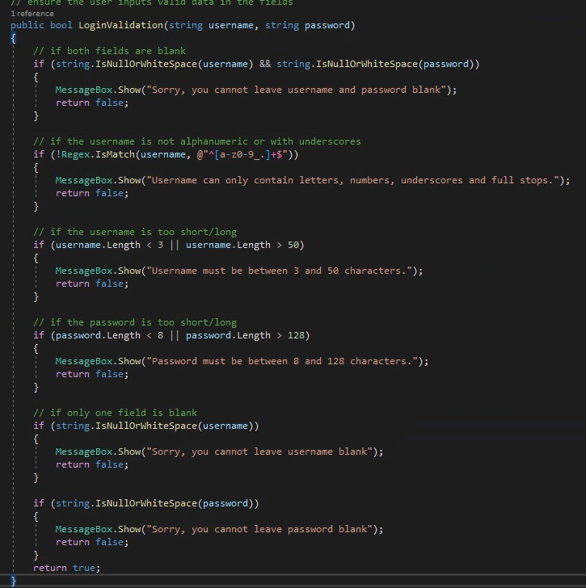
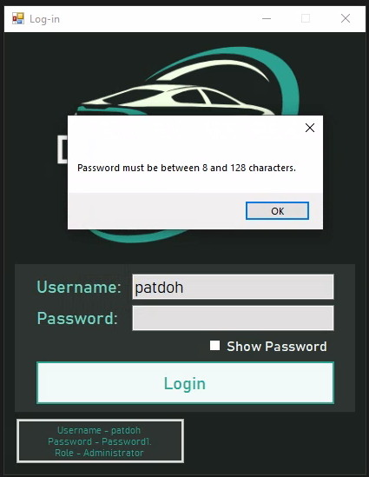
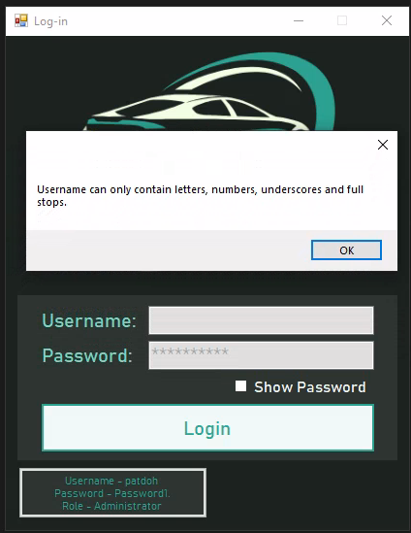
Before:
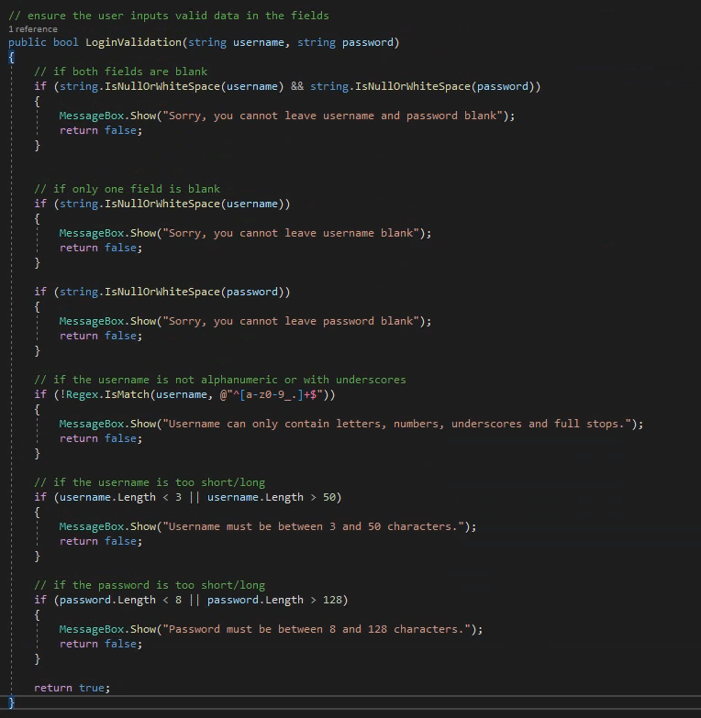
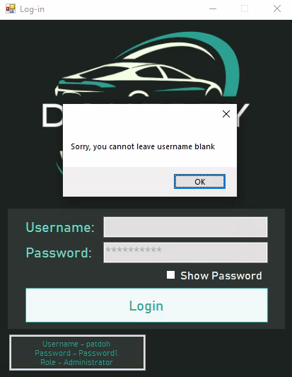
After:

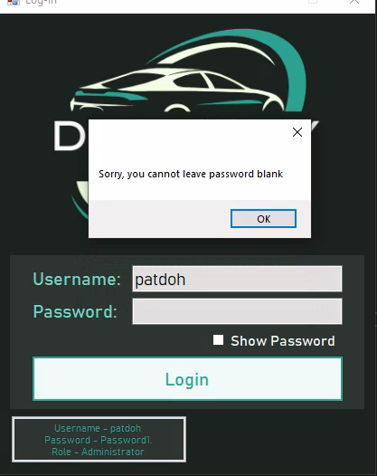

This error was a result of an improper sequence of checks. For the password, the length check initiated before the presence check which - as an empty password has length 0 - triggered the “Password must be between 8 and 128 characters” message before the “Sorry, you cannot leave password blank” message. Similarly, for the username’s regex check, an empty string will always return null, triggering the username’s format check before the presence check, once again displaying an inappropriate error message. The fix for this was to ensure that the presence check was the very first check made when validating input credentials.

1.1.24
Before:
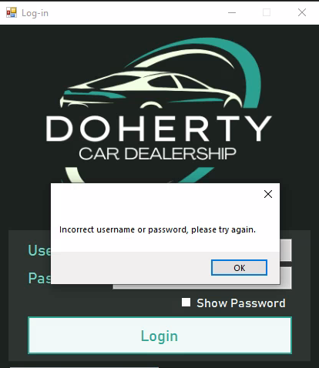
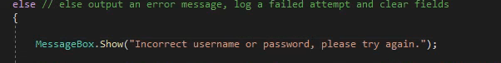
After:
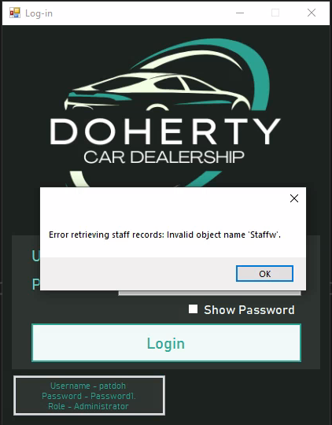

This error was a result of a missing check, causing the program to be unable to differentiate between an empty result because of a lack of matches and an empty result because of a system error. Consequently, even if the program gracefully handled an error, it displayed an inappropriate message. The fix for this was to check if the retrieval method returned the output expected with an error (null) before displaying the incorrect username/password error.

frmStartingMainMenuForm

3.1.2
Before:

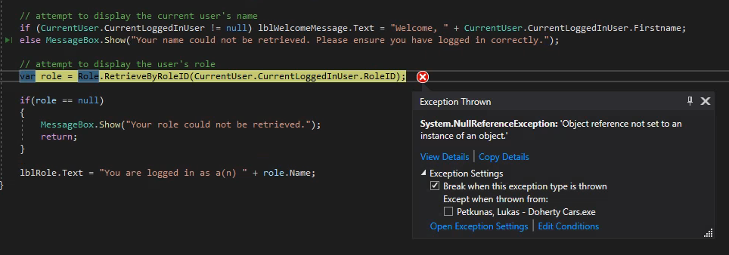
Program crashes
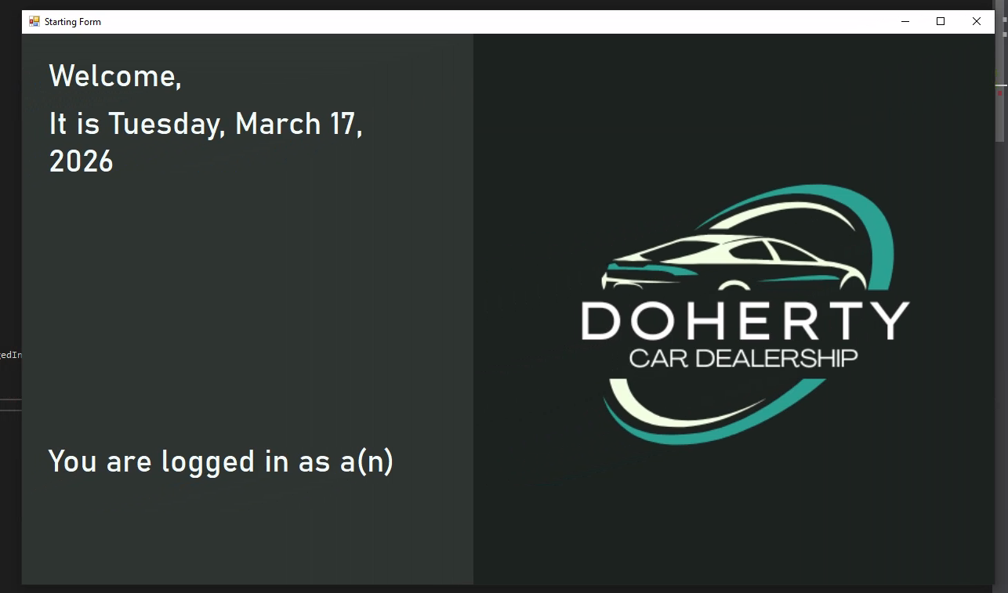
After:

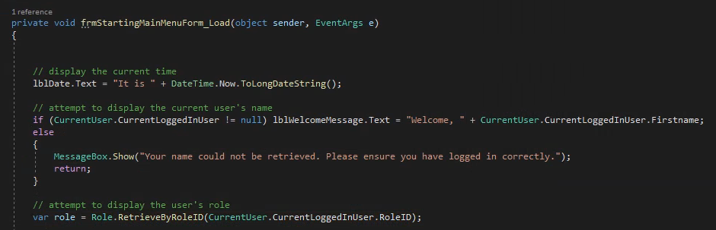

This error was a result of a lack of exiting in the event of a lack of a user object. Even though the check which ensured that a valid CurrentLoggedInUser exists was properly executed, the code still continued to execute and ultimately attempted to retrieve the RoleID property on a null object, throwing a Null Reference Exception. The fix for this was to return out of the method when an invalid setup was detected, preventing further processing.

frmCustomerData

4.1.2
Before:
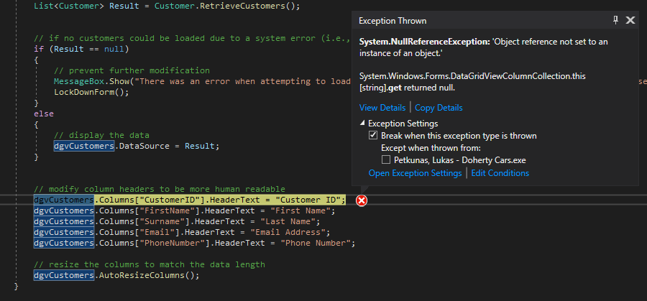
Program crashes
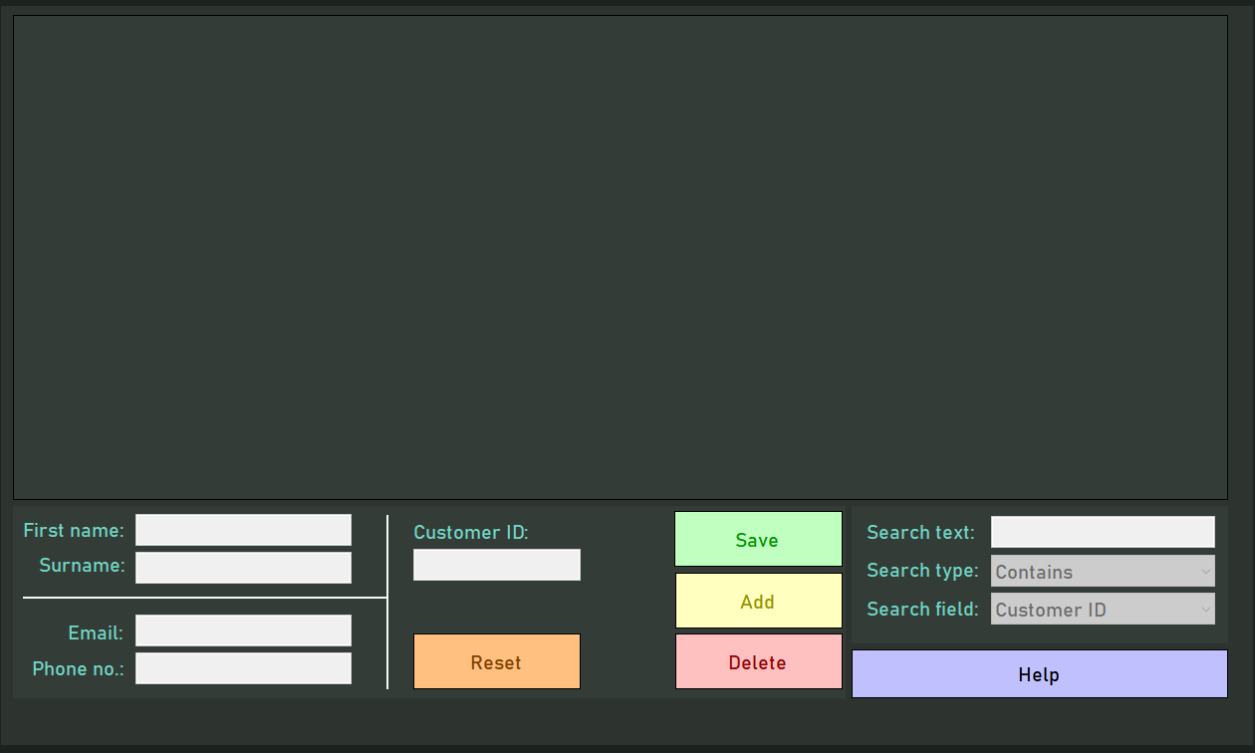
After:

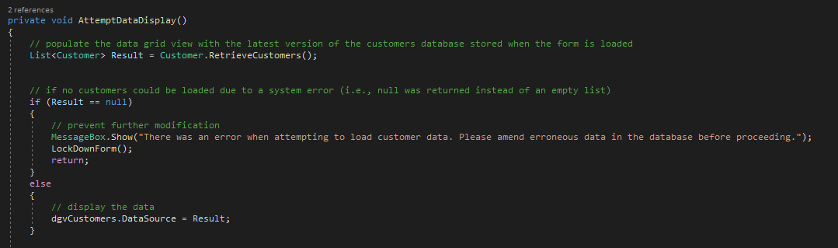

Similarly to 3.1.2, this error was a result of a lack of exiting when no data could be loaded. Even though the program could detect when no data could be retrieved as a result of a system error (denoted by the null check), no return statement was implemented and as a result the program still attempted to change the header text of the now non-existent fields, causing a Null Reference Exception. The fix for this was to implement a return statement when no data could be loaded. Note that most other CRUD forms had the same issue, but this was amended after this specific test case.

frmServiceAppointments

11.2.14
Before:
Program crashes
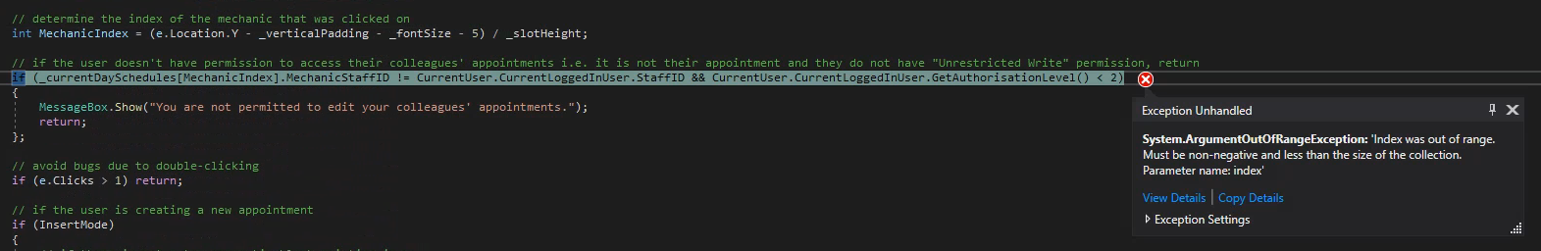

After:
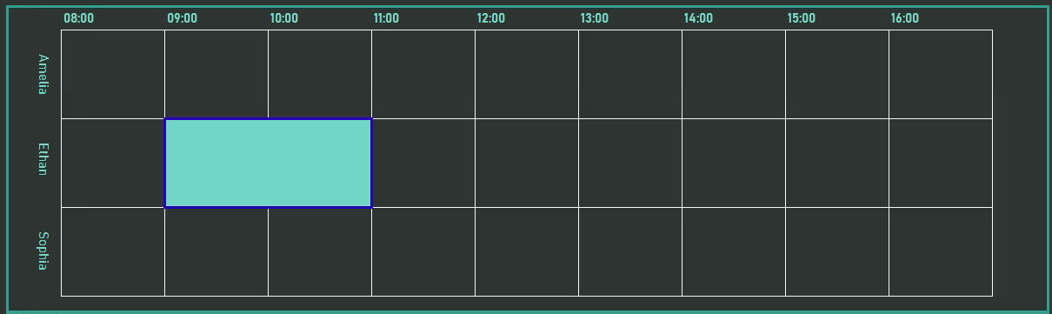
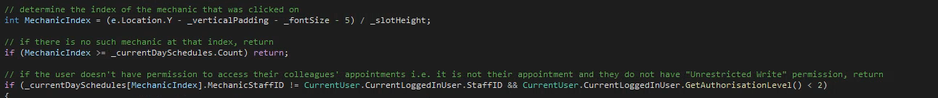

This error was a result of improper validation regarding the calculation of the index which was clicked on in the panel viewer. Technically, the calculation returned the correct value - in this specific test case, the area below the timetable would qualify as the 4th position (index 3) if there was a 4th mechanic, but the lack of a mechanic in this index caused a Null Reference Exception when attempting to access the mechanic schedules using this calculated index. The fix for this was to implement a check which ensures that the calculated index falls within the bounds of the mechanic schedule array.

11.2.21
Before:
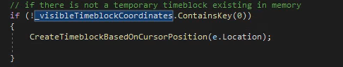


After:
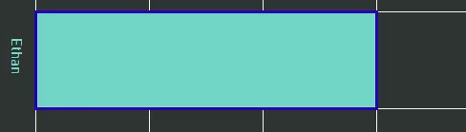
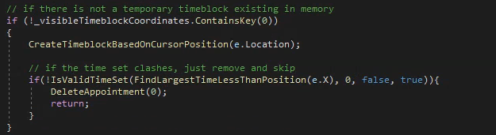

A rather significant issue, this error was a result of lack of validation when attempting to create a new appointment. Even though the creation logic was intact, no checks were made to ensure that the new appointment would not conflict with any others when it was initially created, thus allowing it to intersect with another appointment, preventing further modification as any attempt at movement would cause a validation error, and allowing the user to add an appointment to the database which otherwise contradicts the validation set out in the design of the form. This would have also applied to just clicking on an existing appointment, but was fixed in this test case and as a result didn’t show up later. As a result, a check is now made when the appointment is created to ensure that if it is in a valid position (i.e., if it were moved by 0 pixels would it intersect with another appointment.) If the position is invalid, the new appointment is immediately deleted, thus solving the problem.

Acceptance Testing
In order to ensure that the system is fit for purpose - i.e. it meets the user requirements, is approved for use and is ultimately complete - it is crucial that the end user is involved in the testing process. Thus, staff members from business sectors towards whom the initial requirements were targeted were invited to participate in an anonymous, unguided usage session and questionnaire to effectively evaluate their satisfaction with the final system. In particular, the administrative, technical and customer service business sectors were each invited to participate, and the results from this trial were compiled and analysed.

Questionnaire

To ensure that the system was fit for purpose, the questionnaire was designed with the user requirements in mind as seen on the next page.
Doherty Cars - Questionnaire for new system
Thank you for taking the time to test out the new system. Please take a few minutes to fill out the questionnaire below. If any of the questions are not applicable to you, please leave them unanswered.

- Did you find it was easy to access the system?
☐ Yes ☐ No
- Were you able to use the system for extended periods of time stably, including when logging in and out of the system?
☐ Yes ☐ No
- Were you able to access only sections of the system that were relevant to your job title?
☐ Yes ☐ No
- Did you find that the system prevented you from carrying out actions beyond your level of authorisation?
☐ Yes ☐ No
- Were the records in the database displayed in a clear manner?
☐ Yes ☐ No
- Were you able to create new records easily?
☐ Yes ☐ No
- Were you able to edit records easily?
☐ Yes ☐ No
- Were you able to delete records easily?
☐ Yes ☐ No
- Did you find the system permitted you to carry out actions considered “invalid”?
☐ Yes ☐ No
- Do you believe that the system is secure i.e. unauthorised personnel would find it difficult to access the system, and even harder to affect the data on the system?
☐ Yes ☐ No
- Were you satisfied with the quality of the reports present on the system?
☐ Yes ☐ No
- Did you find the system allowed you to create appointments effectively? ☐ Yes ☐ No
- Did you find the system allowed you to view appointments effectively? ☐ Yes ☐ No
- Did you find the system allowed you to delete appointments effectively? ☐ Yes ☐ No
- Did you find the system allowed you to edit appointments effectively? ☐ Yes ☐ No
- Were you satisfied with the feedback provided by the system in the event of an unsuccessful action?
☐ Yes ☐ No
- Did you find the help forms provided useful?
☐ Yes ☐ No
- Did you find the system visually appealing?
☐ Yes ☐ No
- Did you find the system easy to navigate?
☐ Yes ☐ No
- Was the system responsive (i.e. less than 2 seconds between input and output)?
☐ Yes ☐ No

Responses
The representative group consisted of 1 administrative staff (despite the anonymous nature of the test, it is unfortunate to say that this is guaranteed to be Patrick Doherty), 3 mechanics (technical) and 3 customer service staff. The responses gathered were as follows:

# | Question | A | M1 | M2 | M3 | CS1 | CS2 | CS3 | Total Y | Total N
1 | Easy to access system? | Y | Y | Y | Y | Y | Y | Y | 7 | 0
2 | Use system stably (login/out)? | Y | Y | Y | Y | Y | Y | Y | 7 | 0
3 | Access only relevant sections? | Y | Y | Y | Y | Y | Y | Y | 7 | 0
4 | System prevented unauthorised actions? | Y | Y | Y | Y | Y | Y | Y | 7 | 0
5 | Records displayed clearly? | Y | Y | Y | Y | Y | N | Y | 6 | 1
6 | Create new records easily? | Y | Y | Y | Y | Y | Y | Y | 7 | 0
7 | Edit records easily? | Y | Y | Y | Y | Y | Y | N | 6 | 1
8 | Delete records easily? | N | Y | N | Y | Y | Y | Y | 5 | 2
9 | System permitted invalid actions? | N | N | N | N | N | N | N | 0 | 7
10 | System secure? | Y | Y | Y | Y | Y | Y | Y | 7 | 0
11 | Satisfied with reports? | Y | – | – | – | Y | Y | N | 3 | 1
12 | Create appointments effectively? | Y | Y | Y | Y | – | – | – | 4 | 0
13 | View appointments effectively? | Y | Y | Y | Y | – | – | – | 4 | 0
14 | Delete appointments effectively? | Y | Y | Y | N | – | – | – | 3 | 1
15 | Edit appointments effectively? | Y | Y | Y | Y | – | – | – | 4 | 0
16 | Feedback useful? | Y | Y | Y | Y | Y | Y | Y | 7 | 0
17 | Help forms useful? | Y | Y | Y | Y | Y | N | Y | 6 | 1
18 | System visually appealing? | Y | Y | N | Y | Y | Y | Y | 6 | 1
19 | Easy to navigate? | Y | Y | Y | Y | Y | Y | Y | 7 | 0
20 | System responsive (<2s)? | Y | Y | N | Y | Y | Y | Y | 6 | 1

Analysis
As can be seen from the responses, users are overall satisfied with the quality of the system. Many “No” responses can be attributed to personal preferences. For example, question 8 has received the most negative feedback, and this is most likely due to the restrictions put in place that prevent certain records - such as vehicle types - from being deleted if they are associated with another record - in this case a vehicle. This forces the user to navigate another form to delete or modify the perpetrating child record, ultimately delaying the user for the sake of referential integrity.

Regarding other questions, many received all “Yes” responses (or in the case of question 9, all “No”s) so it may be assumed that those aspects of the system are complete and suitable. It is unknown why the customer service staff member in question 5 responded negatively, as the customer table will display all possible relevant data on the system (perhaps they were expecting additional information such as join date, address etc.) but as the owner is satisfied with viewing data it will be regarded as an anomaly. The same applies to question 7, as customer service members have it rather easy when it comes to the complexity of the data they edit, and the validation system is clear in its feedback.

Question 11’s negative response may have been justified, as although the information provided by the reports should be detailed enough, it could be presented in a clearer and more punctual manner, although this is more so a limitation of the library used than a fault of the system.

Question 14’s negative response is most likely an anomaly, as there is little reason to be unsatisfied with deleting when the system does not implement any restrictions on deleting selected appointments.

Question 17’s negative response may also be justified, as the help forms - though detailed - are rather verbose and could be made more effective through the use of images or more compartmentalised sections.

Questions 18 and 20 can be regarded as anomalies due to the subjective nature of the questions and the overall positive responses received.

Testing conclusion

Considering the rather thorough unit and integration testing phase and the success of the acceptance testing phase, it can be confidently said that no critical action must be taken at this point that would force certain aspects of the system to be redesigned or reimplemented, and the project can safely move onto the evaluation phase.


User guide

Hardware and Software Requirements
Before you attempt to utilise the system, ensure that the following requirements are met on the workstation on which the system will be executed. These are considered the minimum specifications, and as such any problems caused by hardware or software issues cannot be attributed to the program if they occur.

If you are unsure of your system’s specification, please contact the administrator or an IT specialist.

Software requirements:
- Operating system:
  - Windows 10 or later (64-bit)
  - OR Windows Server
- Runtime/framework
  - .NET 8 (Windows Desktop Runtime)
- Dependencies
  - Microsoft SQL Server
  - Visual Studio 2019
  - Relevant NuGet packages (refer to Visual Studio 2019’s documentation)
Hardware requirements:
- Minimum:
  - Dual-core 1.6 GHz CPU
  - 4GB RAM
  - 500MB-2GB free disk space
  - 1366x768 resolution display
  - Stable LAN connection
- Recommended:
  - Intel i5/Ryzen 5 or equivalent
  - 8GB+ RAM
  - 2-5GB free SSD disk space
  - 1920x1080 resolution display

Installation
Before you begin utilising the system, it is crucial that you have the appropriate program files present on your workstation. As a prerequisite, ensure that you have the software system’s project’s files present in a readily accessible folder. If you do not, please consult an IT specialist or administrator regarding access to these files.

Compilation
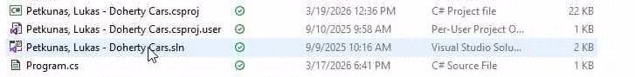
- With the project folder open, find the solution file and open it in Visual Studio 2019. This will open the project and attempt to load all of its files. Before attempting to compile, ensure that all necessary files have been loaded, especially if you rely on a cloud-based storage solution such as OneDrive.
- From here, locate the section in the toolbar with the button labelled “Start.” Beside this should be a list from which you can select compilation methods. For standard usage, select “Release” before proceeding.
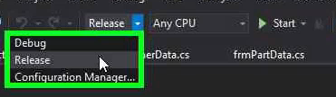

- After selecting the desired compilation method, go to the “Build” section in the header and choose the first option.
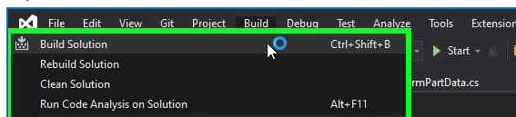
- After this, within the project folder, there will be a “bin” folder. In here, you will be able to enter the folder with the same name as the compilation method you chose (e.g. “Release”) to access the compiled program files. For standard usage, the expected directory is “(project folder)/bin/Release/”

Execution
Within the appropriate folder as described in the “Compilation” section, you will find an executable file with the same name as the project. Double-clicking this will run the system locally.
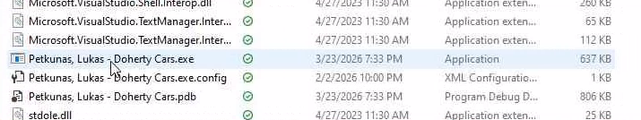

Note that while all the files within the folder are necessary for the program’s execution, the folder need not stay in the same directory. Therefore, once you are finished building, you may move the folder containing the executable to a different location, dispose of the project files and uninstall Visual Studio 2019 if it is unnecessary for you.

If you have any concerns regarding the setup of the program, do not hesitate to contact an administrator or IT specialist.

Operating the system

Logging-in
To log-in, simply input your credentials into the form that initially appears when opening the program, with your username and password in the appropriate fields, and hit “Log-in.” In the event of a successful log-in, you will be redirected to the main menu form. Otherwise, you will be given appropriate feedback. To ensure that you have entered your password correctly, you may avail of the provided “Show Password” checkbox
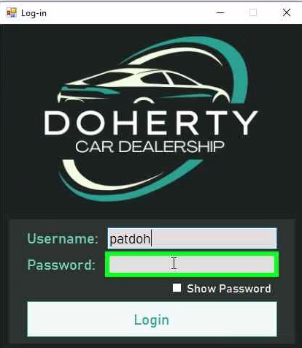
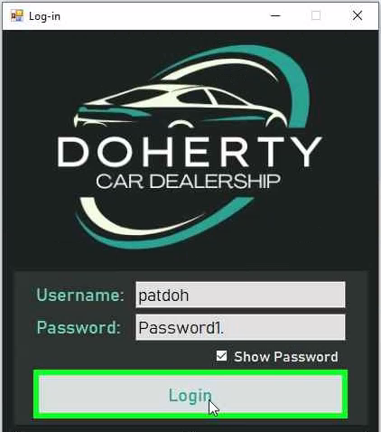
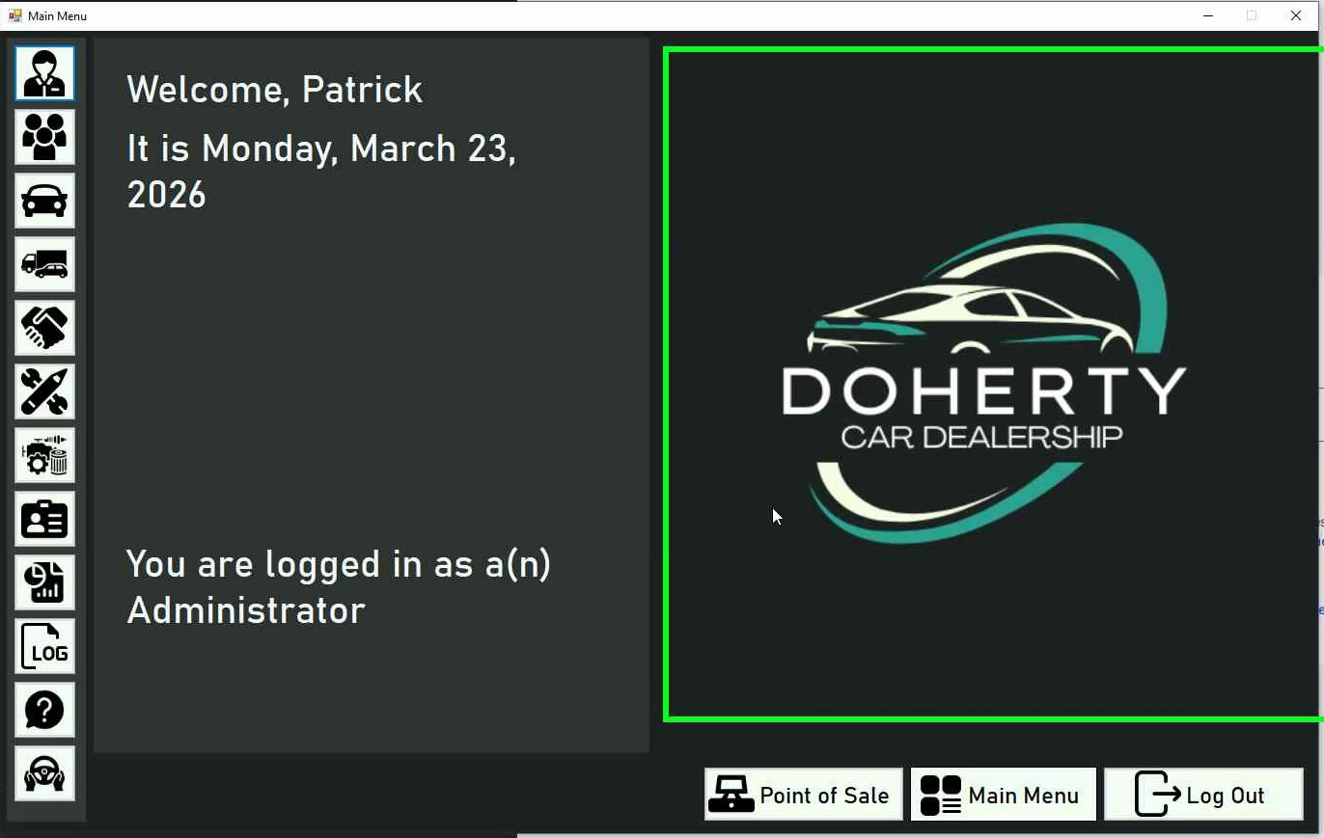
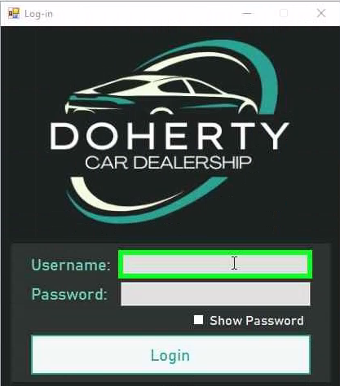

Navigation
Once you have logged in, you will notice unlabelled buttons to the left of the main menu. For more information on them, you may hover over the panel, which will expand the panel and buttons and label the buttons appropriately. If you are not authorised to access a form, the appropriate button will be disabled and made distinctly gray.

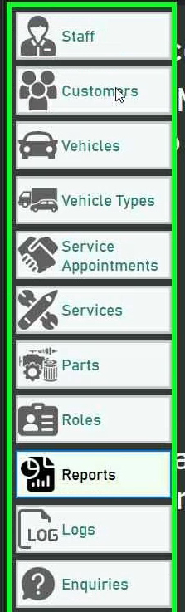
Clicking on any of the buttons will cause their respective form to open in the viewing panel, allowing you to interact with the data stored on the system. If at any point you wish to stop using the system, you may press the “Log Out” button.

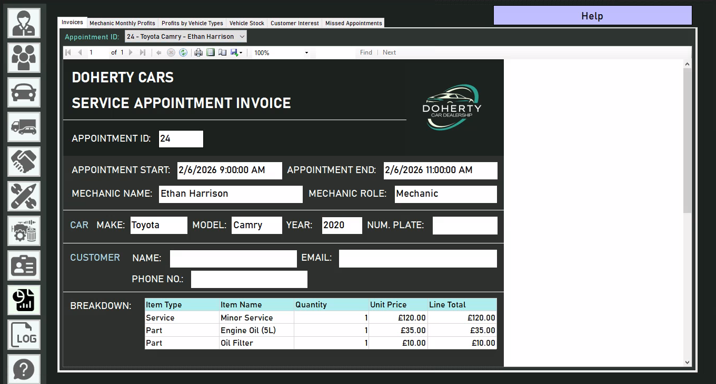

Creating a new user
For the sake of security, no registration form has been provided to prevent unauthorised access to the system. Instead, it is up to administrators (or similarly authorised users) to create user accounts for staff members. First, the administrator must access the system as demonstrated in the previous section.

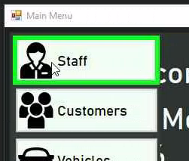
First, access the staff data form.
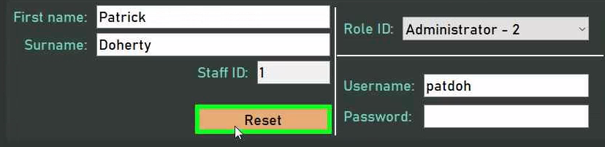
From here, you may find the fields automatically populated. Use the “Reset” button to clear them and make data input easier for you.
Input the new user’s details as appropriate. Make avail of the provided help form if any issues occur during this process. Once you are satisfied with the user details, you may press the “Add” button. This will create a new record with the provided details, and the user will be able to access the system using the credentials you have allocated to them.

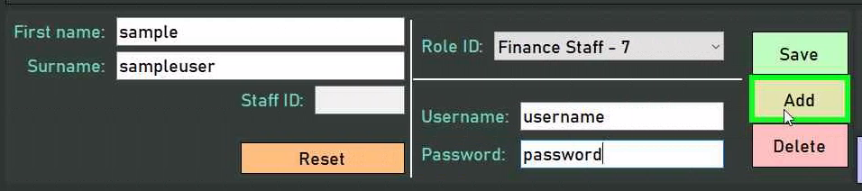

CRUD operations (general)
As 7 of the provided forms use the same general CRUD system (these being the forms for staff, customers, vehicles, vehicle types, parts, services and roles,) much of the behaviour behind these forms carries over and thus each form will not be covered individually. Instead, the most complex of these forms - the vehicles form - will be covered in-depth to allow you to extrapolate the guidance provided onto the other forms.

If you find yourself stuck with any idiosyncrasies of certain forms, do not hesitate to consult the provided help form or - if needs be - an administrator.

Creating
On accessing a form, you may find that details have been automatically populated. To clear the provided fields to prevent you from having to manually delete the populated data, hit the “Reset” button.

From here, you are able to input the desired data for the new record in the provided fields. An attempt has been made to denote the purpose of each field as clearly as possible using a text label to the left of it. Note that every form will have a read-only slot for a record’s ID. When creating a new record, this will be ignored, as the system will automatically handle allocating IDs to new records.

Text fields (such as “Make” and “Model” in this form) can simply be provided by typing in the desired values upon selecting the appropriate TextBox.
Fields that must have restricted values are denoted by ComboBoxes. For fields that simply have a finite number of possible values, these will be determined before the form loads. However, for fields which depend on other tables - in this case, the customers table - all records from those tables will be retrieved, processed and provided as an option in the CheckBox, with pertinent information such as name denoting the record each option in the list represents.
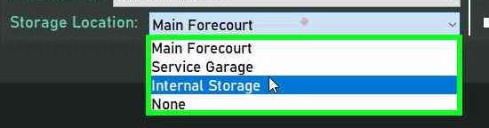
An example of predetermined values
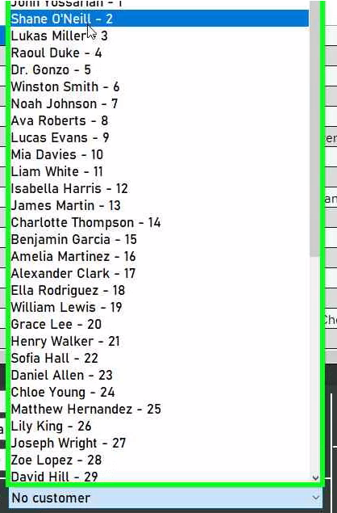
An example of values fetched during runtime

Regardless, to select an option, click on the ComboBox to expand the list, and then click on the desired item in the list.

For numerical data, the NumericUpDown controls provided allow you to either manually go to the number which you desire (using the up and down arrows provided to increase and decrease the value respectively) or simply type in the desired number. Note that they will automatically reject numbers that are either invalid or do not fall within the predetermined ranges.
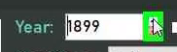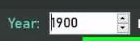
Lastly, for boolean data (that is, anything that is just true or false), CheckBoxes have been provided, which you can tick for “true” and untick for “false.”
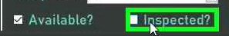

Once you are satisfied with your details, click the “Add” button. This will perform validation on your provided data. If any of the data does not meet the rules enforced by the system, an error message will be displayed and you will be given the chance to amend your provided data. If it is deemed fine, the record will be added to the system, which should be evidenced by its appearance in the table.
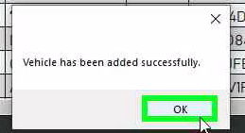
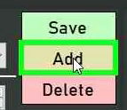

Reading
To select the record which you wish to edit, click on the appropriate row in the table provided. This will select that user for editing or deleting, populating their details into the fields provided.

Note that foreign keys (fields which come from other tables) are identified simply by their ID in the table, but upon selection the appropriate record will be selected in that ID’s ComboBox, allowing you to see which foreign record the selected record is associated with.
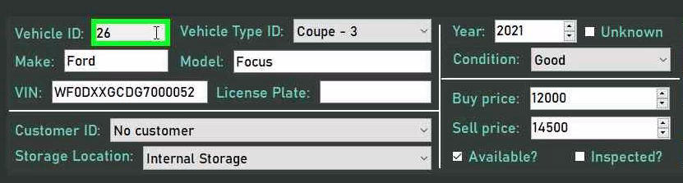

Updating
To update a record, first select the desired record as described in the previous section. Then, with the existing details populated into the appropriate fields, you are able to edit these details (or replace them with entirely new ones) with the same procedure described in the “Creating” section.

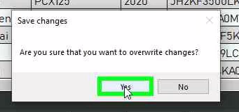
Once you are satisfied with your input details, click on the “Save” button. Your data will be validated, and if it passes the checks carried out by the system then the details input will be stored under the same ID as the selected record, as should be evidenced by the presence of new details in the table.
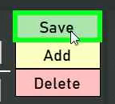

Deleting
To delete a record, simply select it in the table and press the “Delete” button. Note that some forms may have certain rules implemented that could prevent deletion if the record is associated with records in another table, so consult the provided help form to see if these rules apply.
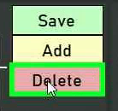
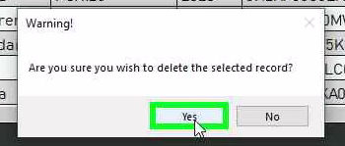

Searching
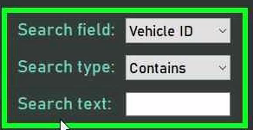
Searching is provided in each CRUD form through the use of 3 controls.
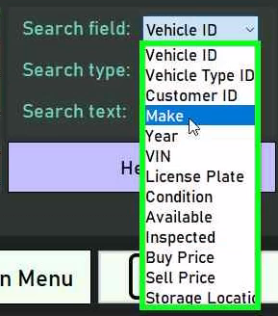
To select the field in the table you wish to search by, select it in the ComboBox.

Similarly, a ComboBox is provided for the type of search, of which there are presently “Contains” - where the provided text can make up part of or the entire field - or “Exact” - where the field must exactly match the provided text.
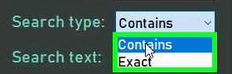
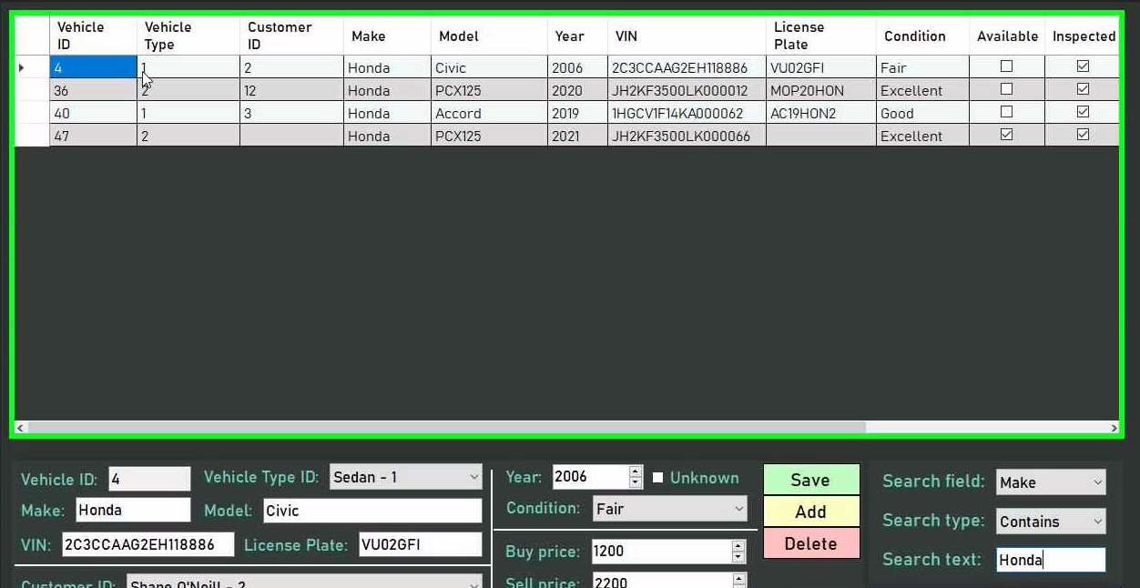
As you type into the search text field, you will find that the table automatically updates to match your query, thus allowing you to filter the database effectively.

CRUD operations (appointments)
Due to the rather distinct nature of the service appointments form, an additional section has been provided to guide mechanics in performing CRUD operations in the form.

Creating
To create a timeblock, you must first activate “Insert Mode.” This will clear any changes you made to the timetable and deselect any appointments, so ensure you are ready to do so.
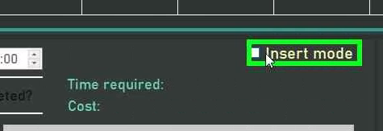

When you have activated “Insert Mode,” click on any free slot on the timetable. Note that you will be able to change the times later, so where you set it initially does not matter, but you must ensure the appointment is provided enough time to fit all of its services. Also note that you are not allowed to create appointments on your colleagues’ slots if you are not a lead mechanic.
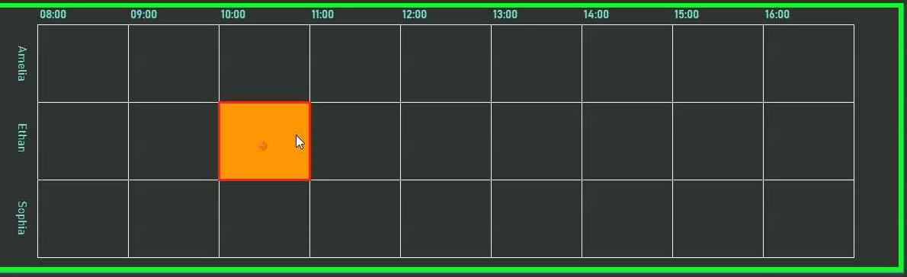

Once you have created the appointment, you may change the start and end times by either dragging and dropping the start or end of the appointment, or by using the provided NumericUpDown controls. Do note that these do not allow you to type times in.
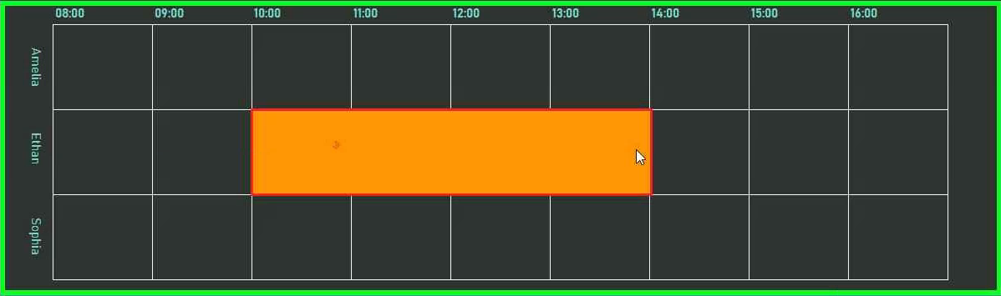
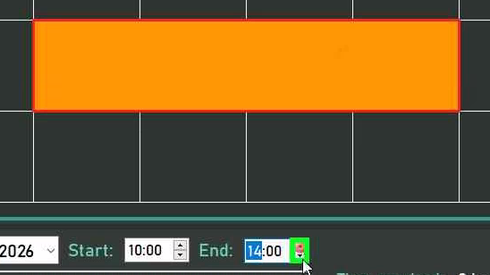

Once you are satisfied with the times, you will find that most of the fields are of a similar nature to the CRUD forms, so special focus will be made on the service and part selection system.

To select a service you wish to add on, simply double-click on it in the provided list. To deselect a service, simply click on it again. The service’s price and time will be added on to the running total, as displayed in the appropriate fields.
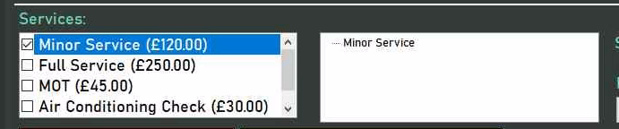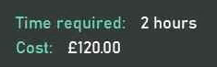

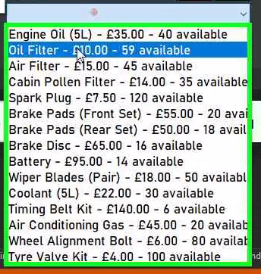
Some services may require parts. For these, select the service you wish to add parts to, and the part you wish to add on, and then click the “Plus” button to add and “Minus” button to subtract parts. Note that checks will be made to ensure that you do not exceed the part quantity stored in the part table, and the parts added on will be subtracted from the parts table upon creating the appointment.
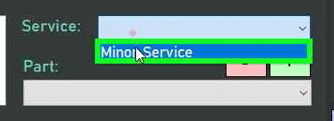
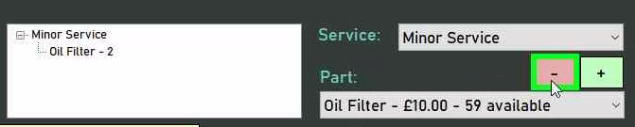
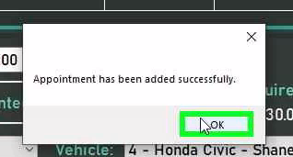
Once you are satisfied with the appointment details, click the “Add” button. If the appointment details are valid, the appointment will be added to the database as indicated by the orange timeblock turning blue.
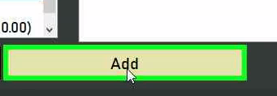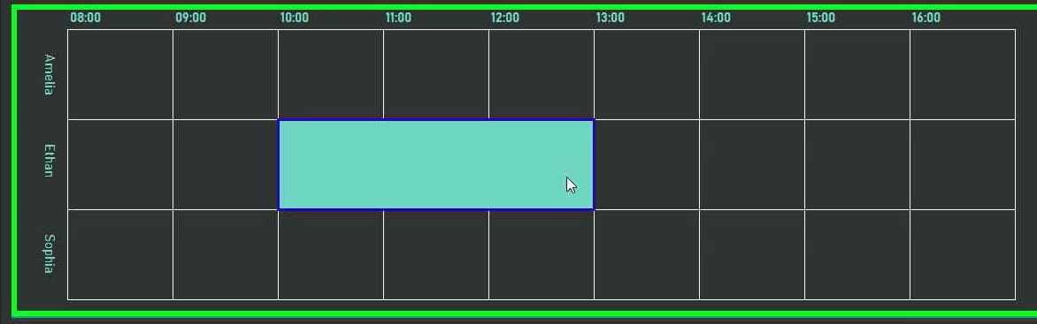
If at any point you wish to stop creating the timeblock, you may either disable “Insert Mode” or press the “Delete” button to delete the orange timeblock.
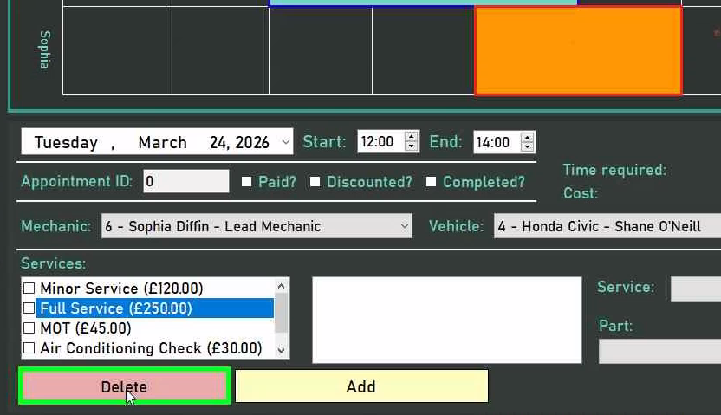

Reading
To access the timetable for a specific day, choose that day in the DateTimePicker provided. Once in the desired timetable, to view the details for a desired appointment, click on its timeblock representation. This will automatically populate its details into the appropriate fields.
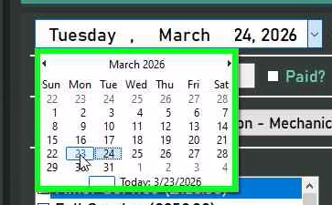
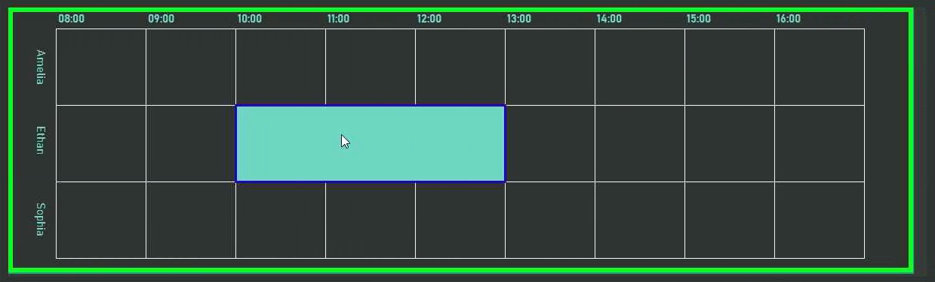
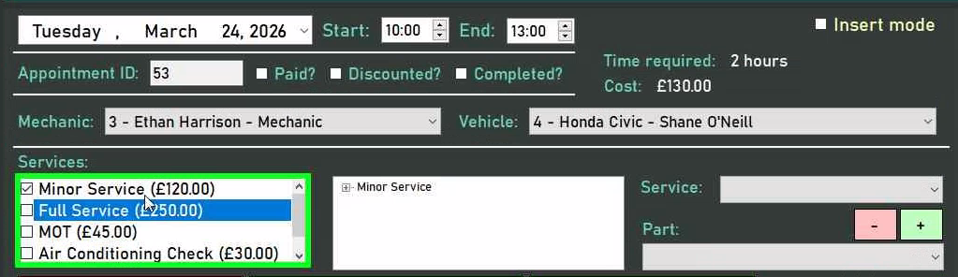

Updating
To update an appointment, select it by clicking on the timeblock representation, then modify the appointment’s details much in the same way as in the “Creating” section. Once you are satisfied with the appointment details, simply click the “Save” button. This will validate your appointment, and if all is deemed correct the new details will be stored in the database.
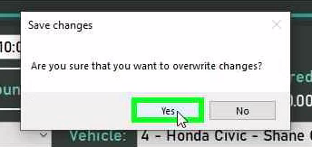
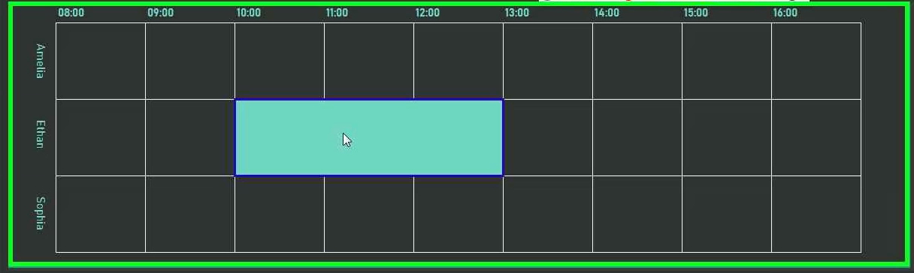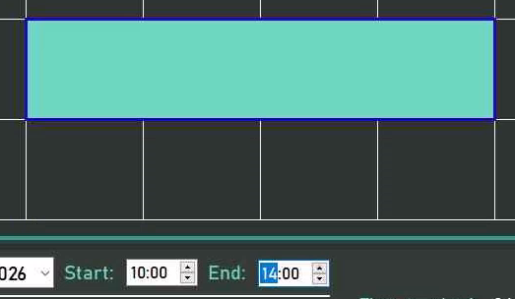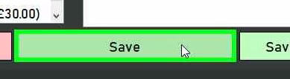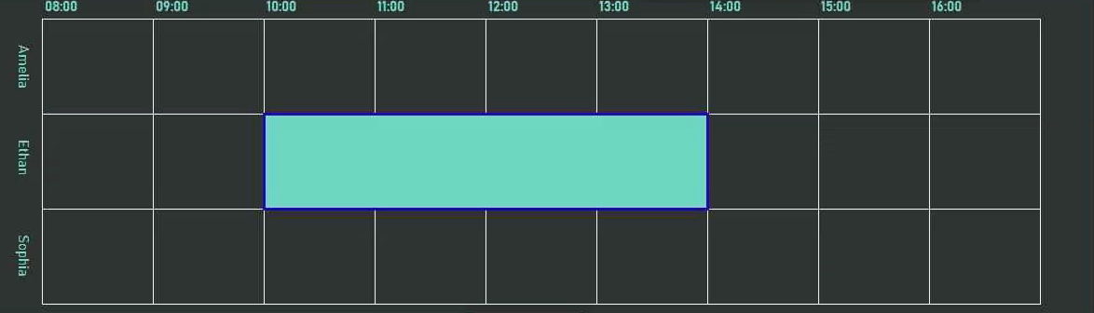

Updating Schedule
Updating a schedule undergoes much the same process as regular updating, except that only times will be saved for multiple appointments. To do this, first manipulate the relevant appointments to have the desired times, and then click the “Save New Schedule” button. If the times are valid, they will be saved to the database. Otherwise, you will be told which appointments need allocated more time.
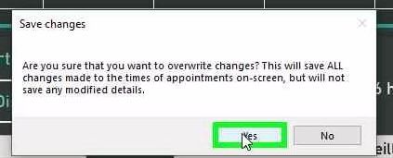
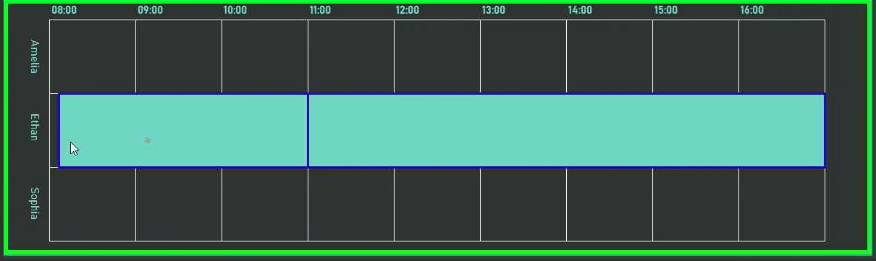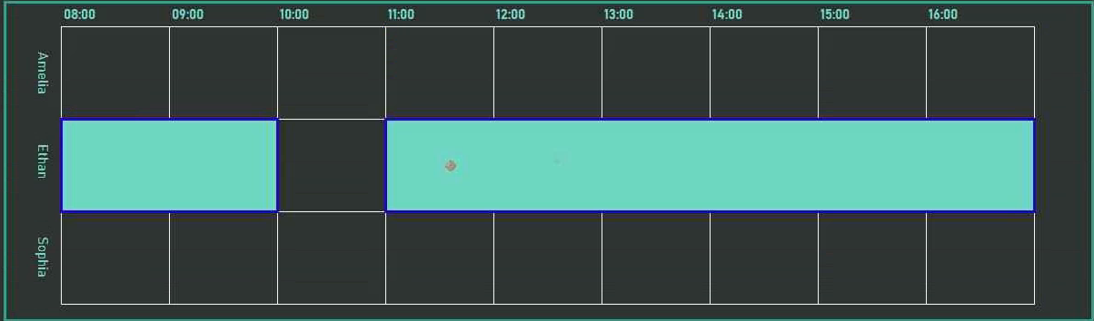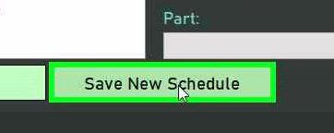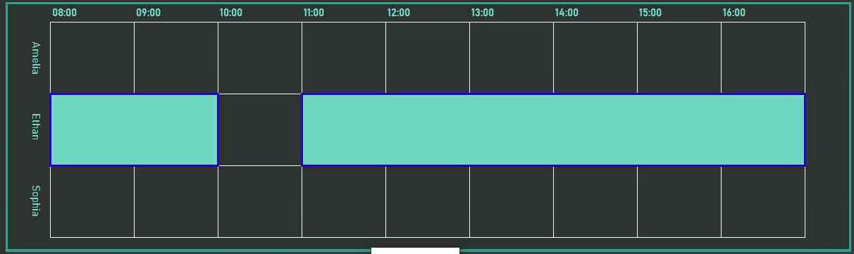

Deleting
To update an appointment, select it by clicking on the timeblock representation, then click the “Delete” button.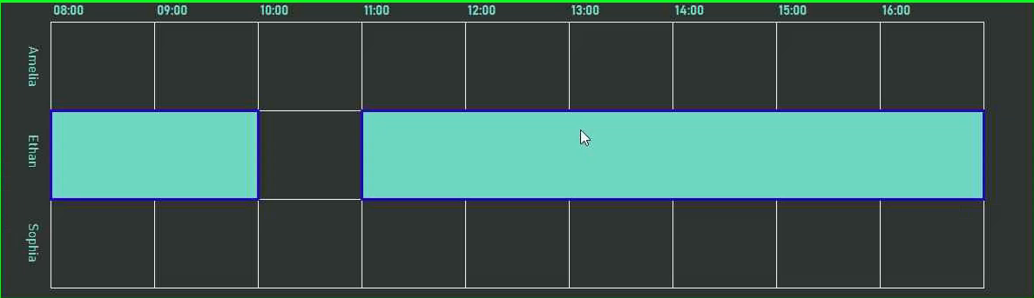

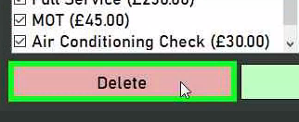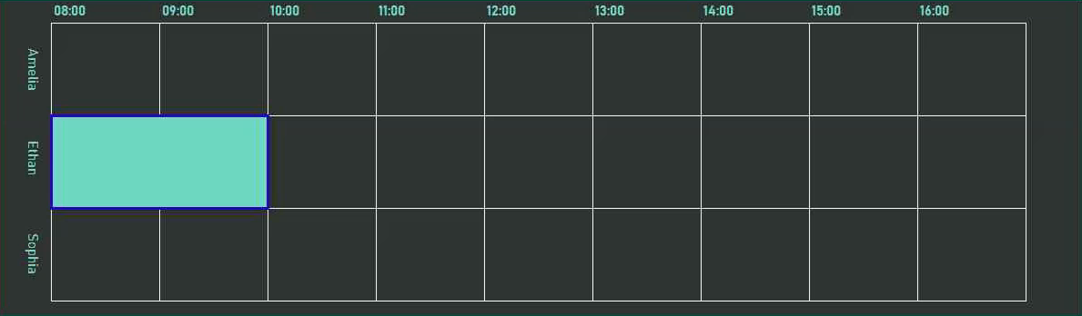

Searching
You may search for specific appointments using the allocated section. Here, 2 ComboBoxes have been provided: one for mechanics, and one for vehicles. If you wish to make a search more specific, you may select one of the available options in the ComboBoxes, otherwise you may leave them in their default state of “None.”
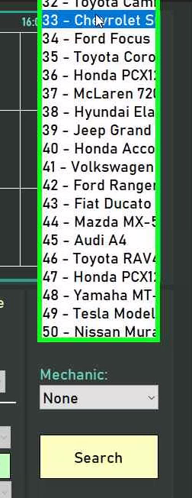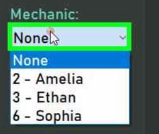
Once you are satisfied with the criteria, you may press the “Search” button to query the database with the provided filter. This will output a MessageBox displaying the details of all the appointments that match your search criteria if any were found.
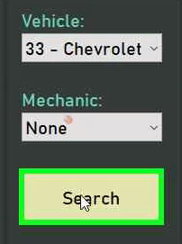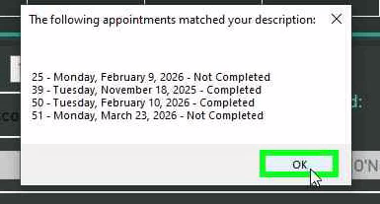

Reports

Changing reports
To change to a different report in the reports menu, simply click the tab with the name of the report you wish to access. This will automatically display the desired report with the most up-to-date information.
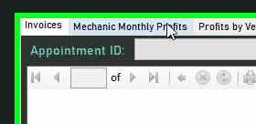
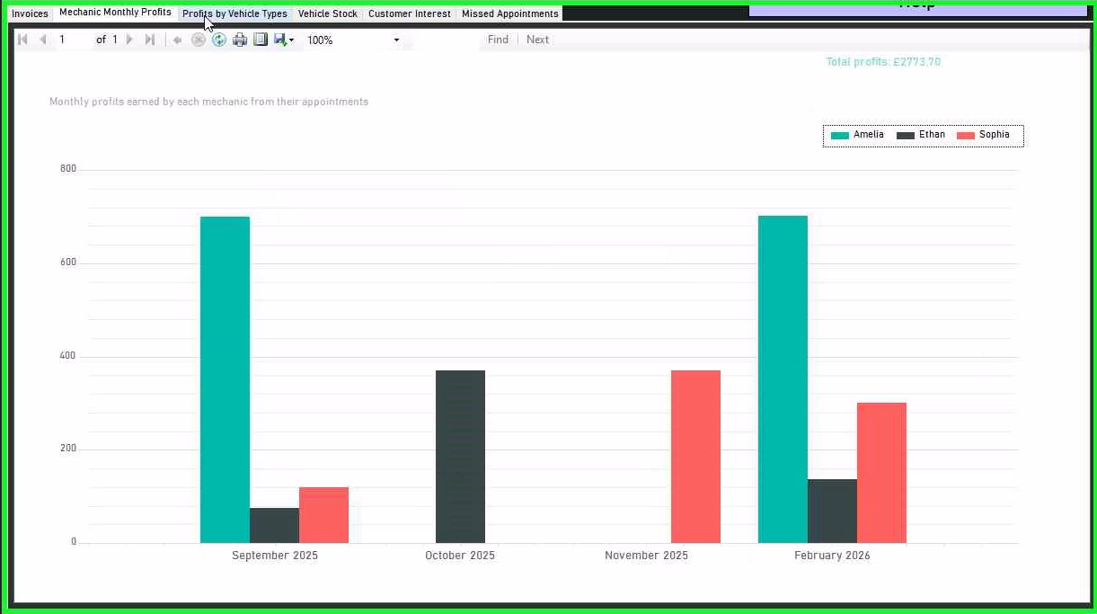

Printing reports
To print a report, click the printer icon seen in the toolbar at the top of the report.
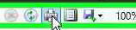

This will open the default system print dialog, from which you can select the printer with which you wish to print the report and any other settings. The specific details of this dialog depend on the system you are using, and thus will not be discussed further.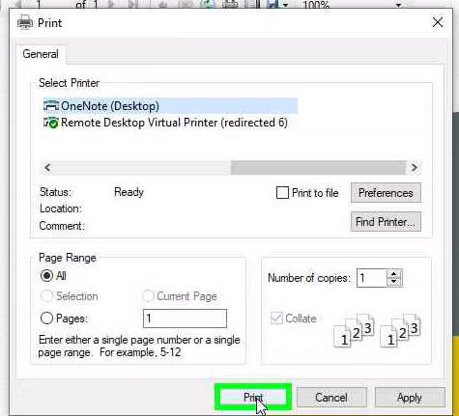

Logs

Filtering
The logs form provides 3 filtering options.

By default, the form displays the logs for the current day, but the log date can be selected using the DateTimePicker.
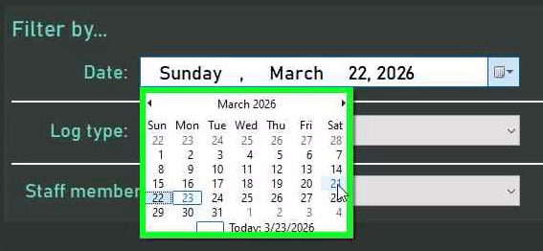
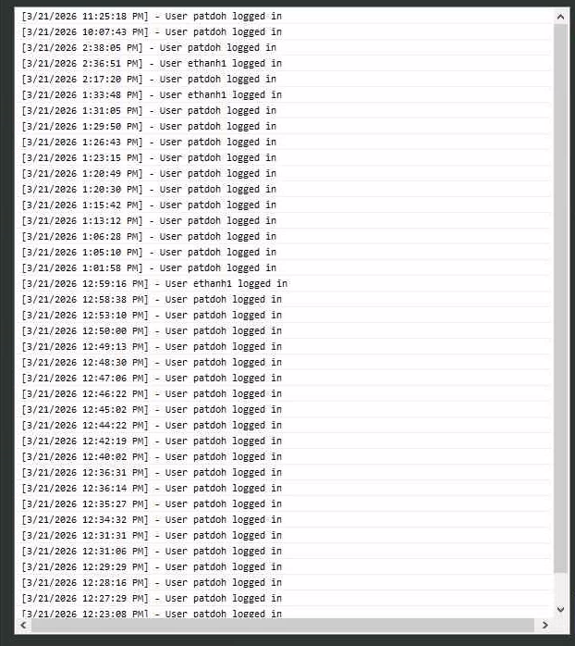
To further filter logs, the user can select the staff member associated with a log or the log type, both accommodated using ComboBoxes. 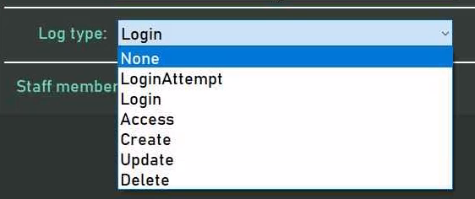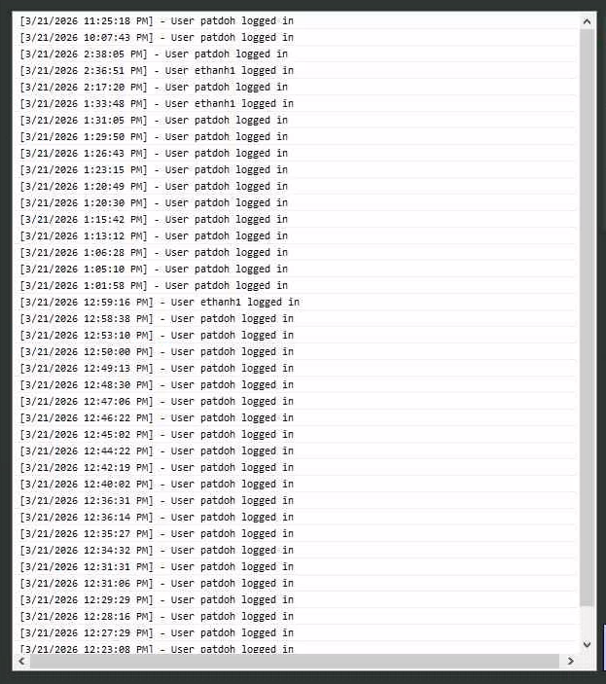
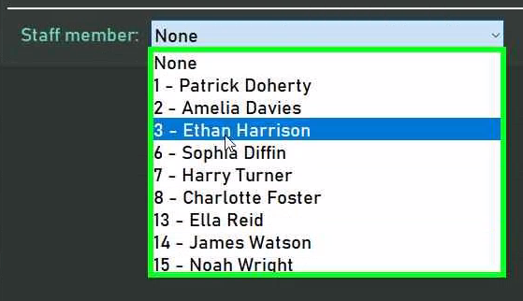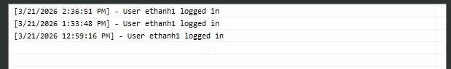

Logs can only be read to ensure integrity and accountability.

FAQ
- What does the password “hash” stored in the staff table mean?
A password hash is a one-way transformation of a password that lets the system verify it without ever storing the actual password, ensuring the security of the system
- What is a vehicle type’s “complexity”?
A vehicle type’s complexity is the scalar factor by which the duration of a service appointment is multiplied when a vehicle of that type is being serviced, aiming to ensure that more complex cars are given ample time to be serviced thoroughly.
- What is a role’s “authorisation level”?
A role’s authorisation level denotes the level of access which a user of that role has in the system. It does not denote which forms they can access - that is the job of the sector - and presently has 3 values: 0, representing read-only, where a user can only read and not modify record; 1, representing restricted write, where a user has permission to make changes to less crucial data on the system, but is restricted from performing more critical tasks; and 2, representing unrestricted write, where the user has unrestricted access to operations on the data present in the database.
- Why has _____ not been implemented yet?
Time.
- What do I do in the event of an error?
A number of help forms have been provided which aim to guide you if the event is a result of any behaviour that is unique to that form. If the help form does not help you, contact the administrator or a member of the IT department.
- How do I add on more mechanics / how do I modify the working hours for mechanics?
It is currently assumed that the number of 3 mechanics will remain the same in the foreseeable future, and likewise for working hours, and as such only editing the source code will allow you to modify the parameters of the appointment viewer. Note that the appointment viewer was designed to be dynamic, and so should respond to such change appropriately, but technical knowhow is still required to make these changes.
- Why are my changes not saving to the database?
Changes may not be saved to a database either because of the use of the “Debug” compilation option, or system error preventing data from being saved. Either way, more thorough investigation on your end will be required.
- What are the log types on the system?
At the moment, to reflect the current operations available to the user on the system, the log types available are unsuccessful login attempts (LoginAttempt), successful logins (Login), accessing forms (Access), creating new data (Create), updating existing data (Update), and deleting existing data (Delete.) These are not final, and may be amended in the future as more functionality is added.

Evaluation

Purpose of evaluation

By comprehensively evaluating my performance and the effectiveness of my decisions throughout the design, development, and testing phases, crucial feedback can be generated which can feed into future development cycles, thus optimising my performance in the future. Furthermore, I can explicitly demonstrate the suitability of the program for Doherty Car’s, thus helping prove I met the requirements set out initially. Additionally, the quality of the final solution can be effectively assessed, highlighting key sections of the system that may require future modification or expansion in future development cycles. This evaluation will aim not only to identify my successes, but also my shortcomings in both my technical capabilities and personal effectiveness.
By critically analysing the design phase, my efficiency in identifying the problems faced by Doherty Cars and the effectiveness of my proposed solutions to each subproblem can be evaluated, allowing for informed determination as to the practicality and effectiveness of my initial approaches. Ultimately, this helps me identify weaknesses in my problem-solving processes. Similarly, determining whether the selected development approach and estimated timescale were effective and accurate allows for an informed determination of changes to planning that may have to be implemented in the future, ensuring I adhere to the most structured and efficient approach possible.
Similarly, evaluating the development process enables the identification of stages where my performance fell short or where user requirements were not fully met. This ensures that future iterations are executed with greater precision, efficiency, and adherence to user requirements.
Lastly, a thorough review of the testing phase ensures that test cases are comprehensive, verifying that all potential execution paths were considered. This mitigates the risk of system crashes and inconsistencies, reinforcing the robustness of the final system. Furthermore, it ensures that my fact-finding techniques were effective in gathering feedback from the end users, preventing me from making invalid or incomplete conclusions in the future.
Ultimately, this iterative evaluation process not only strengthens the integrity of the program but also enhances my ability to deliver high-quality solutions in future projects.

Meeting user requirements

The following table evaluates the extent to which the finished system succeeds in fully meeting the original user requirements produced through analysis of the problems faced by Doherty Cars, thus ensuring that the final product is suitable for their needs and does not deviate from their initial expectations. Screenshots will be provided as evidence for each requirement.

User requirement | Description | Screenshot evidence
1. …implement a login system that authenticates staff members using their username and password, preventing unauthorised system access | This requirement has been fully fulfilled through the implementation of frmLogin, which appears upon the program starting up.  Staff members can only access the system if they input a valid pair of credentials - an existing username and a password that hashes to form the same hash associated with that username - and hit “Login”, otherwise they are left barred from the rest of the system.  This ultimately ensures unauthorised access is prevented, as without knowing a valid set of credentials - and due to the inability to create another on startup - the only way access can be provided is if a user is registered onto the system by an administrator, as discussed in requirement 17. |   Upon starting the program  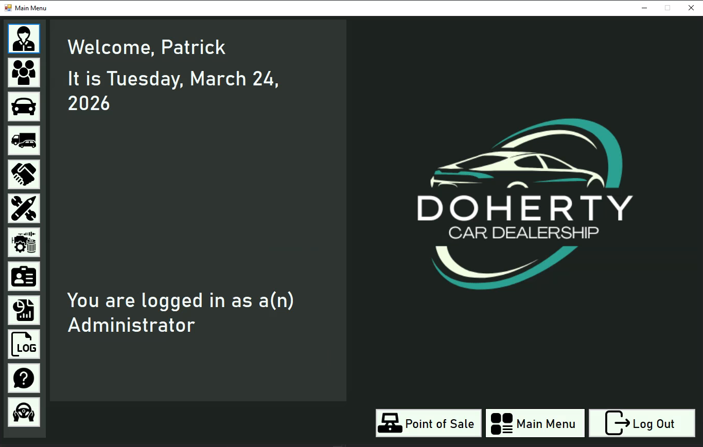  On logging in with valid credentials  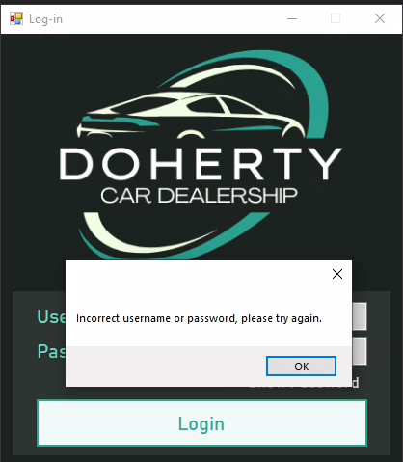  On an invalid login attempt
2. …keep a record of the logged-in user in memory, enabling dynamic modification of the system and its functionality using their information | This requirement has been fully fulfilled through the implementation of the static CurrentUser class, which is used to store the object representation of the staff record containing the credentials that were used to log in.  From here, these details are publicly accessible throughout the entire program.  This is most evident in the frmStartingMainMenu form, where the class is used to display the current user’s name, but it is also the driving force behind the logging, sector and authorisation logic of the program, as the logging functionality constantly retrieves the current user’s username when writing a new log, and the authorisation and sector functionality both require access to the current user’s role ID to determine permissions during runtime. |   The current user’s name and role displayed in frmStartingMainMenu
3. …allow users to log out and log back in with different credentials | This requirement has been fully fulfilled through the provision of a “Log Out” button in frmMainMenu which is constantly visible to any logged-in user. Upon clicking it, the user is redirected back to the login screen, whereupon the details of the previous user are erased from memory to prevent any clashes with the new user about to log in. Thus, the usage of different credentials during the same session has been accommodated for. | 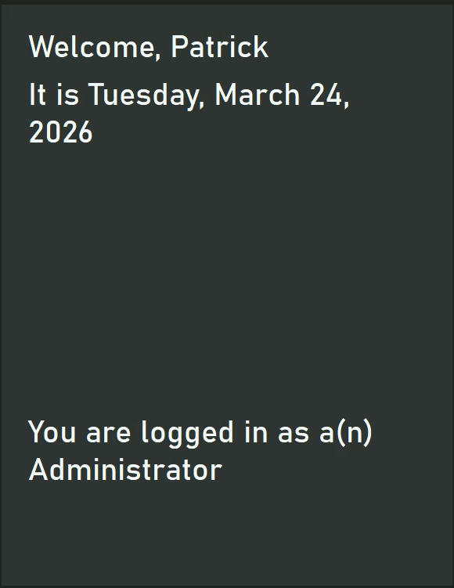  1st login  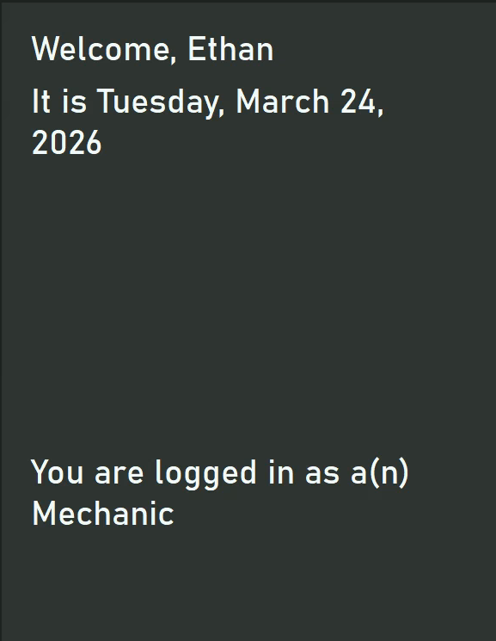  2nd login
4. …assign access to certain forms based on the user’s role, ensuring they only modify data that is relevant to them | This requirement has been fully implemented through the combination of the “Sector” property in the Role class and custom logic in frmMainMenu. On loading the form, the current user’s role is fetched, and using this role their sector is fetched.  By default, all buttons in the form are automatically disabled to prevent unauthorised access, and only through explicit association with a sector in a dictionary is a button re-enabled. These sector-to-button associations were established during the design phase, and ensure that each sector’s accessible data is directly relevant to the operation of that sector. |   The buttons seen in the main menu form, allowing for navigation through the system. Note the grayed out buttons, indicating the current user is not authorised to access them.
5. …allow users to easily access relevant forms through the use of a centralised main menu form | This requirement has been fulfilled through the frmMainMenu form. With the exception of frmLogin, all forms within the system can be loaded into memory through the comprehensive selection of buttons provided.  The form’s centralised nature stems from the fact that these forms are displayed in the viewing panel provided directly within the main menu, with forms being disposed and instantiated dynamically as the user cycles through the buttons.  Consequently, the user never has to leave the form to carry out any actions required, providing ease of use and ensuring that their train of thought is not interrupted when having to change between forms rapidly.
6. …maintain records relevant to the business externally in a database, including tables for:  a. Customers  b. Staff  c. Vehicles  d. Vehicle types  e. Parts  f. Roles  g. Services  h. Service appointments | This requirement has been fully implemented through the use of a comprehensive relational database solution. Each of the entities relevant to the business has its own table (with the exception of service appointments, which has two additional tables to handle parts and services logic) which themselves contain fields representing all the crucial characteristics identified.  The integrity of the data is maintained through the use of constraints applied to certain fields, most notably primary-foreign key relationships in staff, vehicles, and service appointments, and composite keys in all 3 service appointment tables. | 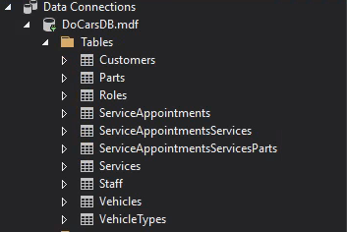  The tables viewed in SQL server
7. …allocate certain permissions - namely read, restricted write and unrestricted write - based on the user’s role’s authorisation level, determining the actions they can take on the system | This requirement has been fully implemented through the use of the authorisation level property within the Role class, with 0 representing read-only, 1 representing restricted write and 2 representing unrestricted write.  Within each CRUD form, a static method is executed during each CRUD action which compares the authorisation level of the current user to the authorisation level required for that action. If the user is below the required level, they are informed of the level they require and are not permitted to execute that action. Otherwise, the form behaves as expected.  Ultimately, this aims to reduce the absence of accountability present in the old systems that were implemented by Doherty Cars, as only trusted users are able to carry out the actions that plagued Mr Doherty in the past. | 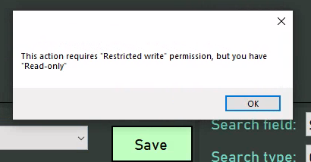  Attempting to save (which requires authorisation level 1 in this form) while the user has authorisation level 0  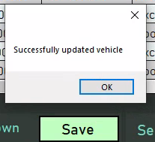  Otherwise
8. …enable users to access pertinent records in the database by providing a form for each table and displaying it in a tabular, interactive format | This requirement has been implemented through the use of the frm_____Data forms (and to an extent, the frmServiceAppointments form with its appointment viewing table) which each contain a DataGridView control.  On the loading of a data form, all the records present on the database in the table which the form is concerned with are fetched and processed to instantiate objects of the representative entity class. This list of objects is then set to be the data source of the DataGridView, which is automatically populated with the fields and records present in the list.  Furthermore, the DataGridView dynamically updates upon the execution of a CRUD action, displaying the most recent version of the data present on the system, and allows for the selection of records by clicking on their respective row, feeding into the “interactive” aspect of the requirement. | 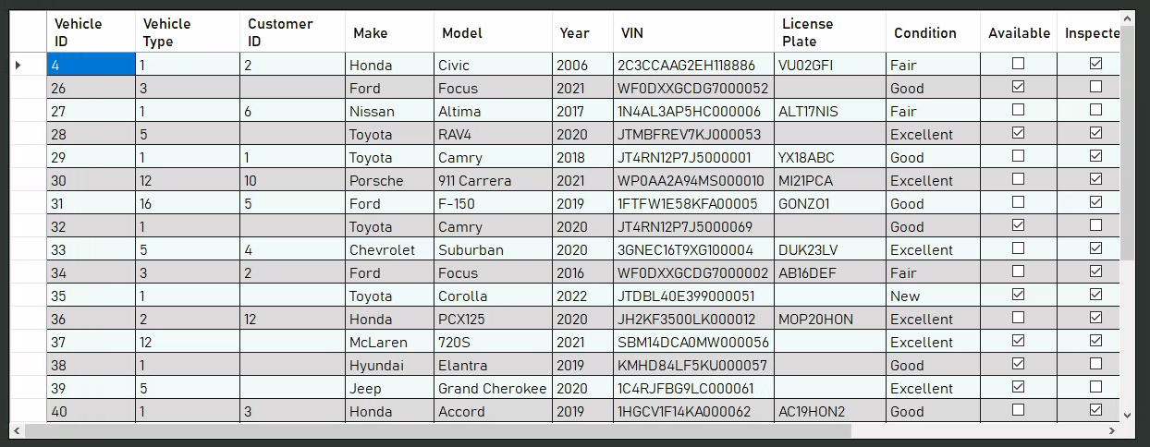  Sample table seen in frmVehicleData. The rest of the frm____Data forms look similar to this.  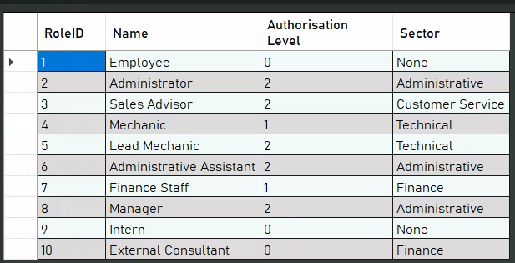  Same for frmRoleData.
9. …validate any data input to the system before making changes to the database to ensure data is consistent, accurate and correct | This requirement has been implemented extensively throughout the program, with each entity class having its own validation method which ensures that the provided fields follow business logic as well as checks in its properties, preventing invalid objects from being created. Furthermore, many user controls have hard-coded limitations (such as NumericUpDown controls not taking values outside of the provided range.) Lastly, a separate “Validation” class has been implemented which holds commonly required validation methods, thus aiding in the validation process. | 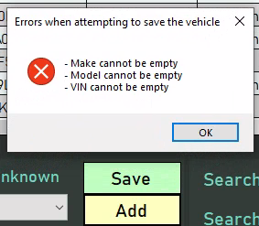  Sample validation error message in frmVehicleData
10. …enable users to create new records in the database by inputting the data into the respective fields provided within the table’s form | This requirement has been implemented through the use of the frm_____Data forms’ and frmServiceAppointments’ “Add” buttons.  Users are permitted to input the details they desire into the fields provided in the form, and - once they are satisfied - are able to press the “Add” button to attempt to add a record to the system. Validation will be carried out initially, but if the data passes this then a new entity object will be created in memory and used to add a new record to the appropriate table. | 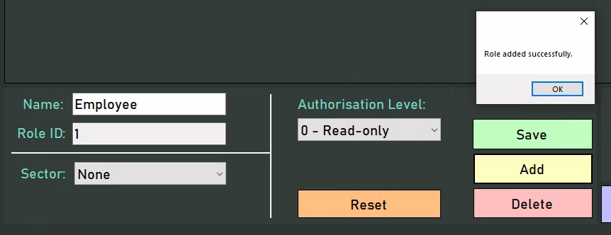  Adding a new record  The new record
11. …allow users to easily select records that they wish to modify or delete, either through the use of controls or mouse interaction | This requirement has been implemented through the use of the frm_____Data forms’ DataGridView and frmServiceAppointments’ appointment viewer.  In the data forms, selecting a record is simply a matter of clicking on the row for that specific record, which will automatically populate that record’s details in the provided fields. In frmServiceAppointments, the user must simply click on the timeblock representing the relevant appointment. In both cases, it is simply a matter of clicking on the desired record. | 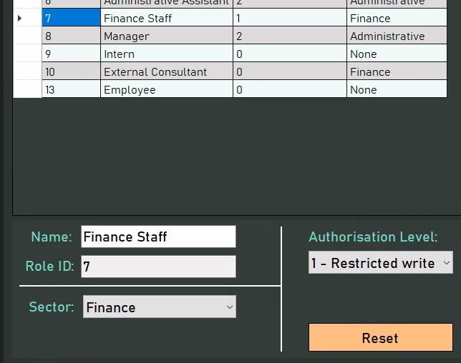  Clicking the record (in blue) has populated its details in the appropriate fields
12. …enable users to update a selected record in the database by making changes to the data automatically populated into the form | This requirement has been implemented through the use of the frm_____Data forms’ and frmServiceAppointments’ “Save” buttons.  Users are permitted to input the details they desire into the fields provided in the form, and - once they are satisfied - are able to press the “Save” button to attempt to save new details to the system. Validation will be carried out initially, but if the data passes this then the details are saved under the same ID as the selected record | 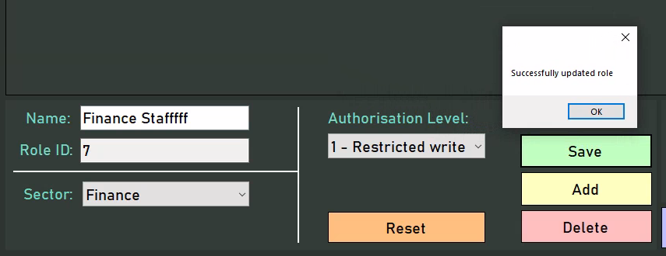  Updating a record  The updated record
13. …allow users to soft delete a selected record, ensuring that it is ignored by the system during data display and processing, but still exists on the database | This requirement has been implemented through the use of the frm_____Data forms’ and frmServiceAppointments’ “Delete” buttons.  Upon selecting a record through the functionality provided in requirement 11, the user is simply able to press the “Delete” button which - if the action is valid - will set the DateDeleted flag for the selected record to the current date, thus ensuring that the data for that record still exists, but has been visibly labelled as redundant to the system. | 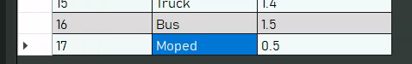  Before clicking delete  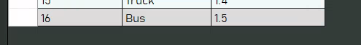  After clicking delete  The record still exists
14. …clear a form’s fields after a CRUD action to accommodate new data entry | This requirement has been implemented through the use of the frm_____Data forms’ “Reset” buttons, and the frm_____Data forms’ and frmServiceAppointments’ LoadFormDefaults() methods.  The user can deliberately clear the fields in a data form by pressing the “Reset” button, additionally unselecting any selected records, which aids in data entry by ensuring there is no conflict with populated data. Similarly, upon creating, updating or deleting a record in either the data or service appointments forms, the fields will be cleared and any records unselected to prevent any issues or conflicts with the previous state of the form when inputting new data. | 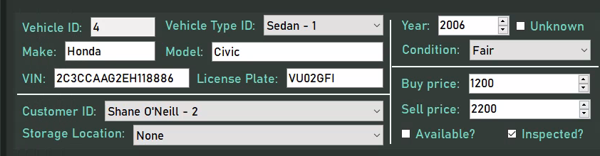  Before updating the vehicle  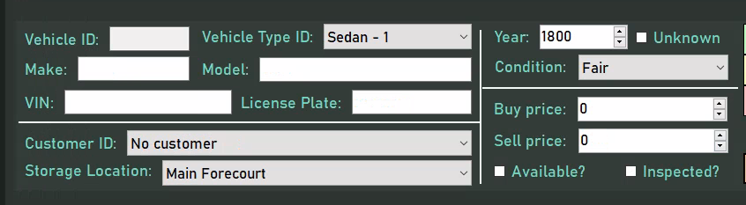  After updating the vehicle
15. …prevent data entry upon a system error, ensuring data cannot become corrupted or lost due to a non-existent or broken database | This requirement has been implemented in virtually every form, as most forms which retrieve data from the database make explicit checks to ensure that valid data - or at the very least, no data for a valid reason - was received, thus preventing crashes as a result of Null Reference or SQL exceptions.  This is most evident in the data forms, where checks are made when loading all records from a table to ensure that no errors occurred. If they did, then the entire form is locked down, with all search and CRUD functionality disabled, ultimately preventing further potential damage to the system through attempting to push new data to an already broken setup. | 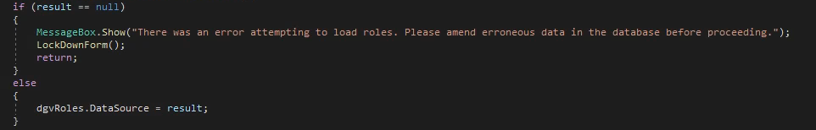  The code checking to see if a valid result was returned
16. …properly handle entity relationships, ensuring referential integrity through foreign keys. In particular, when soft-deleting, the following rules will apply:  a. Deleting a customer will delete any of their vehicles and service appointments related to those vehicles  b. Deleting a vehicle will delete any of its service appointments  c. Deleting a staff member will not be permitted while they have existing service appointments  d. Deleting a vehicle type will not be permitted while its being used by existing vehicles  e. Deleting a part will not be permitted while its being used in an existing service appointment  f. Deleting a role will not be permitted while it applies to existing staff  g. Deleting a service will not be permitted while its being used in an existing service appointment | This requirement has been fulfilled within each relevant entity’s representative class. In the customer and vehicle classes, statements are combined in their respective delete methods which attempt to delete any associated records in other tables as well, thus ensuring that changes cascade through the system and that no references are maintained to non-existent data.  In the rest of the classes, a check is made before attempting to delete a record to see if the relevant record has any associated records in other tables. If it does, an exception is thrown - which is handled by the method - with the error message that such an action would be invalid, and no further action is taken.  Ultimately, referential integrity is adamantly maintained throughout the system to prevent any mishaps due to careless deletion. | 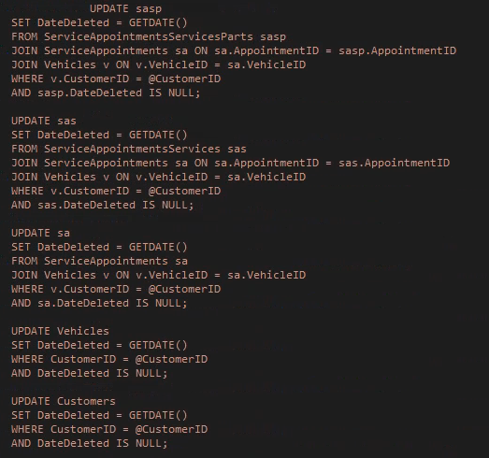  The SQL for deleting a customer. Notice that vehicles, service appointments and satellite data are all processed when a customer is deleted  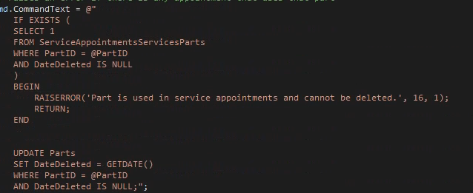  The SQL for deleting a part. Notice that an error is thrown if a part used for an appointment is attempted to be deleted.
17. …ensure that new users added to the system by administrators can log in using the administrators’ determined username and password | This has been implemented through the frmLogin form, Staff table and frmStaffData form. When a new user is added to the system, they are required to be provided a valid username and password, which is then pushed to the system alongside the new record to the Staff table. When the user attempts to login, the Staff table is referenced, thus forming a connection between the CRUD and login behaviour of the system. Important to note is the “administrator” part of the requirement, as sufficiently high authorisation level - and a relatively unrestricted sector - is required before adding new users | 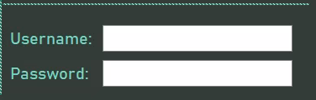  The fields provided
18. …allow mechanics to easily view, modify, create and delete appointments using a drag and drop system, displaying each day’s available and taken timeslots | This requirement has been fully fulfilled through the use of the custom control provided in frmServiceAppointments.  Within it, each day is presented as a timetable, with a row for each mechanic, allowing for easy viewing of the appointments scheduled for each day. From here, appointments can be easily selected by clicking on their representative timeblocks, populating the provided fields with the appointment data.  The user is then permitted to edit the fields as required, and use the “Save” button to save the new appointment details to the database. If they wish to delete the selected appointment instead, they may use the “Delete” button.  Similarly, a user may use the provided timetable in “Insert Mode” and click on an empty space to create a new appointment which can then be populated with details.  The drag-and-drop aspect of the requirement is fulfilled through the control’s ability to dynamically modify times when a timeblock is dragged on, simplifying the appointment modification process by abstracting appointment times.  This all culminates in a suitable solution to the appointment booking problems initially laid out by Doherty Cars, providing a sleek, intuitive solution to an otherwise convoluted scheduling problem. | 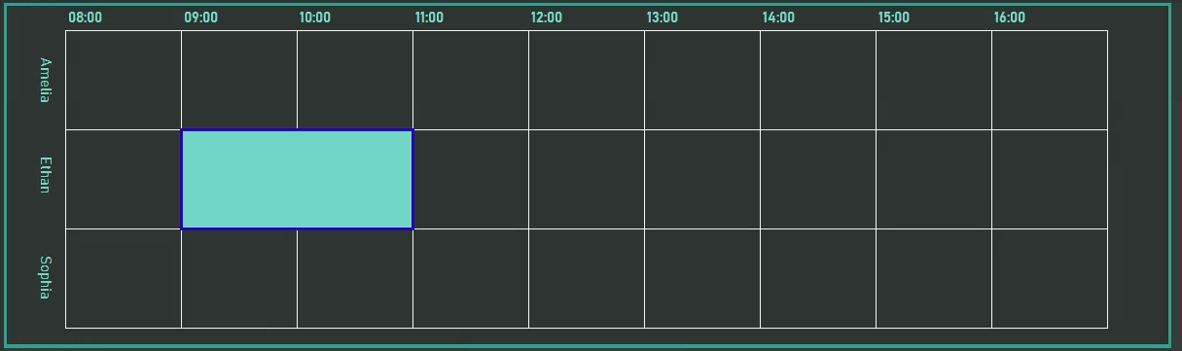  The viewer  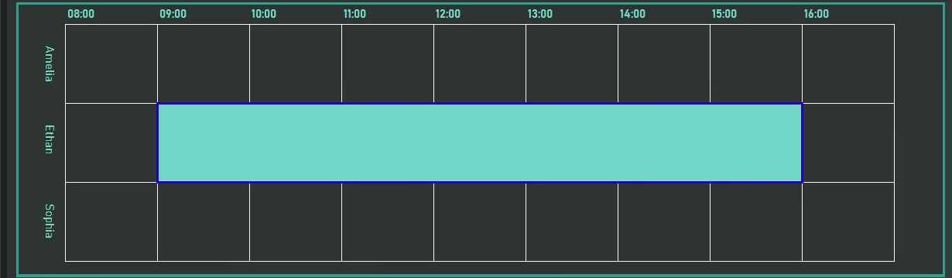  After dragging the appointment  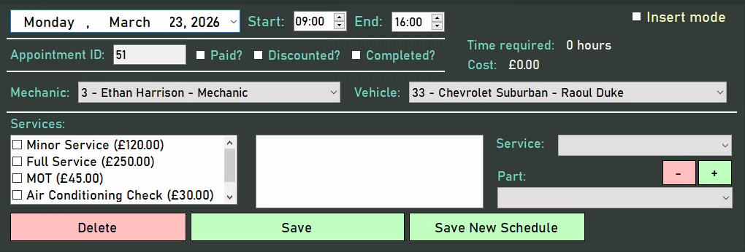  The fields provided
19. …enable mechanics to select the services and parts used for each appointment | This requirement has been fully fulfilled through the CheckedListBox and ComboBox provided in frmServiceAppointments.  Each service present on the system is provided as an option in the CheckedListBox. To add a service on to a selected appointment, the mechanic may double click the desired appointment, and the same applies for removing services.  Once a service has been added, it is added as an option in the ComboBox provided for adding parts, wherein the mechanic can choose a service they wish to add parts to and the part they wish to add, and use the provided “Plus” and “Minus” buttons to change quantities.  When the appointment is saved, these service and service-part relationships are stored in the appropriate tables, helping handle an otherwise complex process. | 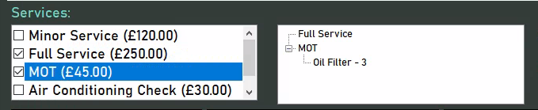  Service selection  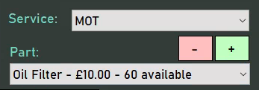  Part selection
20. …ensure that all appointments created are valid i.e. don’t conflict with other appointments, fit within one work day, and don’t occur on a weekend | This requirement has been fully fulfilled through extensive validation in the frmServiceAppointments provided control. Many checks are implemented to ensure that dragging and manually setting times does not allow the user to cause an appointment to overlap with another, cause it to go out of the bounds of the day or cause it to become 0 hours long. Similar checks are implemented when changing the mechanic that an appointment belongs to. Additionally, it is impossible for the user to set the appointment date to be a weekend.  All of these checks culminate into a robust scheduling solution for the mechanics, ensuring none of the confusion of the previous paper-based system remains. | 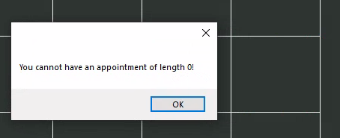  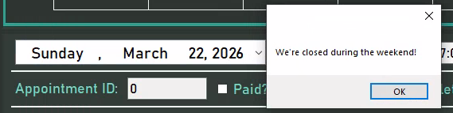  A range of errors
21. …generate reports and invoices using data stored on the database to analyse the business’ performance and assist with customer service | This requirement has been fully fulfilled in the frmReports form, where each report has been provided a separate tab. Each report fetches data from the database and combines and processes it differently, providing unique insights into the business’ operation.  Each report is dynamic, as updating the data on the database and reopening the report in the same session results in an altered report. For the sake of brevity (as the report design has already been specified in the design phase), specific details of reports will be omitted, but many reports are provided for the outlined purposes, with vehicle and appointment profit reports for business performance, and customer vehicle interest and missed appointments for customer service. | All the reports available  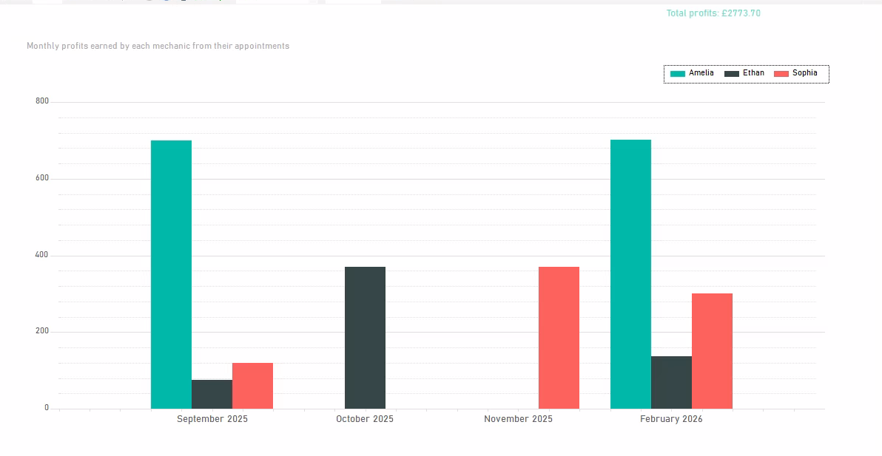  A sample report
22. …automatically determine an appointment’s length and cost based on the services carried out, parts used and the type of vehicle serviced | This requirement has been fully fulfilled through the use of the provided labels in frmServiceAppointments and the reports provided.  In frmServiceAppointments, as a user adds on services and parts, their time and cost are added on in memory and this is then reflected in the provided labels, ensuring that mechanics can stick within a certain time or budget.  Similarly, the reports provided automatically calculate the cost of an appointment using its parts and services, allowing management to effectively determine the productivity of mechanics and the most profitable services.  Ultimately, both implementations of this requirement contribute to the efficient operation of the business. | 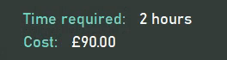  As seen in the service appointments form  As seen in the reports form
23. …capture any error messages resulting from invalid data or system errors and display them to the user so they can respond accordingly | This requirement has been fully fulfilled, with all CRUD forms and the login form all containing validation checks to ensure that the data input follows the rules set beforehand - outputting an appropriate message if not - and try-catch statement outputting exception messages in the event that any action executes unsuccessfully. This allows the user to amend any erroneous data or pinpoint an issue in the system, contributing to the usability of the system. | Sample validation error message in frmVehicleData
24. …provide relevant feedback through confirmation and success messages to provide certainty | This requirement has been fully fulfilled, most evident in CRUD forms where confirmation messages are displayed for update and delete actions, and success messages are displayed for create, update and delete actions, ultimately ensuring that the user is certain that their action was executed successfully and contributing to the ease of use of the system. | 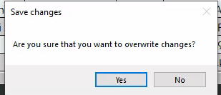  Confirmation message  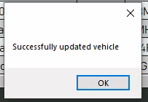  Success message
25. …log user actions externally with timestamps, activity type and user, ensuring that no critical actions can be taken on the system without accountability | This requirement has been fulfilled within each form through the use of a Logging class which provides a method to write logs to an external logs.txt file. Particularly, LoginAttempt and Login logs are captured in frmLogin, Access logs in frmMainMenu, and Create, Update and Delete logs in all data forms and frmServiceAppointments. Each log also contains the timestamp of when it was recorded and the username of the user who carried out the action, preventing actions on the system from being carried out without accountability. | 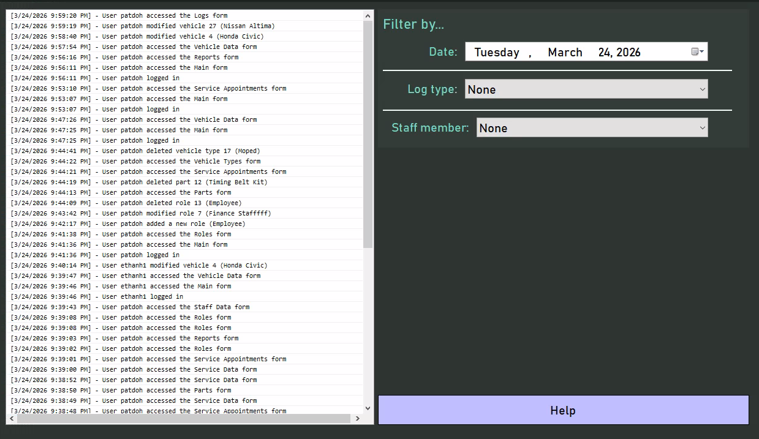  The logs form. Note the list of logs on the left, and the filter options on the right
26. …offer help forms to ensure that new users of the system are able to navigate and make use of it effectively, mitigating any risk of error and thus data loss | This requirement has been fulfilled within each form (except frmLogin, frmMainMenu and frmStartingMainMenuForm) through the use of a dedicated button. Upon clicking the button, a help form appears containing text pertaining to the usage of the form from which it originated, with a focus on the intricacies of the CRUD functionalities in data forms, thus ensuring that anyone unfamiliar with the system can quickly understand how to use the system and any limitations set in place, preventing data loss through invalid CRUD attempts. | 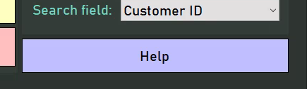  A help button  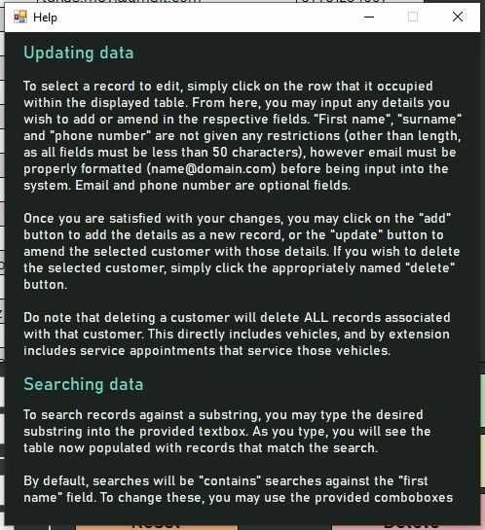  A help form
27. …hash passwords before storing them to ensure the security of the system | This requirement has been fulfilled in frmStaffData, as the plain text passwords provided are run through a hashing algorithm before they are stored in the “Password” field of the database. Consequently, users are able to freely log in, as their password is hashed using the same process and compared to the same hash to authenticate them, but any malicious actors are unable to do anything with the hash, thus ensuring the security of the system. | 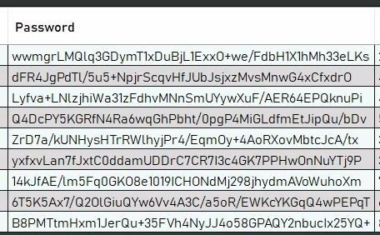  Passwords as stored on the system
28. …implement an intuitive and visually appealing interface to maximise staff efficiency | This requirement has been fulfilled, as clearly labelled fields and buttons are present throughout the system, helping even a technologically illiterate audience navigate the system, and many important functionalities are colour-coded (e.g. red for delete, green for save, yellow for add.) This ultimately contributes to the aesthetic appeal of the program by making it seem less bland and the efficiency aspect of the requirement by ensuring staff members quickly locate their desired functionality.  Furthermore, the presence of the company’s logo in the login form and starting main menu form (as well as the dynamic nature of the starting form) both serve to “bulk out” the program and make it seem more sophisticated. | 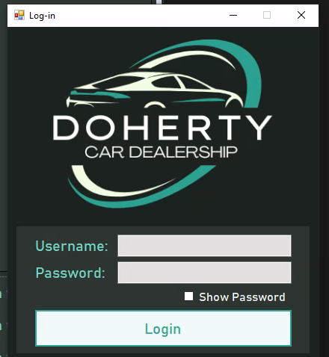  Login form    Starting main menu form
29. …ensure users can easily navigate between their required forms, and that navigation is fluid | The requirement is fulfilled through the use of the expanding panel in frmMainMenu, which uses the sine function to fluidly expand to reveal the purpose of each button, making navigation significantly more pleasant. Furthermore, the purpose of each button is explicitly denoted, making locating the desired form easier and ultimately contributing to the fluid nature of the system’s navigation. | 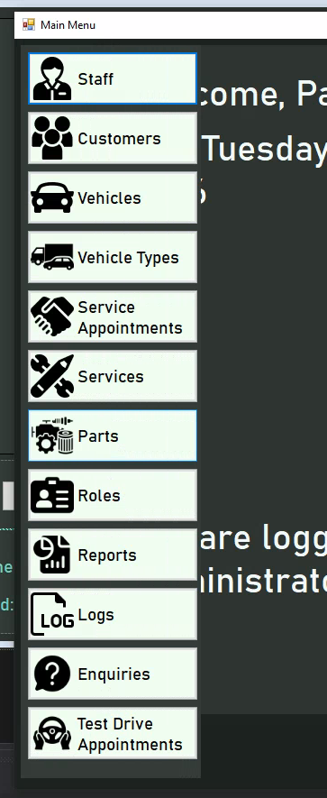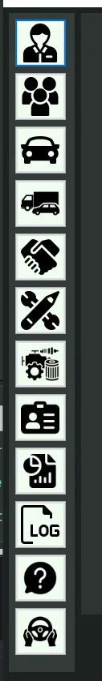  Expanded and unexpanded buttons
30. …implement icons where applicable to graphically denote the purpose of each section and aid in navigation | The requirement is fulfilled through the use of icons in frmMainMenu to represent the function of each button, allowing users to easily locate the button which they require by looking at the abstract representation of each form’s functionality, and consequently making the system easier to navigate and less visually basic. | The icons seen
31. …have designs consistent throughout the program. In particular, all menus will:  follow a similar colour scheme  implement the same fonts and and similar font sizes throughout | This requirement has been fulfilled throughout the program through the use of a consistent teal colour scheme - a colour which is both aesthetically pleasing and calming - with all elements of the system adhering to it, and the use of Bahnschrift (size 11) font throughout most of the program, with both aspects only having slight variations where required for clarity. Ultimately, this serves to create a consistent and easily navigable system for the user, aiding in its use. | 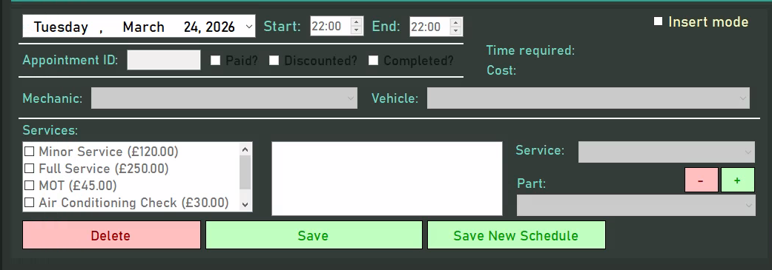  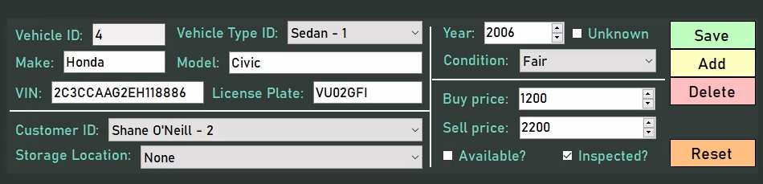  As can be seen, controls are consistently coloured and have identical fonts throughout
32. …respond to user input within acceptable time frames (i.e less than 2 seconds) | This requirement has been fulfilled throughout the program through the use of efficient methods and logic, as only frmReports regularly takes longer than half a second to load fully - most due to the inefficacies of the Microsoft Report Viewer - but still falls under the two second limit, meaning the system is sufficiently fast for a regular user. | No screenshots can be provided for this

Future development

Although it has been evidenced that I met the requirements set out during the project initiation phase - and thus the scope and operation of the program is as anticipated - this is not to say that the project can be considered to be in a fully completed state, with many problem areas initially identified by Doherty Cars still to be addressed. With this in mind, the program was developed to be extensible in the future, particularly with the presence of buttons for features not yet present and the modularity of the appointment viewer. Given more time (and with a potential development cycle in the future) many further issues faced by the business can be mitigated.

One of the most obvious sections of the system that can be properly addressed in future iterations of development is vehicle stock management. Although the present system is satisfactory in storing the details of vehicles as outlined in the problem specification, much of the data regarding the lifecycles of these vehicles relies on manual input and is not sustainable as the number of vehicles in storage increases with the business’ growth. As a result, rather than a tabular form, a more abstract representation of vehicle stock could have been created, with the business able to create visual top-down models of garages and storage spaces within which they are able to identify parking spaces. Each of these parking spaces could have been colour-coded depending on the status of the space or the vehicle on the space, such as “empty,” “checking,” “logging” or “preparing,” consequently allowing staff members to briefly glance at a vehicle and quickly comprehend the stage of its lifecycle it is at. This would also mitigate the issue of sold vehicles (i.e., those no longer in the company’s storage) being displayed alongside unsold vehicles as in the current system.

From here, each vehicle could be edited by clicking on its parking space, and vehicles could be searched by supplying the desired vehicle's details, with the matching vehicle automatically highlighted or - if the vehicle is in a different storage location - that location chosen. Furthermore, supplier information could have been stored in the database in a separate table, allowing for management to easily assess the quality and reliability of cars sourced from certain suppliers. Similarly, important documentation such as warranty and delivery information and supplier invoices can be embedded alongside every vehicle - with viewers for these documents embedded directly into the system - allowing for easy bookkeeping, which prevents the confusion caused by the scattered maintenance of these documents with the current system implemented.

This proposed system would work for both used and new cars - perhaps with identifiers for each such as a different parking space shape - with additional statuses for used cars (e.g. “valuating.”) To address Mr Doherty’s concern with vehicles remaining in storage for longer than commercially viable, prompts could be implemented which force users accessing the system to decide the course of action regarding these vehicles once there is a certain amount of time between the purchase of a vehicle and the current date. This proposed solution would prevent the administrative issues currently involved in vehicle management by Doherty Cars, ultimately contributing to the efficiency of the business’ operations. Furthermore, it would slot into the point of sale system also to be developed, ensuring that sales are only carried out with valid vehicles and at the most appropriate price.

Another section of the system that could be derived from existing implementation is test drive bookings. Much like service appointments, test drive bookings are not allowed to intersect with each other, nor are vehicles allowed to be booked if they are currently under maintenance. As such, the custom appointment viewer control can be modified for test drive appointments, allowing the user to select the vehicle for which they wish to view and edit appointments. Using existing service appointments and test drive bookings, vehicle availability could be determined by finding times in which neither occur for the selected vehicles. The fields provided for this implementation would be similar to those for service appointments, allowing the user to select the customer record, staff record and the validation status for the booking. Dynamic calculation of booking costs can be executed using the duration of the bookings, and bookings can be linked across days to ensure extended bookings - such as those across weekends - are accurately calculated. All of these features would culminate in increased user satisfaction and reduced staff confusion, as validation and cross-table checks would prevent clashes caused by the current paper calendar system.

Lastly, an enquiries system could be implemented, drawing from the existing functionalities of the customer, vehicle and service appointment tables. An “inbox” system could be created, where - upon receiving communications from an existing or potential customer - users would be able to categorise messages by customer or enquiry type. This would allow users to filter by enquiries relevant to their business sector and - once an enquiry has been followed through with a sale or appointment depending on the enquiry type - associate them with records from other tables. Ultimately, by creating a centralised inbox system, the disorganised management system would be alleviated, ensuring that customers are treated to a prompt and professional customer service experience, which would drive sales. To further ensure that enquiries are followed up, a “reply” system could be implemented which ensures that staff members can respond to enquiries from within the system, automatically marking the enquiry as “in progress” or “completed” and thus preventing multiple staff members from responding to the same enquiry, increasing the business’ appearance of professionalism. Similarly, the integration of the enquiries system with the existing customer table would ensure that returning customers are appropriately marked, allowing these valued clients to be treated to appropriate discounts and thus aiding the business’ reputation for reliable customer service.

As evidenced by these proposed solutions, many of the solutions would simply integrate into or be derived from existing functionality in the system, thus ensuring that the issues of the current system are addressed in a uniform and homogenous manner, aiding in the business’ effective operation. Given more time, the current hindering paper-based system could be fully phased out, but at the present only sections of the system most affected by it have been addressed.

Strengths and weaknesses of the system

Feature / Functionality | Strengths | Weaknesses | Potential improvements
Login system | - By accessing user details stored in the database in a reliable and robust manner, it provides a mechanism through which users access the system, allowing them to utilise the specific sections of the program authorised for their sector  - By only allowing users with unique usernames to access the system, it introduces a way to for the logging system to identify the users behind specific actions, accommodating the accountability desired by Mr Doherty  - Implements extensive validation and error-trapping, ensuring that the login processes operate smoothly, and that valid user data is saved | - The passwords in textboxes are stored as plain text in memory  - Users are not given a way to graphically represent themselves, such as through a profile picture  - The password hashing method uses PBKDF2 with a static iteration count of 75623. This is somewhat arbitrary and not updated dynamically, thus leading to potential weakness in regards to brute force attacks | - Use a more computationally expensive hashing protocol, such as Argon2, to prevent brute-force attacks even with specialised equipment such as GPUs  - Store passwords using C#’s built-in SecureString class, ensuring passwords are removed from memory as soon as possible  - Allow users to upload a custom image to represent themselves, serving as an avatar throughout the system
Navigation | - Every button within the system is distinctly labelled, indicating its purpose and thus, in the event of a button that opens another form, its destination. This ensures that users can easily traverse the system, able to trivially find their desired form  - Every form is optimised to ensure that loading occurs promptly upon opening, ensuring the system is pleasant to use by minimising wait times.  - The hover-to-expand logic in the main menu ensures that the users can easily access buttons when they wish to change forms, but that the buttons do not take up unnecessary space in the form when they are not being used, thus providing the user with a minimalistic experience | - The loading of frmReports is often slower than the rest of the forms on the system due to the inefficacies of the ReportViewer package, and as a result the user may be unsatisfied with the response times when attempting to view these reports | - Load logic could be implemented in frmReports which ensures that rather than loading all reports simultaneously, only those that have their tab opened are to have their data fetched and displayed. This would ultimately prevent the unnecessary loading of data not relevant to the current user and optimise the form’s performance
Service appointments | - Exhaustive validation concerning the movement and manipulation of timeblocks ensures that all changes made to the appointments result in a valid state, consequently preventing the confusion and clashes of the previous system in place.  - The drag-and-drop nature of the form ensures that even less technically proficient users are able to make changes to appointment times, as much of the time logic is now abstracted behind the timeblock representations provided  - The modular design of the appointment viewer control - with much of the logic (particularly regarding rendering, business hours and mechanics) depending on constant values that can be changed within the source code to accommodate changes to the circumstances of the business. As a result, minimal time will be spent on maintenance, as changes to the control must be made only in one place. | - Currently, although the timeblocks make it easy to understand the timings of an appointment, they leave a lot to be desired with regards to the details of the appointment such as vehicle, services, completion status etc, requiring these details to be populated into the fields provided before the user can view them.  - Currently, not as much feedback is provided to the user as would be desired. For example, when adding enough services to go over the time allocated to the appointment, the user only becomes aware of this when they attempt to add or save the appointment. Similarly, no visual feedback is provided when a user clicks on an unauthorised timeblock. | - Rather than a constant teal colour scheme, the appointments could be colour-coded to indicate their status. For example, a paid appointment could be golden, completed green, and missed red, allowing the user to quickly gauge which appointments are important  - In a similar vein to the above, appointments could dynamically change colour in response to invalid actions. For example, clicking on a colleagues’ appointment could trigger it to flash red if unauthorised, or an appointment could go through a gradient depending on whether the time allocated to an appointment is comfortable, just on the verge or insufficient.
Logging | - By storing the username associated with an interaction with the system, it is relatively easy to identify who the perpetrating user is when a malicious action is executed  - By storing the time of a log and allowing filtering by date, the precise log can be easily located by reverse engineering the times between which a malicious action occurred and checking between those | - Logs are stored in a plain text file externally to the system, meaning even if the system does not provide the means for editing logs, a sufficiently persistent user could delete logs from the text file and cover up their tracks | - Store logs in an encrypted file, thus ensuring that even if a user opens the log file externally, they are not able to identify the required log and delete it. Their only resort would be to delete all logs on the system, a relatively easy action to trace on a workstation.
Help forms | - Due to the ubiquitous nature of the help forms, it is easy for users to find the information concerning the specific form they require assistance with. This minimises user frustration by ensuring that they are able to quickly learn the intricacies of the system | - Although much comprehensive information is provided concerning the various aspects of the system, the help forms are notably lacking in images. As a result, the help functionality appears rather bland and verbose, making it difficult for the user to effectively find the information they desire | - Images could be embedded for the CRUD form or, for the service appointments form, animated GIFs to show the usage of the system, thus ensuring that users can gain a quick overview of the system rather than having to parse through large chunks of text
Reports | - The invoices report is interactive through the use of a ComboBox of service appointments, simplifying the billing and bookkeeping process by displaying all pertinent details for an appointment in one centralised document  - Most reports provide a graph/chart which allows for a comprehensive overview of the operations of the business, allowing management to easily assess the performance of the business and the profitability of certain executive decisions | - Most reports are rather brief in nature, providing a general overview of the entire operations of the business. | - Provide search criteria for the reports, allowing users to select the specific time periods, records etc. they wish to include in the report, thus allowing for more precise analysis
Database | - Through the extensive use of constraints, the integrity of the data is ensured. For example, foreign key relationships are enforced within most tables provided, ensuring that referential integrity is maintained and that the system does not break when attempting to refer to a non-existent record. Similarly, many of the field length guidelines are hard-coded into the table, ensuring that all data provided is reasonable and appropriate.  - As users are not able to access the CRUD forms - and thus the interface to their related tables - without proper authorisation or sector, the security of the data on the database is maintained, ensuring that malicious or naive actors are not able to view or modify restricted data.  - As the database is in 3NF, data redundancy is minimised, thus reducing the storage space occupied by the database and preventing an invalid setup through the presence of repeating groups, particularly with services and service parts in appointments | - Though measures have been implemented to ensure that unintentional or malicious manipulation of the database is impossible through the provided system, the database is still present locally on the workstation, meaning the records could easily be edited and deleted when opened in an application such as SQL Server  - Similarly, the data on the database is not encrypted. If someone were to open the database externally, all the data would be in plain text, compromising the system’s security  - Some of the fields in the database have predetermined values (such as the “Sector” field in the Roles table,) and these would most likely be better off as foreign keys from a separate table as to ensure that errors when inputting the hard-coded values do not compromise the robustness of the system | - Use a cloud-based service to store the database online, thus not only ensuring that users on a workstation could access the database just through the file, but also that staff members could access the system remotely, aiding in productivity.  - Encrypt the data input into the database using a suitable encryption method such as Argon2 to prevent unauthorised access  - Implement additional tables, such as a new “Sectors” table, to ensure that there is no reliance on strings as keys
CRUD logic | - A plethora of try-catch statements and checks are implemented when interacting with the database to ensure that any system errors are gracefully handled and that the source of any errors is promptly located.  - Extensive validation is provided when attempting to create or update records to ensure it adheres both to the rules set out by the database and the business, ensuring the integrity of the data provided  - Where necessary, custom delete logic has been implemented which ensures that where deletes cascade, the appropriate records are manipulated using the same foreign key, and where they are forbidden, checks are made using the foreign key and errors are thrown in the event of an invalid action  - When reading records from the database, a ComboBox has been provided in each form which allows the user to view information regarding the foreign record(s) associated with the selected record and change the record associated if necessary, thus maintaining referential integrity in a simple, easy-to-use way. | - When reading data from tables which contains foreign keys, the keys are displayed as they are found on the table, making it difficult to visualise the data associated with a particular record  - The search functionality leaves a lot to be desired, with only 2 search modes provided and only search by substring available. | - A custom class implementation for each entity specifically used for displaying in a DataGridView could be created, containing additional fields for information about foreign records not found in the entity’s table, which would then be instantiated when fetching records from a table and would consequently be displayed, helping the user visualise the data associated with each record  - Additional search modes could be introduced, such as “Starts with”, “Ends with” and “Does not contain.” Furthermore, searching by text length could be implemented
Design | - The system is visually consistent; the same font and similar font colours are used throughout, and the same colour scheme of teal, with accent colours of white, is implemented in every form. This ensures that a professional atmosphere is maintained throughout, and that using the system is as pleasant for the user as possible, improving retention | - Little is implemented beyond the essentials for the system to operate, thus making the system seem rather rudimentary and dull | - Tastefully add picture boxes in appropriate places. This can include a picture box for the user’s avatar in the main menu form, a logo in the login and main menu forms, etc.

Design process

During the design process, many of the tasks executed served as crucial to the overall completeness and usability of the system. During the initial client meeting and discussion of problems, the precise and encapsulated selection of issues to address ultimately helped ensure that the scope of the program was kept manageable, preventing me from experiencing burnout from “crunching” to attempt to deliver features too grandiose for the provided time, or from leaving the client unsatisfied through the project not meeting the outlined requirements. From these selected issues, the 32 user requirements generated served to effectively steer the direction of development and ultimately allow me to generate a tentative timeline and scope, which ensured effective communication as to the progress of the project to Doherty Cars. From these issues, a comprehensive list of user requirements was generated, which provided a general notion of what was expected to be delivered.

Though the project management tools were novel to me - particularly the use of PERT charts - they helped me outline the exact tasks required for the project to be fully completed, as well as task dependencies, which assisted in the prioritisation of critical project sections. This helped me ensure that the project adhered to the project timeline, consequently reducing the pressure involved in developing the system by providing a sense of direction. This indirectly helped ensure the quality of the project by allowing me to focus solely on the details of implementation rather than the more general structure of the system. If not for these tools, I do not believe I would have been able to adhere to the time constraints provided by Doherty Cars.

The use of both the initial storyboards and the final, computerised storyboards proved essential in translating the requirements set out by the business into a working system. The hand-drawn sketches allowed for my interpretation of the system to be depicted before attempting to start building the system, and thus our ideas to be consolidated by discussing these sketches, allowing both parties to pinpoint potential challenges or opportunities that might not have been apparent from the outset. Consequently, the storyboarding process facilitated a clearer mutual understanding, reducing the risk of miscommunication and saving time that might otherwise have been spent revising the system due to misunderstandings.

Using the user’s feedback on the initial, hand-drawn sketches, more accurate computerised sketches of the forms were created with the feedback’s criticisms in mind. These were detailed enough to be fit for implementation, identifying the final controls which were to be present in each form, and a general annotation regarding their purpose. This made the start of the building process substantially more convenient, as it was a mere case of translating the design into Windows forms. Furthermore, it made programming the system more tangible, as the general purpose and functionality of each control was already identified, and thus the most optimal way to fit each method together could be created prospectively, reducing the need for retrospective modification of the system. This effect is further emphasised by the validation identified and pseudocode written for each control in each form: not only was a general notion of the form’s functionality fostered, but the fundamental structure of each method was predetermined, allowing for the main concern when building the system to be writing the code, as opposed to developing the solution. Additionally, identifying the structure of the database - including specifics such as constraints and data types - before building the solution ensured that the solution was accurately designed to retrieve and process the data required to effectively manipulate the entities relevant to the business.

One part of the design process, which may be deemed excessive, is the use of UML diagrams such as sequence and activity diagrams, which outline the behaviour and structure of the system in an abstract, top-down manner. Once again, these assisted in translating the design into a working solution, but a significant amount of time was spent constructing diagrams which could have otherwise been spent building the solution. If another methodology such as Agile had been chosen, these may have been crucial in receiving user feedback between iterations, helping guide the direction of the system, but the Waterfall methodology used meant that these diagrams were left ineffective when implementing the system at a low level. Therefore, it has been identified that textual descriptions of the behaviour of the system would have served equally effectively, meaning development time could have been reduced.

Despite this criticism, time management was not a major concern during the design process, especially considering the benefits of executing it; more time was saved programming with a concrete idea in mind rather than blindly throwing code together in an attempt to create a solution than was lost creating the initial design. Therefore, I believe that the design process was ultimately successful.

Implementation process

Given the novelty of the development area when compared to my previous projects, the initial building process may have not occurred as smoothly as I had anticipated, with much of the CRUD functionality’s intricacies having to be identified during development. However, as mentioned in the evaluation of the design process, the sketches produced were easily translatable into Windows forms, helping me focus on grappling with aspects I was less comfortable with. Much of the CRUD functionality was rather simple to implement - most notably the creation and update logic - but the reading logic required for more complex tables (i.e. those with primary-foreign key mechanisms involved) and reports involving joins, as well as the delete logic (preventing invalid deletes or ensuring deletes cascaded) require more extensive planning and implementation due to the less logical and more descriptive nature of SQL. As for the design of the system, the colour scheme and structure of the system were identified preemptively in the design process, meaning little thought had to be put into laying out and appropriately executing the teal colour scheme seen in the final product.

Furthermore, the final quality of my code was acceptable. During the process in which I identified the specific implementation for each aspect of the forms, what would be deemed “spaghetti” code was created in an attempt to design an initial working solution upon which I could build. This may have caused some time loss, as additional time was spent refactoring the code in order to make it more modular, and this could’ve been prevented by reversing my programming process, rather than writing comments to explain code to the user, I should’ve written code to explain comments to the computer, thus ensuring that structure of the solution was identified before programming it. In a similar vein, the names of some variables and the explanations of the purpose of certain lines of code in the solution leave a lot to be desired, and could’ve been improved by planning before developing the solution. An attempt was made to ensure that all methods and public properties were written in PascalCase, and all private properties in _camelCase, but there may be sections of the program where this convention was abandoned when focusing on the implementation of the system.

However, I am satisfied with the robustness of the code; various try-catch and if statements are included throughout the program - even where they may be deemed edge cases - to ensure that the program does not crash as a result of an invalid operation. Consequently, users may feel comfortable using the system with the knowledge that their actions are unlikely to cause any unintended interruptions, especially to the database system. Furthermore, the modular, encapsulated nature of the code - with each form calling the CRUD and validation logic of the representative entity classes - ensures that maintenance is easy, as any desired changes must be made only in one place to be put in action throughout the form, and test cases are easily identified, as test data can be developed with one specific aspect of implementation in mind. Additionally, the code was separated into regions, helping with the readability and navigation of large files.
Once again, the novel nature of SQL to me may have slightly stalled me during the implementation process, but I am ultimately satisfied with the reliability and robustness of the queries produced, particularly in the effective handling of database errors, ensuring that the system does not crash as a result of an invalid operation. However, one aspect notably missing from the final implementation is the use of transactions when executing multiple statements at once - for example, in the saving and adding of new service appointments. Though preliminary checks ensure the database is operational before the CRUD form for service appointments is ever loaded, errors can still occur during runtime and - if occurring during these SQL statements - may result in partially complete records in the database, reducing the integrity of the data. However, this will have to be fixed in the next development iteration.

One notable absence in my solution is the absence of any images, islands or additional “decorative” functionality throughout the program, which may cause the program to appear bland and uninteresting. However, I believe that the business-oriented purpose of the program does not call for this, and this criticism may be overlooked considering the program operates efficiently and effectively.
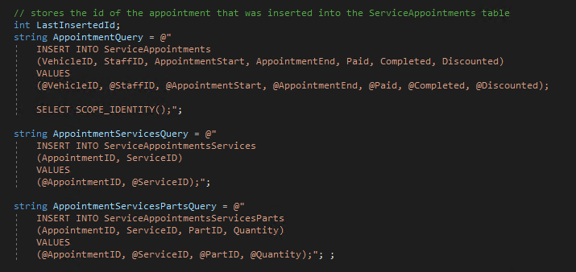
An example of a method that would require transactions. Each statement is executed sequentially, so if one does not execute correctly then the data from the previous statements will still remain.

Evaluation of chosen methodology

As outlined in the planning stage, the Waterfall model was followed throughout development. Though seen as rudimentary in the professional development world, this sequential and structured approach offered by it proved it well-suited to the project’s constraints when compared to other methodologies, ensuring that time was managed effectively and that scope was controlled to prevent excessive workload or delays.

A key advantage of the Waterfall model is its linear progression: upon completing a section of the project, there was no need to return to it, allowing full focus on a single task. This contrasts with RAD (specifically with iterative prototyping), where multiple sections of the system can be developed, tested and evaluated simultaneously to provide feedback. While this may have helped with defining user requirements if they were changing, it would have greatly increased complexity due to the need to schedule client meetings, plan the next course of action and accommodate any changes to the project plan. Specifically, the final nature of the “requirements” phase in Waterfall prevented this - once the requirements were initially declared, they were fixed for the project’s duration, ensuring that scope creep was avoided and that the requirements to be implemented were reasonable for the provided time and resources.

Another benefit to the Waterfall model was its approach to implementation: while the system’s development was split into phases (as evident on the Gantt chart provided), once one of these batches was completed, there was no need to return to it, leaving a working subset of the system that could be integrated with future batches. This contrasts starkly with Agile (specifically its subsets of XP, DSDM and Scrum) where the focus is on features as opposed to sections of the system, taking a more quantity-over-quality approach. Although a functional system covering all bases could have been developed early on, there would have been a requirement to constantly return to parts of the system already partially developed - which would have required more documentation to ensure that the progress and objectives in each part were clear - and ensure that any additional functionality did not cause any conflicts with the systems already in place. All of this would have culminated in a hindrance in an already sufficiently complex project.

However, one thing that I found to be unsatisfactory regarding the Waterfall model was its approach to testing. Unlike RAD and Agile, where testing is carried out throughout the program’s development, Waterfall executes all of its testing on the supposedly completed system at the end. Consequently, if any severe problems - particularly structural - were to be found at the end of the development lifecycle, this would have required a complete redesign and rework, causing a significant delay in the project’s timescale. Luckily, this did not occur, but must be kept in mind in future projects.

Comparison between final design and final system

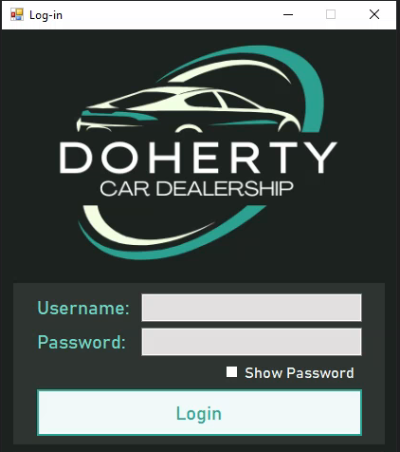
As evidenced by the screenshots below, the final system only minorly deviated from the final designs produced during the design phase of the project, highlighting their success in driving the development of the project and their effectiveness in providing a base from which the developer can work off of. Where forms deviated, it is only in minor features such as button placement or text.

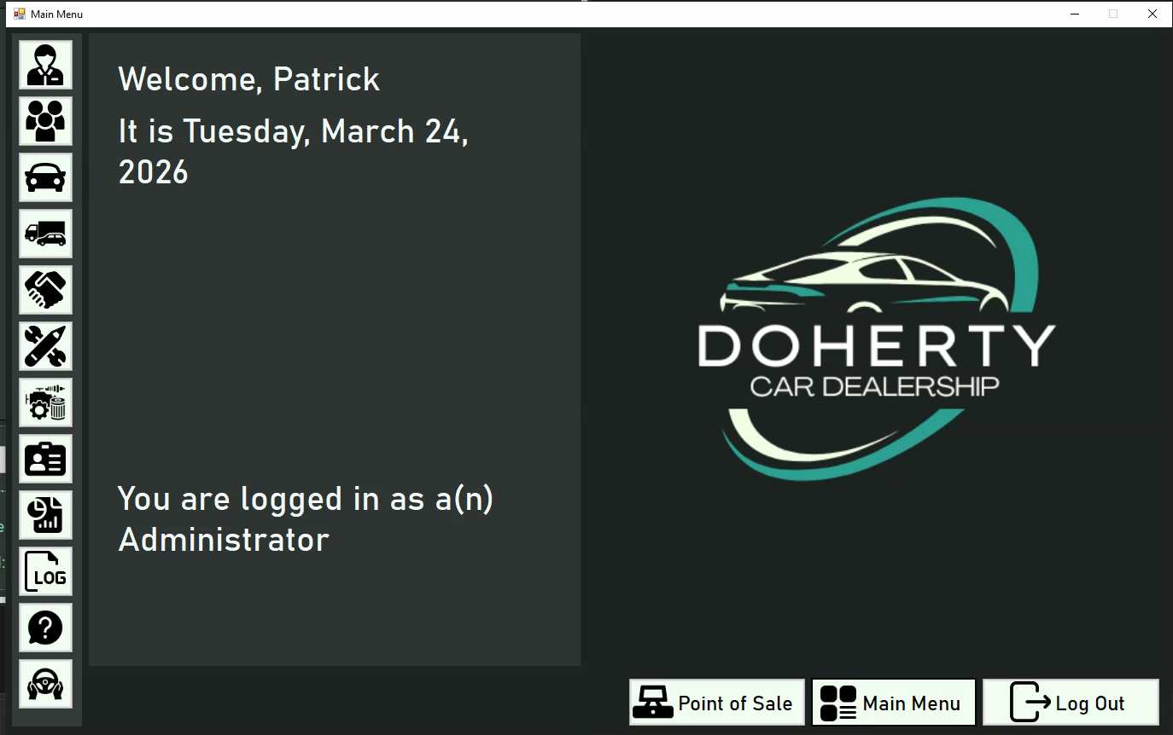



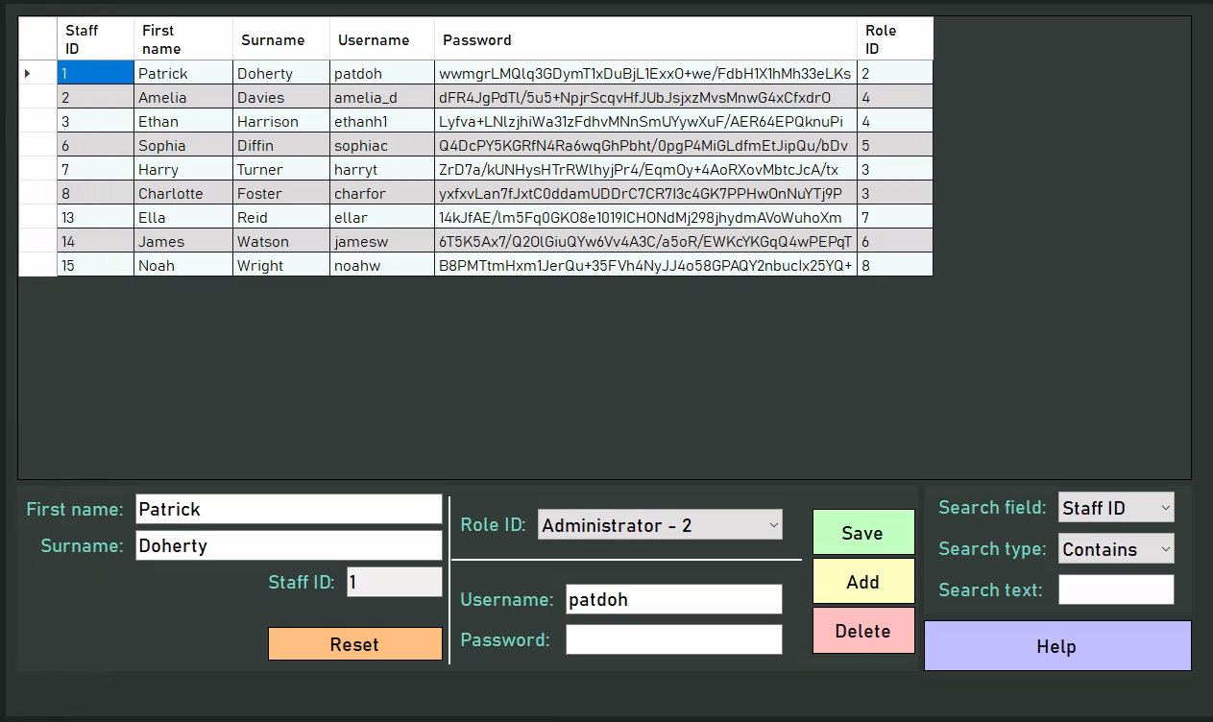
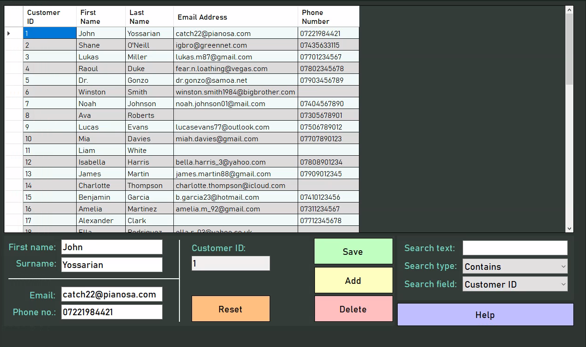

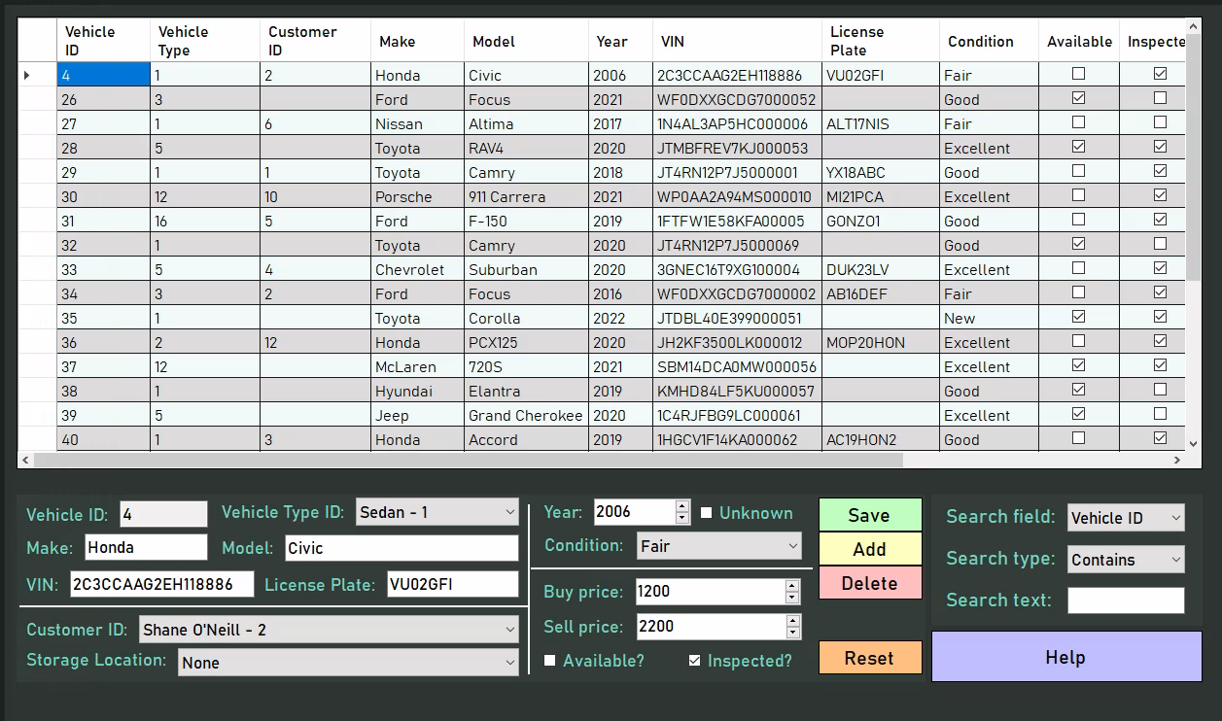

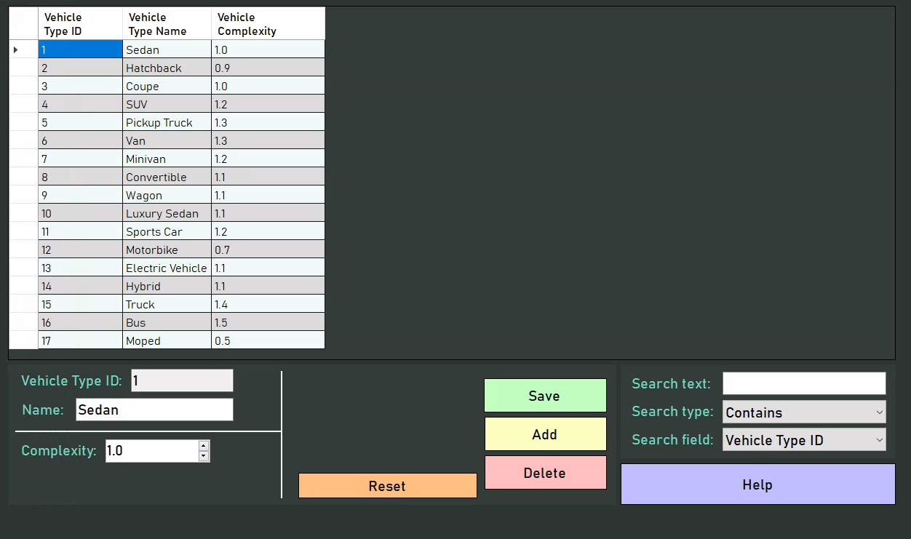

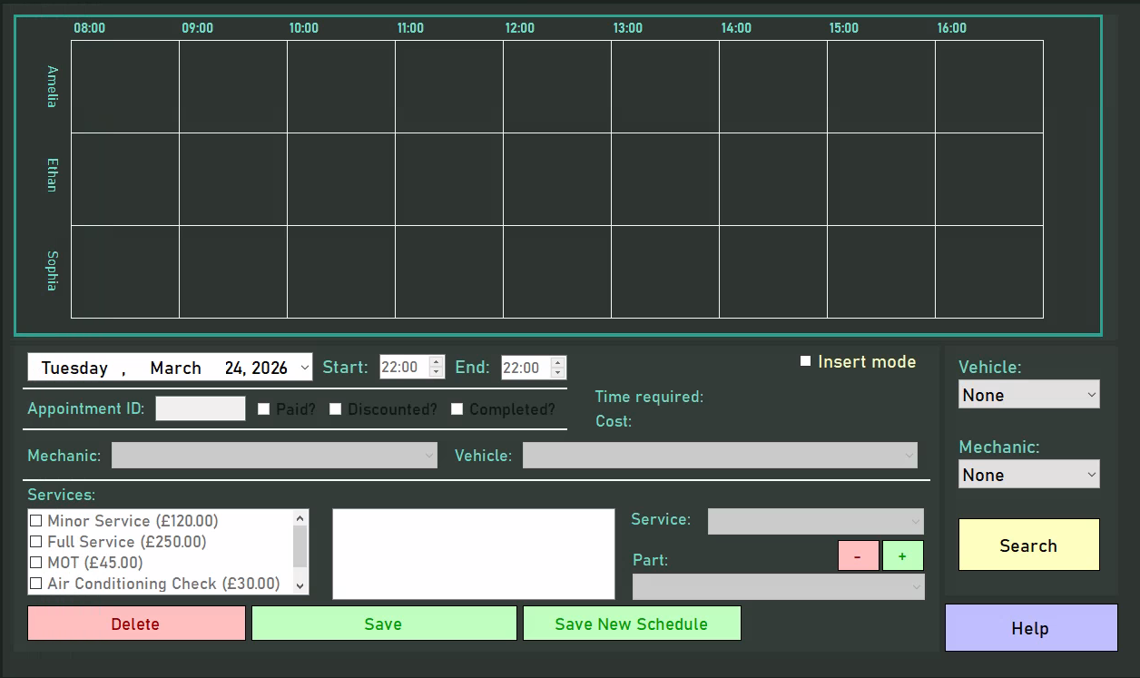

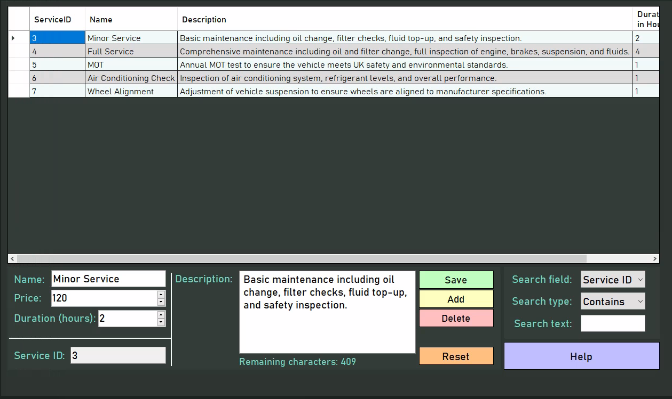
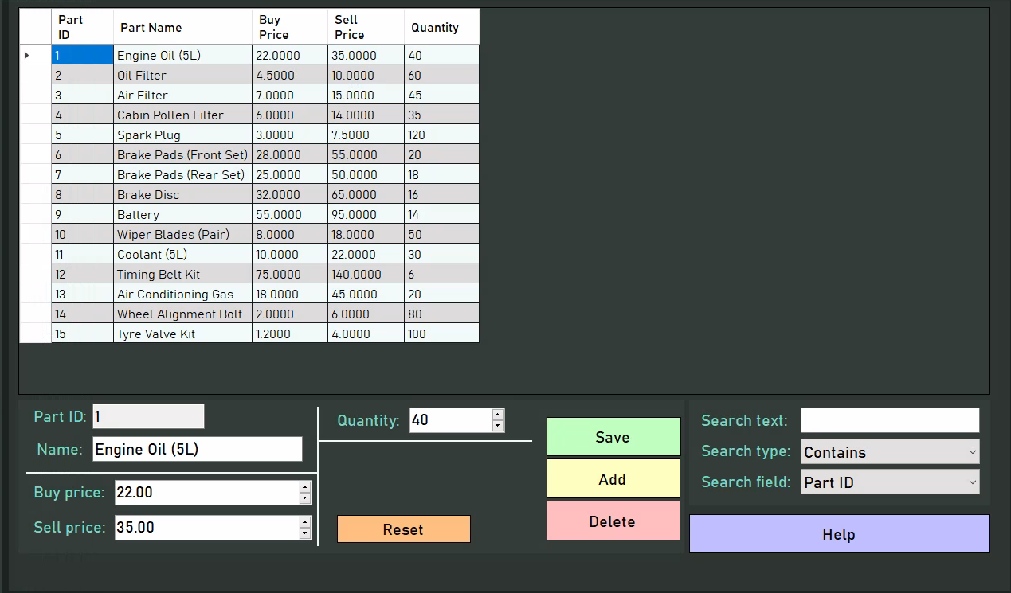
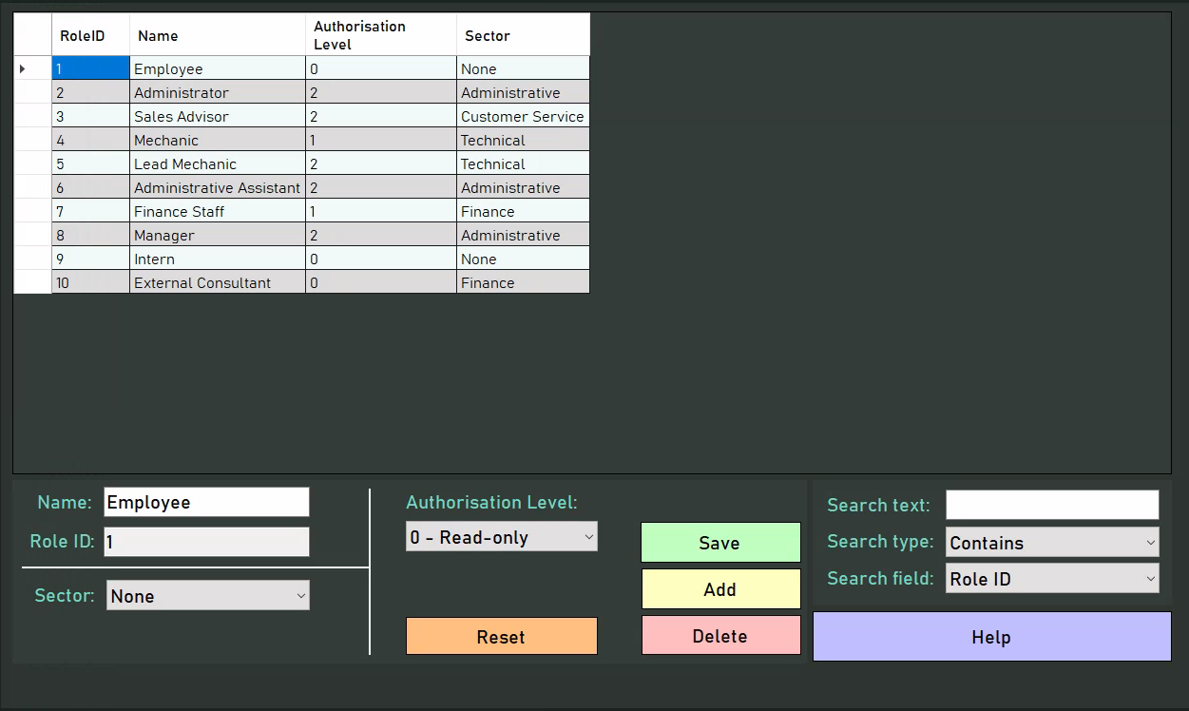

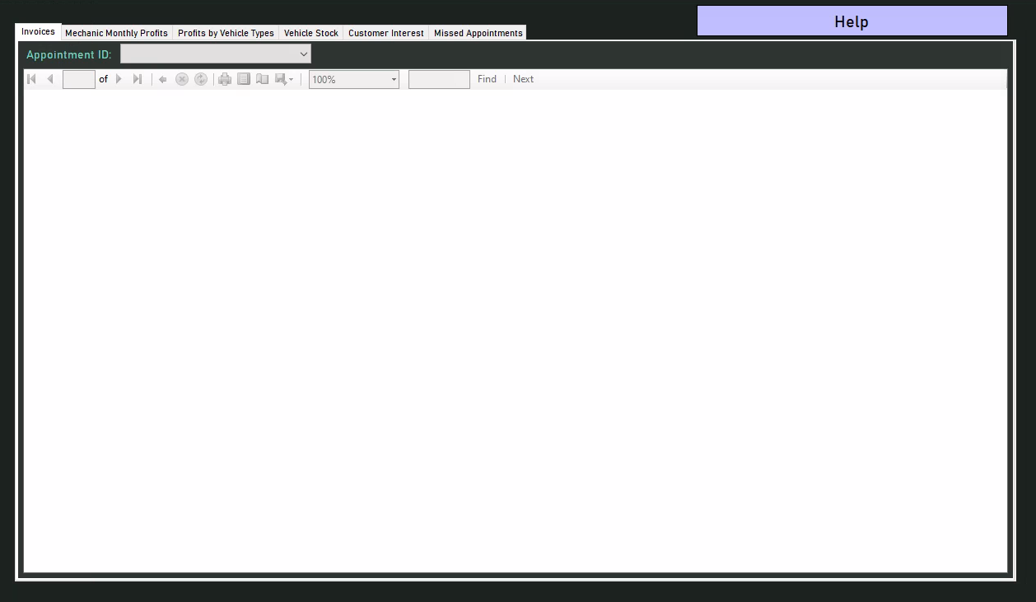

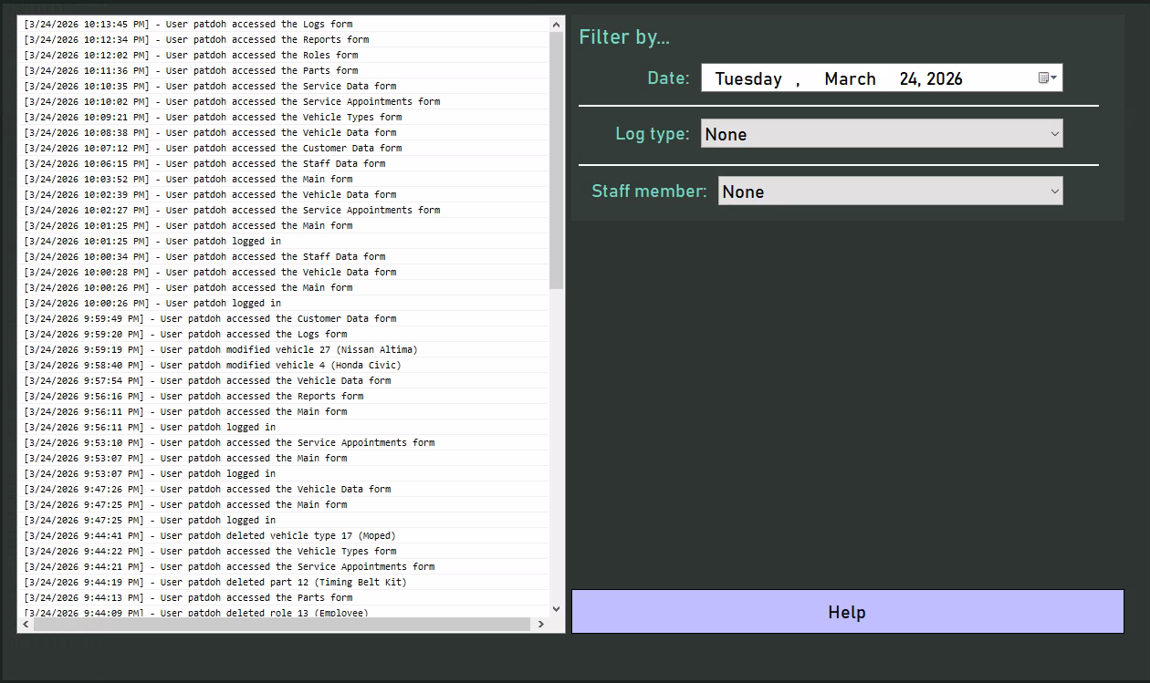

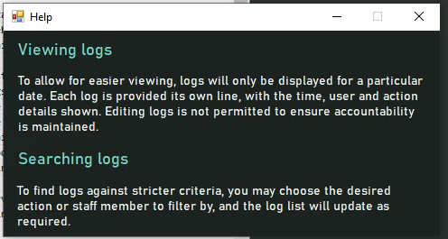

Testing process

Overall, the testing process proved to be highly successful, uncovering various flaws within the system, particularly in the areas of logging in and maintaining the user’s details in memory. The testing process began with a structured approach, starting with the identification of key test items for each form and the development of numerous test cases designed to evaluate all plausible execution paths. By establishing a comprehensive testing framework prior to execution, the process ended up being efficient and methodical, leading to the creation of a greater number of relevant test cases than would have been possible if testing and case development were conducted simultaneously. Additionally, documenting descriptions for each test item and comparing them against the expected outcomes allowed for the detection of a deviation from intended functionality.

However, white-box testing alone would not be able to ensure that the system was fit for purpose. As such, providing key end users with the opportunity to participate in a black-box usage session and fill out a questionnaire at the end provided crucial data as to the strengths and weaknesses of the system and its general usability, thereby ensuring its usability. Though the rather simplistic nature of the provided questionnaire did aid in response time, it made it more difficult to analyse the reasons for user dissatisfaction, which may have slightly hindered the effectiveness of the process. Regardless, the questionnaire has been deemed a success.

Ultimately, the testing process played a crucial role in ensuring the robustness of the system. Tests were designed to verify functionality at multiple levels - unit, subsystem, and full system integration through acceptance testing - ensuring consistent and reliable operation under normal conditions. The inclusion of diverse test data reinforced system stability by validating its ability to handle a wide range of inputs without failure. In cases where errors were identified, debugging tools such as breakpoints were employed to analyse the code, pinpoint faulty lines, and implement necessary modifications. These corrective actions were documented, illustrating the system's iterative evolution and continuous improvement.

Personal and technical skills

Though the success of the project does rely significantly on the approaches and processes involved throughout the development lifecycle, much of it also depends on my skills, both technical and interpersonal.

In terms of technical skills, I believe that I was fit for the project, with much prior development experience, both curricular and extra-curricular. As a result, the C# sections of the program were implemented rather smoothly, contributing to the final system’s robustness and quality. Having much experience with LINQ methods with my background in competitive programming, I was able to effectively process and filter data from the database using code, helping translate an unfamiliar domain - that of database management - into one within which I had more experience, aiding in the development experience. One of the more complex sections of the program is the service appointment viewer, with many interdependent parts - including database, drawing, validation and event logic - all occurring simultaneously. Yet, my experience with the WinForms Graphics library proved to be sufficient for creating a working solution to this problem, highlighting my technical suitability for this project.

However, something my background did not prepare me for was the difference in thinking required when programming in SQL, with its focus on sets rather than procedures. Most notably, I was not conscious of the need for transactions when carrying out complex operations, which would slightly hinder the robustness of the final solution, but the C# logic surrounding this is sufficient to prevent the database entering an invalid state. Despite this, a considerable flaw in the project is the requirement for preexisting records in the service appointments form due to my lack of oversight when considering the way the system will operate: at the present, the mechanics for appointments are fetched using those that are presently stored in the table. As a result, if a new mechanic is added to the system without them having a service appointment already present in the table, they will not be shown. To mitigate this, a flag could have been attached to staff records indicating that they are to be displayed in service appointments, preventing the need for preexisting data. As such, for future projects, I will ensure that I have enough experience with a query language to comfortably understand the limitations and problems of certain approaches and thus ensure that the client is satisfied with the one chosen by me.

With regard to personal skills, I believe that the biggest issue was communication. Although the Waterfall model did not necessitate constant communication with the client for feedback, I admittedly did not provide them with sufficient updates throughout the development process of the project, potentially leaving them uncertain or concerned as to the stage the project is at, which may have reduced client satisfaction. In the future, I will aim to maintain more frequent communication with clients - whether through email or phone - to ensure that all stakeholders are up-to-date as to the status of the project, thus maintaining coherence.

Adherence to project plan

Task No. | Task | Planned Start Date | Actual Start Date | Duration (days) | Actual End Date | Planned End Date | Resources | Comments
Analysis
1 | Initial client meeting/problem discussion | 1-Sep | 1-Sep | 1 | 1-Sep | 1-Sep | Client | The project initiation and analysis phase was executed admittedly cleanly, but this was mostly due in part to the dealership already having outlined the issues with their current system before meeting with me. Had this not been the case, more time may have been required during the initial meeting and during the identification of needs, as often clients have difficulty expressing their initial requirements.  The constant interaction with the client at the start was effective in determining the requirements for the rest of the system, as it provided a chance for me to correct any flaws in my interpretation of the business’ issues, thus ensuring the efficacy of this stage.  The timeline was easily adhered to due to the provision of the problem specification, thus providing additional time for the subsequent phases, and this ultimately improved the quality of the system by ensuring no tasks were rushed.
2 | Identification of client needs & current system issues | 2-Sep | 2-Sep | 2 | 3-Sep | 4-Sep | Client
3 | Definition of functional requirements | 5-Sep | 4-Sep | 3 | 6-Sep | 7-Sep | —
4 | Definition of non-functional requirements | 5-Sep | 4-Sep | 2 | 5-Sep | 6-Sep | —
5 | Initial sketches based on requirements | 8-Sep | 7-Sep | 4 | 10-Sep | 11-Sep | —
6 | Client review & sign-off | 12-Sep | 11-Sep | 1 | 11-Sep | 12-Sep | Client
Design
7 | Definition of system scope & methodology | 13-Sep | 12-Sep | 3 | 14-Sep | 15-Sep | — | First seen in this phase is the difficulty in estimating the duration of tasks. Though some slack was present from the initiation phase, it was quickly absorbed by the delay caused by drawing use cases and data flow diagrams. This could have been easily avoided by either using more efficient UML software such as PlantUML rather than the admittedly cumbersome draw.io to reduce the time taken to draw the same diagrams, or by drawing fewer diagrams altogether, as it was found that these diagrams did not prove critical in later phases of the project.  Regardless, the other tasks were completed on schedule, and SQL Server proved to be an effective tool in creating the initial design of the database, helping with maintaining the schedule of the project and providing certainty as to the direction of development. As such, it will be a tool regularly used in future projects.
8 | Creation of final sketches | 16-Sep | 15-Sep | 7 | 21-Sep | 22-Sep | —
9 | Use case and data flow diagrams | 21-Sep | 20-Sep | 4 | 23-Sep | 23-Sep | —
10 | Identification of data entities & relationships | 24-Sep | 24-Sep | 3 | 26-Sep | 26-Sep | —
11 | Database schema design | 26-Sep | 26-Sep | 4 | 29-Sep | 29-Sep | SQL Server
Implementation
12 | Project setup in Visual Studio and database setup | 30-Sep | 30-Sep | 1 | 30-Sep | 30-Sep | Visual Studio, SQL Server | The implementation phase - as expected - was the most turbulent. With constant fluctuations in the task completion times - with several being completed early, several being delayed - there was an uncertainty as to how long the phase would actually take. Though ultimately it resulted in the project being delivered earlier than expected, in future projects, buffer periods would have helped ensure that any unexpected changes to the schedule would not impact the project’s delivery time  Many external resources also helped, as many unexpected errors or unfamiliar functionalities were quickly amended through the use of websites such as the official SQL and C# documentation when faced with unfamiliar features, or Stack Overflow when faced with troubling issues.  Lastly, the ease of use of both Visual Studio and SQL Server proved to be crucial in the relatively smooth development of the project, as many of the features - such as automatic event generation and pop-up windows in Visual Studio and automatic query generation and simple data input in SQL Server - aided in tasks that would have otherwise been extremely arduous.  However, although these applications are useful, a more modern development approach suitable for a short timescale - such as a Ruby On Rails web app - may have proven more effective for a small-scale operation like Doherty Cars, and consequently a different IDE such as RubyMine required.
13 | Implementation of tables & relationships | 1-Oct | 1-Oct | 4 | 4-Oct | 5-Oct | Visual Studio, SQL Server
14 | Seeding of test data | 6-Oct | 5-Oct | 2 | 6-Oct | 8-Oct | SQL Server
15 | Implementation of frmLogin (validation, hashing) | 9-Oct | 7-Oct | 13 | 19-Oct | 20-Oct | Visual Studio, SQL Server
16 | Role-based access logic | 9-Oct | 7-Oct | 10 | 16-Oct | 16-Oct | Visual Studio
17 | Logging of user actions | 21-Oct | 20-Oct | 4 | 23-Oct | 24-Oct | Visual Studio, SQL Server
18 | Validation class implementation | 21-Oct | 20-Oct | 3 | 22-Oct | 23-Oct | Visual Studio
19 | Implementation of frmMainMenu | 24-Oct | 23-Oct | 5 | 27-Oct | 28-Oct | Visual Studio
20 | Implementation of frmStaffData | 29-Oct | 28-Oct | 16 | 12-Nov | 15-Nov | Visual Studio, SQL Server
21 | Implementation of frmRoleData | 16-Nov | 13-Nov | 5 | 17-Nov | 20-Nov | Visual Studio, SQL Server
22 | Implementation of frmCustomerData | 16-Nov | 13-Nov | 11 | 23-Nov | 27-Nov | Visual Studio, SQL Server
23 | Implementation of frmVehicleData | 16-Nov | 13-Nov | 17 | 29-Nov | 29-Nov | Visual Studio, SQL Server
24 | Implementation of frmVehicleTypeData | 30-Nov | 30-Nov | 5 | 4-Dec | 4-Dec | Visual Studio, SQL Server
25 | Implementation of frmServiceData | 30-Nov | 30-Nov | 6 | 5-Dec | 5-Dec | Visual Studio, SQL Server
26 | Implementation of frmPartData | 30-Nov | 30-Nov | 6 | 5-Dec | 6-Dec | Visual Studio, SQL Server
27 | ServiceAppointments (display logic) | 7-Dec | 6-Dec | 24 | 29-Dec | 27-Dec | Visual Studio, SQL Server
28 | ServiceAppointments (CRUD logic) | 28-Dec | 30-Dec | 16 | 14-Jan | 17-Jan | Visual Studio, SQL Server
29 | Implementation of frmReports | 18-Jan | 15-Jan | 7 | 21-Jan | 24-Jan | Visual Studio, SQL Server
30 | Implementation of frmLogs | 25-Jan | 22-Jan | 4 | 25-Jan | 28-Jan | Visual Studio, SQL Server
31 | Implementation of frmHelp(s) | 25-Jan | 22-Jan | 4 | 25-Jan | 27-Jan | Visual Studio
32 | Final clean-up | 28-Jan | 26-Jan | 12 | 6-Feb | 6-Feb | Visual Studio
Testing
33 | Unit testing | 31-Jan | 29-Jan | 12 | 9-Feb | 9-Feb | Visual Studio, SQL Server | The testing phase was unremarkable, as each task was completed within the allocated time. Only tasks 34-35 had a slight but negligible fluctuation. This was mostly due in part to the effectiveness of the debugging software provided by Visual Studio, helping ensure that all the functionality could be easily tested, and the source of any issues promptly identified and amended. The relatively small test user base also helped ensure that the project was delivered within the allocated time, as little effort was required to locate and interact with them.
34 | Integration testing | 9-Feb | 9-Feb | 7 | 15-Feb | 16-Feb | Visual Studio, SQL Server
35 | System testing | 16-Feb | 15-Feb | 7 | 21-Feb | 21-Feb | Visual Studio, SQL Server
36 | Acceptance testing | 21-Feb | 21-Feb | 6 | 26-Feb | 26-Feb | Client, Test Users
Evaluation
37 | Distribution of questionnaires | 23-Feb | 23-Feb | 4 | 26-Feb | 28-Feb | Test Users | Due to the scale of the project, it was found that the evaluation phase took longer than anticipated, highlighting errors in my estimation and time management skills and forcing me to rush closure. Although this made little impact on the quality and delivery date of the final system, it could have been interpreted as unprofessional by the client. Thus, greater care needs to be taken when estimating times in the future, and preventative measures such as buffer periods could be used to mitigate such delays, as, had it not been for the questionnaires and user guide taking less time than expected, the critical path would have been delayed.
38 | Creation of user guide | 26-Feb | 26-Feb | 7 | 4-Mar | 7-Mar | —
39 | Project evaluation & reflection | 8-Mar | 5-Mar | 9 | 13-Mar | 12-Mar | —
40 | Closure | 13-Mar | 14-Mar | 2 | 15-Mar | 15-Mar | —

As evidenced by the table above, many tasks were started and completed earlier than anticipated. As a significant portion of these were on the critical path (i.e., had no slack, so that their completion time determines the completion time of the project), this ultimately resulted in there being slack (i.e., time by which the tasks could be delayed and still be delivered on time) which impacted the project by providing flexibility - compensating for the tasks that eventually ended up being completed later than anticipated - and improvements on the system’s quality - providing some tasks such as testing additional time to ensure that they were carried out more thoroughly.

Regardless, these changes to the project plan made no major impact on the delivery of the project, as it was still closed on the time determined during project initiation with all tasks having been completed. These variations highlight the inherent difficulty in accurately estimating task durations, but ultimately demonstrate the project plan was sufficiently robust to accommodate change without negatively affecting the final outcome. and instead these variations were to be expected due to the difficulty in estimating the duration of tasks ahead of time.

User feedback

As a final step, an interview was conducted with Mr Doherty to assess his overall satisfaction with the system and, more importantly, to identify any areas where improvements could be made.

During the interview, Mr Doherty interacted with the system in real time, providing feedback as he explored its features and functionality. This hands-on evaluation allowed for a more detailed and practical assessment of the system’s usability and effectiveness. The following is a summary of his points:

frmLogin
- Mr Doherty expressed satisfaction with the colour scheme, typography, and overall layout of the form, noting that these design choices effectively set the tone for the rest of the system, making it suitable for a business. Similar feedback was provided for other forms, though it has been omitted here for brevity.
- However, he did express annoyance at the form’s validation messages, as they only displayed issues one at a time. He stated that he would’ve preferred errors to be listed as they do in CRUD forms, but due to the insignificance of the issue said this can be ignored.

frmMainMenu
- Mr Doherty was impressed with the expanding sidebar provided in the main menu, saying it gave the impression of sleekness and aided in the optimal navigation of the system.
- Mr Doherty was pleased with the sector access logic implemented, saying it would definitely help tackle the issue of staff members accessing data not applicable to them.
- He did comment that the starting main menu form was rather bland, containing only basic information about the user. To expand on this, he suggested that a clock or company news feed could be implemented to fill the whitespace. However, due to the aesthetic nature of the suggestion, he said this was not essential.

frm______Data
As has previously been done before, for the sake of brevity all comments regarding data forms will be grouped under one category
- Mr Doherty was satisfied with the current implementation of CRUD processes. Due to the rather cookie-cutter nature of CRUD implementation as a whole, no comments unique to the system were made regarding this.
- He noted that the ubiquitous presence of validation, as well as the list of errors that appears when invalid data is submitted, would ensure the integrity of any information provided to the system, thus preventing the issues regarding consistent bookkeeping and valid data that plagued him initially.
- Specifically for the staff data form, he was confident in the security of the system as a result of the password hashing implemented, further protecting the business data from erroneous or malicious manipulation.
- Specifically for vehicles, he had the critique that the validation for the VIN did not follow the logic required for a VIN (i.e., 17 characters) but noted that the field still served its purpose as a unique physical identifier and thus did not matter too much for the purpose of the system.
- Specifically for vehicle types, he had the critique that the use of a scalar multiplier for determining the time for servicing a vehicle was rather reductionist, and would have preferred if mechanics were able to use their professional judgement. Regardless, the current solution to the problem has been deemed effective for now.
- Mr Doherty was particularly pleased with the presence of the “Reset” buttons, noting that they would save significant amounts of time when editing, deleting or saving multiple records, ensuring that previous form states do not interfere with future records.
- Furthermore, he was satisfied with the help forms provided, deeming them informative enough for use by staff.
- Mr Doherty - much like I did - pointed out the rather small selection of search options for the database. However, with the small scale of the business, he said that this was something that could be overlooked.

frmServiceAppointments
- From the outset, Mr Doherty was pleased with the appointment viewer control, saying that it would assist significantly in the creation and viewing of appointments on the system in a centralised manner, replacing the inconsistent and scattered paper calendars previously implemented.
- On interacting with the appointment viewer for a bit, Mr Doherty was very happy with the drag-and-drop nature of editing appointment times, saying that it even made the process almost “fun.” Furthermore, he greatly appreciated the validation implemented which prevented appointments from intersecting or going out of bounds, something that greatly irritated him with the way appointments were previously arranged.
- He was pleased with the subtle differences when creating appointments in “Insert Mode”, noting that it very explicitly separated the functionality of editing and adding appointments as to ensure that changes were not accidentally made to appointments when adding new ones.
- Similarly, he was very happy with the service and part adding systems, noting that it was easy to use and provided significant visual feedback as to the effect that adding a service and part would have.
- He thought that the schedule saving button - although not essential - was a good feature, ensuring that reordering a day did not necessitate multiple save operations.
- However, he did deem the searching system rather rudimentary, as he thought a message box would provide very transient information, and would have instead opted for a DataGridView as seen in other forms. However, with the small scale of operations so far, he deemed this okay.

frmLogs
- He was very satisfied with the implementation of this form, saying that it would greatly mitigate the issues in accountability caused by the current paper-based system. Notably, he was pleased with the inclusion of usernames attached to each action, ensuring that the person associated could be easily located.
- He was happy with the range of log types and the ability to search by staff or log type, but he did note that it would have been better if logs also stated the exact changes that were made to records, as at the present they are identified solely by record ID and old identifier.
- He did note that he would have preferred to be able to search logs by substring as in the frm____Data forms.

frmReports
- Overall, he was happy with the reports provided by the system. Though he did note that some were rather simple, he appreciated the insights they provided, ensuring that the management of the business would be able to make decisions based on the data provided.

Conclusion

Mr Doherty expressed overall satisfaction with the final system and did not request any modifications or reengineering for the current development cycle. His feedback indicates that the system meets the initial requirements and expectations, validating its completeness and functionality.

Extensive evaluation shows that the core issues identified at the project’s outset - and the user requirements derived from them - have been successfully resolved. While minor issues remain, the system is overall effective and ready for deployment at Doherty Cars to support their continued growth.

Appendix

SQL to create tables

Customers
SET ANSI_NULLS ON
GO
SET QUOTED_IDENTIFIER ON
GO
CREATE TABLE [dbo].[Customers](
[CustomerID] [int] IDENTITY(1,1) NOT NULL,
[Firstname] [nvarchar](50) NOT NULL,
[Surname] [nvarchar](50) NOT NULL,
[Email] [nvarchar](50) NULL,
[PhoneNumber] [varchar](15) NULL,
[DateDeleted] [datetime] NULL,
PRIMARY KEY CLUSTERED
(
[CustomerID] ASC
)WITH (PAD_INDEX = OFF, STATISTICS_NORECOMPUTE = OFF, IGNORE_DUP_KEY = OFF, ALLOW_ROW_LOCKS = ON, ALLOW_PAGE_LOCKS = ON, OPTIMIZE_FOR_SEQUENTIAL_KEY = OFF) ON [PRIMARY]
) ON [PRIMARY]
GO

Parts
SET ANSI_NULLS ON
GO
SET QUOTED_IDENTIFIER ON
GO
CREATE TABLE [dbo].[Parts](
[PartID] [int] IDENTITY(1,1) NOT NULL,
[Name] [nvarchar](50) NOT NULL,
[BuyPrice] [money] NOT NULL,
[SellPrice] [money] NOT NULL,
[Quantity] [int] NOT NULL,
[DateDeleted] [datetime] NULL,
PRIMARY KEY CLUSTERED
(
[PartID] ASC
)WITH (PAD_INDEX = OFF, STATISTICS_NORECOMPUTE = OFF, IGNORE_DUP_KEY = OFF, ALLOW_ROW_LOCKS = ON, ALLOW_PAGE_LOCKS = ON, OPTIMIZE_FOR_SEQUENTIAL_KEY = OFF) ON [PRIMARY]
) ON [PRIMARY]
GO

Roles
SET ANSI_NULLS ON
GO
SET QUOTED_IDENTIFIER ON
GO
CREATE TABLE [dbo].[Roles](
[RoleID] [int] IDENTITY(1,1) NOT NULL,
[Name] [nvarchar](50) NOT NULL,
[AuthorisationLevel] [int] NOT NULL,
[Sector] [nvarchar](50) NOT NULL,
[DateDeleted] [datetime] NULL,
PRIMARY KEY CLUSTERED
(
[RoleID] ASC
)WITH (PAD_INDEX = OFF, STATISTICS_NORECOMPUTE = OFF, IGNORE_DUP_KEY = OFF, ALLOW_ROW_LOCKS = ON, ALLOW_PAGE_LOCKS = ON, OPTIMIZE_FOR_SEQUENTIAL_KEY = OFF) ON [PRIMARY]
) ON [PRIMARY]
GO

ServiceAppointments
SET ANSI_NULLS ON
GO
SET QUOTED_IDENTIFIER ON
GO
CREATE TABLE [dbo].[ServiceAppointments](
[AppointmentID] [int] IDENTITY(1,1) NOT NULL,
[VehicleID] [int] NOT NULL,
[StaffID] [int] NOT NULL,
[AppointmentStart] [datetime] NOT NULL,
[AppointmentEnd] [datetime] NOT NULL,
[Paid] [bit] NOT NULL,
[Completed] [bit] NOT NULL,
[Discounted] [bit] NOT NULL,
[DateDeleted] [datetime] NULL,
PRIMARY KEY CLUSTERED
(
[AppointmentID] ASC
)WITH (PAD_INDEX = OFF, STATISTICS_NORECOMPUTE = OFF, IGNORE_DUP_KEY = OFF, ALLOW_ROW_LOCKS = ON, ALLOW_PAGE_LOCKS = ON, OPTIMIZE_FOR_SEQUENTIAL_KEY = OFF) ON [PRIMARY]
) ON [PRIMARY]
GO

ServiceAppointmentsServices
SET ANSI_NULLS ON
GO
SET QUOTED_IDENTIFIER ON
GO
CREATE TABLE [dbo].[ServiceAppointmentsServices](
[AppointmentID] [int] NOT NULL,
[ServiceID] [int] NOT NULL,
[DateDeleted] [datetime] NULL,
PRIMARY KEY CLUSTERED
(
[AppointmentID] ASC,
[ServiceID] ASC
)WITH (PAD_INDEX = OFF, STATISTICS_NORECOMPUTE = OFF, IGNORE_DUP_KEY = OFF, ALLOW_ROW_LOCKS = ON, ALLOW_PAGE_LOCKS = ON, OPTIMIZE_FOR_SEQUENTIAL_KEY = OFF) ON [PRIMARY]
) ON [PRIMARY]
GO

ServiceAppointmentsServicesParts
SET ANSI_NULLS ON
GO
SET QUOTED_IDENTIFIER ON
GO
CREATE TABLE [dbo].[ServiceAppointmentsServicesParts](
[AppointmentID] [int] NOT NULL,
[ServiceID] [int] NOT NULL,
[PartID] [int] NOT NULL,
[Quantity] [int] NOT NULL,
[DateDeleted] [datetime] NULL,
PRIMARY KEY CLUSTERED
(
[AppointmentID] ASC,
[ServiceID] ASC,
[PartID] ASC
)WITH (PAD_INDEX = OFF, STATISTICS_NORECOMPUTE = OFF, IGNORE_DUP_KEY = OFF, ALLOW_ROW_LOCKS = ON, ALLOW_PAGE_LOCKS = ON, OPTIMIZE_FOR_SEQUENTIAL_KEY = OFF) ON [PRIMARY]
) ON [PRIMARY]
GO

Services
SET ANSI_NULLS ON
GO
SET QUOTED_IDENTIFIER ON
GO
CREATE TABLE [dbo].[Services](
[ServiceID] [int] IDENTITY(1,1) NOT NULL,
[Name] [nvarchar](50) NOT NULL,
[Description] [nvarchar](500) NOT NULL,
[DurationHours] [int] NOT NULL,
[Price] [decimal](10, 2) NOT NULL,
[DateDeleted] [datetime] NULL,
PRIMARY KEY CLUSTERED
(
[ServiceID] ASC
)WITH (PAD_INDEX = OFF, STATISTICS_NORECOMPUTE = OFF, IGNORE_DUP_KEY = OFF, ALLOW_ROW_LOCKS = ON, ALLOW_PAGE_LOCKS = ON, OPTIMIZE_FOR_SEQUENTIAL_KEY = OFF) ON [PRIMARY]
) ON [PRIMARY]
GO

Staff
SET ANSI_NULLS ON
GO
SET QUOTED_IDENTIFIER ON
GO
CREATE TABLE [dbo].[Staff](
[StaffID] [int] IDENTITY(1,1) NOT NULL,
[Firstname] [nvarchar](50) NOT NULL,
[Surname] [nvarchar](50) NOT NULL,
[Username] [nvarchar](50) NOT NULL,
[Password] [nvarchar](255) NOT NULL,
[RoleID] [int] NOT NULL,
[DateDeleted] [datetime] NULL,
PRIMARY KEY CLUSTERED
(
[StaffID] ASC
)WITH (PAD_INDEX = OFF, STATISTICS_NORECOMPUTE = OFF, IGNORE_DUP_KEY = OFF, ALLOW_ROW_LOCKS = ON, ALLOW_PAGE_LOCKS = ON, OPTIMIZE_FOR_SEQUENTIAL_KEY = OFF) ON [PRIMARY]
) ON [PRIMARY]
GO

Vehicles
SET ANSI_NULLS ON
GO
SET QUOTED_IDENTIFIER ON
GO
CREATE TABLE [dbo].[Vehicles](
[VehicleID] [int] IDENTITY(1,1) NOT NULL,
[VehicleTypeID] [int] NOT NULL,
[CustomerID] [int] NULL,
[Make] [nvarchar](50) NOT NULL,
[Model] [nvarchar](50) NOT NULL,
[Year] [int] NULL,
[VIN] [nvarchar](50) NOT NULL,
[LicensePlate] [nvarchar](20) NULL,
[Condition] [nvarchar](50) NOT NULL,
[Available] [bit] NOT NULL,
[Inspected] [bit] NOT NULL,
[BuyPrice] [decimal](10, 2) NULL,
[SellPrice] [decimal](10, 2) NULL,
[StorageLocation] [nvarchar](50) NULL,
[DateDeleted] [datetime] NULL,
PRIMARY KEY CLUSTERED
(
[VehicleID] ASC
)WITH (PAD_INDEX = OFF, STATISTICS_NORECOMPUTE = OFF, IGNORE_DUP_KEY = OFF, ALLOW_ROW_LOCKS = ON, ALLOW_PAGE_LOCKS = ON, OPTIMIZE_FOR_SEQUENTIAL_KEY = OFF) ON [PRIMARY]
) ON [PRIMARY]
GO

VehicleTypes
SET ANSI_NULLS ON
GO
SET QUOTED_IDENTIFIER ON
GO
CREATE TABLE [dbo].[VehicleTypes](
[VehicleTypeID] [int] IDENTITY(1,1) NOT NULL,
[Name] [nvarchar](50) NOT NULL,
[Complexity] [decimal](2, 1) NOT NULL,
[DateDeleted] [datetime] NULL,
PRIMARY KEY CLUSTERED
(
[VehicleTypeID] ASC
)WITH (PAD_INDEX = OFF, STATISTICS_NORECOMPUTE = OFF, IGNORE_DUP_KEY = OFF, ALLOW_ROW_LOCKS = ON, ALLOW_PAGE_LOCKS = ON, OPTIMIZE_FOR_SEQUENTIAL_KEY = OFF) ON [PRIMARY]
) ON [PRIMARY]
GO

SQL to populate tables

Customers
SET IDENTITY_INSERT [dbo].[Customers] ON
GO
INSERT [dbo].[Customers] ([CustomerID], [Firstname], [Surname], [Email], [PhoneNumber], [DateDeleted]) VALUES (1, N'John', N'Yossarian', N'catch22@pianosa.com', N'07221984421', NULL)
GO
INSERT [dbo].[Customers] ([CustomerID], [Firstname], [Surname], [Email], [PhoneNumber], [DateDeleted]) VALUES (2, N'Shane', N'O''Neill', N'igbro@greennet.com', N'07435633115', NULL)
GO
INSERT [dbo].[Customers] ([CustomerID], [Firstname], [Surname], [Email], [PhoneNumber], [DateDeleted]) VALUES (3, N'Lukas', N'Miller', N'lukas.m87@gmail.com', N'07701234567', NULL)
GO
INSERT [dbo].[Customers] ([CustomerID], [Firstname], [Surname], [Email], [PhoneNumber], [DateDeleted]) VALUES (4, N'Raoul', N'Duke', N'fear.n.loathing@vegas.com', N'07802345678', NULL)
GO
INSERT [dbo].[Customers] ([CustomerID], [Firstname], [Surname], [Email], [PhoneNumber], [DateDeleted]) VALUES (5, N'Dr.', N'Gonzo', N'dr.gonzo@samoa.net', N'07903456789', NULL)
GO
INSERT [dbo].[Customers] ([CustomerID], [Firstname], [Surname], [Email], [PhoneNumber], [DateDeleted]) VALUES (6, N'Winston', N'Smith', N'winston.smith1984@bigbrother.com', NULL, NULL)
GO
INSERT [dbo].[Customers] ([CustomerID], [Firstname], [Surname], [Email], [PhoneNumber], [DateDeleted]) VALUES (7, N'Noah', N'Johnson', N'noah.johnson01@mail.com', N'07404567890', NULL)
GO
INSERT [dbo].[Customers] ([CustomerID], [Firstname], [Surname], [Email], [PhoneNumber], [DateDeleted]) VALUES (8, N'Ava', N'Roberts', NULL, N'07305678901', NULL)
GO
INSERT [dbo].[Customers] ([CustomerID], [Firstname], [Surname], [Email], [PhoneNumber], [DateDeleted]) VALUES (9, N'Lucas', N'Evans', N'lucasevans77@outlook.com', N'07506789012', NULL)
GO
INSERT [dbo].[Customers] ([CustomerID], [Firstname], [Surname], [Email], [PhoneNumber], [DateDeleted]) VALUES (10, N'Mia', N'Davies', N'miah.davies@gmail.com', N'07707890123', NULL)
GO
INSERT [dbo].[Customers] ([CustomerID], [Firstname], [Surname], [Email], [PhoneNumber], [DateDeleted]) VALUES (11, N'Liam', N'White', NULL, NULL, NULL)
GO
INSERT [dbo].[Customers] ([CustomerID], [Firstname], [Surname], [Email], [PhoneNumber], [DateDeleted]) VALUES (12, N'Isabella', N'Harris', N'bella.harris_3@yahoo.com', N'07808901234', NULL)
GO
INSERT [dbo].[Customers] ([CustomerID], [Firstname], [Surname], [Email], [PhoneNumber], [DateDeleted]) VALUES (13, N'James', N'Martin', N'james.martin88@gmail.com', N'07909012345', NULL)
GO
INSERT [dbo].[Customers] ([CustomerID], [Firstname], [Surname], [Email], [PhoneNumber], [DateDeleted]) VALUES (14, N'Charlotte', N'Thompson', N'charlotte.thompson@icloud.com', NULL, NULL)
GO
INSERT [dbo].[Customers] ([CustomerID], [Firstname], [Surname], [Email], [PhoneNumber], [DateDeleted]) VALUES (15, N'Benjamin', N'Garcia', N'b.garcia23@hotmail.com', N'07410123456', NULL)
GO
INSERT [dbo].[Customers] ([CustomerID], [Firstname], [Surname], [Email], [PhoneNumber], [DateDeleted]) VALUES (16, N'Amelia', N'Martinez', N'amelia.m_92@gmail.com', N'07311234567', NULL)
GO
INSERT [dbo].[Customers] ([CustomerID], [Firstname], [Surname], [Email], [PhoneNumber], [DateDeleted]) VALUES (17, N'Alexander', N'Clark', NULL, N'07712345678', NULL)
GO
INSERT [dbo].[Customers] ([CustomerID], [Firstname], [Surname], [Email], [PhoneNumber], [DateDeleted]) VALUES (18, N'Ella', N'Rodriguez', N'ella.r_03@yahoo.co.uk', NULL, NULL)
GO
INSERT [dbo].[Customers] ([CustomerID], [Firstname], [Surname], [Email], [PhoneNumber], [DateDeleted]) VALUES (19, N'William', N'Lewis', N'will.lewis19@gmail.com', N'07813456789', NULL)
GO
INSERT [dbo].[Customers] ([CustomerID], [Firstname], [Surname], [Email], [PhoneNumber], [DateDeleted]) VALUES (20, N'Grace', N'Lee', N'grace_lee@hotmail.com', N'07914567890', NULL)
GO
INSERT [dbo].[Customers] ([CustomerID], [Firstname], [Surname], [Email], [PhoneNumber], [DateDeleted]) VALUES (21, N'Henry', N'Walker', N'h.walker7@gmail.com', NULL, NULL)
GO
INSERT [dbo].[Customers] ([CustomerID], [Firstname], [Surname], [Email], [PhoneNumber], [DateDeleted]) VALUES (22, N'Sofia', N'Hall', NULL, N'07415678901', NULL)
GO
INSERT [dbo].[Customers] ([CustomerID], [Firstname], [Surname], [Email], [PhoneNumber], [DateDeleted]) VALUES (23, N'Daniel', N'Allen', N'd.allen84@outlook.com', N'07316789012', NULL)
GO
INSERT [dbo].[Customers] ([CustomerID], [Firstname], [Surname], [Email], [PhoneNumber], [DateDeleted]) VALUES (24, N'Chloe', N'Young', N'chloe.young99@gmail.com', NULL, NULL)
GO
INSERT [dbo].[Customers] ([CustomerID], [Firstname], [Surname], [Email], [PhoneNumber], [DateDeleted]) VALUES (25, N'Matthew', N'Hernandez', N'matthewh_77@yahoo.com', N'07717890123', NULL)
GO
INSERT [dbo].[Customers] ([CustomerID], [Firstname], [Surname], [Email], [PhoneNumber], [DateDeleted]) VALUES (26, N'Lily', N'King', N'lily.king4@gmail.com', N'07818901234', NULL)
GO
INSERT [dbo].[Customers] ([CustomerID], [Firstname], [Surname], [Email], [PhoneNumber], [DateDeleted]) VALUES (27, N'Joseph', N'Wright', NULL, N'07919012345', NULL)
GO
INSERT [dbo].[Customers] ([CustomerID], [Firstname], [Surname], [Email], [PhoneNumber], [DateDeleted]) VALUES (28, N'Zoe', N'Lopez', N'zoe_lopez21@hotmail.com', NULL, NULL)
GO
INSERT [dbo].[Customers] ([CustomerID], [Firstname], [Surname], [Email], [PhoneNumber], [DateDeleted]) VALUES (29, N'David', N'Hill', N'david.hill_88@gmail.com', N'07420123456', NULL)
GO
INSERT [dbo].[Customers] ([CustomerID], [Firstname], [Surname], [Email], [PhoneNumber], [DateDeleted]) VALUES (30, N'Hannah', N'Scott', N'hannahscott_01@outlook.com', NULL, NULL)
GO
INSERT [dbo].[Customers] ([CustomerID], [Firstname], [Surname], [Email], [PhoneNumber], [DateDeleted]) VALUES (31, N'Samuel', N'Green', N'sam.green23@gmail.com', N'07321234567', NULL)
GO
INSERT [dbo].[Customers] ([CustomerID], [Firstname], [Surname], [Email], [PhoneNumber], [DateDeleted]) VALUES (32, N'Aria', N'Adams', N'aria.adams5@yahoo.co.uk', N'07722345678', NULL)
GO
INSERT [dbo].[Customers] ([CustomerID], [Firstname], [Surname], [Email], [PhoneNumber], [DateDeleted]) VALUES (33, N'Jackson', N'Baker', NULL, N'07823456789', NULL)
GO
INSERT [dbo].[Customers] ([CustomerID], [Firstname], [Surname], [Email], [PhoneNumber], [DateDeleted]) VALUES (34, N'Maya', N'Gonzalez', N'maya.gonzalez_02@gmail.com', NULL, NULL)
GO
INSERT [dbo].[Customers] ([CustomerID], [Firstname], [Surname], [Email], [PhoneNumber], [DateDeleted]) VALUES (35, N'Logan', N'Nelson', N'logan.nelson7@hotmail.com', N'07924567890', NULL)
GO
INSERT [dbo].[Customers] ([CustomerID], [Firstname], [Surname], [Email], [PhoneNumber], [DateDeleted]) VALUES (36, N'Scarlett', N'Carter', N'scarlett.c_3@gmail.com', NULL, NULL)
GO
INSERT [dbo].[Customers] ([CustomerID], [Firstname], [Surname], [Email], [PhoneNumber], [DateDeleted]) VALUES (37, N'Owen', N'Mitchell', NULL, N'07425678901', NULL)
GO
INSERT [dbo].[Customers] ([CustomerID], [Firstname], [Surname], [Email], [PhoneNumber], [DateDeleted]) VALUES (38, N'Victoria', N'Perez', N'victoria.perez12@outlook.com', N'07326789012', NULL)
GO
INSERT [dbo].[Customers] ([CustomerID], [Firstname], [Surname], [Email], [PhoneNumber], [DateDeleted]) VALUES (39, N'Leo', N'Robinson', N'leo.robinson_9@gmail.com', NULL, NULL)
GO
INSERT [dbo].[Customers] ([CustomerID], [Firstname], [Surname], [Email], [PhoneNumber], [DateDeleted]) VALUES (40, N'Madison', N'Cook', N'madison.cook77@yahoo.com', N'07727890123', NULL)
GO
INSERT [dbo].[Customers] ([CustomerID], [Firstname], [Surname], [Email], [PhoneNumber], [DateDeleted]) VALUES (41, N'Elijah', N'Morgan', NULL, N'07828901234', NULL)
GO
INSERT [dbo].[Customers] ([CustomerID], [Firstname], [Surname], [Email], [PhoneNumber], [DateDeleted]) VALUES (42, N'Layla', N'Bell', N'layla.bell1996@gmail.com', NULL, NULL)
GO
INSERT [dbo].[Customers] ([CustomerID], [Firstname], [Surname], [Email], [PhoneNumber], [DateDeleted]) VALUES (43, N'Nathan', N'Murphy', N'nathan.murphy_3@hotmail.com', N'07929012345', NULL)
GO
INSERT [dbo].[Customers] ([CustomerID], [Firstname], [Surname], [Email], [PhoneNumber], [DateDeleted]) VALUES (44, N'Holly', N'Bailey', NULL, N'07430123456', NULL)
GO
INSERT [dbo].[Customers] ([CustomerID], [Firstname], [Surname], [Email], [PhoneNumber], [DateDeleted]) VALUES (45, N'Ryan', N'Rivera', N'ryan.rivera88@gmail.com', NULL, NULL)
GO
INSERT [dbo].[Customers] ([CustomerID], [Firstname], [Surname], [Email], [PhoneNumber], [DateDeleted]) VALUES (46, N'Lucy', N'Cooper', N'lucy.cooper_2@outlook.com', N'07331234567', NULL)
GO
INSERT [dbo].[Customers] ([CustomerID], [Firstname], [Surname], [Email], [PhoneNumber], [DateDeleted]) VALUES (47, N'Aaron', N'Richardson', NULL, N'07732345678', NULL)
GO
INSERT [dbo].[Customers] ([CustomerID], [Firstname], [Surname], [Email], [PhoneNumber], [DateDeleted]) VALUES (48, N'Zara', N'Cox', N'zara.cox1997@gmail.com', NULL, NULL)
GO
INSERT [dbo].[Customers] ([CustomerID], [Firstname], [Surname], [Email], [PhoneNumber], [DateDeleted]) VALUES (49, N'Isaac', N'Howard', N'isaac.h_05@hotmail.com', N'07833456789', NULL)
GO
INSERT [dbo].[Customers] ([CustomerID], [Firstname], [Surname], [Email], [PhoneNumber], [DateDeleted]) VALUES (50, N'Molly', N'Ward', NULL, N'07934567890', NULL)
GO
INSERT [dbo].[Customers] ([CustomerID], [Firstname], [Surname], [Email], [PhoneNumber], [DateDeleted]) VALUES (51, N'Gabriel', N'Torres', N'gabriel.torres88@gmail.com', NULL, NULL)
GO
INSERT [dbo].[Customers] ([CustomerID], [Firstname], [Surname], [Email], [PhoneNumber], [DateDeleted]) VALUES (52, N'Emma', N'Peterson', N'emma.peterson_07@outlook.com', N'07435678901', NULL)
GO
SET IDENTITY_INSERT [dbo].[Customers] OFF
GO

Parts
SET IDENTITY_INSERT [dbo].[Parts] ON
GO
INSERT [dbo].[Parts] ([PartID], [Name], [BuyPrice], [SellPrice], [Quantity], [DateDeleted]) VALUES (1, N'Engine Oil (5L)', 22.0000, 35.0000, 40, NULL)
GO
INSERT [dbo].[Parts] ([PartID], [Name], [BuyPrice], [SellPrice], [Quantity], [DateDeleted]) VALUES (2, N'Oil Filter', 4.5000, 10.0000, 60, NULL)
GO
INSERT [dbo].[Parts] ([PartID], [Name], [BuyPrice], [SellPrice], [Quantity], [DateDeleted]) VALUES (3, N'Air Filter', 7.0000, 15.0000, 45, NULL)
GO
INSERT [dbo].[Parts] ([PartID], [Name], [BuyPrice], [SellPrice], [Quantity], [DateDeleted]) VALUES (4, N'Cabin Pollen Filter', 6.0000, 14.0000, 35, NULL)
GO
INSERT [dbo].[Parts] ([PartID], [Name], [BuyPrice], [SellPrice], [Quantity], [DateDeleted]) VALUES (5, N'Spark Plug', 3.0000, 7.5000, 120, NULL)
GO
INSERT [dbo].[Parts] ([PartID], [Name], [BuyPrice], [SellPrice], [Quantity], [DateDeleted]) VALUES (6, N'Brake Pads (Front Set)', 28.0000, 55.0000, 20, NULL)
GO
INSERT [dbo].[Parts] ([PartID], [Name], [BuyPrice], [SellPrice], [Quantity], [DateDeleted]) VALUES (7, N'Brake Pads (Rear Set)', 25.0000, 50.0000, 18, NULL)
GO
INSERT [dbo].[Parts] ([PartID], [Name], [BuyPrice], [SellPrice], [Quantity], [DateDeleted]) VALUES (8, N'Brake Disc', 32.0000, 65.0000, 16, NULL)
GO
INSERT [dbo].[Parts] ([PartID], [Name], [BuyPrice], [SellPrice], [Quantity], [DateDeleted]) VALUES (9, N'Battery', 55.0000, 95.0000, 14, NULL)
GO
INSERT [dbo].[Parts] ([PartID], [Name], [BuyPrice], [SellPrice], [Quantity], [DateDeleted]) VALUES (10, N'Wiper Blades (Pair)', 8.0000, 18.0000, 50, NULL)
GO
INSERT [dbo].[Parts] ([PartID], [Name], [BuyPrice], [SellPrice], [Quantity], [DateDeleted]) VALUES (11, N'Coolant (5L)', 10.0000, 22.0000, 30, NULL)
GO
INSERT [dbo].[Parts] ([PartID], [Name], [BuyPrice], [SellPrice], [Quantity], [DateDeleted]) VALUES (12, N'Timing Belt Kit', 75.0000, 140.0000, 6, NULL)
GO
INSERT [dbo].[Parts] ([PartID], [Name], [BuyPrice], [SellPrice], [Quantity], [DateDeleted]) VALUES (13, N'Air Conditioning Gas', 18.0000, 45.0000, 20, NULL)
GO
INSERT [dbo].[Parts] ([PartID], [Name], [BuyPrice], [SellPrice], [Quantity], [DateDeleted]) VALUES (14, N'Wheel Alignment Bolt', 2.0000, 6.0000, 80, NULL)
GO
INSERT [dbo].[Parts] ([PartID], [Name], [BuyPrice], [SellPrice], [Quantity], [DateDeleted]) VALUES (15, N'Tyre Valve Kit', 1.2000, 4.0000, 100, NULL)
GO
INSERT [dbo].[Parts] ([PartID], [Name], [BuyPrice], [SellPrice], [Quantity], [DateDeleted]) VALUES (16, N'Blinker Fluid', 0.5000, 9.9900, 3, CAST(N'2026-01-27T22:45:33.510' AS DateTime))
GO
SET IDENTITY_INSERT [dbo].[Parts] OFF
GO

Roles
SET IDENTITY_INSERT [dbo].[Roles] ON
GO
INSERT [dbo].[Roles] ([RoleID], [Name], [AuthorisationLevel], [Sector], [DateDeleted]) VALUES (1, N'Employee', 0, N'None', NULL)
GO
INSERT [dbo].[Roles] ([RoleID], [Name], [AuthorisationLevel], [Sector], [DateDeleted]) VALUES (2, N'Administrator', 2, N'Administrative', NULL)
GO
INSERT [dbo].[Roles] ([RoleID], [Name], [AuthorisationLevel], [Sector], [DateDeleted]) VALUES (3, N'Sales Advisor', 2, N'Customer Service', NULL)
GO
INSERT [dbo].[Roles] ([RoleID], [Name], [AuthorisationLevel], [Sector], [DateDeleted]) VALUES (4, N'Mechanic', 1, N'Technical', NULL)
GO
INSERT [dbo].[Roles] ([RoleID], [Name], [AuthorisationLevel], [Sector], [DateDeleted]) VALUES (5, N'Lead Mechanic', 2, N'Technical', NULL)
GO
INSERT [dbo].[Roles] ([RoleID], [Name], [AuthorisationLevel], [Sector], [DateDeleted]) VALUES (6, N'Administrative Assistant', 2, N'Administrative', NULL)
GO
INSERT [dbo].[Roles] ([RoleID], [Name], [AuthorisationLevel], [Sector], [DateDeleted]) VALUES (7, N'Finance Staff', 1, N'Finance', NULL)
GO
INSERT [dbo].[Roles] ([RoleID], [Name], [AuthorisationLevel], [Sector], [DateDeleted]) VALUES (8, N'Manager', 2, N'Administrative', NULL)
GO
INSERT [dbo].[Roles] ([RoleID], [Name], [AuthorisationLevel], [Sector], [DateDeleted]) VALUES (9, N'Intern', 0, N'None', NULL)
GO
INSERT [dbo].[Roles] ([RoleID], [Name], [AuthorisationLevel], [Sector], [DateDeleted]) VALUES (10, N'External Consultant', 0, N'Finance', NULL)
GO
INSERT [dbo].[Roles] ([RoleID], [Name], [AuthorisationLevel], [Sector], [DateDeleted]) VALUES (11, N'HR Worker', 0, N'HR', CAST(N'2025-11-12T15:42:00.000' AS DateTime))
GO
INSERT [dbo].[Roles] ([RoleID], [Name], [AuthorisationLevel], [Sector], [DateDeleted]) VALUES (12, N'HR Manager', 1, N'HR', CAST(N'2025-11-06T10:14:00.000' AS DateTime))
GO
SET IDENTITY_INSERT [dbo].[Roles] OFF
GO

ServiceAppointments
SET IDENTITY_INSERT [dbo].[ServiceAppointments] ON
GO
INSERT [dbo].[ServiceAppointments] ([AppointmentID], [VehicleID], [StaffID], [AppointmentStart], [AppointmentEnd], [Paid], [Completed], [Discounted], [DateDeleted]) VALUES (17, 4, 2, CAST(N'2026-02-02T09:00:00.000' AS DateTime), CAST(N'2026-02-02T11:00:00.000' AS DateTime), 0, 0, 0, NULL)
GO
INSERT [dbo].[ServiceAppointments] ([AppointmentID], [VehicleID], [StaffID], [AppointmentStart], [AppointmentEnd], [Paid], [Completed], [Discounted], [DateDeleted]) VALUES (18, 26, 3, CAST(N'2026-02-02T11:00:00.000' AS DateTime), CAST(N'2026-02-02T16:00:00.000' AS DateTime), 0, 0, 0, NULL)
GO
INSERT [dbo].[ServiceAppointments] ([AppointmentID], [VehicleID], [StaffID], [AppointmentStart], [AppointmentEnd], [Paid], [Completed], [Discounted], [DateDeleted]) VALUES (19, 27, 6, CAST(N'2026-02-03T09:00:00.000' AS DateTime), CAST(N'2026-02-03T12:00:00.000' AS DateTime), 0, 0, 0, NULL)
GO
INSERT [dbo].[ServiceAppointments] ([AppointmentID], [VehicleID], [StaffID], [AppointmentStart], [AppointmentEnd], [Paid], [Completed], [Discounted], [DateDeleted]) VALUES (20, 28, 2, CAST(N'2026-02-03T12:00:00.000' AS DateTime), CAST(N'2026-02-03T17:00:00.000' AS DateTime), 0, 0, 0, NULL)
GO
INSERT [dbo].[ServiceAppointments] ([AppointmentID], [VehicleID], [StaffID], [AppointmentStart], [AppointmentEnd], [Paid], [Completed], [Discounted], [DateDeleted]) VALUES (21, 29, 3, CAST(N'2026-02-04T09:00:00.000' AS DateTime), CAST(N'2026-02-04T11:00:00.000' AS DateTime), 1, 1, 0, NULL)
GO
INSERT [dbo].[ServiceAppointments] ([AppointmentID], [VehicleID], [StaffID], [AppointmentStart], [AppointmentEnd], [Paid], [Completed], [Discounted], [DateDeleted]) VALUES (22, 30, 6, CAST(N'2026-02-04T11:00:00.000' AS DateTime), CAST(N'2026-02-04T17:00:00.000' AS DateTime), 0, 0, 0, NULL)
GO
INSERT [dbo].[ServiceAppointments] ([AppointmentID], [VehicleID], [StaffID], [AppointmentStart], [AppointmentEnd], [Paid], [Completed], [Discounted], [DateDeleted]) VALUES (23, 31, 2, CAST(N'2026-02-06T09:00:00.000' AS DateTime), CAST(N'2026-02-06T17:00:00.000' AS DateTime), 1, 1, 0, NULL)
GO
INSERT [dbo].[ServiceAppointments] ([AppointmentID], [VehicleID], [StaffID], [AppointmentStart], [AppointmentEnd], [Paid], [Completed], [Discounted], [DateDeleted]) VALUES (24, 32, 3, CAST(N'2026-02-06T09:00:00.000' AS DateTime), CAST(N'2026-02-06T11:00:00.000' AS DateTime), 0, 0, 0, NULL)
GO
INSERT [dbo].[ServiceAppointments] ([AppointmentID], [VehicleID], [StaffID], [AppointmentStart], [AppointmentEnd], [Paid], [Completed], [Discounted], [DateDeleted]) VALUES (25, 33, 6, CAST(N'2026-02-09T09:00:00.000' AS DateTime), CAST(N'2026-02-09T15:00:00.000' AS DateTime), 0, 0, 0, NULL)
GO
INSERT [dbo].[ServiceAppointments] ([AppointmentID], [VehicleID], [StaffID], [AppointmentStart], [AppointmentEnd], [Paid], [Completed], [Discounted], [DateDeleted]) VALUES (26, 36, 2, CAST(N'2026-02-09T15:00:00.000' AS DateTime), CAST(N'2026-02-09T17:00:00.000' AS DateTime), 1, 1, 0, NULL)
GO
INSERT [dbo].[ServiceAppointments] ([AppointmentID], [VehicleID], [StaffID], [AppointmentStart], [AppointmentEnd], [Paid], [Completed], [Discounted], [DateDeleted]) VALUES (27, 44, 3, CAST(N'2026-02-11T09:00:00.000' AS DateTime), CAST(N'2026-02-11T12:00:00.000' AS DateTime), 0, 0, 0, NULL)
GO
INSERT [dbo].[ServiceAppointments] ([AppointmentID], [VehicleID], [StaffID], [AppointmentStart], [AppointmentEnd], [Paid], [Completed], [Discounted], [DateDeleted]) VALUES (28, 49, 6, CAST(N'2026-02-11T12:00:00.000' AS DateTime), CAST(N'2026-02-11T17:00:00.000' AS DateTime), 1, 1, 0, NULL)
GO
INSERT [dbo].[ServiceAppointments] ([AppointmentID], [VehicleID], [StaffID], [AppointmentStart], [AppointmentEnd], [Paid], [Completed], [Discounted], [DateDeleted]) VALUES (30, 49, 6, CAST(N'2026-02-11T09:00:00.000' AS DateTime), CAST(N'2026-02-11T12:00:00.000' AS DateTime), 0, 1, 0, NULL)
GO
INSERT [dbo].[ServiceAppointments] ([AppointmentID], [VehicleID], [StaffID], [AppointmentStart], [AppointmentEnd], [Paid], [Completed], [Discounted], [DateDeleted]) VALUES (31, 4, 2, CAST(N'2025-09-03T09:00:00.000' AS DateTime), CAST(N'2025-09-03T12:00:00.000' AS DateTime), 1, 1, 0, NULL)
GO
INSERT [dbo].[ServiceAppointments] ([AppointmentID], [VehicleID], [StaffID], [AppointmentStart], [AppointmentEnd], [Paid], [Completed], [Discounted], [DateDeleted]) VALUES (32, 26, 3, CAST(N'2025-10-07T08:00:00.000' AS DateTime), CAST(N'2025-10-07T12:00:00.000' AS DateTime), 0, 0, 0, NULL)
GO
INSERT [dbo].[ServiceAppointments] ([AppointmentID], [VehicleID], [StaffID], [AppointmentStart], [AppointmentEnd], [Paid], [Completed], [Discounted], [DateDeleted]) VALUES (33, 27, 6, CAST(N'2025-09-15T10:00:00.000' AS DateTime), CAST(N'2025-09-15T12:00:00.000' AS DateTime), 1, 1, 0, NULL)
GO
INSERT [dbo].[ServiceAppointments] ([AppointmentID], [VehicleID], [StaffID], [AppointmentStart], [AppointmentEnd], [Paid], [Completed], [Discounted], [DateDeleted]) VALUES (34, 28, 2, CAST(N'2025-11-02T08:30:00.000' AS DateTime), CAST(N'2025-11-02T15:30:00.000' AS DateTime), 0, 0, 0, NULL)
GO
INSERT [dbo].[ServiceAppointments] ([AppointmentID], [VehicleID], [StaffID], [AppointmentStart], [AppointmentEnd], [Paid], [Completed], [Discounted], [DateDeleted]) VALUES (35, 29, 3, CAST(N'2025-09-25T13:00:00.000' AS DateTime), CAST(N'2025-09-25T15:00:00.000' AS DateTime), 1, 1, 0, NULL)
GO
INSERT [dbo].[ServiceAppointments] ([AppointmentID], [VehicleID], [StaffID], [AppointmentStart], [AppointmentEnd], [Paid], [Completed], [Discounted], [DateDeleted]) VALUES (36, 30, 6, CAST(N'2025-12-05T09:00:00.000' AS DateTime), CAST(N'2025-12-05T12:00:00.000' AS DateTime), 0, 0, 0, NULL)
GO
INSERT [dbo].[ServiceAppointments] ([AppointmentID], [VehicleID], [StaffID], [AppointmentStart], [AppointmentEnd], [Paid], [Completed], [Discounted], [DateDeleted]) VALUES (37, 31, 2, CAST(N'2026-01-10T08:00:00.000' AS DateTime), CAST(N'2026-01-10T16:00:00.000' AS DateTime), 0, 0, 0, NULL)
GO
INSERT [dbo].[ServiceAppointments] ([AppointmentID], [VehicleID], [StaffID], [AppointmentStart], [AppointmentEnd], [Paid], [Completed], [Discounted], [DateDeleted]) VALUES (38, 32, 3, CAST(N'2025-10-20T11:00:00.000' AS DateTime), CAST(N'2025-10-20T13:00:00.000' AS DateTime), 1, 1, 0, NULL)
GO
INSERT [dbo].[ServiceAppointments] ([AppointmentID], [VehicleID], [StaffID], [AppointmentStart], [AppointmentEnd], [Paid], [Completed], [Discounted], [DateDeleted]) VALUES (39, 33, 6, CAST(N'2025-11-18T09:00:00.000' AS DateTime), CAST(N'2025-11-18T15:00:00.000' AS DateTime), 0, 1, 0, NULL)
GO
INSERT [dbo].[ServiceAppointments] ([AppointmentID], [VehicleID], [StaffID], [AppointmentStart], [AppointmentEnd], [Paid], [Completed], [Discounted], [DateDeleted]) VALUES (40, 36, 2, CAST(N'2025-09-09T14:00:00.000' AS DateTime), CAST(N'2025-09-09T17:00:00.000' AS DateTime), 1, 1, 0, NULL)
GO
INSERT [dbo].[ServiceAppointments] ([AppointmentID], [VehicleID], [StaffID], [AppointmentStart], [AppointmentEnd], [Paid], [Completed], [Discounted], [DateDeleted]) VALUES (41, 44, 3, CAST(N'2025-12-12T08:00:00.000' AS DateTime), CAST(N'2025-12-12T12:00:00.000' AS DateTime), 0, 0, 0, NULL)
GO
INSERT [dbo].[ServiceAppointments] ([AppointmentID], [VehicleID], [StaffID], [AppointmentStart], [AppointmentEnd], [Paid], [Completed], [Discounted], [DateDeleted]) VALUES (42, 47, 6, CAST(N'2025-11-25T10:00:00.000' AS DateTime), CAST(N'2025-11-25T12:00:00.000' AS DateTime), 1, 1, 0, NULL)
GO
INSERT [dbo].[ServiceAppointments] ([AppointmentID], [VehicleID], [StaffID], [AppointmentStart], [AppointmentEnd], [Paid], [Completed], [Discounted], [DateDeleted]) VALUES (43, 49, 2, CAST(N'2026-02-01T09:00:00.000' AS DateTime), CAST(N'2026-02-01T12:00:00.000' AS DateTime), 1, 1, 0, NULL)
GO
INSERT [dbo].[ServiceAppointments] ([AppointmentID], [VehicleID], [StaffID], [AppointmentStart], [AppointmentEnd], [Paid], [Completed], [Discounted], [DateDeleted]) VALUES (44, 50, 3, CAST(N'2025-10-30T09:00:00.000' AS DateTime), CAST(N'2025-10-30T13:00:00.000' AS DateTime), 1, 1, 0, NULL)
GO
INSERT [dbo].[ServiceAppointments] ([AppointmentID], [VehicleID], [StaffID], [AppointmentStart], [AppointmentEnd], [Paid], [Completed], [Discounted], [DateDeleted]) VALUES (45, 28, 6, CAST(N'2026-01-20T08:00:00.000' AS DateTime), CAST(N'2026-01-20T15:00:00.000' AS DateTime), 0, 0, 0, NULL)
GO
INSERT [dbo].[ServiceAppointments] ([AppointmentID], [VehicleID], [StaffID], [AppointmentStart], [AppointmentEnd], [Paid], [Completed], [Discounted], [DateDeleted]) VALUES (46, 29, 2, CAST(N'2025-09-29T13:00:00.000' AS DateTime), CAST(N'2025-09-29T15:00:00.000' AS DateTime), 1, 1, 0, NULL)
GO
INSERT [dbo].[ServiceAppointments] ([AppointmentID], [VehicleID], [StaffID], [AppointmentStart], [AppointmentEnd], [Paid], [Completed], [Discounted], [DateDeleted]) VALUES (47, 30, 3, CAST(N'2025-12-03T09:00:00.000' AS DateTime), CAST(N'2025-12-03T13:00:00.000' AS DateTime), 0, 0, 0, NULL)
GO
INSERT [dbo].[ServiceAppointments] ([AppointmentID], [VehicleID], [StaffID], [AppointmentStart], [AppointmentEnd], [Paid], [Completed], [Discounted], [DateDeleted]) VALUES (48, 31, 6, CAST(N'2025-11-06T10:00:00.000' AS DateTime), CAST(N'2025-11-06T16:00:00.000' AS DateTime), 1, 1, 0, NULL)
GO
INSERT [dbo].[ServiceAppointments] ([AppointmentID], [VehicleID], [StaffID], [AppointmentStart], [AppointmentEnd], [Paid], [Completed], [Discounted], [DateDeleted]) VALUES (49, 32, 2, CAST(N'2025-09-18T11:00:00.000' AS DateTime), CAST(N'2025-09-18T16:00:00.000' AS DateTime), 1, 1, 0, NULL)
GO
INSERT [dbo].[ServiceAppointments] ([AppointmentID], [VehicleID], [StaffID], [AppointmentStart], [AppointmentEnd], [Paid], [Completed], [Discounted], [DateDeleted]) VALUES (50, 33, 3, CAST(N'2026-02-10T09:00:00.000' AS DateTime), CAST(N'2026-02-10T12:00:00.000' AS DateTime), 1, 1, 0, NULL)
GO
SET IDENTITY_INSERT [dbo].[ServiceAppointments] OFF
GO

ServiceAppointmentsServices
INSERT [dbo].[ServiceAppointmentsServices] ([AppointmentID], [ServiceID], [DateDeleted]) VALUES (17, 3, NULL)
GO
INSERT [dbo].[ServiceAppointmentsServices] ([AppointmentID], [ServiceID], [DateDeleted]) VALUES (18, 4, NULL)
GO
INSERT [dbo].[ServiceAppointmentsServices] ([AppointmentID], [ServiceID], [DateDeleted]) VALUES (19, 5, NULL)
GO
INSERT [dbo].[ServiceAppointmentsServices] ([AppointmentID], [ServiceID], [DateDeleted]) VALUES (19, 6, NULL)
GO
INSERT [dbo].[ServiceAppointmentsServices] ([AppointmentID], [ServiceID], [DateDeleted]) VALUES (20, 4, NULL)
GO
INSERT [dbo].[ServiceAppointmentsServices] ([AppointmentID], [ServiceID], [DateDeleted]) VALUES (21, 5, NULL)
GO
INSERT [dbo].[ServiceAppointmentsServices] ([AppointmentID], [ServiceID], [DateDeleted]) VALUES (22, 4, NULL)
GO
INSERT [dbo].[ServiceAppointmentsServices] ([AppointmentID], [ServiceID], [DateDeleted]) VALUES (23, 4, NULL)
GO
INSERT [dbo].[ServiceAppointmentsServices] ([AppointmentID], [ServiceID], [DateDeleted]) VALUES (23, 7, NULL)
GO
INSERT [dbo].[ServiceAppointmentsServices] ([AppointmentID], [ServiceID], [DateDeleted]) VALUES (24, 3, NULL)
GO
INSERT [dbo].[ServiceAppointmentsServices] ([AppointmentID], [ServiceID], [DateDeleted]) VALUES (25, 4, NULL)
GO
INSERT [dbo].[ServiceAppointmentsServices] ([AppointmentID], [ServiceID], [DateDeleted]) VALUES (26, 3, NULL)
GO
INSERT [dbo].[ServiceAppointmentsServices] ([AppointmentID], [ServiceID], [DateDeleted]) VALUES (27, 5, NULL)
GO
INSERT [dbo].[ServiceAppointmentsServices] ([AppointmentID], [ServiceID], [DateDeleted]) VALUES (27, 6, NULL)
GO
INSERT [dbo].[ServiceAppointmentsServices] ([AppointmentID], [ServiceID], [DateDeleted]) VALUES (28, 4, NULL)
GO
INSERT [dbo].[ServiceAppointmentsServices] ([AppointmentID], [ServiceID], [DateDeleted]) VALUES (31, 3, NULL)
GO
INSERT [dbo].[ServiceAppointmentsServices] ([AppointmentID], [ServiceID], [DateDeleted]) VALUES (31, 5, NULL)
GO
INSERT [dbo].[ServiceAppointmentsServices] ([AppointmentID], [ServiceID], [DateDeleted]) VALUES (32, 4, NULL)
GO
INSERT [dbo].[ServiceAppointmentsServices] ([AppointmentID], [ServiceID], [DateDeleted]) VALUES (33, 3, NULL)
GO
INSERT [dbo].[ServiceAppointmentsServices] ([AppointmentID], [ServiceID], [DateDeleted]) VALUES (34, 4, NULL)
GO
INSERT [dbo].[ServiceAppointmentsServices] ([AppointmentID], [ServiceID], [DateDeleted]) VALUES (34, 7, NULL)
GO
INSERT [dbo].[ServiceAppointmentsServices] ([AppointmentID], [ServiceID], [DateDeleted]) VALUES (35, 5, NULL)
GO
INSERT [dbo].[ServiceAppointmentsServices] ([AppointmentID], [ServiceID], [DateDeleted]) VALUES (35, 6, NULL)
GO
INSERT [dbo].[ServiceAppointmentsServices] ([AppointmentID], [ServiceID], [DateDeleted]) VALUES (36, 4, NULL)
GO
INSERT [dbo].[ServiceAppointmentsServices] ([AppointmentID], [ServiceID], [DateDeleted]) VALUES (37, 4, NULL)
GO
INSERT [dbo].[ServiceAppointmentsServices] ([AppointmentID], [ServiceID], [DateDeleted]) VALUES (37, 7, NULL)
GO
INSERT [dbo].[ServiceAppointmentsServices] ([AppointmentID], [ServiceID], [DateDeleted]) VALUES (38, 3, NULL)
GO
INSERT [dbo].[ServiceAppointmentsServices] ([AppointmentID], [ServiceID], [DateDeleted]) VALUES (39, 4, NULL)
GO
INSERT [dbo].[ServiceAppointmentsServices] ([AppointmentID], [ServiceID], [DateDeleted]) VALUES (40, 3, NULL)
GO
INSERT [dbo].[ServiceAppointmentsServices] ([AppointmentID], [ServiceID], [DateDeleted]) VALUES (40, 5, NULL)
GO
INSERT [dbo].[ServiceAppointmentsServices] ([AppointmentID], [ServiceID], [DateDeleted]) VALUES (41, 4, NULL)
GO
INSERT [dbo].[ServiceAppointmentsServices] ([AppointmentID], [ServiceID], [DateDeleted]) VALUES (42, 3, NULL)
GO
INSERT [dbo].[ServiceAppointmentsServices] ([AppointmentID], [ServiceID], [DateDeleted]) VALUES (43, 4, NULL)
GO
INSERT [dbo].[ServiceAppointmentsServices] ([AppointmentID], [ServiceID], [DateDeleted]) VALUES (44, 4, NULL)
GO
INSERT [dbo].[ServiceAppointmentsServices] ([AppointmentID], [ServiceID], [DateDeleted]) VALUES (45, 4, NULL)
GO
INSERT [dbo].[ServiceAppointmentsServices] ([AppointmentID], [ServiceID], [DateDeleted]) VALUES (45, 6, NULL)
GO
INSERT [dbo].[ServiceAppointmentsServices] ([AppointmentID], [ServiceID], [DateDeleted]) VALUES (46, 3, NULL)
GO
INSERT [dbo].[ServiceAppointmentsServices] ([AppointmentID], [ServiceID], [DateDeleted]) VALUES (47, 4, NULL)
GO
INSERT [dbo].[ServiceAppointmentsServices] ([AppointmentID], [ServiceID], [DateDeleted]) VALUES (48, 4, NULL)
GO
INSERT [dbo].[ServiceAppointmentsServices] ([AppointmentID], [ServiceID], [DateDeleted]) VALUES (49, 4, NULL)
GO
INSERT [dbo].[ServiceAppointmentsServices] ([AppointmentID], [ServiceID], [DateDeleted]) VALUES (50, 5, NULL)
GO
INSERT [dbo].[ServiceAppointmentsServices] ([AppointmentID], [ServiceID], [DateDeleted]) VALUES (50, 7, NULL)
GO

ServiceAppointmentsServicesParts
INSERT [dbo].[ServiceAppointmentsServicesParts] ([AppointmentID], [ServiceID], [PartID], [Quantity], [DateDeleted]) VALUES (17, 3, 1, 1, NULL)
GO
INSERT [dbo].[ServiceAppointmentsServicesParts] ([AppointmentID], [ServiceID], [PartID], [Quantity], [DateDeleted]) VALUES (17, 3, 2, 1, NULL)
GO
INSERT [dbo].[ServiceAppointmentsServicesParts] ([AppointmentID], [ServiceID], [PartID], [Quantity], [DateDeleted]) VALUES (17, 3, 3, 1, NULL)
GO
INSERT [dbo].[ServiceAppointmentsServicesParts] ([AppointmentID], [ServiceID], [PartID], [Quantity], [DateDeleted]) VALUES (18, 4, 1, 1, NULL)
GO
INSERT [dbo].[ServiceAppointmentsServicesParts] ([AppointmentID], [ServiceID], [PartID], [Quantity], [DateDeleted]) VALUES (18, 4, 2, 1, NULL)
GO
INSERT [dbo].[ServiceAppointmentsServicesParts] ([AppointmentID], [ServiceID], [PartID], [Quantity], [DateDeleted]) VALUES (18, 4, 3, 1, NULL)
GO
INSERT [dbo].[ServiceAppointmentsServicesParts] ([AppointmentID], [ServiceID], [PartID], [Quantity], [DateDeleted]) VALUES (18, 4, 4, 1, NULL)
GO
INSERT [dbo].[ServiceAppointmentsServicesParts] ([AppointmentID], [ServiceID], [PartID], [Quantity], [DateDeleted]) VALUES (18, 4, 10, 1, NULL)
GO
INSERT [dbo].[ServiceAppointmentsServicesParts] ([AppointmentID], [ServiceID], [PartID], [Quantity], [DateDeleted]) VALUES (18, 4, 11, 1, NULL)
GO
INSERT [dbo].[ServiceAppointmentsServicesParts] ([AppointmentID], [ServiceID], [PartID], [Quantity], [DateDeleted]) VALUES (19, 5, 10, 1, NULL)
GO
INSERT [dbo].[ServiceAppointmentsServicesParts] ([AppointmentID], [ServiceID], [PartID], [Quantity], [DateDeleted]) VALUES (19, 6, 13, 1, NULL)
GO
INSERT [dbo].[ServiceAppointmentsServicesParts] ([AppointmentID], [ServiceID], [PartID], [Quantity], [DateDeleted]) VALUES (20, 4, 1, 1, NULL)
GO
INSERT [dbo].[ServiceAppointmentsServicesParts] ([AppointmentID], [ServiceID], [PartID], [Quantity], [DateDeleted]) VALUES (20, 4, 2, 1, NULL)
GO
INSERT [dbo].[ServiceAppointmentsServicesParts] ([AppointmentID], [ServiceID], [PartID], [Quantity], [DateDeleted]) VALUES (20, 4, 3, 1, NULL)
GO
INSERT [dbo].[ServiceAppointmentsServicesParts] ([AppointmentID], [ServiceID], [PartID], [Quantity], [DateDeleted]) VALUES (20, 4, 4, 1, NULL)
GO
INSERT [dbo].[ServiceAppointmentsServicesParts] ([AppointmentID], [ServiceID], [PartID], [Quantity], [DateDeleted]) VALUES (21, 5, 15, 4, NULL)
GO
INSERT [dbo].[ServiceAppointmentsServicesParts] ([AppointmentID], [ServiceID], [PartID], [Quantity], [DateDeleted]) VALUES (22, 4, 1, 1, NULL)
GO
INSERT [dbo].[ServiceAppointmentsServicesParts] ([AppointmentID], [ServiceID], [PartID], [Quantity], [DateDeleted]) VALUES (22, 4, 2, 1, NULL)
GO
INSERT [dbo].[ServiceAppointmentsServicesParts] ([AppointmentID], [ServiceID], [PartID], [Quantity], [DateDeleted]) VALUES (22, 4, 5, 6, NULL)
GO
INSERT [dbo].[ServiceAppointmentsServicesParts] ([AppointmentID], [ServiceID], [PartID], [Quantity], [DateDeleted]) VALUES (22, 4, 10, 1, NULL)
GO
INSERT [dbo].[ServiceAppointmentsServicesParts] ([AppointmentID], [ServiceID], [PartID], [Quantity], [DateDeleted]) VALUES (23, 4, 1, 1, NULL)
GO
INSERT [dbo].[ServiceAppointmentsServicesParts] ([AppointmentID], [ServiceID], [PartID], [Quantity], [DateDeleted]) VALUES (23, 4, 2, 1, NULL)
GO
INSERT [dbo].[ServiceAppointmentsServicesParts] ([AppointmentID], [ServiceID], [PartID], [Quantity], [DateDeleted]) VALUES (23, 4, 3, 1, NULL)
GO
INSERT [dbo].[ServiceAppointmentsServicesParts] ([AppointmentID], [ServiceID], [PartID], [Quantity], [DateDeleted]) VALUES (23, 7, 14, 2, NULL)
GO
INSERT [dbo].[ServiceAppointmentsServicesParts] ([AppointmentID], [ServiceID], [PartID], [Quantity], [DateDeleted]) VALUES (24, 3, 1, 1, NULL)
GO
INSERT [dbo].[ServiceAppointmentsServicesParts] ([AppointmentID], [ServiceID], [PartID], [Quantity], [DateDeleted]) VALUES (24, 3, 2, 1, NULL)
GO
INSERT [dbo].[ServiceAppointmentsServicesParts] ([AppointmentID], [ServiceID], [PartID], [Quantity], [DateDeleted]) VALUES (25, 4, 1, 1, NULL)
GO
INSERT [dbo].[ServiceAppointmentsServicesParts] ([AppointmentID], [ServiceID], [PartID], [Quantity], [DateDeleted]) VALUES (25, 4, 2, 1, NULL)
GO
INSERT [dbo].[ServiceAppointmentsServicesParts] ([AppointmentID], [ServiceID], [PartID], [Quantity], [DateDeleted]) VALUES (25, 4, 6, 1, NULL)
GO
INSERT [dbo].[ServiceAppointmentsServicesParts] ([AppointmentID], [ServiceID], [PartID], [Quantity], [DateDeleted]) VALUES (25, 4, 7, 1, NULL)
GO
INSERT [dbo].[ServiceAppointmentsServicesParts] ([AppointmentID], [ServiceID], [PartID], [Quantity], [DateDeleted]) VALUES (26, 3, 1, 1, NULL)
GO
INSERT [dbo].[ServiceAppointmentsServicesParts] ([AppointmentID], [ServiceID], [PartID], [Quantity], [DateDeleted]) VALUES (27, 5, 10, 1, NULL)
GO
INSERT [dbo].[ServiceAppointmentsServicesParts] ([AppointmentID], [ServiceID], [PartID], [Quantity], [DateDeleted]) VALUES (27, 6, 13, 1, NULL)
GO
INSERT [dbo].[ServiceAppointmentsServicesParts] ([AppointmentID], [ServiceID], [PartID], [Quantity], [DateDeleted]) VALUES (28, 4, 9, 1, NULL)
GO
INSERT [dbo].[ServiceAppointmentsServicesParts] ([AppointmentID], [ServiceID], [PartID], [Quantity], [DateDeleted]) VALUES (28, 4, 10, 1, NULL)
GO

Services
SET IDENTITY_INSERT [dbo].[Services] ON
GO
INSERT [dbo].[Services] ([ServiceID], [Name], [Description], [DurationHours], [Price], [DateDeleted]) VALUES (2, N'Blinker Fluid Change', N'Change the fluid in the blinkers of the car. May need spirit level bubbles.', 1, CAST(20.00 AS Decimal(10, 2)), CAST(N'2026-01-27T22:46:11.533' AS DateTime))
GO
INSERT [dbo].[Services] ([ServiceID], [Name], [Description], [DurationHours], [Price], [DateDeleted]) VALUES (3, N'Minor Service', N'Basic maintenance including oil change, filter checks, fluid top-up, and safety inspection.', 2, CAST(120.00 AS Decimal(10, 2)), NULL)
GO
INSERT [dbo].[Services] ([ServiceID], [Name], [Description], [DurationHours], [Price], [DateDeleted]) VALUES (4, N'Full Service', N'Comprehensive maintenance including oil and filter change, full inspection of engine, brakes, suspension, and fluids.', 4, CAST(250.00 AS Decimal(10, 2)), NULL)
GO
INSERT [dbo].[Services] ([ServiceID], [Name], [Description], [DurationHours], [Price], [DateDeleted]) VALUES (5, N'MOT', N'Annual MOT test to ensure the vehicle meets UK safety and environmental standards.', 1, CAST(45.00 AS Decimal(10, 2)), NULL)
GO
INSERT [dbo].[Services] ([ServiceID], [Name], [Description], [DurationHours], [Price], [DateDeleted]) VALUES (6, N'Air Conditioning Check', N'Inspection of air conditioning system, refrigerant levels, and overall performance.', 1, CAST(30.00 AS Decimal(10, 2)), NULL)
GO
INSERT [dbo].[Services] ([ServiceID], [Name], [Description], [DurationHours], [Price], [DateDeleted]) VALUES (7, N'Wheel Alignment', N'Adjustment of vehicle suspension to ensure wheels are aligned to manufacturer specifications.', 1, CAST(35.00 AS Decimal(10, 2)), NULL)
GO
SET IDENTITY_INSERT [dbo].[Services] OFF
GO

Staff
SET IDENTITY_INSERT [dbo].[Staff] ON
GO
INSERT [dbo].[Staff] ([StaffID], [Firstname], [Surname], [Username], [Password], [RoleID], [DateDeleted]) VALUES (1, N'Patrick', N'Doherty', N'patdoh', N'wwmgrLMQlq3GDymT1xDuBjL1ExxO+we/FdbH1X1hMh33eLKs', 2, NULL)
GO
INSERT [dbo].[Staff] ([StaffID], [Firstname], [Surname], [Username], [Password], [RoleID], [DateDeleted]) VALUES (2, N'Amelia', N'Davies', N'amelia_d', N'dFR4JgPdTl/5u5+NpjrScqvHfJUbJsjxzMvsMnwG4xCfxdrO', 4, NULL)
GO
INSERT [dbo].[Staff] ([StaffID], [Firstname], [Surname], [Username], [Password], [RoleID], [DateDeleted]) VALUES (3, N'Ethan', N'Harrison', N'ethanh1', N'Cf6exrQtOCjvLbtx7w/0WewP5fMhRE01wtOQLjEcvrjsspgN', 4, NULL)
GO
INSERT [dbo].[Staff] ([StaffID], [Firstname], [Surname], [Username], [Password], [RoleID], [DateDeleted]) VALUES (6, N'Sophia', N'Diffin', N'sophiac', N'Q4DcPY5KGRfN4Ra6wqGhPbht/0pgP4MiGLdfmEtJipQu/bDv', 5, NULL)
GO
INSERT [dbo].[Staff] ([StaffID], [Firstname], [Surname], [Username], [Password], [RoleID], [DateDeleted]) VALUES (7, N'Harry', N'Turner', N'harryt', N'ZrD7a/kUNHysHTrRWlhyjPr4/EqmOy+4AoRXovMbtcJcA/tx', 3, NULL)
GO
INSERT [dbo].[Staff] ([StaffID], [Firstname], [Surname], [Username], [Password], [RoleID], [DateDeleted]) VALUES (8, N'Charlotte', N'Foster', N'charfor', N'yxfxvLan7fJxtC0ddamUDDrC7CR7I3c4GK7PPHwOnNuYTj9P', 3, NULL)
GO
INSERT [dbo].[Staff] ([StaffID], [Firstname], [Surname], [Username], [Password], [RoleID], [DateDeleted]) VALUES (13, N'Ella', N'Reid', N'ellar', N'OjBk+2Ex87lGejh0RqVjTR1HlxDiu/+6Jm943zkjGyyF0ynb', 7, NULL)
GO
INSERT [dbo].[Staff] ([StaffID], [Firstname], [Surname], [Username], [Password], [RoleID], [DateDeleted]) VALUES (14, N'James', N'Watson', N'jamesw', N'6T5K5Ax7/Q2OlGiuQYw6Vv4A3C/a5oR/EWKcYKGqQ4wPEPqT', 6, NULL)
GO
INSERT [dbo].[Staff] ([StaffID], [Firstname], [Surname], [Username], [Password], [RoleID], [DateDeleted]) VALUES (15, N'Noah', N'Wright', N'noahw', N'B8PMTtmHxm1JerQu+35FVh4NyJJ4o58GPAQY2nbucIx25YQ+', 8, NULL)
GO
INSERT [dbo].[Staff] ([StaffID], [Firstname], [Surname], [Username], [Password], [RoleID], [DateDeleted]) VALUES (16, N'Isla', N'Bennett', N'islab', N'w92fsSH6VdDz+3DNqCK1J7oB8YCyZhb4QWFjqfhQvsjuSDSb', 9, CAST(N'2025-12-11T09:54:00.000' AS DateTime))
GO
SET IDENTITY_INSERT [dbo].[Staff] OFF
GO

Vehicles
SET IDENTITY_INSERT [dbo].[Vehicles] ON
GO
INSERT [dbo].[Vehicles] ([VehicleID], [VehicleTypeID], [CustomerID], [Make], [Model], [Year], [VIN], [LicensePlate], [Condition], [Available], [Inspected], [BuyPrice], [SellPrice], [StorageLocation], [DateDeleted]) VALUES (4, 1, 2, N'Honda', N'Civic', 2006, N'2C3CCAAG2EH118886', N'VU02GFI', N'Fair', 0, 1, CAST(1200.00 AS Decimal(10, 2)), CAST(2200.00 AS Decimal(10, 2)), NULL, NULL)
GO
INSERT [dbo].[Vehicles] ([VehicleID], [VehicleTypeID], [CustomerID], [Make], [Model], [Year], [VIN], [LicensePlate], [Condition], [Available], [Inspected], [BuyPrice], [SellPrice], [StorageLocation], [DateDeleted]) VALUES (26, 3, NULL, N'Ford', N'Focus', 2021, N'WF0DXXGCDG7000052', NULL, N'Good', 1, 0, CAST(12000.00 AS Decimal(10, 2)), CAST(14500.00 AS Decimal(10, 2)), N'Internal Storage', NULL)
GO
INSERT [dbo].[Vehicles] ([VehicleID], [VehicleTypeID], [CustomerID], [Make], [Model], [Year], [VIN], [LicensePlate], [Condition], [Available], [Inspected], [BuyPrice], [SellPrice], [StorageLocation], [DateDeleted]) VALUES (27, 1, 6, N'Nissan', N'Altima', 2017, N'1N4AL3AP5HC000006', N'ALT17NIS', N'Fair', 0, 0, CAST(12000.00 AS Decimal(10, 2)), CAST(14500.00 AS Decimal(10, 2)), NULL, NULL)
GO
INSERT [dbo].[Vehicles] ([VehicleID], [VehicleTypeID], [CustomerID], [Make], [Model], [Year], [VIN], [LicensePlate], [Condition], [Available], [Inspected], [BuyPrice], [SellPrice], [StorageLocation], [DateDeleted]) VALUES (28, 5, NULL, N'Toyota', N'RAV4', 2020, N'JTMBFREV7KJ000053', NULL, N'Excellent', 1, 1, CAST(22000.00 AS Decimal(10, 2)), CAST(26000.00 AS Decimal(10, 2)), N'Main Forecourt', NULL)
GO
INSERT [dbo].[Vehicles] ([VehicleID], [VehicleTypeID], [CustomerID], [Make], [Model], [Year], [VIN], [LicensePlate], [Condition], [Available], [Inspected], [BuyPrice], [SellPrice], [StorageLocation], [DateDeleted]) VALUES (29, 1, 1, N'Toyota', N'Camry', 2018, N'JT4RN12P7J5000001', N'YX18ABC', N'Good', 0, 1, CAST(15000.00 AS Decimal(10, 2)), CAST(18000.00 AS Decimal(10, 2)), NULL, NULL)
GO
INSERT [dbo].[Vehicles] ([VehicleID], [VehicleTypeID], [CustomerID], [Make], [Model], [Year], [VIN], [LicensePlate], [Condition], [Available], [Inspected], [BuyPrice], [SellPrice], [StorageLocation], [DateDeleted]) VALUES (30, 12, 10, N'Porsche', N'911 Carrera', 2021, N'WP0AA2A94MS000010', N'MI21PCA', N'Excellent', 0, 1, CAST(75000.00 AS Decimal(10, 2)), CAST(85000.00 AS Decimal(10, 2)), NULL, NULL)
GO
INSERT [dbo].[Vehicles] ([VehicleID], [VehicleTypeID], [CustomerID], [Make], [Model], [Year], [VIN], [LicensePlate], [Condition], [Available], [Inspected], [BuyPrice], [SellPrice], [StorageLocation], [DateDeleted]) VALUES (31, 16, 5, N'Ford', N'F-150', 2019, N'1FTFW1E58KFA00005', N'GONZO1', N'Good', 0, 1, CAST(28000.00 AS Decimal(10, 2)), CAST(34000.00 AS Decimal(10, 2)), NULL, NULL)
GO
INSERT [dbo].[Vehicles] ([VehicleID], [VehicleTypeID], [CustomerID], [Make], [Model], [Year], [VIN], [LicensePlate], [Condition], [Available], [Inspected], [BuyPrice], [SellPrice], [StorageLocation], [DateDeleted]) VALUES (32, 1, NULL, N'Toyota', N'Camry', 2020, N'JT4RN12P7J5000069', NULL, N'Good', 1, 0, CAST(16000.00 AS Decimal(10, 2)), CAST(19000.00 AS Decimal(10, 2)), N'Main Forecourt', NULL)
GO
INSERT [dbo].[Vehicles] ([VehicleID], [VehicleTypeID], [CustomerID], [Make], [Model], [Year], [VIN], [LicensePlate], [Condition], [Available], [Inspected], [BuyPrice], [SellPrice], [StorageLocation], [DateDeleted]) VALUES (33, 5, 4, N'Chevrolet', N'Suburban', 2020, N'3GNEC16T9XG100004', N'DUK23LV', N'Excellent', 0, 1, CAST(35000.00 AS Decimal(10, 2)), CAST(42000.00 AS Decimal(10, 2)), NULL, NULL)
GO
INSERT [dbo].[Vehicles] ([VehicleID], [VehicleTypeID], [CustomerID], [Make], [Model], [Year], [VIN], [LicensePlate], [Condition], [Available], [Inspected], [BuyPrice], [SellPrice], [StorageLocation], [DateDeleted]) VALUES (34, 3, 2, N'Ford', N'Focus', 2016, N'WF0DXXGCDG7000002', N'AB16DEF', N'Fair', 0, 1, CAST(9000.00 AS Decimal(10, 2)), CAST(11000.00 AS Decimal(10, 2)), NULL, NULL)
GO
INSERT [dbo].[Vehicles] ([VehicleID], [VehicleTypeID], [CustomerID], [Make], [Model], [Year], [VIN], [LicensePlate], [Condition], [Available], [Inspected], [BuyPrice], [SellPrice], [StorageLocation], [DateDeleted]) VALUES (35, 1, NULL, N'Toyota', N'Corolla', 2022, N'JTDBL40E399000051', NULL, N'New', 1, 1, CAST(15000.00 AS Decimal(10, 2)), CAST(18000.00 AS Decimal(10, 2)), N'Main Forecourt', NULL)
GO
INSERT [dbo].[Vehicles] ([VehicleID], [VehicleTypeID], [CustomerID], [Make], [Model], [Year], [VIN], [LicensePlate], [Condition], [Available], [Inspected], [BuyPrice], [SellPrice], [StorageLocation], [DateDeleted]) VALUES (36, 2, 12, N'Honda', N'PCX125', 2020, N'JH2KF3500LK000012', N'MOP20HON', N'Excellent', 0, 1, CAST(2500.00 AS Decimal(10, 2)), CAST(3200.00 AS Decimal(10, 2)), NULL, NULL)
GO
INSERT [dbo].[Vehicles] ([VehicleID], [VehicleTypeID], [CustomerID], [Make], [Model], [Year], [VIN], [LicensePlate], [Condition], [Available], [Inspected], [BuyPrice], [SellPrice], [StorageLocation], [DateDeleted]) VALUES (37, 12, NULL, N'McLaren', N'720S', 2021, N'SBM14DCA0MW000056', NULL, N'Excellent', 1, 1, CAST(280000.00 AS Decimal(10, 2)), CAST(320000.00 AS Decimal(10, 2)), N'Service Garage', NULL)
GO
INSERT [dbo].[Vehicles] ([VehicleID], [VehicleTypeID], [CustomerID], [Make], [Model], [Year], [VIN], [LicensePlate], [Condition], [Available], [Inspected], [BuyPrice], [SellPrice], [StorageLocation], [DateDeleted]) VALUES (38, 1, NULL, N'Hyundai', N'Elantra', 2019, N'KMHD84LF5KU000057', NULL, N'Good', 1, 0, CAST(14000.00 AS Decimal(10, 2)), CAST(17000.00 AS Decimal(10, 2)), N'Main Forecourt', NULL)
GO
INSERT [dbo].[Vehicles] ([VehicleID], [VehicleTypeID], [CustomerID], [Make], [Model], [Year], [VIN], [LicensePlate], [Condition], [Available], [Inspected], [BuyPrice], [SellPrice], [StorageLocation], [DateDeleted]) VALUES (39, 5, NULL, N'Jeep', N'Grand Cherokee', 2020, N'1C4RJFBG9LC000061', NULL, N'Excellent', 1, 0, CAST(36000.00 AS Decimal(10, 2)), CAST(42000.00 AS Decimal(10, 2)), N'Main Forecourt', NULL)
GO
INSERT [dbo].[Vehicles] ([VehicleID], [VehicleTypeID], [CustomerID], [Make], [Model], [Year], [VIN], [LicensePlate], [Condition], [Available], [Inspected], [BuyPrice], [SellPrice], [StorageLocation], [DateDeleted]) VALUES (40, 1, 3, N'Honda', N'Accord', 2019, N'1HGCV1F14KA000062', N'AC19HON2', N'Good', 0, 1, CAST(16000.00 AS Decimal(10, 2)), CAST(19000.00 AS Decimal(10, 2)), NULL, NULL)
GO
INSERT [dbo].[Vehicles] ([VehicleID], [VehicleTypeID], [CustomerID], [Make], [Model], [Year], [VIN], [LicensePlate], [Condition], [Available], [Inspected], [BuyPrice], [SellPrice], [StorageLocation], [DateDeleted]) VALUES (41, 3, 7, N'Volkswagen', N'Golf', 2018, N'WVWZZZ1KZJW000063', N'NJ18JKL2', N'Good', 0, 1, CAST(13000.00 AS Decimal(10, 2)), CAST(15500.00 AS Decimal(10, 2)), NULL, NULL)
GO
INSERT [dbo].[Vehicles] ([VehicleID], [VehicleTypeID], [CustomerID], [Make], [Model], [Year], [VIN], [LicensePlate], [Condition], [Available], [Inspected], [BuyPrice], [SellPrice], [StorageLocation], [DateDeleted]) VALUES (42, 6, NULL, N'Ford', N'Ranger', 2019, N'1FTEX1C86KFB000054', NULL, N'Good', 1, 0, CAST(28000.00 AS Decimal(10, 2)), CAST(33000.00 AS Decimal(10, 2)), N'Internal Storage', NULL)
GO
INSERT [dbo].[Vehicles] ([VehicleID], [VehicleTypeID], [CustomerID], [Make], [Model], [Year], [VIN], [LicensePlate], [Condition], [Available], [Inspected], [BuyPrice], [SellPrice], [StorageLocation], [DateDeleted]) VALUES (43, 7, NULL, N'Fiat', N'Ducato', 2018, N'ZFA25000000000055', NULL, N'Fair', 1, 1, CAST(20000.00 AS Decimal(10, 2)), CAST(24000.00 AS Decimal(10, 2)), N'Service Garage', NULL)
GO
INSERT [dbo].[Vehicles] ([VehicleID], [VehicleTypeID], [CustomerID], [Make], [Model], [Year], [VIN], [LicensePlate], [Condition], [Available], [Inspected], [BuyPrice], [SellPrice], [StorageLocation], [DateDeleted]) VALUES (44, 9, NULL, N'Mazda', N'MX-5', 2020, N'JMZND18ZL01000059', NULL, N'Excellent', 1, 1, CAST(20000.00 AS Decimal(10, 2)), CAST(25000.00 AS Decimal(10, 2)), N'Service Garage', NULL)
GO
INSERT [dbo].[Vehicles] ([VehicleID], [VehicleTypeID], [CustomerID], [Make], [Model], [Year], [VIN], [LicensePlate], [Condition], [Available], [Inspected], [BuyPrice], [SellPrice], [StorageLocation], [DateDeleted]) VALUES (45, 1, NULL, N'Audi', N'A4', 2017, N'WAUZZZ8K1HA000060', NULL, N'Good', 1, 1, CAST(18000.00 AS Decimal(10, 2)), CAST(21000.00 AS Decimal(10, 2)), N'Main Forecourt', NULL)
GO
INSERT [dbo].[Vehicles] ([VehicleID], [VehicleTypeID], [CustomerID], [Make], [Model], [Year], [VIN], [LicensePlate], [Condition], [Available], [Inspected], [BuyPrice], [SellPrice], [StorageLocation], [DateDeleted]) VALUES (46, 5, 9, N'Toyota', N'RAV4', 2019, N'JTMBFREV7KJ000064', N'LK19MNO2', N'Good', 0, 1, CAST(22000.00 AS Decimal(10, 2)), CAST(26000.00 AS Decimal(10, 2)), NULL, NULL)
GO
INSERT [dbo].[Vehicles] ([VehicleID], [VehicleTypeID], [CustomerID], [Make], [Model], [Year], [VIN], [LicensePlate], [Condition], [Available], [Inspected], [BuyPrice], [SellPrice], [StorageLocation], [DateDeleted]) VALUES (47, 2, NULL, N'Honda', N'PCX125', 2021, N'JH2KF3500LK000066', NULL, N'Excellent', 1, 1, CAST(2500.00 AS Decimal(10, 2)), CAST(3200.00 AS Decimal(10, 2)), N'Internal Storage', NULL)
GO
INSERT [dbo].[Vehicles] ([VehicleID], [VehicleTypeID], [CustomerID], [Make], [Model], [Year], [VIN], [LicensePlate], [Condition], [Available], [Inspected], [BuyPrice], [SellPrice], [StorageLocation], [DateDeleted]) VALUES (48, 13, NULL, N'Yamaha', N'MT-07', 2019, N'JYARM07F0KA000067', NULL, N'Good', 1, 0, CAST(6000.00 AS Decimal(10, 2)), CAST(7500.00 AS Decimal(10, 2)), N'Internal Storage', NULL)
GO
INSERT [dbo].[Vehicles] ([VehicleID], [VehicleTypeID], [CustomerID], [Make], [Model], [Year], [VIN], [LicensePlate], [Condition], [Available], [Inspected], [BuyPrice], [SellPrice], [StorageLocation], [DateDeleted]) VALUES (49, 14, NULL, N'Tesla', N'Model 3', 2021, N'5YJ3E1EA7MF000068', NULL, N'Excellent', 1, 1, CAST(35000.00 AS Decimal(10, 2)), CAST(42000.00 AS Decimal(10, 2)), N'Main Forecourt', NULL)
GO
INSERT [dbo].[Vehicles] ([VehicleID], [VehicleTypeID], [CustomerID], [Make], [Model], [Year], [VIN], [LicensePlate], [Condition], [Available], [Inspected], [BuyPrice], [SellPrice], [StorageLocation], [DateDeleted]) VALUES (50, 5, NULL, N'Nissan', N'Murano', 2020, N'JN8AZ2NE9K9000070', NULL, N'Excellent', 1, 1, CAST(27000.00 AS Decimal(10, 2)), CAST(32000.00 AS Decimal(10, 2)), N'Main Forecourt', NULL)
GO
SET IDENTITY_INSERT [dbo].[Vehicles] OFF
GO

VehicleTypes
SET IDENTITY_INSERT [dbo].[VehicleTypes] ON
GO
INSERT [dbo].[VehicleTypes] ([VehicleTypeID], [Name], [Complexity], [DateDeleted]) VALUES (1, N'Sedan', CAST(1.0 AS Decimal(2, 1)), NULL)
GO
INSERT [dbo].[VehicleTypes] ([VehicleTypeID], [Name], [Complexity], [DateDeleted]) VALUES (2, N'Hatchback', CAST(0.9 AS Decimal(2, 1)), NULL)
GO
INSERT [dbo].[VehicleTypes] ([VehicleTypeID], [Name], [Complexity], [DateDeleted]) VALUES (3, N'Coupe', CAST(1.0 AS Decimal(2, 1)), NULL)
GO
INSERT [dbo].[VehicleTypes] ([VehicleTypeID], [Name], [Complexity], [DateDeleted]) VALUES (4, N'SUV', CAST(1.2 AS Decimal(2, 1)), NULL)
GO
INSERT [dbo].[VehicleTypes] ([VehicleTypeID], [Name], [Complexity], [DateDeleted]) VALUES (5, N'Pickup Truck', CAST(1.3 AS Decimal(2, 1)), NULL)
GO
INSERT [dbo].[VehicleTypes] ([VehicleTypeID], [Name], [Complexity], [DateDeleted]) VALUES (6, N'Van', CAST(1.3 AS Decimal(2, 1)), NULL)
GO
INSERT [dbo].[VehicleTypes] ([VehicleTypeID], [Name], [Complexity], [DateDeleted]) VALUES (7, N'Minivan', CAST(1.2 AS Decimal(2, 1)), NULL)
GO
INSERT [dbo].[VehicleTypes] ([VehicleTypeID], [Name], [Complexity], [DateDeleted]) VALUES (8, N'Convertible', CAST(1.1 AS Decimal(2, 1)), NULL)
GO
INSERT [dbo].[VehicleTypes] ([VehicleTypeID], [Name], [Complexity], [DateDeleted]) VALUES (9, N'Wagon', CAST(1.1 AS Decimal(2, 1)), NULL)
GO
INSERT [dbo].[VehicleTypes] ([VehicleTypeID], [Name], [Complexity], [DateDeleted]) VALUES (10, N'Luxury Sedan', CAST(1.1 AS Decimal(2, 1)), NULL)
GO
INSERT [dbo].[VehicleTypes] ([VehicleTypeID], [Name], [Complexity], [DateDeleted]) VALUES (11, N'Sports Car', CAST(1.2 AS Decimal(2, 1)), NULL)
GO
INSERT [dbo].[VehicleTypes] ([VehicleTypeID], [Name], [Complexity], [DateDeleted]) VALUES (12, N'Motorbike', CAST(0.7 AS Decimal(2, 1)), NULL)
GO
INSERT [dbo].[VehicleTypes] ([VehicleTypeID], [Name], [Complexity], [DateDeleted]) VALUES (13, N'Electric Vehicle', CAST(1.1 AS Decimal(2, 1)), NULL)
GO
INSERT [dbo].[VehicleTypes] ([VehicleTypeID], [Name], [Complexity], [DateDeleted]) VALUES (14, N'Hybrid', CAST(1.1 AS Decimal(2, 1)), NULL)
GO
INSERT [dbo].[VehicleTypes] ([VehicleTypeID], [Name], [Complexity], [DateDeleted]) VALUES (15, N'Truck', CAST(1.4 AS Decimal(2, 1)), NULL)
GO
INSERT [dbo].[VehicleTypes] ([VehicleTypeID], [Name], [Complexity], [DateDeleted]) VALUES (16, N'Bus', CAST(1.5 AS Decimal(2, 1)), NULL)
GO
INSERT [dbo].[VehicleTypes] ([VehicleTypeID], [Name], [Complexity], [DateDeleted]) VALUES (17, N'Moped', CAST(0.5 AS Decimal(2, 1)), NULL)
GO
SET IDENTITY_INSERT [dbo].[VehicleTypes] OFF
GO
SET ANSI_PADDING ON
GO

SQL for additional constraints

Staff
ALTER TABLE [dbo].[Staff] ADD UNIQUE NONCLUSTERED
(
[Username] ASC
)WITH (PAD_INDEX = OFF, STATISTICS_NORECOMPUTE = OFF, SORT_IN_TEMPDB = OFF, IGNORE_DUP_KEY = OFF, ONLINE = OFF, ALLOW_ROW_LOCKS = ON, ALLOW_PAGE_LOCKS = ON, OPTIMIZE_FOR_SEQUENTIAL_KEY = OFF) ON [PRIMARY]
GO
SET ANSI_PADDING ON
GO

Vehicles
ALTER TABLE [dbo].[Vehicles] ADD UNIQUE NONCLUSTERED
(
[VIN] ASC
)WITH (PAD_INDEX = OFF, STATISTICS_NORECOMPUTE = OFF, SORT_IN_TEMPDB = OFF, IGNORE_DUP_KEY = OFF, ONLINE = OFF, ALLOW_ROW_LOCKS = ON, ALLOW_PAGE_LOCKS = ON, OPTIMIZE_FOR_SEQUENTIAL_KEY = OFF) ON [PRIMARY]
GO

Customers
ALTER TABLE [dbo].[Customers] ADD DEFAULT (NULL) FOR [DateDeleted]
GO

Parts
ALTER TABLE [dbo].[Parts] ADD DEFAULT (NULL) FOR [DateDeleted]
GO

Roles
ALTER TABLE [dbo].[Roles] ADD DEFAULT ((0)) FOR [AuthorisationLevel]
GO
ALTER TABLE [dbo].[Roles] ADD DEFAULT (NULL) FOR [DateDeleted]
GO

ServiceAppointments
ALTER TABLE [dbo].[ServiceAppointments] ADD DEFAULT ((0)) FOR [Paid]
GO
ALTER TABLE [dbo].[ServiceAppointments] ADD DEFAULT ((0)) FOR [Completed]
GO
ALTER TABLE [dbo].[ServiceAppointments] ADD DEFAULT ((0)) FOR [Discounted]
GO
ALTER TABLE [dbo].[ServiceAppointments] ADD DEFAULT (NULL) FOR [DateDeleted]
GO
ALTER TABLE [dbo].[ServiceAppointments] WITH CHECK ADD CONSTRAINT [FK_ServiceAppointments_Staff] FOREIGN KEY([StaffID])
REFERENCES [dbo].[Staff] ([StaffID])
GO
ALTER TABLE [dbo].[ServiceAppointments] CHECK CONSTRAINT [FK_ServiceAppointments_Staff]
GO
ALTER TABLE [dbo].[ServiceAppointments] WITH CHECK ADD CONSTRAINT [FK_ServiceAppointments_Vehicle] FOREIGN KEY([VehicleID])
REFERENCES [dbo].[Vehicles] ([VehicleID])
GO
ALTER TABLE [dbo].[ServiceAppointments] CHECK CONSTRAINT [FK_ServiceAppointments_Vehicle]
GO

ServiceAppointmentsServices
ALTER TABLE [dbo].[ServiceAppointmentsServices] ADD DEFAULT (NULL) FOR [DateDeleted]
GO
ALTER TABLE [dbo].[ServiceAppointmentsServices] WITH CHECK ADD CONSTRAINT [FK_ServiceAppointmentsServices_AppointmentID] FOREIGN KEY([AppointmentID])
REFERENCES [dbo].[ServiceAppointments] ([AppointmentID])
GO
ALTER TABLE [dbo].[ServiceAppointmentsServices] CHECK CONSTRAINT [FK_ServiceAppointmentsServices_AppointmentID]
GO
ALTER TABLE [dbo].[ServiceAppointmentsServices] WITH CHECK ADD CONSTRAINT [FK_ServiceAppointmentsServices_ServiceID] FOREIGN KEY([ServiceID])
REFERENCES [dbo].[Services] ([ServiceID])
GO
ALTER TABLE [dbo].[ServiceAppointmentsServices] CHECK CONSTRAINT [FK_ServiceAppointmentsServices_ServiceID]
GO

ServiceAppointmentsParts
ALTER TABLE [dbo].[ServiceAppointmentsServicesParts] ADD DEFAULT (NULL) FOR [DateDeleted]
GO
ALTER TABLE [dbo].[ServiceAppointmentsServicesParts] WITH CHECK ADD CONSTRAINT [FK_PartID] FOREIGN KEY([PartID])
REFERENCES [dbo].[Parts] ([PartID])
GO
ALTER TABLE [dbo].[ServiceAppointmentsServicesParts] CHECK CONSTRAINT [FK_PartID]
GO
ALTER TABLE [dbo].[ServiceAppointmentsServicesParts] WITH CHECK ADD CONSTRAINT [FK_ServiceAppointmentsServices_AppointmentID_ServiceID] FOREIGN KEY([AppointmentID], [ServiceID])
REFERENCES [dbo].[ServiceAppointmentsServices] ([AppointmentID], [ServiceID])
GO
ALTER TABLE [dbo].[ServiceAppointmentsServicesParts] CHECK CONSTRAINT [FK_ServiceAppointmentsServices_AppointmentID_ServiceID]
GO

Services
ALTER TABLE [dbo].[Services] ADD DEFAULT (NULL) FOR [DateDeleted]
GO

Staff
ALTER TABLE [dbo].[Staff] ADD DEFAULT ((1)) FOR [RoleID]
GO
ALTER TABLE [dbo].[Staff] ADD DEFAULT (NULL) FOR [DateDeleted]
GO
ALTER TABLE [dbo].[Staff] WITH CHECK ADD CONSTRAINT [FK_Staff_RoleID] FOREIGN KEY([RoleID])
REFERENCES [dbo].[Roles] ([RoleID])
GO
ALTER TABLE [dbo].[Staff] CHECK CONSTRAINT [FK_Staff_RoleID]
GO

Vehicles
ALTER TABLE [dbo].[Vehicles] ADD DEFAULT (NULL) FOR [DateDeleted]
GO
ALTER TABLE [dbo].[Vehicles] WITH CHECK ADD CONSTRAINT [FK_Vehicles_Customer] FOREIGN KEY([CustomerID])
REFERENCES [dbo].[Customers] ([CustomerID])
GO
ALTER TABLE [dbo].[Vehicles] CHECK CONSTRAINT [FK_Vehicles_Customer]
GO
ALTER TABLE [dbo].[Vehicles] WITH CHECK ADD CONSTRAINT [FK_Vehicles_VehicleType] FOREIGN KEY([VehicleTypeID])
REFERENCES [dbo].[VehicleTypes] ([VehicleTypeID])
GO
ALTER TABLE [dbo].[Vehicles] CHECK CONSTRAINT [FK_Vehicles_VehicleType]
GO

VehicleTypes
ALTER TABLE [dbo].[VehicleTypes] ADD DEFAULT ((1)) FOR [Complexity]
GO
ALTER TABLE [dbo].[VehicleTypes] ADD DEFAULT (NULL) FOR [DateDeleted]
GO

